2019-11-12

TESOL Module 1 Language and Learning

TESOL
Teacher: Jasmine
Name: An hyemin (Candy)

My daddy liked to meet a foreigner. So I could come across the language of the other country. It started to listen at first after all, it got to learn naturally till the language and cultural background. One know the second foreign language, that be over the language and to know the culture and people about understand.
I learned English in the elementary school for the first time. She taught me with GT(Grammar translation method). She always read a sentence about book and I had to memorize many words every day. Sometimes it was difficult to me. So , I fell by the confidence. I lost an interest to study English. It was failure as a language learning experience.
When I was eight-teen, I studied Japanese. I had to learn Japanese because there was my Grandmother and her family. So, I was a goal to learn Japanese and I go to Japan for a trip. So, I went to a language school. My teacher taught me with CLT(Communication Language Teaching). He didn’t taught Hirakana(あ [a])) from the first time. He always facilitator, the students talked about Today’s topic. Of course, I learned to Hirakana with game or mini puzzle. I was unable to speak Japanese at first but I could meet a good partner and I do well. I could learn the Japanese which I use when traveler in fact through a conversation. It was very activity. I think almost students enjoyed every time in the classroom. It was success as language learning experience.
My case, I am a English teacher at the kindergarten for 7years. I think my teaching type is Traditional classrooms. The first is Chalk–talk. Actually I don’t use the white board but some time. I use the green board. When I teaching about the phonics or sentence. I stick on the board to flash card. And I pointed the words and say then after children followed me that words. The second is Jug+Mug. The children just follow a teacher. A teacher prepares everything for the English class. And a teacher teaches the children prepared everything. Like pour the water into the empty cup. Third is T-center. A teacher is a center and lead the children and teach. But sometimes I teach the Modern Classrooms. The attention span of the children is very short. So, I think the visual, auditory, active static element is very important for children class.
This week I taught about ‘This is my family’ to my children.
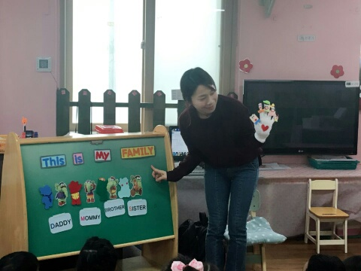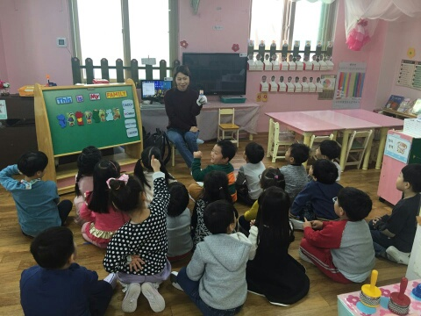
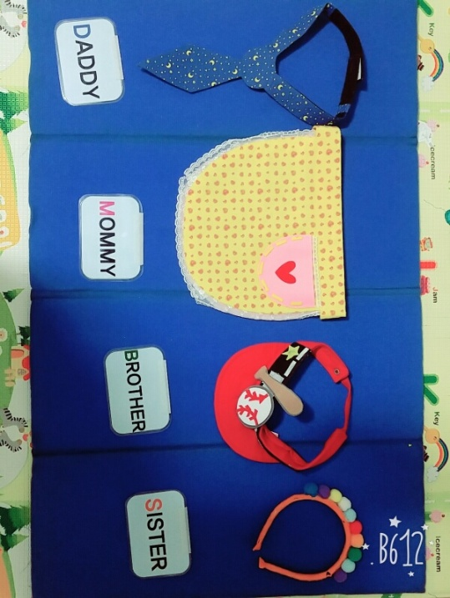
My teaching method is ALM & TPR. The fist I taught DM. I using the five fingers and singing about finger family song. The second I teach the words about family members with flash cards(using the secret bag). The third we are going to the dance with family song. They wearing a tie, apron, cap, hair band and introduce by oneself to the front. (I am daddy, I am mommy..etc.)

{Material for activity/ lmiatte T’s action until ready to speak}
The forth I give worksheet for the writing. They write about family. Just trace the word. They could do sing a song with finger family and they got to know about family members. As result, I think TPR(Total Physical Response) is the best Teaching method.

