Listening ☐ Speaking ☐ Reading ☐ Grammar ☐ Writing
Topic: At the immigration desk

Instructor:  Soweon Yoon  (Renz) | Level:  Intermediate (Adult) | Students:  12 | Length:  30 Minutes

Materials:
■ Realia : A declaration form of Australia
■ A picture of an immigration desk(airport)
■ White board and board markers
■ Vocabulary worksheet
■ While-listening worksheet
■ Worksheet for role-playing
■ Computer for audio file

Aims:
■ Main aim: Ss will be able to understand the situation at the immigration desk by listening to the dialogue.
■ Secondary aim: Ss will be able to do role-plays with partners on the supposition they are at the immigration desk.
■Personal aim: I want them to experience several situations at the airport in advance and apply them to the real world.

Language Skills:
■ Speaking: Ss will do role-plays with their partners.(pair work)
■ Listening: Ss will listen to the dialogue at the immigration desk.
■ Reading: Ss will read scripts of topic.
■ Writing: Ss will take notes while listening.

Language Systems:
■ Lexis : New vocabularies in the dialogue
■ Function : Asking and answering the questions.
■ Discourse : immigration desk at the airport

Assumptions:
Students already know
■ How the class is set up and run (Ss will sit with their partners for pair work)
■ Four language skills and language systems
■ Some students already have experience having gone to the airport.

Anticipated Errors and Solutions:
■ If students do not understand new vocabulary
☞ give them supplementary demonstration and offer pictures, photos or relia.
■ If some students have difficulty of role playing
☞ encourage them to speak and permit to refer to the dialogue.
■ If some students finish their tasks early
☞ offer them other tasks about today’s objectives.

References:
■ Pictures and photos: www.google.com

■ English definitions : www.naver.com

■ Listening file:

Lead-In
Materials: A declaration form of Australia

Time | Set Up | Student Activity | Teacher Talk
1 min | Whole class | Focusing on a teacher and answering questions | Good afternoon! How are your feelings?  Have you been to other countries?  Have you seen this form before?

Pre-Activity
Materials: Board, Board markers, photo, worksheet #1

Time | Set Up | Student Activity | Teacher Talk
2min  5min | Whole class  Pairs | Answering teacher’s questions | Procedure:  - Brainstorming  Elicit  (Show the students visual aid-picture)  -How many people are there?  -What do you think the front man looking at?  -What are those on the desk?  -How is the feeling of the man who stands by the glass?  -Where do you think they are?  T write down students; answers on the board  Model  Write the subject “At the immigration desk” on the board.  - New Vocabulary  Instruction  “We are going to learn new vocabulary before listening. I will give you a worksheet. First, Read the definition of words. If you don’t know the meanings exactly, talk to partners and share your ideas.”  (Give vocabulary worksheets to Ss)  “I will give you 3 minutes. Let’s start!”  Monitoring  Monitors Ss to do right. If Ss ask questions, answers them.  CCQ  Checks the meanings of vocabulary with some questions.  -  -  -  -  -

Main Activity
Materials: Computer for listening, worksheet #2
Time | Set Up | Student Activity | Teacher Talk
5min  5min  2min | Whole class | Students guess what people do at the immigration desk. i  Students listen to a dialogue and answer the questions.  Students check the answers with a teacher. | Procedure  - Present  Instruction  “As I mentioned, today’s topic is ‘at the immigration desk.’ So we will need to know what people are doing at the immigration desk. When you arrive at other countries’ airport, you will go to immigration desk at first. Does anyone knows what people are doing at immigration desk?”  “You have to stop by immigration desk before entering other countries. The staff checks your passport and asks about your reason to enter a country.”  - Practice  Listening  (Give listening worksheets to Ss)  “Now, you will listen to a dialogue at the immigration desk. While you are listening, you will do notetaking what you listened in the box.”  ICQ  What is the title of subject will we listen?  Do you need to take a note while listening?  (The first listening)  “Ok, Did you note take well? I will give you one more time to listen. While you are listening, now you will answer the questions below the box.”  ICQ  Do you have to answer the questions now?  (The second listening)  Check answers  “Now let’s check the answers together.”  Check answers with a teacher

Post Activity
Materials: Worksheet #3
Time | Set Up | Student Activity | Teacher Talk
8min  2min | Pairs  Whole class | Students do role-plays with their partners.  Students say goodbye to T. | - Product  (Role-playing)  Instruction  “Now, you will do role-playing with your partners. I will give your worksheet for role-playing. One worksheet for a pair”  (Give listening worksheets to Ss)  “Ok, do you all have your worksheet? There are three situations at the immigration desk. Your pair can choose one situation and do a role-play like the listening dialogue that we listened. I will give you 5 minutes.”  ICQ  What we are doing?  Are you working in pairs?  How much time will you have?  - Conclude lesson  Summarize today’s lesson by checking new vocabulary and a dialogue.  “Class, today we had a class about immigration desk. Thank you for actively participating today. See you next time. Bye!”

SOS Activity
Materials: Worksheet #3
Time | Set Up | Student Activity | Teacher Talk
5min | Pairs | Students do role-plays with their partners. | Feedback  “Let’s share your role-plays. Does anyone volunteer?”  (Sharing the role-plays)

****Plus include all worksheets, PPTs, scripts, photos of realia… EVERYTHING you use
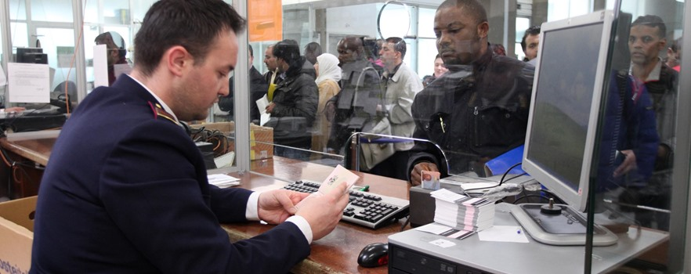
<At the immigration desk >

(A: examiner B: visitor)

A: Good evening sir. May I see your passport and immigration card please?
B: Sure. Here you are
A: Do you have anything to declare?
B: No. I just have these duty-free items that I bought on the plane
A: That's okay. Welcome to Australia! Is this your first tirp here?
B: No. I came here on business a few years ago but I couldn't stay long.
A: Are you here on business or pleasure this time?
B: Purely pleasure this time
A: Good. Are you planning on traveling around during your stay?
B: Well, I've only got a week so I'm planning on staying in Sydney
A: Yes. Australia is a big place you'll need a week to see it all
B: Maybe next time this time I'm going to try to see all the tourist areas of Sydney
A: Good. I hope you enjoy your stay!
B: Thank you!

Worksheet #1 Name: _____________

Vocabulary_at the immigration desk
 | Word | Meaning
1 | passport | (noun) an official document that shows that the holder is a citizen of a country. A passport gives one the right to travel in other countries and return to one's own country
2 | immigration | (noun) the act of coming to live permanently in a new country
3 | declare | (verb) to announce in a formal way
4 | duty-free | (adjective / adverb) exempt from a duty or tax
5 | business | (noun) the work a person does to earn money; job or trade
6 | stay | (verb) to spend time in a place  syn. remain
7 | pleasure | (noun) a feeling of happiness, delight, or joy  syn. delight, enjoyment
8 | tourist | (noun) a person who is travelling for pleasure
9 | enjoy | (verb) to find pleasure or joy in

Worksheet #2 Name: _____________

At the immigration desk

1. Note-taking box

2. Listen carefully and answer the questions.

1) What are an examiner asks to give to a visitor?

2) The visitor has something to declare. ( T / F )

3) It is the first time that the visitor comes to Australia. ( T / F )

4) Where and how long will the visitor stay in Australia?

Worksheet #3 Pair work
Role-play_at the immigration desk
Choose one situation among below three. Suppose that you are an examiner and visitor at the immigration desk and do a role-play with your partner.
Situation #1
Departure : Incheon, South Korea
Arrival : New York, USA
Goal : travel / sightseeing (alone)
Duration : two weeks
Place to stay : Times guest house
Declared items : X

Situation #2
Departure : Incheon, South Korea
Arrival : Tokyo, Japan
Goal : studying
Duration : six months
Place to stay : Sakura university
Declared items : Perfume

Situation #3
Departure : Incheon, South Korea
Arrival : Singapore
Goal : travel / sightseeing (family)
Duration : 5 days
Place to stay : Marina Bay Sands Hotel
Declared items : Cigarettes

