Listening Speaking Reading Grammar Writing

Topic: About Sexist comments.

Instructor:  An Hye min  (Candy) | Level:  Upper Intermediate (Adult) | Students:  12 | Length:  30 Minutes

Materials:
- Realia: the picture of Ariana Grande and two Radio casters in the Radio station.
- Flash card:Three optical illusion pictures.
- Fill in the blanks Worksheet(12copies)
- Vocabulary worksheet(12copies)
- White board & marker pen
- Computer for video file.

Aims: (3)
- Main: To enable students to improve their listening skill by how they talk about Ariana Grande and two man cast.
- Second: Ss learn the proper intonation of the language.
- Personal: I want to improve of listening and speak louder.

Language Skills: (4- Integrated)

- Speaking: Ss will discuss in pairs and groups, 'If you could you choose… which one would you pick?',
- Listening: Ss will listen to the article about sexist comments.
- Reading: Ss will read scripts of topic.
- Writing: Ss will fill on the blanks of the worksheet.

Language Systems: (3-5)
- Grammar: present participle ( have+p.p ing), If you would be etc.
- Lexis: New vocabulary in the script(assuming, Shelby model, obviously etc)
- Function: request.
- Discourse: Discussion.

Assumptions:
- All Students are adult (Age 20 above)
- The number of students in similar men and women?
- Ss will understand the script without sexist comments?

Anticipated Errors and Solutions:
- If students can’t complete the gap fill task .
->students will listen to the script again and chunk the listening.
- If student need help in listening.
-> Listening them slowly about 1 sentence.
- If some student keep quiet during discussion.
->encourage them to speak and help to speak.

References:
-English Definitions
http:google.co.kr
-Visual aid & script
https://www.youtube.com/watch?v=ACN9NU9WYfo

- Listening and Speaking Activities for Adult ESL Learners (by. Jane C. Miller)
- http://www.englishisapieceofcake.com/

Lead-In
Materials:
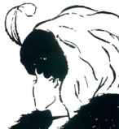
Realia: The picture of optical illusion (3)

Time | Set Up | Student Activity | Teacher Talk
2min | T-s  Whole  class | Gussing & Answering teacher’s  questions | (Greeting)Hello everyone!  How are you today?  Today I have a three optical illusion pictures!  What do you see?  Can you tell me , what can you see?

Pre-Activity
Materials:
Realia: the picture of Ariana Grande and two Radio casters in the Radio station.
Flash card: makeup things , cell phone, color papers , twitters mark( or kakao )
Visual video
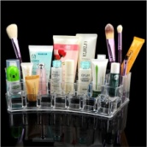

Time | Set Up | Student Activity | Teacher Talk
8min | T-s  Whole  class  S  T-S | Answering teacher’s  questions | Procedure:  (Elliciting)  everybody look at the picture!  If you could use makeup or your phone one last time which one would you pick?  how long can you go without looking hour without twitter(or kakao)?  (CCQ’S)  If you, man.  Are you going to do the necessary moment only a day instant messaging?  (No)  If you, women.  can you propose to your boyfriend?  (yes)  Okay, look at this picture!  (Show the students the picture of Aariana Grande at the radio station)  Do you know she is?  What are they does? About what?

Main Activity
Materials:
Fill in the blanks Worksheet(12copies)
Vocabulary worksheet(12copies)

Time | Set Up | Student Activity | Teacher Talk
4min  8min | T-S  S  T-S |  | I will give you a worksheet#1 of vocabularies and idioms about sexist comments.  First read carefully and then find the appropriate word from the word box.  I will give you 3minte.  (ICQ)  So, what are you going to do?  (find appropriate words )  Are you working in pair?  (no)  Are you working individually?  (yes)  How much time do you have for find words?(3min)  Okay, can you tell me , what is a appropriate word about sexist comments.  Let’s check together!  I will tell you the title of this listening script.  (write on the headline or script on the white board “ About sexist comments”.  Here is the worksheet #2 fill the blank.  (Instruction) Everyone, listen carefully to the script first. While listening , try to remember the sentence in the blank.  Write on the blank and fill it.  I will give you 3mint.  Are you done?  (ICQ)Do you take a note while listening?  (no)  Okay , now I will listening about script one more time. If you are not done, please fill it all blank while the listening.  If you are done, check it all blank.  (Check answers)  Okay I think all of you finished the  Worksheet. Now, let’s check together!  Go through the answer of each sentence one by one.

Post Activity
Materials:
Make a list of 5-10 very simple sentences.
Time | Set Up | Student Activity | Teacher Talk
8 | S-s  T-producer | Role- play  -As a whole class, or in groups of 4-5 | So, now let’s game together!  The name of “Expanding Sentences”  I say.  “If you could use makeup or your phone one last time which one would you pick?”  Next,  “pick cell phone”  ask each student in turn to add a word, phrase, or clause to the sentence so it gradually expands and becomes more complex.  (Demo)  “ pick cell phone”  “my sister picks the cell phone”  “my old sister picks the cell phone everyday”  …  Everybody understand?  Let’s do it!

SOS Activity
Materials:
Time | Set Up | Student Activity | Teacher Talk
2-3min | S-S | Bingo game with whole class | Everybody let’s play bingo together!  Here is the word (about today’s voca).  Let’s draw a line and make a blank 4 x 4 or 5 x 5 bingo grids with squares large enough to write vocabulary words in this box. When you have 4 or 5 beans in a row, they call out “Bingo”..

****Plus include all worksheets, PPTs, scripts, photos of realia… EVERYTHING you use

what can you see?

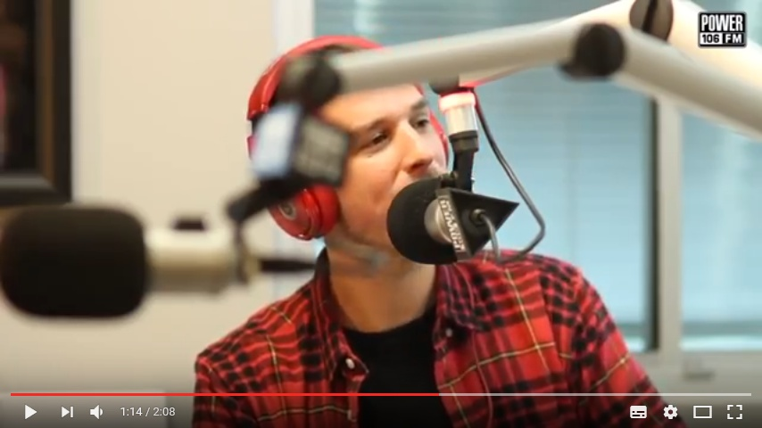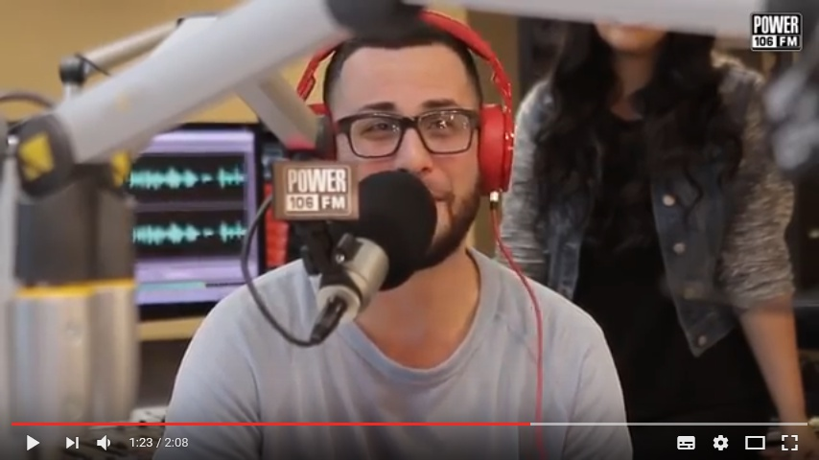

-Visual aid & script https://www.youtube.com/watch?v=ACN9NU9WYfo

