☐ Listening ☐ Speaking ☐ Reading ☐ Grammar ☐ Writing
Topic: How to break up with your boyfriend /girlfriend nicely?

Instructor:  Diana ( Eunyoung Kim)  Jasmin ( Hohyun Lee ) | Level:  Upper Intermediate (Adult) | Students:  15 | Length:  30 Minutes

Materials:
▶ Computer and beam projector
▶ White board and marker
▶ Video file (Friends – Ross and Rachel break up scene)(2’15”) (pre-task)
▶ Visual aid – 1 picture of ghost (3 copies) (task-preparation)
▶ Worksheet #1 Rankings worksheet (15 copies) (task-realization)
▶ Worksheet #2 Group discussion crossword (15 copies) (SOS activity)
▶ Crossword Answer
▶ Audio script for video file

Aims:
▶Main aim: Students will be able to discuss actively ‘How to break up with your boyfriend nicely?’ with worksheet #1.
▶Personal aim: I want to encourage students to actively participate in speaking during the class.

Language Skills: (4- Integrated)
▶Speaking: Students will discuss topic with ranking worksheet #1 and answer teacher’s questions.
▶Listening: Students will listen to other students’ opinions and video file.
▶Reading: Students will read worksheets.
▶Writing: Students will write the reason on the ranking worksheet.

Language Systems:
▶Phonology: Correct pronunciation of “Cliché”( It make /ch/ sound to /ʃ/)
▶Lexis: Cliché, Ghost, Reason,
▶Grammar: Gerund /~ing/ ex) Telling, Lying, Taking etc.
▶Function: Listing items (various break up techniques) and giving information
▶Discourse: Discussion

Assumptions:
Students already know
▶How the class is set up and run
▶Four language skills and language systems
▶to remember experiences of breaking up with boyfriend in real life or in the movies

Anticipated Errors and Solutions:
▶If students are nervous to answer,
>> We will, as teachers, will lead them with specific questions.
▶If students get excited from the topic and the conversations get loud
>> We would pick the loudest student and ask their opinions more seriously to take control of the course.

References:
▶Web page : Main topic and worksheet #1 picture
https://goo.gl/l8piOb
▶Video : Youtube - Friends : Ross and Rachael break up
https://goo.gl/PEi8Jb
▶ Web page : Vocabulary
https://goo.gl/HR6lIQ
▶Web page : picture of ghost
https://goo.gl/iILEjQ

Pre-task
Materials: White board and marker,
Video file (Friends – Ross and Rachel break up scene)(2’15”)

Time | Set Up | Student Activity | Teacher Talk
6min | Whole  class | Answering teacher’s question  Watching the video  Answering teacher’s question | “Good afternoon, everyone! How was your week? (Wait Ss response)  Okay, good. I’m glad to hear that.”  <Brainstorming>  Eliciting  “I will show you a video.  (Write down name of ‘Friends’)  The title is ‘Friends’. Have you ever seen the famous sitcom ‘Friends’ before?  (Write down name of Ross and Rachel.)  To sum up, Rachel wants to break up with Ross In the sitcom . Ross seems to have dated another girl, and Rachel is hurt deeply by that. So let’s see what’s going on.”  “Now, let’s see.”  ( Show the students the video)  “In the sitcom, Who broke up with who?”  “Have you ever broken up with your boyfriend/girlfriend before?”  “How did you feel when you broke up?”  “Did that happen nicely or unpleasantly?”  (Write down what students mentioned)  “Very good.  Thank you. Like this, breaking up with boyfriend/girlfriend is common and can be little bit hard.  Modeling  “From now on, we are going to talk about  (Write down the topic on the board)  ‘How to break up with your boyfriend /girlfriend nicely?’”  It’s seems to be exciting, isn’t it?”

Task Preparation
Materials: White board and marker,
Visual aid – 1 picture of ghost (3 copies)

Time | Set Up | Student Activity | Teacher Talk
4min | Whole class | Listening teacher’s talk  Speaking and answering the question | <Vocabulary>  Instruction  “Before I hand out the ranking worksheet,  I will introduce 3 terms.”  (Write ‘cliché’ on the board)  “Has everyone heard of this word? Can you read it? Could you follow me /kli:ʃei/? Can you tell me what it means?  Yes, ‘cliché’ is a phrase or opinion that is overused and betrays a lack of original thought.”  CCQ  -“For example, whenever some people late for the meeting, they use clichés. Can you think what kind of they are using cliché at that situation? (Wait Ss response)  I’m late because of a traffic jam. That’s one isn’t it?”  (Write ‘ghost’ on the board)  “Has everyone heard of this word? Can you tell me what it means?  Yes, ghost is the spirit of a dead person that someone believes they can see or feel.”  CCQ  -“Have you ever seen ghost before?  Does anybody want to see it? Okay, I will show you.” (Show the Visual aid)  “What can you see in this picture?”  (Write ‘reason’ on the board)  “Has everyone heard of this word? Can you tell me what it means?  Yes, reason is a cause, explanation, or justification for an action or event.”  CCQ  “You may cry sometimes to see the movies, the reason why? Yes, it is. The movie is sad.”

Task Realization
Materials: Worksheet #1 Rankings worksheet ( 15 copies)

Time | Set Up | Student Activity | Teacher Talk
2min  4min  1min  5min  3min | Whole class  Individually  Whole class  Group  Individually | Listening teacher’s talk and answering the question.  Students rank in the worksheet by themselves  Listening teacher’s talk and answering the question.  Speaking their opinion in the group  Listening teacher’s talk and answering the question. | <Discussion>  (Hand out worksheet #1)  Instruction  “Let’s look at the worksheet. There are 8 pictures with sentences. There are various ways to break up with boyfriend are suggested. Which attitude do you think is nicer? Rank them in priorities and write down the reason why. Do it by yourself. I will give you 4 minutes.”  ICQ  “ How much time do you have?”  “Are you working in the group?”  “Let’s start.”  Monitoring  Monitor discreetly and answer students if they have a question.  “1 minute left.”  (Ask if they need more time. If so, give them 1 more minute.)  “Time’s up, everybody. Good job.  From now on, discuss your own ranking with your group. Your task is to agree on the rankings. I’ll give you 5 minutes.”  ICQ  “ How long we are going to discuss?”  “Are you working in the group?”  “Let’s start.”  Monitoring  Monitor discreetly and answer students if they have a question. Also, teacher jot down mistakes in language students use.  “Alright, did you enjoy today’s activity? Now I want to share some of your rankings.  (Students name) Which attitude do you think is the nicest ? Why?  (Students name) Which attitude do you think is the most unpleasantly ? Why?  Thank you for sharing your opinion.”

Post-task
Materials: : White board and marker,

Time | Set Up | Student Activity | Teacher Talk
5min | Whole class | Listening teacher’s talk and answering the question. | < Feedback>  “Did you enjoy today’s activity? Can you agree to others rankings? Why? (Listen to students feedback on the activity)  <Language focus>  “Now, we’re going to do some error correction”  Error correction  (Write student’s errors you noticed during discussion and write them on the board.  Let the students try to correct as a whole class)  <Conclusion>  “Very good, everyone. Do you have any questions? If not, let’s finish today’s class. Thank you for your participation.”
SOS Activity
Materials: Worksheet #2 Group discussion crossword (15 copies) (with answer sheet)

Time | Set Up | Student Activity | Teacher Talk
4min  1min | Whole class  Whole class | Listening Teacher’s direction and fill in the crossword  Answering teacher’s questions | Instruction  “Here is a crossword puzzle. You can fill the crossword with given words. The given words are connected with breaking up technique or emotion.  Work with group. I will give you 4 minutes.”  ICQ  “How much time do you have?  “Are you in the group?”  Monitoring  Assist students if they need any help. Give a time warning “1 minute left”.  Answer check  Check the answers together.  (Teacher write down the answer)

Visual aid – picture of ghost
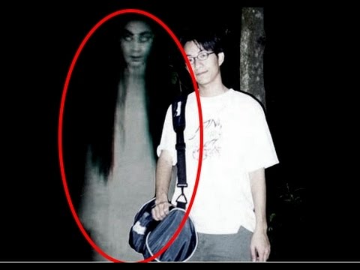

Worksheet #1 Rankings
■ How to break up with your boyfriend/girlfriend nicely?
Various ways to break up with boyfriend/girlfriend are suggested.
Which attitude do you think is nicer? Rank them in priorities and write down the reason why.
1. Telling him to his face
( ) why?:
2. Ghosting/ Disappearing without explanation
( ) why?:
3.Using clichés
( ) why?:
4. Taking some of the blame
( ) why?:
5.Saying kind things
( ) why?:
6.Giving actual reason
( ) why?:
7.Promising a friendship
( ) why?:
8.Staying conscious of your online messages
( ) why?:

Worksheet #2 Group discussion crossword
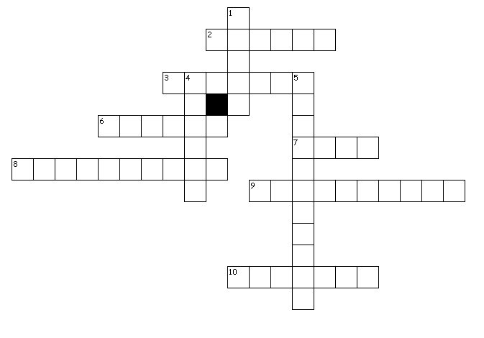
Across
2. a phrase or opinion that is overused and betrays a lack of original thought.
3. a declaration or assurance that one will do a particular thing or that a particular thing will happen.
6. existing in fact; typically, as contrasted with what was intended, expected, or believed.
7. to be in charge or command of.
8. the action or state of moving or being moved apart.
9. an inner feeling or voice viewed as acting as a guide to the rightness or wrongness of one's behavior.
10. to settle or find a solution to (a problem, dispute, or contentious matter).

Down
1. to assign responsibility for a fault or wrong.
4. a cause, explanation, or justification for an action or event.
5. a statement or account that makes something clear.

-Separation - Reason - Promise -Lead
-Cliché - Conscience - Blame
-Resolve - Actual - Explanation

Crossword Answer

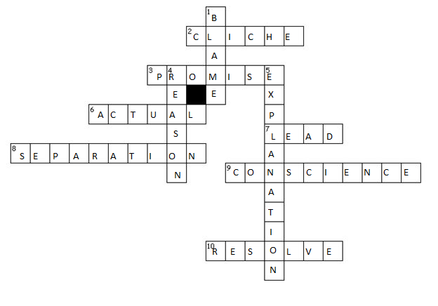

Audio script for video file
[Cut to Living Room]
Ross: You know what, you know what, I’m-I’m not the one that wanted that, that break, okay. You’re the one that bailed on us. You’re the one that, that ran the moment things got just a little rough!
Rachel: That’s....
Ross: That’s what?!
Rachel: That is neither here nor there.
Ross: Okay, well here we are. Now we’re in a tough spot again, Rachel. What do you want to do? How do you want to handle it? Huh? Do you wanna fight for us? Or, do you wanna bail? (sits down next to her) Look, I, (on the verge of tears) I did a terrible, stupid, stupid thing. Okay? And I’m sorry, I wish I could take it back, but I can’t. (We see Monica and Phoebe are almost in tears.) I just can’t see us throwing away something we know is so damn good. Rachel, I love you so much.
(He kisses her on her shoulder, then her neck, then the side of her face, then just before he kisses her on the lips....)
Rachel: No Ross!! (stands up and moves away from him) Don’t! You can’t just kiss me and think you’re gonna make it all go away, okay? It doesn’t work that way. It doesn’t just make it better. Okay?
Ross: Okay, okay, okay.
Rachel: (softly) I think you should go.
Ross: What?
Rachel: (softly) I really think you need to go now.
Ross: (moving over to stand in front of her) Okay, okay. This morning you said there was nothing so big that we couldn’t work past it together...
Rachel: Yeah, what the hell did I know!
Ross: Look, look, there’s got to be a way we can work past this. Okay, (takes a hold of one of her arms.) I can’t imagine, I can’t imagine my life without you. (Both of them are starting to cry.) Without, without these arms and your face and this heart. Your good heart Rachel (drops to his knees and hugs her around her waist) and, and....
Rachel: (crying) No. I can’t, you’re a totally different person to me now. I used to think of you as somebody that would never, ever hurt me, ever. God, and now I just can’t stop picturing you with her, I can’t, (Ross stands up and backs away) it doesn’t matter what you say, or what you do, Ross. It’s just changed, everything. Forever.

