Background Information Sheet – Complete all sections accurately.
Name & Class |  | Date & Place | Lesson Type |  |  | Plan |  | Topic |  |  | Length | Level
Jeannie JungHa Park  144th WD |  | 30/11/2016  Gangnam | Listening |  |  | PPP |  | Responding to good news |  |  | 45min | Intermediate
Class profile
Number of students: 9 Age: Adult Nationality: Korean
Motivations: To learn how to respond to good news.
Individual or class hobbies and interests: Most students like to hear good news.
Special considerations: Discourse plays a little fast so students may not catch the meanings.
Main aim
- Students will practice their listening comprehension skills using a top-down model.
Subsidiary aims
- Students will practice their oral fluency during the productive stage.
Description of any language skills specifically used/practiced:  - Listening – to a discourse/conversation between two people  - Speaking – sharing answers to questions and a discussion  - Writing – answers to questions; taking notes  - Reading – N/A |  |  |  |  |  |  | Description of any language systems specifically used/practiced:  - Lexis : congratulations, splendid  - Discourse : noticing changing sub-topic one to the other  - Grammar : “Are you excited?” “I am very excited.”  - Function : congratulations!

Anticipated difficulties with lesson activities and classroom management:
- Audio equipment may fail.
- Students may not understand the context clearly.
How I can deal with these difficulties:

Use the backup recording, laptop or mobile phone and portable speakers.
- Give clear instruction and assure that students think and compare answers with classmates with re-listen
- Inform students that this lesson is for leaning expressions to good news that they can also use it in real-life situation.
Assumptions:
- Students may have certain knowledges of responding to relevant questions.
- Students may predict the conversation.
Material(s) needed:
PC, projector(to show a picture), whiteboard, markers, worksheet, teacher’s guide with answers
audio-filehttp://downloads.bbc.co.uk/worldservice/learningenglish/howto/reacting_good_news_extra.mp3

Checklist. Mark down those included in this lesson plan ( or N/A)
 | model sentences for target language |  |  |  | concept questions for target language |  |  |  |  | analysis sheet for target language
 | stages clearly titled and separated |  |  |  | purpose of each stage indicated |  |  |  |  | anticipated timing included
 | interaction pattern marked |  |  | N/A | a board plan (if relevant) |  |  |  |  | examples of all tasks used
 | answer sheet to all exercises |  |  | N/A | Tape or text script |  |  |  |  | all materials labelled and numbered
Personal aim :
- What I most hope to demonstrate in this lesson is the ability to give clear instruction and increase S.T.T. in the classroom.

Stage 1: Lead-in  The purpose of this stage is to ease into the topic, relaxing both teacher and students by focusing their attention on an interesting subject and encouraging the class to share their opinions freely, thus increasing STT and participation. This stage may be used to create a basis from which to elicit ideas and lexis relating to the text. | Inter  action | Time | Instructor’s comments
*classroom desk arrangement : 3 people sitting as a group; like a letter “T” and facing front*  - Greet the class and ask students to discuss what they see in the picture.  Show PPT  - Instruction:  Good Morning class! (with happy smiley face)  Let’s look at the picture. What do you think it is?  (Figure 1,ppt)  Based on what you can see, what do you know?  Discuss your ideas with your partner for a minute.  - Students share their ideas Teacher is monitoring.  - Feedback Nominate and invite comments from 2 or 3 pairs.  - Expected answers :  - Thumbs up  - Clapping/applause  - Tossing a person  - Fireworks/balloon/  - Party supplies  - Congrats something  - Celebration  - Birthday  - Feeling good  - Good job/ well-done  - Hearing good news | T-S  S-S  T-S | 2’  1’  2’

Stage 2: Presentation  The purpose of this stage is to make the listening less challenging to the students by making use of guiding questions which help predict expected content; answers to these questions may be guessed during this stage and checked later in the lesson; pre-teaching keywords and phrases from the text. Knowledge of the purpose of the text, form and style could be highlighted to further aid comprehension. Thus, schema is activated. | Inter  action | Time | Instructor’s comments
- Instruction :  Today, we are going to assess a listening text. To help you do this, I will ask you some questions.  Then, you will listen to the text. You will also write down your answers and compare them with your partners’.  - Distribute the worksheets or handouts.  - Guiding questions :  Before we start, let’s look at a question (show Figure2,ppt);  When or what situations do we use these gestures which you see from the picture and what are the expressions we can say? Discuss with your partners in a minute.  - Students share and make notes their ideas Teacher is monitoring.  - Feedback Nominate and invite comments from 2 or 3 pairs.  - Expected answers: (Figure 3,ppt)  - Celebration – wedding, birthday, promotion, getting a job, give a birth to a baby  - Congratulations!  - Good job, well-done,  - Fantastic, wonderful, excellent  - Excited, happy, amazed etc.  - Pre-teach vocabulary : congratulations, splendid : the words you should focus on. (figure 4,ppt)  Congratulations! Eliciting : What do you see? (a student, graduation cap, flowers etc.) Why does she wear a cap? (for graduation) What can you tell her? (congratulations) CCQ : Does this word ‘congratulations’ refer to happiness or sadness?(happiness) Can you say it in a serious situation? (no)  Splendid Eliciting : write down the phrases on the board. Student will find out the word. gorgeous palace excellent work s_ _ _ _ _ _d wonderful scenery CCQ : Is splendid negative word? (no, positive) Do you have splendid friends? (yes) | T-S  S-S  T-S  T-S | 40”  1’  1’20”  3’30”

Stage 3: Practice - Listening for gist comprehension  The purpose of this stage is to allow the students to practice gist skills to identify the main idea of the text. Specific and authentic exercises designed to encourage this skill should be used in a natural way. Students draw on their world-knowledge (top-down) to make an initial impression and general sense of the text and perhaps comparing the accuracy of their guesses to the guiding questions used for the text. | Inter  action | Time | Instructor’s comments
- Instruction :  Now you are going to listen what we have talked just now and think about the questions (figure 5,ppt) on your own.  Then discuss the answers with your partners’(group). Do not bother writing.  I.C.Q Do you need to write down? Yes!  Do you share ideas with your partners? Yes!  Are you ready to listen? Yes! / Not yet (wait for 5 seconds to be ready)  Show PPT-figure 5 (questionnaires-multiple choice)  Play the audio (play 10 seconds).  - What do you think you are listening to?  - What are they talking about?  - How would you describe the speakers?  - Students listen to the audio and share answers Teacher is monitoring.  - Feedback students give quick answers on each question.  - Expected answers to the questions :  - What do you think you are listening to? 2 people conversation  - What are they talking about? good news  - How would you describe the speakers? British | T  S  T-S | 30’’  1’30”  2”

Stage 4: Practice - Literal comprehension  The purpose of this stage is for students to focus on literal understanding e.g. of facts, ideas etc. A variety of exercises may be used and should be constructed for short responses e.g. objective questions. The information highlighted should, ideally, be of significance to the next stage. | Inter  action | Time | Instructor’s comments
- Instruction : Show ppt - figure 6  Now let’s listen to the audio fully.  And write down answers to these questions and share with your partners’(in a group)  What do you think? Did they talk about good news?  Where does William get married?  What will happen after one month?  I.C.Q Do you need to use your pen? Yes!  Do you share ideas with your partners? Yes!  Are you ready to listen? Yes! / Not yet (wait for 5 seconds to be ready)  - Audio plays 1’10” long students listen.  - After listening, “Now write down answers individually” Students individually work to complete answers.  “Now, you can share and discuss your answers in groups.”  - Students share answers Teacher is monitoring.  - Feedback: Nominate at least 2/3 class for the answers check answers of matchings.  What do you think? Did they talk about good news? Yes  Where does William get married? in a modern place/house etc.  What will happen after one month? Matt’s wife gives birth to a baby (something related to a baby) | T  S  S  T  S  T-S | 1’  1’10”  50”  10”  1’  3’

Stage 5: Practice - Interpretive comprehension  The purpose of this stage is to allow student to listen intensively for inference. Discriminating between fact and opinion and understanding the writer’s true thinking are possible considerations during this stage. Contrasting ideas may be highlighted, and use of certain language which affects meaning can be analysed in context. | Inter  action | Time | Instructor’s comments
- Instruction :  Let’s listen again.  You will write down the answers and discuss in groups. show ppt – figure 7  What parts of the conversation do they feel excited? And why do you think so?  What was the way of asking excitement?  - Audio plays 1’10” long students listen again.  After listening, “Now, you can share and discuss your answers with your group.”  - Students share answers in groups Teacher is monitoring.  - While monitoring check if audio is needed again. (option)  - Feedback: Nominate at least 2/3 class for the answers check answers of gap filling.  What parts of the conversation do they feel excited? And why do you think so?  marriage and baby- changing tones, say words of congratulations and splendid  What was the way of asking excitement?  are you excited? | T  S  T-S | 30”  3’  2’30”

Stage 6:_Production - Applied Comprehension  The purpose of this stage is to complete the final step in reading comprehension by getting students to apply to themselves the information from the text and which was focused on during the practice stages. The task should take into account your students’ background information in order to be suitable as an applied task. Speaking or writing skills may be practiced here. This stage is an important part of language acquisition. | Inter  action | Time | Instructor’s comments
- Instruction :  Now, let’s do some quiz!  First, you will find 6 correct answers with your group members.  Show ppt – figure 8. (teacher’s guide is given only to the teacher.)  Students work together. Teacher is monitoring  - Worksheet answers check with explanation  We can use a lot of expressions to give them positive responses.  Explain with appropriate reasons language system; grammar  - Based on what you have learned from the exercises answer these following questions. show ppt, figure 9  If you have some good news. Why don’t you talk to your friends in your group?  What are the expressions your friends and you responded?  Try to use the expressions what we have done for quiz!  You have 7 minutes!  - Students share ideas together in a group.  Teacher is monitoring and making notes of students’ error or new ideas. Reduce TTT and increase STT.  - Feedback: acknowledge positive responses and offer suggestions students may know the new good news!  - Expected answers  If you have some good news. Why don’t you talk to your friends in your group?  - Getting married/ giving birth to a child/ getting certificate/ increasing allowance/ having a nephew or niece etc.  What are the expressions your friends and you responded?  Try to use the expressions what we have done for quiz!  - Wow! Fantastic! Splendid! Are you excited? Are you nervous? Are you happy? Etc. | T  S  T-S  T  S  T-S | 30”  1’30”  4’  30”  7’  7’

Stage 7:_Wrap-up  The purpose of this stage is to end the lesson with some positive feedback about the lesson and the students’ participation. Review the ideas from the production stage if possible, and perhaps offer error correction. Classroom management should be considered, such are collecting worksheets, giving homework, stimulate interest in the next class or arranging the desks etc. | Inter  action | Time | Instructor’s comments
- To wrap up, summarise the main points and ask students some questions.  So, I will ask some questions to all of you.  <<Qs-As>>  How difficult was the listening material? okay, good, not difficult  What was the difficult word to remember? splendid, thus  Which part was fun? talking about the picture, sharing own good news and reaction  Did you like sharing ideas with your group members? yes  - You all did well! I also enjoyed the class with you sharing ideas.  Next time remember, when you listen to a good news, enjoy it like you did in class today.  Keep up the splendid work!  And there is homework to do. You should write a postcard to celebrate your friend’s wedding.  We will work on writing class for the next lesson.  Well-done! And I will see you in next class, bye!  - Class dismissed  - Follow up work for the next lesson  - Students work in a group to review today’s class.  - Teach students how to write a postcard. | T  T-S  T | 20”  2’30”  1’
Instructor’s Final Comments
Overall strengths of this lesson (planning and teaching) | Areas to work on

Overall comment

For this stage of the course, your lesson today was

- Above standard

- To standard

- Below Standard

Instructor: …………………………… Date: …………/……………/…………

Item: Congratulations | Anticipated Problems | Possible solutions
Meaning:  Expression of pleasure or joy  (words expressing one's praise for an achievement or good wishes on a special occasion) | Students may not be familiar with the meaning. | Eliciting :  What do you see? (a student, graduation cap, flowers etc.)  Why does she wear a cap? (for graduation)  What can you tell her? (congratulations)  CCQ :  Does this word ‘congratulations’ refer to  happiness or sadness? (happiness)  Can you say it in a serious situation? (no)
Form:  Noun | Students may get confused with the verb. | Noun comes from the verb.  verb : congratulate  noun : congratulation
Pronunciation:  /kənˌɡrætjʊˈleɪʃənz/ | Students may not know where the stress is and it is difficult to pronounce. | Write down phonetic symbols on the board with stress.  Drill it.
Item: splendid | Anticipated Problems | Possible solutions
Meaning:  Excellent; very good; gorgeous; wonderful | Students may not be familiar with the meaning. | Eliciting : write down the phrases on the board. Student will find out the word.  gorgeous palace  excellent work s_ _ _ _ _ _d  wonderful scenery  CCQ :  Is splendid negative word? (no, positive)  Do you have splendid friends? (yes)
Form: Adjective | Students may get confused with the verb. | Teach the function of adjectives  It helps nouns.  Eg. a splendid palace  a splendid work  a splendid scenery
Pronunciation: /ˈsplɛndɪd/ | Students may not know where the stress is and it is difficult to pronounce. | Write down phonetic symbols on the board with stress.  Drill it with some exercises; a splendid house, a splendid swimming pool etc.
Language Analysis Sheet – Vocabulary

Language Analysis Sheet – Vocabulary
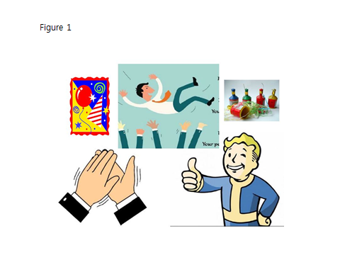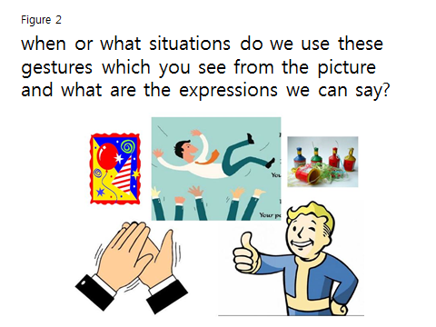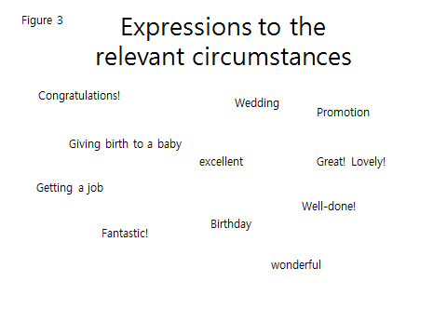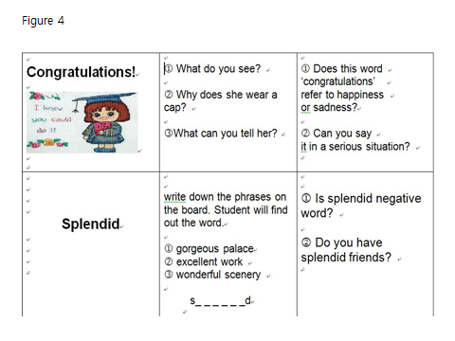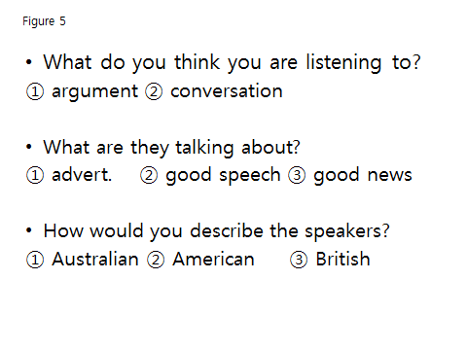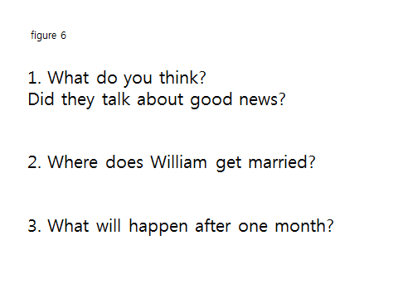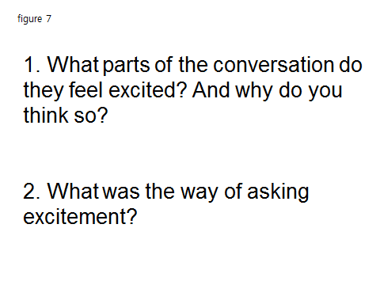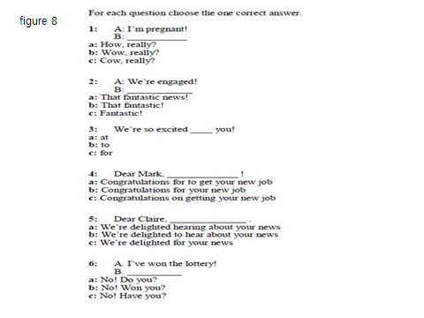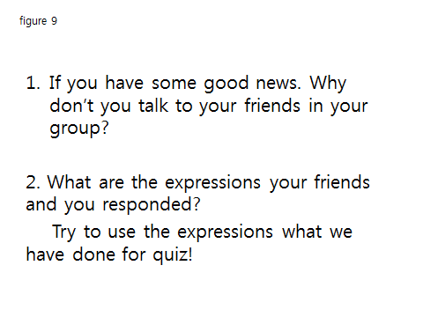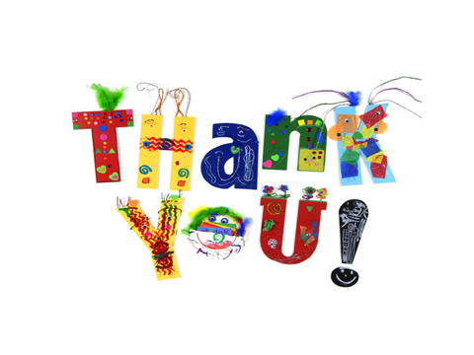

Worksheet Date : Name:

Exercise 1
1) When or what situations do we use these gestures which you see from the picture and what are the expressions we can say?

Exercise 2
1) What do you think you are listening to?
- argument ② conversation
2) What are they talking about?
- advertisement ② good speech ③ good news
3) How would you describe the speakers?
- Australian ② American ③ British
Exercise 3
- What do you think? Did they talk about good news?

- Where does William get married?

- What will happen after one month?

Exercise 4
- What parts of the conversation do they feel excited?
And why do you think so?

- What was the way of asking excitement?

Exercise 5
- If you have some good news. Why don’t you talk to your friends in your group?

- What are the expressions your friends and you responded?
Try to use the expressions what we have done for quiz!
Worksheet_Teacher’s Guide
Date: Name:

Exercise 1
- When or what situations do we use these gestures which you see from the picture and what are the expressions we can say?

Celebration – wedding, birthday, promotion, getting a job, give a birth to a baby
Congratulations! Good job, well-done, fantastic, wonderful, excellent, excited, happy, amazed etc.

Exercise 2
1) What do you think you are listening to?
- argument ② conversation
2) What are they talking about?
- advertisement ② good speech ③ good news
3) How would you describe the speakers?
- Australian ② American ③ British

Exercise 3
- What do you think? Did they talk about good news?

- Yes

- Where does William get married?

- in a modern place/house etc.

- What will happen after one month?

- Matt’s wife gives birth to a baby (something related to a baby)

Exercise 4
- What parts of the conversation do they feel excited?
And why do you think so?

- marriage and baby- changing tones, say words of congratulations and splendid

- What was the way of asking excitement?

- are you excited?

Exercise 5
- If you have some good news. Why don’t you talk to your friends in your group?

- Getting married/ giving birth to a child/ getting certificate/ increasing allowance/ having a nephew or niece etc.

- What are the expressions your friends and you responded?
Try to use the expressions what we have done for quiz!

- Wow! Fantastic! Splendid! Are you excited? Are you nervous? Are you happy? Etc.

<<Dialogue>>

Matt: Hello William.
William: Now the reason I have called you into the studio today is because I have some
good news.
Matt: Ah excellent – I like good news.
William: I am going to be getting married next month…
Matt: Oh congratulations, that’s fantastic news! Are you excited?
William: I am very excited, yes! Erm and er.. yeah… so…
Matt: Are you getting married in a church?
William: No, we’re not getting married in a church – but er, no, we’re doing the modern
thing -
Matt: You’re doing the modern thing rather than the traditional…
William: Yes, that’s right.
Matt: Very good.
William: That’s my news.
Matt: That’s splendid news. I also have some very exciting news…
William: You don’t! Do you also..?
Matt: I… I also have some exciting news.
William: What’s your news?
Matt: In one month’s time, my wife is having a baby boy – our first child.
William: Is she?!
Matt: Yes, she is.
William: Wow, I didn’t know that! When did you… well, you must have found out a
long time ago…
Matt: I found out a long time ago, but we’ve been keeping it quiet.
William: Oooh, well congratulations! Do you know if it’s a boy or a girl?
Matt: I said it was a boy.
William: Oh yes! Good point… OK Matt, that’s all I wanted to tell you.
Matt: Ah, fantastic – well, good luck.
William: Good luck to you too. Bye bye.

<<Quiz>>

For each question choose the one correct answer.
1: A: I’m pregnant!
B: ___________
a: How, really?
b: Wow, really?
c: Cow, really?

2: A: We’re engaged!
B: ____________
a: That fantastic news!
b: That fantastic!
c: Fantastic!

3: We’re so excited ____ you!
a: at
b: to
c: for

4: Dear Mark, _____________ !
a: Congratulations for to get your new job
b: Congratulations for your new job
c: Congratulations on getting your new job

5: Dear Claire, ______________ .
a: We’re delighted hearing about your news
b: We’re delighted to hear about your news
c: We’re delighted for your news

6: A. I’ve won the lottery!
B. __________
a: No! Do you?
b: No! Won you?
c: No! Have you?

<<Quiz_answer>>
For each question choose the one correct answer.
1: A: I’m pregnant!
B: ___________
a: How, really?
Wrong – What informal word expresses surprise and pleasure?
b: Wow, really?
Correct – This is an informal way to express surprise and pleasure
c: Cow, really?
Wrong – This is very rude! What informal word expresses surprise and pleasure?

2: A: We’re engaged!
B: ____________
a: That fantastic news!
Wrong – ‘That’s fantastic news’ would be correct – but there’s no verb here
b: That fantastic!
Wrong – ‘That’s fantastic’ would be correct’ – but there’s no verb here
c: Fantastic!
Correct – We can use some very positive adjectives like ‘fantastic’ by themselves

3: We’re so excited ____ you!
a: at
Wrong – You need a different preposition here
b: to
Wrong – You need a different preposition here
c: for
Correct – This is a good way to show you are sharing someone’s excitement

4: Dear Mark, _____________ !
a: Congratulations for to get your new job
Wrong – We don’t use ‘for’ or the infinitive with ‘congratulations’
b: Congratulations for your new job
Wrong – We don’t use ‘for’ with ‘congratulations’
c: Congratulations on getting your new job
Correct – You can use ‘on’ and the ‘-ing’ form of a verb with ‘congratulations’

5: Dear Claire, ______________ .
a: We’re delighted hearing about your news
Wrong – You need an infinitive after ‘delighted’
b: We’re delighted to hear about your news
Correct – This is a polite way to show you are happy for someone
c: We’re delighted for your news
Wrong – You can say ‘We’re delighted for you’ – but you need another verb here

6: A. I’ve won the lottery!
B. __________
a: No! Do you?
Wrong – The verb tense should agree with the initial statement
b: No! Won you?
Wrong – Use the helping verb to make questions in the present perfect
c: No! Have you?
Correct – This is a very natural way to react to a surprise

