☐ Listening ■ Speaking ☐ Reading ☐ Grammar ☐ Writing
Topic: Playing Detective

Instructor:  Aesun Jeon(April)  Jungyoon Choi(Alicia) | Level:  Intermediate | Students:  6 students | Length:  30 Minutes

Materials:
- Computer
- Projector
- Picture #1
- Picture #2
- Realia : A cellphone
- Video #1 Lemonade detectives
- Worksheet #1 (6 copies for every students, 2 more for extra)
- Worksheet #2 (3 copies for 3 groups of the students , 2 more for extra)
- Worksheet #3 (6 copies for every students, 2 more for extra)

Aims:
- Main aim : Ss will be able to improve their speaking skills by discussing and
playing a game
- Secondary aim : Ss will be able to practice speaking, using “could have p.p”,
“couldn’t have p.p” grammar
- Personal aim : I want Ss to be able to express the reasons why they
couldn’t/could do something in the past

Language Skills:
- Listening: Ss will listen the video clip.
- Speaking: Ss will discuss and naturally participate in the games.
- Reading : Ss will read vocabularies and meaning in worksheet #1
- Writing : Ss will write their opinions about why someone looks suspicious
in worksheet #2

Language Systems:
- Phonology: -sp-, gr-, etc (Blends)
- Lexis: brag, chug, grin, gasp, suspicious, detective, realistic, etc.
- Function: Speculating, guessing
- Grammar: 2nd conditional
could have + (past participle), couldn’t have + (past participle)
- Discourse: Discussing about who took the money from cashbox.

Assumptions:
Students already know
- The concept of 2nd conditional
- Easily describe their own experiences and discuss opinions

Anticipated Errors and Solutions:
- Ss may not remember the characters’ name in worksheet #1
→ Put each character’s picture with name in worksheet #1
- Ss feel clueless when they fill in the crosswords
→ Write the vocabulary in the board in random and find the answer.

References:
- Little Fox : www.littlefox.co.kr
Find "The Lemonade Detectives", The Mystery of the Missing Money 1

Lead-In
Materials:
- Realia : A cellphone
- Picture #1

Time | Set Up | Student Activity | Teacher Talk
2min | Whole  class | Ss may not recognize the lesson has already started, but they have been unknowingly participating in the class, being in the conversation with the teachers. | Introduction  (Naturally start the lesson pretending that a teacher has lost her cellphone.)  "Where is my cellphone?  I just put it here on the desk"  "Ariel, did you see my cellphone?  It was right here.”  (Point to the desk)  “You must have seen it”  "Did you take it?”  Another teacher may say:  "Oh, wait! Chris could have taken it.  I saw he was sitting right there!  “No, Chris couldn't have stolen.  He was talking to the teacher"  (After looking all over for the cell phone, she found out that the cell phone was in her bag.)  “I found it. It’s right here.”  “I am sorry I was just kidding.”

Pre-Activity
Materials:
- Board and board marker
- Worksheet #1
- Picture #1

Time | Set Up | Student Activity | Teacher Talk
3 min  5min | Whole  class  Individual | Ss may answer teachers, questions  Ss match the words in worksheet #1 | 1. Brainstorming  Model  When the teacher mention the target language during the talk as below,  "You must have seen it.”  “Oh wait, Chris could have taken it”  “No, Chris couldn’t have stolen”  Another teacher writes those same sentences on the board.  So, can you guess what is going to be our topic today?  Elicit  (Showing the picture of Sherlock Homes)  “Do you know who this is?”  “Right, it’s Sherlock Homes"  "He is one of my favorite characters in a mystery novel"  "We are going to talk about how to find a suspect in a mystery situation using the phrases  (Pointing to the writing on the board)  2. New vocabulary  Instruction  “First, we are going to learn some new vocabulary before watching a video.  I will give you a worksheet. Here it is.”  (Distribute the worksheet #1)  These words are related to the video which we’re going to watch, and some are relevant to what we are going to discuss today.  I'll give you 3 minutes. Match the words and meanings together, drawing the lines.  Demonstration  Let’s do the first question together.  (solve one question together)  ICQ  What do we need to do?  Do you work yourself?  How much time do you have to finish?  Monitoring  (Monitoring Ss carefully and help them if they want.)  Check answers  "Let's check the answer on by one."  "Number one”  (Name a student)  “Number two.”  (Name another student)  (It goes on to the last question)

Main Activity
Materials: Computer
Projector
Picture #2
Video #1
Worksheet #2

Time | Set Up | Student Activity | Teacher Talk
10 min | Whole  Class  Pair | Answering teacher’s questions  Answering teacher’s questions  Ss will discuss with their partners.  Ss will explain their own opinions | Elicit  (Put the picture #2 on the board)  “I will show you a picture. In this picture, what can you see? There is a lemonade stand. What are they doing? (Point each group of picture) What about them? (Point another in the picture) What can you see?”  (Wait)  “Good.”  “Now, we are going to watch a short video. In this story, a girl, Maggie is selling lemonade at a stand in order to make some extra money.”  “While talking to her cousins, she found out that all the money she earned was gone. She believes that someone must have stolen the money.”  “Now, I want to you to find out who stole the money.”  “Let’s listen to the story.”  (Play the video file.)  CCQ  “So, how many groups are there in this story?”  (Wait)  “Right, there are 5 different groups of people. Two teenage girls, A boy with a skateboard, A little boy with his mother, Nathan and his little sister, and lastly, Maggie’s cousins”  “Could her cousins have stolen the money?”  “No, then, why couldn’t they have stolen the money? What were they doing?”  “They were talking to Maggie when the money disappeared, right? That’s why they couldn’t have stolen the money”  “Like this, I want you to think about who looks the most suspicious and the reasons why they could/couldn’t have stolen Maggie’s money based on what they were doing at the scene.  (Hand out the worksheet #2)  “Okay. Let’s look at the paper.  “I will give you 3minutes to discuss with your partner. Then, you may present.”  (Put the students into 3 groups)  ICQ  “Who are we looking for?”  “How many minutes do you have?  “Do you work alone?”  “Good. Let’s begin.”  Monitoring  (Monitoring Ss carefully and help them if they want.)  (Give Ss time warning. 1min. flexible with the time. Give 1 more min, if needed)  “Okay. Time’s up. Let’s check who might be the suspect together”  Check answers  Ask each group to share its opinion.  “Who do you think stole the money?”  “What made you think so?”

Post Activity
Materials: None

Time | Set Up | Student Activity | Teacher Talk
10min | individual | Ss make their own conversation | 1. Free production  Introduction  Let's talk out your personal experience when you lost your personal belongings and how you reacted.  Demonstration  For example, I have lost my money.  (A teacher's personal experience)  I will tell you my story.  When I was young, I saved quite big money in my piggy bank. One day I kept my piggy at the top of my bookshelf and I forgot. When I wanted to use my money, I couldn’t find it. I didn’t consider at all and I went to my brother’s room and yell at him. “You took my piggy bank! I saw you were in my room few days ago, and you must have stolen my piggy! And I told my parents. But we couldn’t find my piggy bank anywhere. Few months later, I found my piggy with tons of dust. I told my brother the truth when I was over 20. I wouldn’t have assumed he did something bad.  So like, you can share your own story.  ICQ  What are we going to talk about?  Are we going to talk about the video?  Conclude the lesson  When you lost something, don't jump  to the conclusion right way! Someone  might get hurt!!

SOS Activity
Materials: - Worksheet #3,
- board and board markers

Time | Set Up | Student Activity | Teacher Talk
If needed | individual | Ss solve crosswords. | 1.Crosswords  Instruction  There are the vocabularies which we did in worksheet #1. We have a crosswords activity. You can find some hints on the board; fill the paper in with those words. You can solve crosswords with your partner for 3 minutes.  Model  (While one instructor gives instruction, the other instructor writes down the words on the board.)  (distribute worksheet # 3)  Check the answer  Let’s check the answers together. Read aloud the answers one by one.

Picture #1

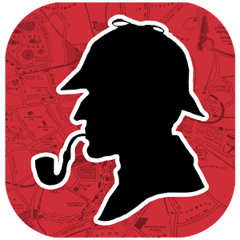

Picture #2
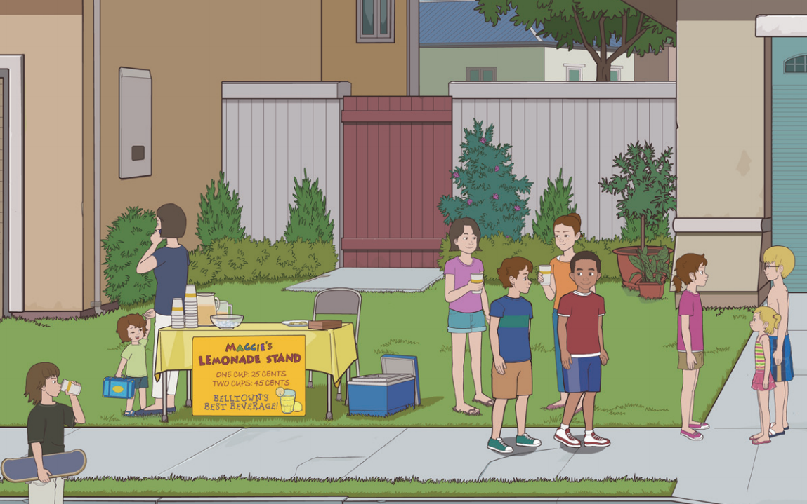

New Word List #1

brag guess
detective suspect
sip gasp
realistic chug
Suspicious grin
Worksheet #1
Gasp ▪ ▪ to smile widely
Chug ▪ ▪ to talk about yourself in a way that shows too much
pride

sip ▪ ▪ causing a feeling that something is wrong

guess ▪ ▪ to breathe in suddenly with your mouth open because of
surprise, shock, or pain

grin ▪ ▪ to form an opinion or give an answer about something
when you do not know much or anything about it
suspicious ▪ ▪ to drink all the soda, etc., in a bottle without stopping

detective ▪ ▪ able to see things as they really are and to deal with
them in a practical way

suspect ▪ ▪ a person whose job is to find information about sth or
someone

brag ▪ ▪ to drink slowly by taking only small amounts into your
mouth

realistic ▪ ▪ to think that (someone) is possibly guilty of a crime or
of doing something wrong
New Word List #1

brag guess
detective suspect
sip gasp
realistic chug
Suspicious grin
Answer sheet #1
Gasp ▪ ▪ to smile widely
Chug ▪ ▪ to talk about yourself in a way that shows too much
pride

sip ▪ ▪ causing a feeling that something is wrong

guess ▪ ▪ to breathe in suddenly with your mouth open because of
surprise, shock, or pain

grin ▪ ▪ to form an opinion or give an answer about something
when you do not know much or anything about it
suspicious ▪ ▪ to drink all the soda, etc., in a bottle without stopping

detective ▪ ▪ able to see things as they really are and to deal with
them in a practical way

suspect ▪ ▪ a person whose job is to find information about sth or
someone

brag ▪ ▪ to drink slowly by taking only small amounts into your
mouth

realistic ▪ ▪ to think that (someone) is possibly guilty of a crime or
of doing something wrong
Worksheet #2
Name | Description | Reasons
Two Teenage Girls
A Boy with A Skateboard
A Boy with His Mother
Nathan & His Little Sister
Henry & Cole (Cousins) | They were talking with Maggie | They couldn’t have stolen the money because there were talking with Maggie.

Answer sheet #2
Name | Description | Reasons
Two Teenage Girls | <answers may vary> | <answers may vary>
A Boy with A Skateboard | <answers may vary> | <answers may vary>
A Boy with His Mother | <answers may vary> | <answers may vary>
Nathan & His Little Sister | <answers may vary> | <answers may vary>
Henry & Cole (Cousins) | They were talking with Maggie | They couldn’t have stolen the money because there were talking with Maggie.

