☐ Listening ☐ Speaking ☐ Reading ■ Grammar ☐ Writing
■ Title : FIRST CONDITIONAL

Instructor:  Yuna (Yuna Lee)  Sylvia(Si-yeon Ahn) | Level:  Intermediate | Students:  12 | Length:  30 Minutes

Materials:
- White Board & Color Markers
- Sketch book
- Work Sheet for Main Activity: “What is this?” - Guessing game
- Work Sheet for SOS Activity : “Grammar Worksheet – Completing Sentences”
- Realia : long lighter, hairband, hand cream, cosmetic sheet mask

Aims (Objectives)
- Ss will be able to have better understanding of first conditional sentences through main activity (Communication)
- Ss will work cooperatively and enjoyably in group (Group Dynamics)
- Teacher’s Personal Aim : use integrated-skill

Language Skills:
- Listening : Teacher’s elicitation, Teacher’s explanation of realia, Other Ss’s responses to interview, Other Ss personal experience
- Speaking : Asking and answering during interview, Discussing
- Reading : Worksheet
- Writing: Filling worksheet

Language Systems:
- Grammar: If + Present simple, (Will) future simple
- Lexis :
- Phonology : Correcting Pronunciation
- Discourse : Playing main guessing activity
- Function: Giving Information
Assumptions:

- How the class is set up and run : Group
- Ss are familiar with each other and the classroom setting / environment
- Ss enjoy playing main activity

Anticipated Errors and Solutions:

- If some student don’t understand the rule
Demonstrate > Explain
- If there are some time left
SOS activity Grammar worksheet

References:

- SOS Worksheet
http://www.allthingsgrammar.com/first-conditional.html

Pre-task
Materials : Realia (Passport), Visual Aids ( Accommodation, Companion, Sight-seeing ),
Marker, Question Box
Time | Set Up | Student Activity | Procedure / Teacher Talk
30sec | Whole  Class | Listening, answering question | <Greeting & Brief Rapport>  “Hi, everyone! How are you?”  “This is Slyvia and Yuna.”  “Today we are going to learn what is conditional sentences, their structure and specific use as well as some tips. Let's start”  “We use conditional sentences when we want to express a condition. Let see some examples so that you can understand them better.”
4min | Whole  class | - Guessing the Realia  - Answering to teacher’s questions | <Write FIRST CONDITIONAL on a board and elicitate the Ss>  “Can anyone help us finishing the sentence?  If it's sunny, (I will go for a picnic).”  “You can see that the conditional sentence has two parts. In English, there are all 4 kinds of conditional sentences and they all have two parts. And either part can go beginning of the sentence.”  “It is the same to say, (practice example)”  Let's start with the first conditional.  We use the first conditional, when there’s a condition and result of this condition.  (Write on board the form)  “We create a first conditional using this structure.  If + present simple, will infinitive without to. so future simple.  Can you give me another example using the realia?”  (Ask for more examples using realia: lighter, hair band )  “Another thing you should know you can use the moral verbs (write on board: might, could/can, may, going to, want to... etc) instead of the future simple.”  (For example... practice)

Task Preparation
Materials : Passport Realia, Visual Aids ( Accommodation, Companion, Sight-seeing )
Time | Set Up | Student Activity | Procedure / Teacher Talk
2min | Whole  class | - Understanding the activity by see the worksheet and listening to the teacher’s explanation.  - Answering | <Activity>  “We are going to do the ‘guessing vocabulary activity’ using conditional sentences.”  “Let me explain the rule and we will show you how it’s done.  1) We are going to let the one student sit in the chair.  2) We are going to show / share the vocabulary, except the one who is sitting in front.  3) Student have to give a hint to the person using the first conditional sentences.  4) When he or she guessed and got the answer then it’s next student student’s turn.”  (Demonstration)  “Before we begin, another important thing you have to remember is, you cannot say the word, if the vocabulary resembles. for example if the water bottle is the answer are you allow to say you can contain the water.”  Do you need another demonstration?  (Ss:No)
17min | Pair | - Role-playing acting, Speaking | “Okay before we begin let me ask you few things”  CCQ)  How about if the answer is novel writer, are you allow to say your job is writing stories?  (S:No)  Very good!  Let's begin.  Ss Activity

Task Realization
Materials: Role-play work sheet, Name Tag
Time | Set Up | Student Activity | Teacher Talk
1min | Whole  class | - Discussing  - Few Ss Demonstrating in front of the class  - Ss Exchanging Feedback | “Alright. Time’s up!  “How was it?”  Sharing Feedback  “That was very good. It looks fun to watching you guys are playing!”

Post Activity
Materials: None
Time | Set Up | Student Activity | Teacher Talk
2min | Indi-  visual,  Whole Class | - Ss Exchanging Feedback | So today we learned the first condition.  Let’s review. Everyone look at the worksheet now.”  Review with Worksheet  “Another thing you could remember is that either part can go first (It is same to say...practice)  Just notice that if we start the conditional sentence with the part with if, we need to put a comma between the two parts. If not, we don't need to put comma.”  “So today we learned the first condition.  Hope you learned something and I will see you guys next week!

SOS Activity
Materials: ???
Time | Set Up | Student Activity | Teacher Talk
3min | Whole group | - Reading  - Present Public Speaking | <instruction>  “Since we have some time left, we are going to do some some worksheet activity”  “Everyone look at the number one. Here, we have to fill-out main or if clauses.”  Let Ss work on Grammar writing activity  Check the anwer together  “Thank you everyone. Hope to see you next time!”
WORKSHEET 143th WK YUNA & SYLVIA

FIRST CONDITIONAL

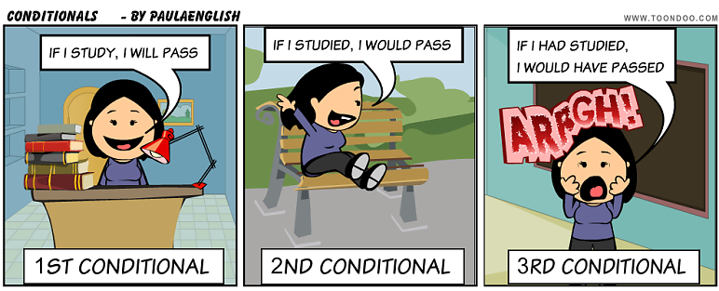

“We use conditional sentences when we want to express a condition.”

1) Zero Condition
General truths or scientific facts;
- If we heat water to 100 degrees Celsius, it _______.
- If you it rains, we get _______.
- If you shower, you will be _________.
- If you heat the ice-cream, it ________.

2) First Conditional
- If it rains, I ( ) _______________.
- If I shower, ( ) _______________,
- If I _____________ this weekend, I ( ) go to Itaewon with my best friend.
- If you heat the ice-cream, I ( ) ____________.
- SOS ACTIVITY
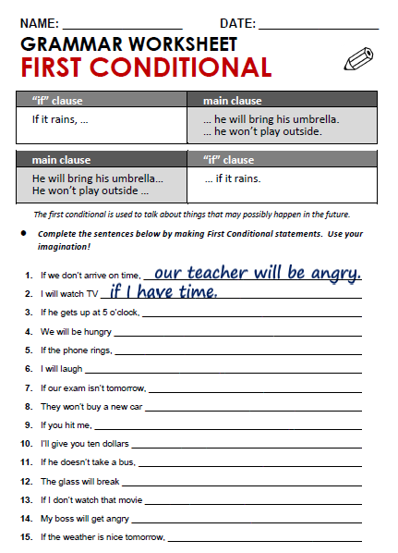
- Realia : long lighter, hairband, hand cream, cosmetic sheet mask

