☐ Listening ☐ Speaking ☐ Reading Grammar ☐ Writing

Topic: Relative Pronouns

Instructor:  Soweon Yoon  (Renz) | Level:  Intermediate (Adult) | Students:  16 | Length:  30 Minutes

Materials:
■ Computer for video files
■ White board and board markers
■ Worksheet #1 for practice (16 copies)
■ Pyramid game set
■ Worksheet #2 for SOS activity (16 copies)

Aims:
■ Main aim: Ss will be able to improve their speaking skills with more grammatical accuracy when making sentences with relative pronouns.
■ Secondary aim: Ss will be able to demonstrate somethings to others by using relative pronouns in sentences.
■Personal aim: I want the Ss to understand how to use relative pronouns in sentences by doing activities.

Language Skills:
■ Speaking: Ss will share their ideas with partners and play Pyramid game with group members.
■ Listening: Ss will listen to video files which demonstrate relative pronouns and about rules of Pyramid game.
■ Reading: Ss will read the screen and worksheets.
■ Writing: Ss will make sentences with relative pronouns.

Language Systems:
■ Phonology: difference of wh- in who[hu:] / which[wɪtʃ]
■ Lexis: New vocabularies in the class
■ Grammar: Relative pronouns(who, whom, whose, which, that)
■ Function: Demonstrating to others
■ Discourse: Dialogue

Assumptions:
Students already know
■ How the class is set up and run (Ss will sit with their partners for pair work)
■ Four language skills and language systems

Anticipated Errors and Solutions:
■ If students do not understand relative pronouns
☞ give them supplementary demonstration and offer more examples.
■ If some students have difficulty in demonstrating something during Pyramid game
☞ encourage their team members to help them.
■ If some students finish their tasks early
☞ offer them other tasks about today’s objectives.

References:
■ Picture #1: https://goo.gl/5WCHAL
■ Picture #2: https://goo.gl/4VDpaZ
■ Picture #3: https://goo.gl/aAdFkz
■ Picture #4: https://goo.gl/H0b3Vh
■ Video file #1: https://youtu.be/As0h2-fzVME
■ Video file #2: https://youtu.be/28LNdwfhW6I

Lead-In
Materials:
Time | Set Up | Student Activity | Teacher Talk
2 min | Whole class | ■ Greeting  ■ Focusing on a teacher and answering questions | Procedure:  ■ Greeting  “Good morning! How are your feelings?  I will describe one of the students of this class. Listen carefully and guess who I am describing.”  -Someone who has black hair.  -Someone whose name is started with C.  -Someone who is wearing …  ■ Introducing the topic  “When I described someone(student’s name) I said ‘who, whose’. Do you know what these words are called? Today, we will learn relative pronouns.”

Pre-Activity
Materials: Computer for a video file, whiteboard and board markers

Time | Set Up | Student Activity | Teacher Talk
2 min  5 min | Whole class  Whole class | ■ Answering the questions  ■ Watching a video about relative pronouns and doing exercises | Procedure:  ■ Eliciting  -What is the role of relative pronouns?  -What do you know about the types of relative pronouns? Tell me about what you know.  -What are their differences?  ■ Present (Video)  “Let’s watch the video about relative pronouns.”  While watching video, T will stop for seconds for Ss to do exercises. And let Ss repeat the complete sentences.  CCQs  - Which relative pronouns are used for person?  - Which relative pronouns are used for things?  - Which relative pronoun is used for both person and things?

Main Activity
Materials: Worksheet #1

Time | Set Up | Student Activity | Teacher Talk
3min  2min  1 min | Whole class  Pairs  Whole class | ■ Doing worksheet #1  ■ Sharing ideas with partners  ■ Checking the answers of the blanks | Procedure  ■ Practice  “I will give you this worksheet. On the worksheet there are four pictures and below the pictures, there are sentences. You will fill in the blank with proper relative pronouns and make one more sentence following the given words. I will give you 3 minutes.”  ICQs  -What will you fill in the blanks with?  -Will you make one more sentence?  -How much time will you have?  (Giving worksheets to students)  ■ Pair works  “Ok, now you will check the answers with your partners. And also share your sentences that you made. I will give you 2 minutes.”  ICQs  -Will you talk with groups?  -How much time will you have?  ■ Checking the answers  “Let’s check the answers of the blanks. What is the blank of number 1? Number 2? Number 3? And number 4? Good job everyone.”

Post Activity
Materials: Pyramid game set, computer for a video file, white board and board markers

Time | Set Up | Student Activity | Teacher Talk
2 min  10min  4 min | Whole class  Groups  Whole class | ■ Knowing the rules of the game through watching a video  ■ Each of groups choose a category and play games | Procedure  ■ Produce (Pyramid game)  “Now we will play a game name Pyramid! Before starting the game, we will watch the video and be aware of the rules of this game.”  (Watching the video #2)  ICQs  -Is Joey good at this game? Why not?  “Ok, in the video, they are playing Pyramid with pairs but we will do with groups. This is group A, group B and group C. If two people of the group come out and demonstrate the word, the group members will answer what it is. But, the explainer has to demonstrate with using relative pronouns at the first sentence like ‘this is something which~’ or ’ this person is someone who~’.  ICQs  -Do you play a game with pairs?  -How many people will be explainers of one group?  -What will you make the first sentence with?  ■ Playing the Pyramid game  -30 seconds per one game  -Write scores the group gets on the board.  -The group got highest score is the winner.  ■ Error Correction & Feedback  If there are grammar errors that students did, correct the errors with whole class.  “I hope today’s activities helped you be aware of relative pronouns. Did you enjoy the activity?”

SOS Activity
Materials: Worksheet #2
Time | Set Up | Student Activity | Teacher Talk
5min | Pairs | Doing cryptography about relative pronouns. | “This is a cryptography about relative pronouns we learned today. If you finish, raise your hand and I will check it.”  (Giving worksheets to students)

Worksheet #1
Complete the sentences with an appropriate relative pronoun and make a sentence following the given words.
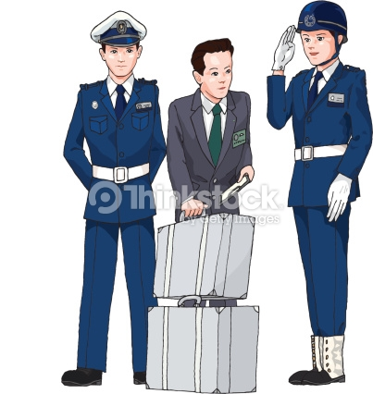
2/ Here is the man ( ) suitcases are in the police station. Because

1/ Mark drives a car ( ) can go very fast. Because

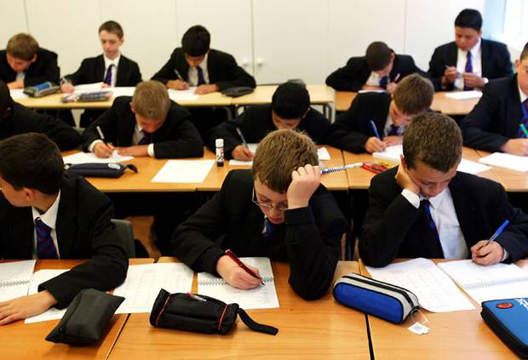
4/ She didn’t like the letter ( ) she received last week. Because

3/ The boys ( ) are in the classroom doing the test. Suddenly,

Worksheet #2
CRYPTOGRAPHY

YBCY ECX MQ TWQF

NVK LQVLAQ CXF YBGXJW

Worksheet #2
CRYPTOGRAPHY

YBCY ECX MQ TWQF

NVK LQVLAQ CXF YBGXJW
Pyramid Game Set: Word list

Spoon Feeding: Food you eat with a spoon
soup / fried-rice / jam / pudding / ice cream / tea?
Born in the USA: Things typically American
The Statue of Liberty / Lincoln / CNN / NASA / Pentagon / flag of the USA / The White House
Up, Up and Away: Airports & air travel
airplane / gate / stward(ess) / passport / luggage / exchange
Pair Work: Things that come in pairs
socks / shoes / scissors / glasses / twins / wings / gloves / pants
Teacher's pet: Words related to school
blackboard(whiteboard) / president / student / notebook /
Lights, camera, action!: Words related to cinema
genres / popcorn / animation / projector / subtitle / Hollywood / camera
Life's a Beach: Things on the beach
jelly fish / popsicle / parasol / swimming suit / sunglasses / tubes / life vest / sandals
Too Many Cooks: Things found in the kitchen
mug / grill / chef / pan / pot / fork / plate / fridge / oven
Pocket Pool: Things epople have in pockets
loose change / cell phone / card / key / pen / wallet / glasses / cigarettes
Shhh! The Baby's Sleeping: Words beginning with sh
shark / shelf / sheep / shadow / shampoo / shack

