Listening Speaking Reading Grammar Writing

Topic: Advice with using auxiliary Verb ( Should vs Shouldn’t )

Instructor:  Candy, Joo | Level:  Intermediate | Students:  17 | Length:  30 Minutes

Materials:
White board, board markers
Computer
PPT files
You tube for song
Vocabulary pictures(4)
Advice column (#worksheet1/ 7copies )
Grammar board game (#worksheet 2/ 9copies )&Dices(9)
Fill in the blank (#worksheet3/ 17copies )
Grammar Quiz (#worksheet4/ 17copies )

Aims:

Main Aim: Ss will be able to improve their speaking skills with more grammatical accuracy when they want to advise.
Secondary Aim: Ss will be able to speak more fluently through communicative language exercises.
Personal Aim: I want the Ss to apply the auxiliary verb, should and to utilize it when Ss want to advise.

Language Skills:
Reading : Read Problems about shopping ( Worksheet 1 )
Listening : Song Lyrics, T’s instructions, interacting with group members
Speaking : Advising friends about the shopping ( Worksheet 1 )
Writing : Filling in the blank ( Worksheet 3 )

Language Systems:
Phonology : N/A
Lexis : Meanings of “Should” Vs. “Shouldn’t”
Grammar : Auxiliary verb “Should” Vs. “Shouldn’t”
Function : Giving advice
Discourse : Advice column

Assumptions:
Ss already know
what the auxiliary verbs, should and shouldn’t are..
the language skills and systems
they are confused and unclear about the use of auxiliary verb, should and shouldn’t

Anticipated Errors and Solutions:
There are various activities, shorten the activity time
If Ss make grammatical errors, note it for another grammar teaching class

References:

Worksheets :

- worksheet 1 : advice column
https://kr.pinterest.com/pin/363454632408381117/
- worksheet 4 : multiple questions :
https://kr.pinterest.com/pin/363454632408381117/
- worksheet 2 board Game :
http://www.printablee.com/post_path-game-board-templates-printable_259631/

Song :
- The title 'Should I stay or should I go?" :
https://youtu.be/BN1WwnEDWAM

Lead-In
Materials: White board, board markers
Time | Set Up | Student Activity | Teacher Talk
2mins | Whole Class | Greeting  Answering T’s CCQ  (I should ~)  (when you want to give advices to other people) | Procedure  **Greeting  Hello, everyone!  How are you today?  **Eliciting  - CCQ  1. If your boyfriend runs away, and finds another girl friend, what should you do?  2. If you are fat now, and you want to be prettier, what should you do?  **Introducing the topic  - Do you know when you use 'should'?  - Today, I will help you use the auxiliary verb, should and shouldn’t in your life.  Are you ready?

Pre-Activity
Materials: PPT file, computer, video clip(You Tube), worksheet 1 (6 copies)

Time | Set Up | Student Activity | Teacher Talk
2min  6min | Whole Class | - Listening to the music  Answering the questions  (He should stay!!)  Discussing | **Procedure  Now, we are going to listen to the song 'should I stay or should I go?'  ** Listening to the music  (Show the PPT with lyrics)  Did you enjoy the music?  **Eliciting  - ICQ  Should he stay or should he go?  ***Instruction & Vocabulary  **Vocabulary  Before we have a discussion, we will check some vocabularies.  1. be on sale  Ex) Which items will be on sale?  2. window shopping  Ex) What are they looking at?  Are they buying the items?  3. try on  Ex) Show the realia.(Joo will take off her sweater and Candy will put it on)  4. come out of  Ex) They come out of the doctor's office.  **Instruction (Worksheet 1)  Now, we are going to have a discussion  I will give you worksheet, and 3 people will be in a group  1. Read about three problems,  2. Give two advice to your two partners.  3. Use as a speaking activity to reinforce 'should'  I will give you 6 minutes for discussing.  **ICQ  How many people are in your group?  How much time do you have for discussing?  ** Checking  (Choose one group)  What did you advise to your partners?

Main Activity
Materials: Worksheet 2 (9 copies), 9 dice , 17 game pieces

Time | Set Up | Student Activity | Teacher Talk
15 min |  | Play the board game | Now, we are going to do a board game?  **Procedure  **Instruction (worksheet 2)  Now, we are going to do a grammar board game. You will play a game in pairs.  ** Demonstration  (Candy and Joo roll the dice)  1. Roll the dice, you can see the number.  2. You have to go the squares along the number of dice.  3. I read the sentence, and your partner will give you advice.  4. You have to use 'should' when you give advice to your partner.  We will give you 10 minutes  ** ICQ  How many people in your team?  How much time do you have?  (monitoring)  Time's up!  I got some incorrect sentences here.  (write the sentences on the board)  - You should tells everyone.  - You was should run away.  (eliciting)  How can we correct these sentences?

Post Activity
Materials: Worksheet 3 (17 copies)

Time | Set Up | Student Activity | Teacher Talk
5min | individual | Filling in the blank (worksheet3) | Now, we will give you worksheet,  Fill in the blank  **Instruction (worksheet 3)  There are 5 sentences in the worksheet.  So, fill in the blank. I will give you 1 minutes  **ICQ  How many sentences do you have?  How much time do you have?  **Monitoring  (check the answer)  Okay! Everybody, did you have a great time? It’s time to say goodbye! See you on next week! Bye bye!

SOS Activity
Materials: Worksheet 4
Time | Set Up | Student Activity | Teacher Talk
5min |  | Finding answers and mark on it  (worksheet 4) | **Instruction (worksheet 4)  There are 16 multiple-choice questions in the worksheet, so find the answer and mark on it. I will give you 1 minute.  **CCQ  How many questions do you have?  How much time do you have?  ** Monitoring  (check the answer)

<Worksheet 1>

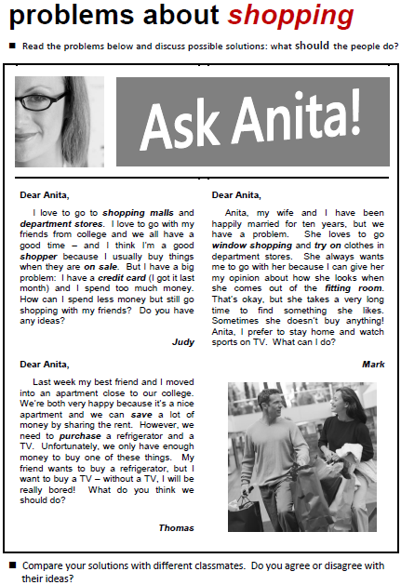

<Worksheet 2>
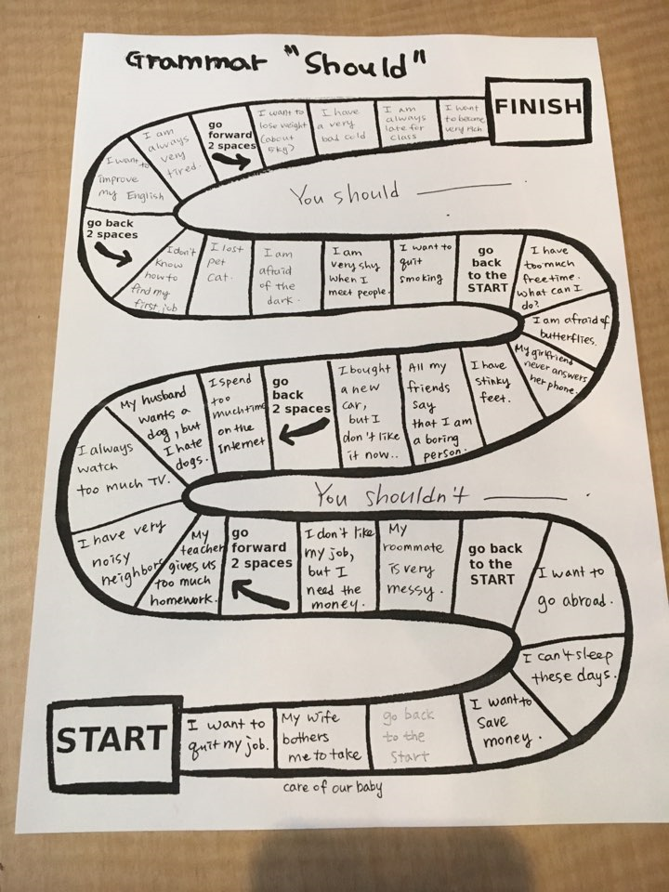

<Worksheet 3>

Fill in the blanks with should/shouldn't

1. ____________________ we go on a picnic? I am too tired.

2. My boy friend _____________ try to quit smoking

3. You _______________ cross the street until the light is green

4. It's very late. We ______________ go to bed.

5. You will be fat. You _____________ eat a lot.

6. _____________ we buy a ticket to go inside the museum?

7. You ____________ study hard if you want to get a good grade.

8. He __________ drink coffee a lot if he wants to sleep at night.

9. She __________ go to the hospital because she has fever.

10. I __________ exercise to keep my health.
<Worksheet 4>
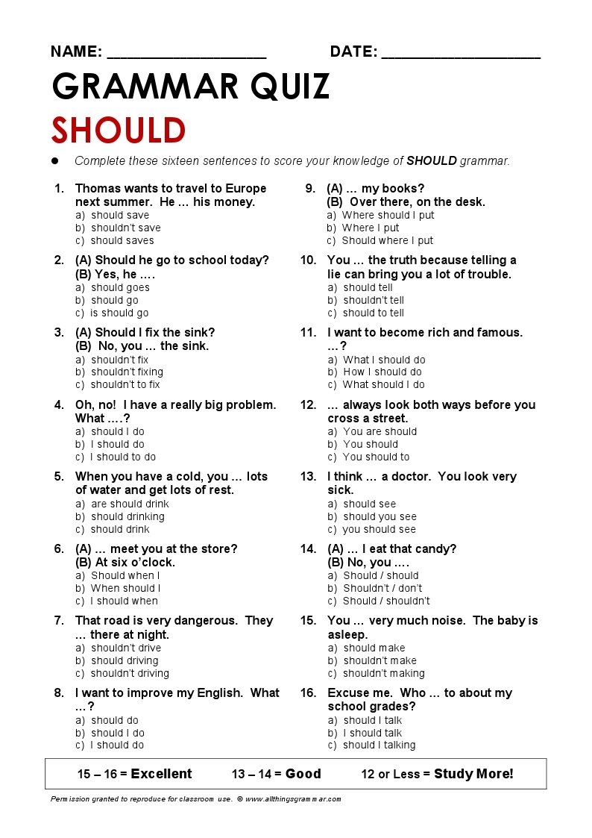

<PPT>

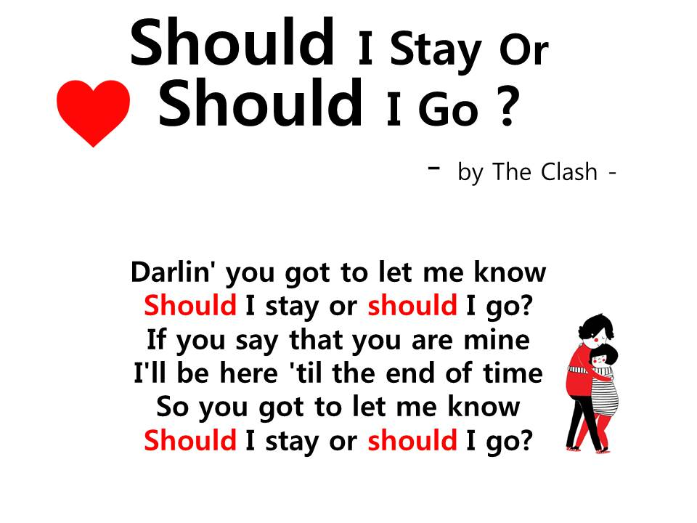

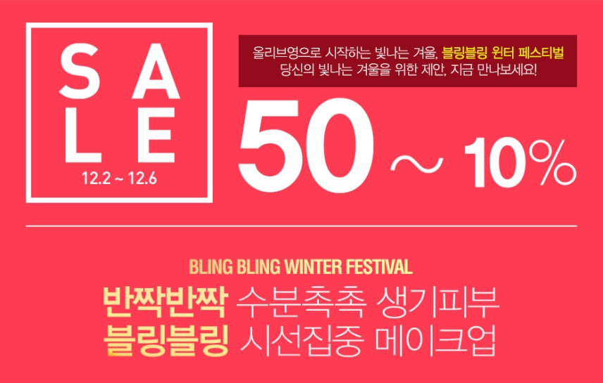
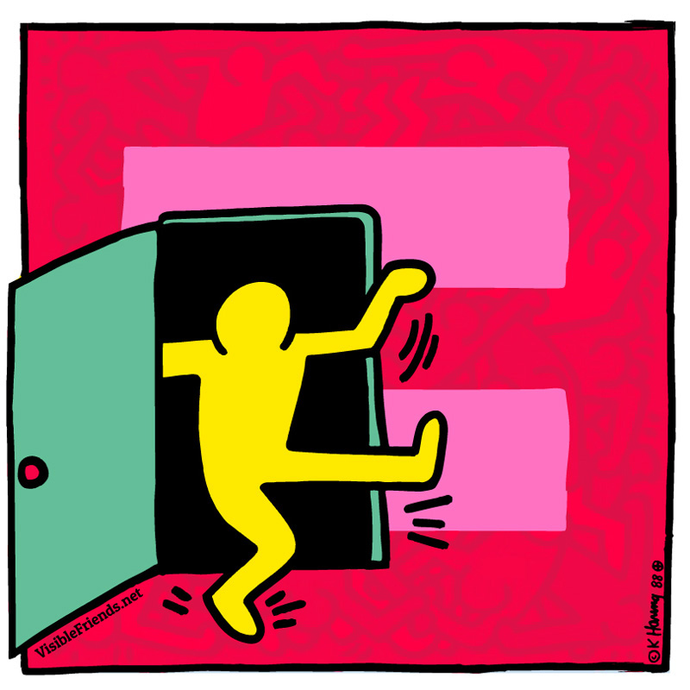
<Vocabulary pictures>

