☐ Listening ☐ Speaking ☐ Reading ⬛ Grammar ☐ Writing

Topic: Comparatives

Instructor:  Celine & Kristine | Level:  Intermediate | Students:  15 | Length:  30 Minutes

Materials:
- Realia (an apple and a tangerine)
- Wish list Worksheets,
- Video
- Video Script
- Board Markers & white board
- Sketch book(pictures)
- Speed quiz answers sheet

Aims:
- Main Aim: Student will be able to improve their writing and reading skills with more grammatical accuracy especially in comparatives.

- Second Aim: Students will be able to use comparatives more properly and correctly.

Language Skills:

- Reading: Scrip of video.
- Listening: ‘an elephant is bigger than a flea song, T’s instruction
- Speaking: Answering Speed quiz and sharing their in post activities.
- Writing: Post activity “wish list”

Language Systems:
- Phonology: sound of S (S vs. Z)
- Lexis: comparatives change words ( ‘far-farther’, ‘good-better’, ‘heavy-heavier’)
- Grammar: Comparatives (-ier, -er, less than, more than, less than)
- Function: Comparing- clearly compare A and B
- Discourse: Group & Class sharing

Assumptions:

- Ss already know how the class is set up and run.
- Ss already know some easy comparatives.
- Ss might have some confusion on irregular comparatives (i.e. funnier, happier…etc.)

Anticipated Errors and Solutions:

- Students may confuse with using of ‘-er’ and more’
We’ll explain when to use ‘- er’ and ‘more’ during the pre-activity time.

- If Ss make grammatical errors, note it for another grammar teaching class.

References:

- Video “An elephant is bigger than a flea” https://youtu.be/S297ljlu7BY
- Video script picture 1 (elephant) http://blog.naver.com/momilye/220868815154
- Video script picture 2 (crocodile) http://cafe.naver.com/motiontree/12527
- Worksheet#2 picture(detective) http://blog.naver.com/bamda/220772823860

Lead-In
Materials: Realia
White board & market

Time | Set Up | Student Activity | Teacher Talk
2min | W/class | Greeting  Answering eliciting question | Procedure:  <Greeting& brief rapport>  Hello everyone. How are you all today? Did you all had lunch? Anyone hungry?  <Eliciting the comparatives>  Here are an apple and a tangerine. Is apple bigger than tangerine? Which one looks more delicious? What about the pencils? Which one is longer than the other one?  “Can you guess what our topic is based on questions we just asked?”  (Writing title and samples of comparative sentences on the board.)  “today, we are going to learn about comparatives”  (quickly going over the sentences)

Pre-Activity
Materials: Video “An elephant is bigger than a flea”, Video script

Time | Set Up | Student Activity | Teacher Talk
8min | W/ class | Will listening the song and write down comparatives. | Procedure:  <Instructions>  “Now, we are going to play the song. Listen carefully and write the comparatives in the song as many as you can. “  <ICQ>  “What do you have to try to listen for?”  (Play the song, 1: 30min.)  (Ask Ss if they need to hear one more time)  “Okay, when you are done, please share with your group and make a group comparative list. And then, come out to the board and write down your group list on the board. “  “I’ll give 2min.”  (Students writing their lists on the board)  “Okay, ** group got the most of comparative! Let’s go over these lists.”  (Handing out the video script)  (Bigger, stronger, longer, better, easier)  - big→ bigger  (same one more consonant +er)  - strong→ stronger  - long→ longer  - good→ better  → (irregular comparatives)  - easy→ easier  → last ‘y’ → ’ier’  (Going over the list and point out the  One ‘-r’ ‘-er’, ‘y→ier’, words and elicit from Ss if they know any other words like that. And introduce words using ‘consonant +er’, ‘more or less + adj., adv.’ for comparative and writing down on the board)  <CCQ>  “When do you use more?”  (Ss: when there are 3 syllbus)  “How do you make words end with y comparative? “  (Ss: We have to change y to i and put –er)

Main Activity
Materials: board, board maker, sketch book

Time | Set Up | Student Activity | Teacher Talk
13 | Group | Answering on speed quiz | Procedure:  <Instruction>  “Now, we are going to do activity called ‘comparatives speed quiz’.  We’ll divide class into 2 groups. Group A and Group B. Then, we’ll show you pictures with verb. You have to come up with 1 or 2 comparative sentences on each pictures. Group which shouts their group name first gets chance to answer first. Since this is speed quiz, you will have 10 sec. to answer on each picture. If your time is over, other group will get chance to answer. Each time, different members have to answer the questions.  <ICQ>  “Who gets the first chance to answer?”  “How many sentences do you have to make for each picture?”  “How much time do you have for each picture?”  “Let’s start!”  <Going over the answers & feedback>  “Okay, let’s go over some irregular comparatives verbs on answers.”  (Going over the answers with Ss and writing down them on the board.)

Post Activity
Materials: Wish list worksheet.

Time | Set Up | Student Activity | Teacher Talk
7 min. | individual | Working on their worksheet | Procedure:  <Instruction>  “Okay, now we’ll hand out another  worksheet so that, you can make your wish  list! Your task is make your 7 wish lists by  using comparatives. You will have 5min.  for this task”.  (Demonstrating & Handing out the worksheet)  <ICQ>  What do you have use when you make your  wish list? How much time do you have?  <Monitoring>  (Discreetly monitor and add ideas if Ss have  trouble writing.)  (give time warning if needed)  <Sharing wish list and feedback>  Let’s hear some of wish list! Can anyone want  to share your wish list?  (Listening 3-4 Ss wish lists)  We hope today’s activity helped you to understand comparative more clearly and use them more easily.  You guys did good job!

SOS Activity
Materials: board & marker

Time | Set Up | Student Activity | Teacher Talk
5 min | Individual |  | Procedure:  <Instruction>  “Now, we’ll going to give you the condition of ‘find something ____than this. You have to find something in the classroom fits to this condition. “  (Writing the tile of activity on the board.)  ‘Find something bigger than my mobile phone?’  <ICQ>  “What do you have to find?”

Realia (an apple and a tangerine)
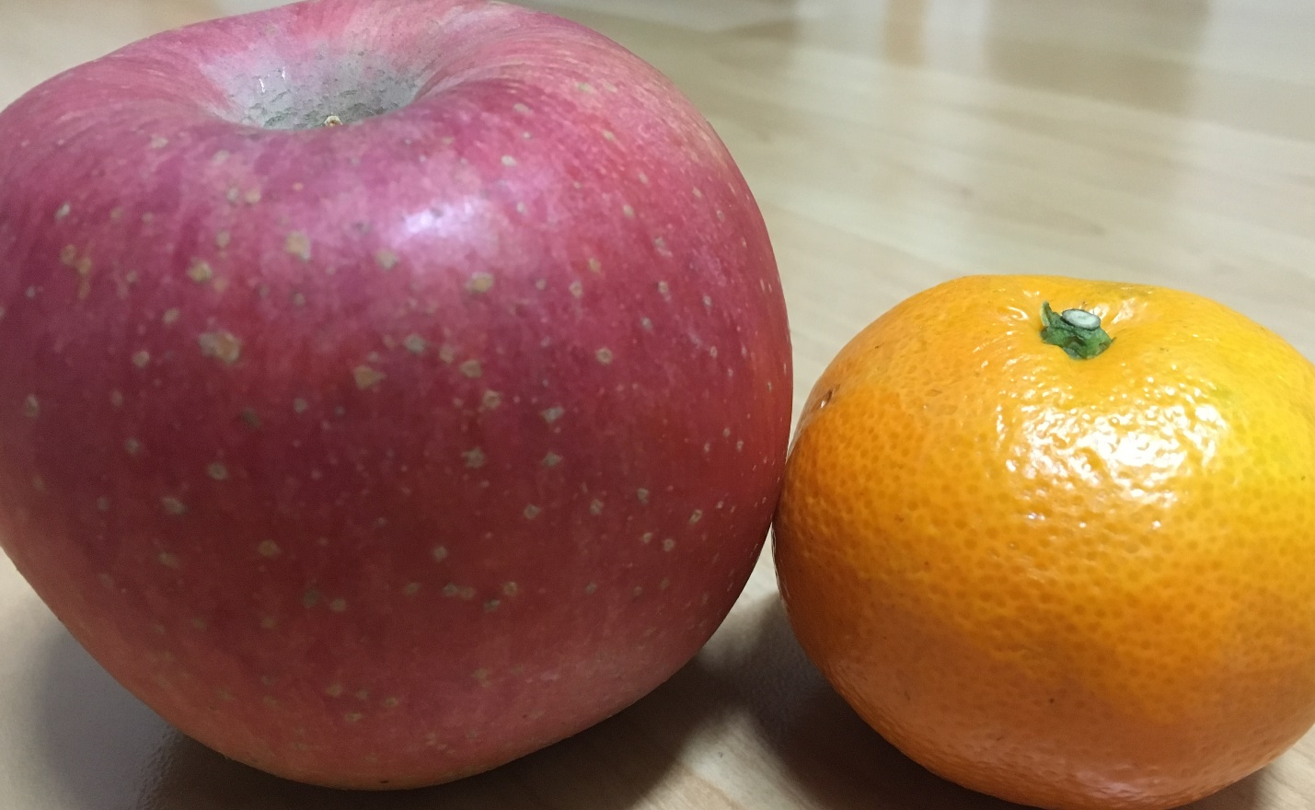

Song‘An elephant is bigger than a flea’ script

Bigger, stronger, longer, better, easier,

An elephant is bigger than flea.
I said an elephant is bigger than a flea.
An elephant is stronger.
An elephant lives longer.
An elephant is bigger than flea.
An elephant is better than a flea.
Why?
Because an elephant is easier to see in the dark.
An elephant is bigger,
much, much bigger.
An elephant is bigger than flea.

A crocodile is bigger than a fly.
I said a crocodile is bigger than a fly.
A crocodile is stronger.
A crocodile lives longer.
A crocodile is bigger than a fly.
A crocodile is better than a fly.
Why?
Because a crocodile can smile and he can cry.
A crocodile is better.
He can even knit a sweater.
A crocodile is better than a fly.

Comparatives speed quiz answers.

 | Answers
1 | Rabbit is faster than turtle | Turtle is slower than rabbit
2 | Train is longer than pencil | Pencil is shorter than train
3 | Diamond is more expensive than silver | Silver is cheaper than diamond
4 | Desert is hotter than arctic | Arctic is colder than desert
5 | A more delicious B | A less delicious B
6 | Lusy is happier than Jenny | Jenny is sadder than Lusy.
7 | Ant is smaller than butterfly | Butterfly is bigger than ant
8 | A is better than B | B is worse than A
9 | Old phone is heavier than smart phone | Smart phone is thinner than smart phone.
10 | A less than B
11 | Beauty is prettier than beast | Beast is uglier than beauty
12 | Far-farther/ A is father than B

Comparatives speed quiz pictures.
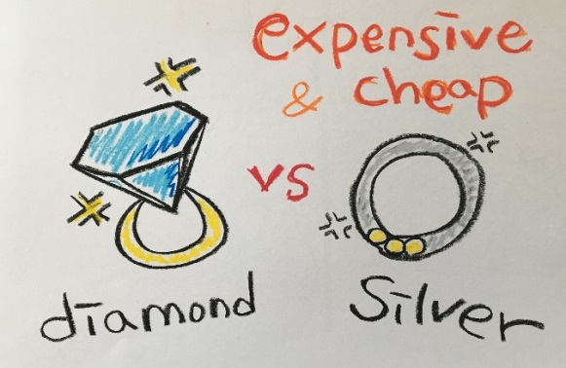
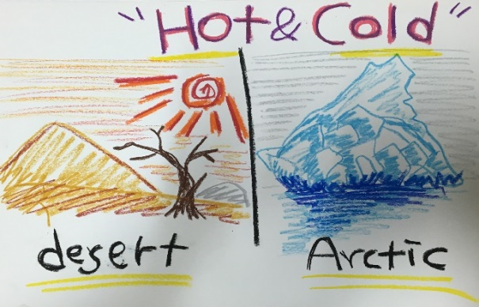

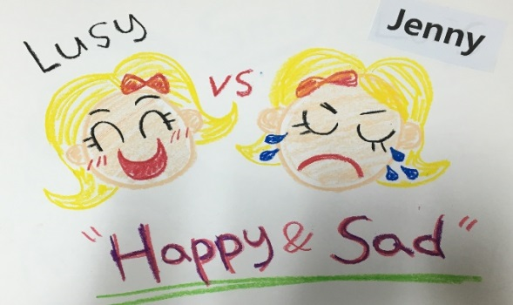
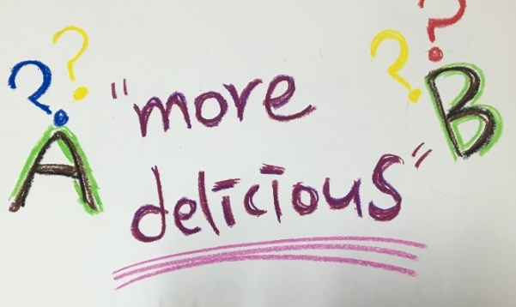

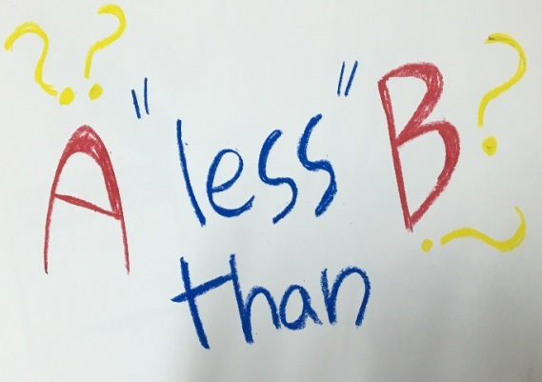
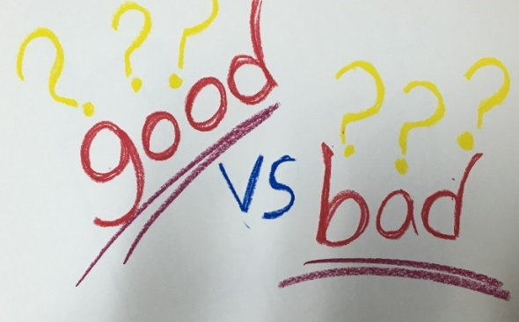

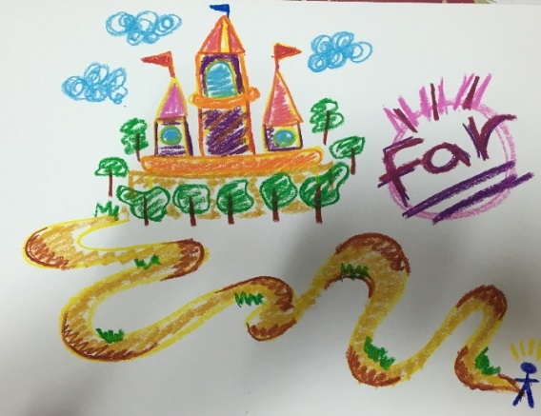
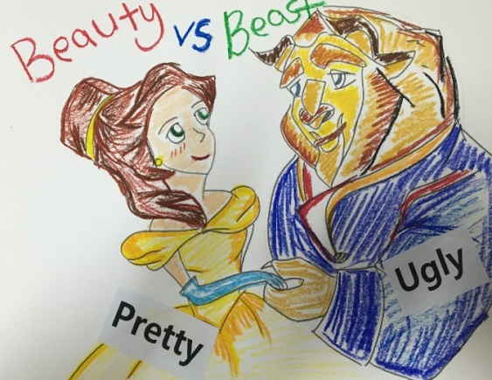

Vocabulary List

- Bigger
- Stronger
- Longer
- Good- Better
- Easier
- Happy- happier
- Funny - Funnier
- Bad- Worse
- More – Less

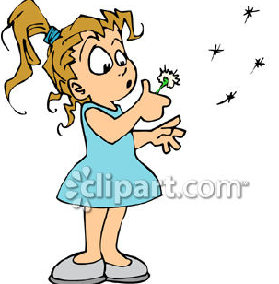
Worksheet
<Wish list>
Direction: Make your wish list using comparatives.
Ex) I want a nicer car…etc.

1. I want a bigger house. __________

2. _______________________________

3. _______________________________

4. _______________________________

5. _______________________________

6. _______________________________

7. _______________________________

