Name & Class | Date & Place |  | Lesson Type |  | Plan |  | Topic |  |  | Length | Level
144th WD  Jeannie JungHa Park | 07/12/2016  Gangnam |  | Speaking |  | TBL |  | Job Interview |  |  | 35mins | Advanced
Class profile
Number of students: 8 Age: Adult Nationality: Korean
Motivations: Quick adaptation of impromptu and unexpected situation/ Ability to use formal language
Individual or class hobbies and interests: Most students want to apply for jobs
Special considerations: all women
Main Lesson aim
- Students learn and practice to react to unexpected situations and to use formal language.
Subsidiary aims
- Students practice their oral fluency during task-realization stage.
Description of language skills specifically used/practiced:  - Listening – N/A  - Speaking – sharing and discussing answers to questions  - Writing – answers to questions, brainstorming  - Reading – identifying role cards |  |  |  |  |  | Description of language systems specifically used/practiced:  - Lexis N/A  - Grammar N/A  - Discourse interviewer and interviewee  - Function formal situations

Anticipated difficulties with lesson activities and classroom management:
Some students may feel anxious because they are about to apply for jobs.
How I can deal with these difficulties:

Provide them appropriate answers to questions.
Assumptions:
Some students already knew some appropriate answers due to experiencing certain parts.
Students may predict some situations.
Material(s) needed:
PC, projector, whiteboard, markers, worksheet, role cards

Checklist. Tick those included in this lesson plan (or N/A)
model sentences for target language |  |  |  | concept questions for target language |  |  |  | N/A | analysis sheet for target language |  |  | N/A
stages clearly titled and separated |  |  |  | purpose of each stage indicated |  |  |  |  | anticipated timing included
interaction pattern marked |  |  |  | a board plan (if relevant) |  |  |  | N/A | examples of all tasks used
answer sheet to all exercises |  |  |  | tape script |  |  |  | N/A | all materials labelled and numbered
Personal aim :
- What I most hope to demonstrate in this lesson is the ability to use formal language and to adapt of impromptu and unexpected situation

Stage 1:_Pre-task  The purpose of this stage is to focus students’ attention and involve them in an interesting task (e.g. brainstorming to the board; help complete a chart etc.) that encourages the class to share their ideas freely, thus increasing STT and participation. Visuals may be used to introduce this task; be specific and focus on what is needed to complete this task. This task should provide useful information for the main speaking task they will prepare. Provide the class with the basic inspiration and language they need before going to the next stage (e.g. topic, context, useful grammar/lexis, and an example/demonstration). | Inter  action | Time | Instructor’s comments
- Lead-in: greet the class and ask students to talk about what they see in the picture. (immediate answers)  - Look at this picture everyone. Show PPT (picture1)  What do you think about this picture? Who is he? What is he doing? (interview)  Have you ever experienced job interview? Where would it be? (yes: company, cafe, school etc.)  How did you feel when you have an interview? (nervous) Show PPT (picture2)  Feedback : nominate 1 or 2 students each questions differently  - Pre-task : ask questions about job interview and students brainstorm some questions about it  Instruction: Today we are going to work on job interview.  What do you think the questions would be? (explain yourself, what is your weakness? Etc.)  What attitude is to be concerned? (formal, gentle, tone of the voice, etc.)  Please write down some questions in a group of 4. I will give you nearly 3 minutes.  ICQ: Do you need to write down? (yes)  Do you share ideas in your group? (yes)  Students share ideas and write down some tough questions  Teacher is monitoring.  Feedback : nominate 2 or 3 students  Expected answers to questions:  - Why should I hire you? What is your greatest weakness?  Language should be polite. Formal language use.  Vocabulary use; ex. Kids-children, want to - would like to | T-S  T  S  T-S | 1’30”  30”  2’  2”

Stage 2: Task Preparation  The purpose of this stage is for students to work communicatively in pairs or groups to prepare a communicative task (e.g. roleplay, discussion, debate etc.) which they will deliver to the class/teacher. Student’s may research the task, use dictionaries and ask the teacher for guidance. Instructions, groupings handouts/worksheets, resources and possibly an example/demonstration, if appropriate, should be given in this stage. Students should know exactly what is expected of them, and have enough time to prepare and practice well. Students should be chatting busily and enjoying their task. | Inter  action | Time | Instructor’s comments
Discuss how to answer to a question in a job interview in a group.  Make answers to relevant questionnaires on each interviewee.  - Instruction: preparing role-play  Even if you prepared well, you cannot avoid tough questions in the job interview!  show PPT (picture3)  Create questions and answers based on the background information on the role cards.  Interviewees are going to have interviews in different field.  (café, school, restaurant and company. You may not know where to be interviewed.)  After your preparation, each one of you will present as an interviewer and an interviewee.  I will give you role cards – Based on the role cards you can make Qs-As.  Classroom desk arrangement: 4 students in a group sitting in a square shape.  You have 13 minutes. You may begin now.  ICQ: How much time do you have? 13 minutes  How many jobs are you looking for? 4 jobs  Are you going to present job interview? yes  - Preparation begins: Students change the desk arrangement and start working  - Teacher is monitoring and guiding them to find good questions and answers and telling time schedule.  - Feedback: Students may need help while preparation.  - Last 2 minutes of preparation stage :  desk arrangement changes : face to face  students decide who goes first in a group and sit in order. | T  S  S | 3’  12’30”  1’

Stage 3: Task Realisation  The purpose of this stage is for the students to perform/deliver the task they prepared in the previous stage, focusing on their speaking skills such as fluency and pronunciation. The teacher should monitor from a distance and take notes about students’ incorrect usage of typical language and also emerging language – this will inform the teacher about future grammar lessons and also provide useful error correction in the next stage. | Inter  action | Time | Instructor’s comments
Role-play takes place.  - Instruction:  Desk arrangement is being done : four in a row face to face group A and B  Play rock-scissors-paper and decide who goes first in each group.  First actresses in each group play rock-scissors-paper to decide between interviewer and interviewee.  Interviewer picks a recruit and interviewee picks a person.  Role play starts.  - Students pick one question from each group and do a play.  - Teacher is monitoring and observing | T  S-S | 30”  7’

Stage 4 : Post Task  The purpose of this stage is to provide meaningful feedback, error correction and suggestions for further study or homework. Another brief communicative task could be done which is designed to summarise the lesson before wrapping up. | Inter  action | Time | Instructor’s comments
Students finish role paly and teacher wraps up the class.  - Instruction : to wrap up, summarise the role play and ask some questions  Well done everyone. It was great work!  What are the points which should be fixed in this role play?  What are the important or good points for the job interview?  - Attitude, facial expression, tone of the voice and honesty  Did you like sharing and preparing with your group members?  Any suggestions?  - Great job guys. I am very pleased to teach you this speaking class.  Your next class will be writing about resume.  So please be prepared about your personal information!  Then see you next class! Bye!  - Class dismissed  - Follow up work for the next lesson  - Students work in a group to review today’s lesson.  - Teach students how to write a resume | T-S  T | 4’  1’

Instructor’s Final Comments
Overall strengths of this lesson (planning and teaching) | Areas to work on

Overall comment

For this stage of the course, your lesson today was

- Above standard

- To standard

- Below Standard

Instructor: …………………………………….… Date: …………/……………/..……….

Powerpoint Presentation Pictures

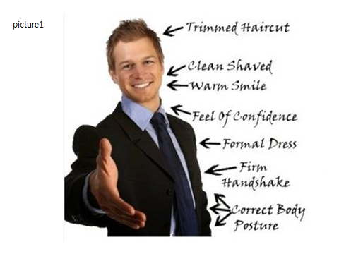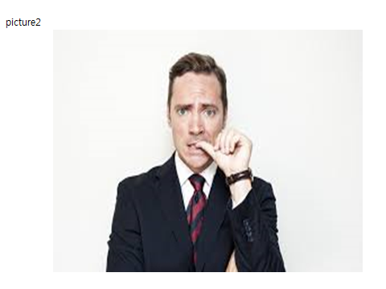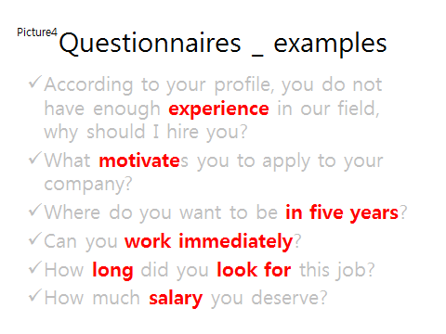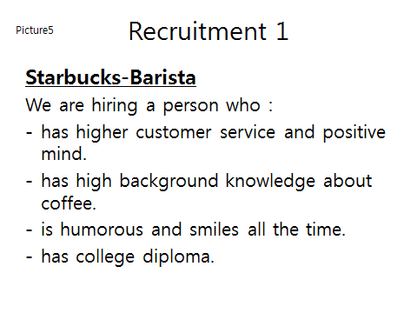
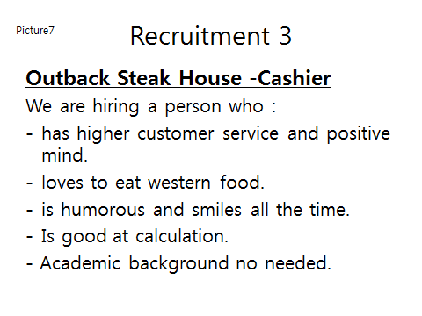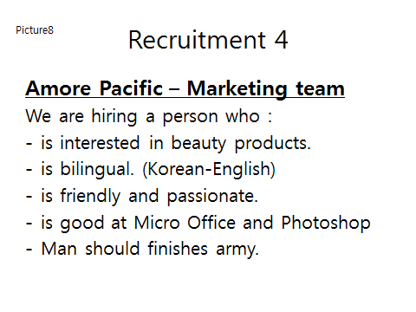

ROLE CARDS

