☐ Listening ☐ Speaking ⬛ Reading ☐ Grammar ☐ Writing

Topic: Guess! My zodiac sign!

Instructor:  Esther & Kristine | Level:  Intermediate | Students:  15 | Length:  30 Minutes

Materials:
- Realia: tarot card
- Visual aid: picture#1, #2, #3, #4, #5, #6, #7, #8
- Board Markers & white board
- The zodiac sign & personality word image matching worksheet
- Strength & weakness list Worksheets
- The zodiac signs reading main worksheet

Aims:

- Ss will predict the meaning of the zodiac sign by watching and listening Ts’ explanation.
- Ss will know their zodiac sign
- Ss will practice reading by participating individual work and pair work.
- Ss will practice speaking, listening and writing ability by sharing ideas in pairs and
other’s opinion.
- Ss will be able to check their words, phrases, and clauses when they make Sentences
in their real life.

Language Skills:

- Reading: main activity ‘The zodiac sign’ worksheet
- Listening: T’s instruction, sharing classmate’s ideas
- Speaking: answering to eliciting, guessing and matching main activity
Sharing idea in group ‘post activity’
- Writing: pre-activity worksheet and ’strength &weakness worksheet’

Language Systems:
- Phonology: sound of (v,b) ex) virgo , birth
- Lexis: personality words (‘eloquent’, ‘authoritative’, ‘faithful’)
- Grammar: would be, might be, can be
- Function: asking for other opinion, instruction to the other Ss.
- Discourse: Group & Class sharing

Assumptions:

- Ss already know how the class is set up and run.
- Ss already know some easy personality word (ex, shy, polite, honest)

Anticipated Errors and Solutions:

- Ss may not understand the zodiac sign
→ Use Eliciting way (visual aid)
- Ss may not understand difficult personality word in main worksheet
→ reading before, practice pre-activity ‘strength & weakness worksheet’

References:

- People watching star picture1#: https://goo.gl/nMipIi
- Harry potter picture 2#: https://goo.gl/PPO26E
- Chines zodiac signs picture3#: https://goo.gl/dVlwRL
- Zodiac sign picture4#: https://goo.gl/zIfI3t
- Match Worksheet picture5#: https://goo.gl/KQa5q1
- Picture6# (Eloquent word): https://goo.gl/iip7Qe
- Picture7# (Authoritative word) https://goo.gl/XSqv8A
- Picture8# (faithful word) https://goo.gl/nnirns
- Worksheet ‘the zodiac sign’ content: https://goo.gl/MJRjfw
- Worksheet ‘the zodiac sign’ picture: https://goo.gl/vfx1dH

Lead-In
Materials: picture 1~4, White board & market

Time | Set Up | Student Activity | Teacher Talk
1min  4min | W/class | Greeting  Answering eliciting question | Procedure:  <Greeting& brief rapport>  “Hello everyone. How are you all today?”  “This year is almost done, after two weeks coming Christmas and at the end of the year is almost upon us. Right?  “Do you have any special plan at the end of the year?”  “Some people have a party with family or friend. and some people going to meet a fortune teller.”  <Eliciting>  “Okay before we get into our topic, I’ll show you some picture that are related to fortune.”  “If you think about fortune, what are the words that pops up into your head?  Picture1  <CCQ>  can you find some star sign in this picture?  (ss: yes)(ts: we called zodiac sign)  “What are they doing?”  (ss: people watching star in the sky)  Picture2  <CCQ>  “Have you ever meet a fortune teller?  (ss:yes or no)  “what are they doing?”  (ss: watching crystal boll)  have you ever tried reading in the internet or magazine about your fortune?  (ss: yes, I have or I don’t have.)  Picture3 and picture 4  <CCQ>  “Do you believe the zodiac sign?”  (ss: yes or no)  “which is different picture A and B?”  (SS: pattern or character)  “Do you know the zodiac sign name?”  “Can you guess what our topic is based on questions we just asked?”  (Writing title on the board.)  “today, we will learn about the zodiac sign.”

Pre-Activity
Materials: ‘the zodiac sign & personality word image matching’ worksheet,
‘strength & weakness worksheet’

Time | Set Up | Student Activity | Teacher Talk
2min  3min  3min | pair | Working on their worksheet | Procedure:  Eliciting  “Do you think you are born with your personality?”  <Instructions>  “when we will read before we are going to do activity. We called zodiac sign & personality matching activity. I’ll give a worksheet#1.  (handing out)  “Do you see these pictures in worksheet?  these are the zodiac sign character, you will try to visualize of zodiac’s personality  and write down personality word as many as you can in pair.”  <vocabulary>  (‘eloquent’, ‘authoritative’, ‘faithful’)  - Eloquent: why do some people join speech academy? (ss: speaking well)  (Because they want be eloquent speaker)  - Authoritative: when politician speech to people, how about theirs voice?  (ss: powerful)  (ex: an authoritative tone of voice)  - Faithful: can you share your secret to close friend? Why? (Ss: trust)  (ex: my best friend is faithful)  “I’ll give you 3min.  <ICQ>  “How much time do you have?”  (ss: 3min)  “Is this individual activity?”  (ss: no, pair)  <Monitoring>  (Discreetly monitor and add ideas if Ss have  trouble writing.)  “Okay, when you are done, please share with another group. “  (could share your idea?)  “okay, Let’s move on!”  “Now, we will hand out another worksheet so, you write down your strength and weakness list! You task is make your 5 lists by using personality word  I’ll give 3min.”  <ICQ>  “How much time do you have?”(ss: 3min)  “Is this activity group activity?”(ss: no)  “Okay, time’s up!”

Main Activity
Materials: board, board maker, ‘the zodiac sign worksheet’, ‘strength & weakness worksheet’

Time | Set Up | Student Activity | Teacher Talk
1min  5min  3min | Individual  pair | Reading on the worksheet | Procedure:  <Guiding questions>  “How date of birth affects personality?”  <CCQ>  “How many zodiac signs we know?”  (ss: twelve)  <Instruction>  “Now, I’ll give reading worksheet.  First, you just skimming and underline key point of personality word or important information.  second, if you have time you will match with your ‘strength & weakness’ in worksheet.  Read individually and silently  I’ll give 5min.”  <ICQ>  “When do you read first time, do you match your strength & weakness worksheet with your main work sheet?” (ss: no, skimming)  “How much time do you have?” (ss:5min)  “Let’s start!”  <Monitoring>  (Discreetly monitor and add ideas if Ss have  trouble reading.)  “time’s up!”  “When you are done, you will give your ‘strength & weakness’ worksheet to your partner and Don’t say your date of birth and guess your partner’s zodiac sign.”  And when you are guessing, you should use modal verb such as ‘may be, can be, would be’ expression.  .  <ICQ>  “How to make a sentence?”  (modal verbs)  (give time warning if needed)  “I’ll give you 3min.”

Post Activity
Materials:

Time | Set Up | Student Activity | Teacher Talk
5 min. | In pairs | Sharing Ss idea | Procedure:  <Instruction>  <Sharing main worksheet list and feedback>  “we are keep going main activity, if you find your partner’s the zodiac sign.”  “Could you tell me your partner sign and personality?”  <Language Focus>  Error Correction of Grammar  “Did you enjoy today’s activity?  “We hope you had fun ‘the zodiac sign’ of  today class. Thank you!”  “You guys did good job!”

SOS Activity
Materials: board & marker

Time | Set Up | Student Activity | Teacher Talk
5 min | Group | Board Race activity | Procedure:  <Instruction>  “We are going to ‘Board race activity’.  -First, I'll break Ss into two teams one person from each team has to run up to the board and write a word  -under the correct column depending on which form it takes then they run back to their team and hand the marker to the next person in  line who runs up to the board and does the same.  - we will continue until the sentences are completed.  - So, you have to write down your own zodiac sign briefly.”  The team that finishes first will win.  (Ts makes two teams in the class)  - Let’s start!  “Time’s up. Let’s check writings together.”

Realia (Tarot card)
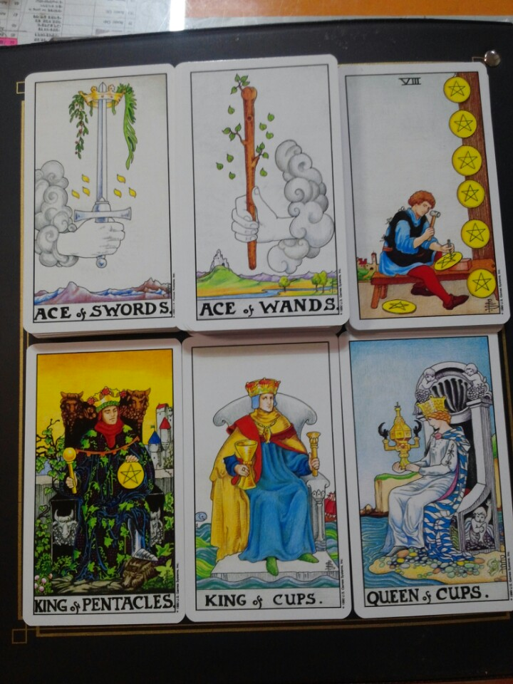

Visual aid
Picture2#

Picture1#
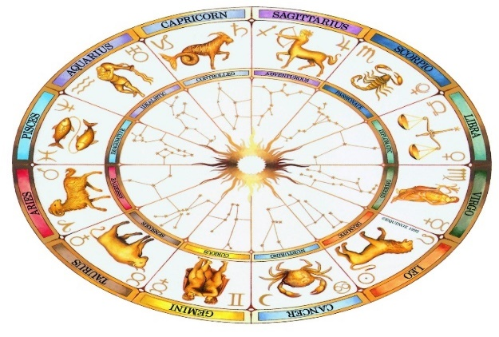
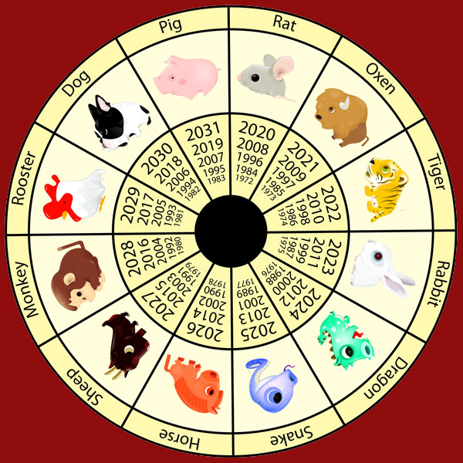
Picture4#
Picture3#
p

picture#6 picture#7

picture#8

Strength & Weakness list
Adventurous, Energetic, Authoritative, passionate, Patient,
Frank, Faithful, Stubborn, Intelligent, Eloquent, Pessimistic,
Tolerant, Shy, Sensitive, Honest, Perfectionist.
Strength
1.
2.
3.
4.
5.
Weakness
1.
2.
3.
4.
5.

