2016.12.10.
Reading Lesson Plan

TESOL
Teacher: Jasmine
Name: Diana, Ellen
Class No: 143th WK

☐ Listening ☐ Speaking ■ Reading ☐ Grammar ☐ Writing
Topic: How to Read Literature to Children.

Instructor:  Diana (Eunyoung Kim)  Ellen(SeoYeong Byun) | Level:  Upper Intermediate(Adult) | Students:  15 | Length:  30 Minutes

Materials:
▶ White board and marker
▶ Worksheet #1 -1 box with Mad, Sad, Happy, Exciting, Scared Flash Cards
1box with 10 Sentence Index Cards
▶ Worksheet #2 – Readings(15 copies), Guiding question list (8 copies)
▶ Worksheet #3 – SOS activity instruction cards (3 copies)
▶ Vocabulary picture – 1 copy
▶ Video – “The rainbow fish” (Kindergarten reading)

Aims:
▶ Main aim: Students will be able to understand how to read to others depending on age.
▶ Personal aim: I want to encourage students to actively participate in reading during class especially while working on worksheets to fully understand how to read to others.

Language Skills:
▶ Speaking: Students will practice reading to others.
▶ Writing: Students will know when to use emotion/teaching reading skills when reading.
▶ Listening: Students will listen to other students’ opinions.
▶ Reading: Students will read one students opinions.
▶ Grammar: Students will properly understand reading and grammar.

Language Systems:
▶Phonology: Correct pronunciation of Literature “/ˈlidərəCHər,ˈlidərəˌCHo͝or/”
▶Lexis: How to Read Literature to Children.
▶Function: Giving information of how and when to use emotion when reading to children
▶Discourse: Asking questions and answering

Assumptions:
▶ Ss will need to practice reading with emotion, level of emotion, and how to.
▶ Ss will need practice reading out loud.
Anticipated Errors and Solutions:
▶If students are nervous to answer,
>> We will, as teachers, will lead them with specific questions.
▶If students get excited from the topic and the conversations get loud
>> We would pick the loudest student and ask their opinions more seriously to take control of the course.

References:
▶ Little Red Riding Hood Reading = http://goo.gl/FgyFa
▶ Stuart Little Reading = Book pages 1-2
▶ Harry Potter and the Sorcerer’s Stone = http://www2.sdfi.edu.cn/netclass/jiaoan/englit/download/Harry%20Potter%20and%20the%20Sorcerer's%20Stone.pdf
▶ Images : Vocabulary ( http://goo.gl/BI6ILI ), Worksheet#2 ( http://goo.gl/2dbSqG )
Worksheet #3( http://goo.gl/i2uVNP)
▶ Video : The rainbow fish (https://www.youtube.com/watch?v=h6S4IPMs5ZY)

Pre-Task
Materials: Emotion Index Cards with Sentences

Time | Set Up | Student Activity | Teacher Talk
2min | Whole  class | Answering teacher’s question. | Greeting  -Good afternoon, everyone! How was your week? (Wait for Ss response)  Okay, good. I’m glad to hear that.  Eliciting  - There are different ways to read to children depending on age. We are going to cover 3 age groups – Kindergarten, Elementary, and Junior High School. First is how to read to kindergarten children. For young children we need to use emotion when we read to interest them.  (Write down “Mad, Sad, Happy, Exciting, Scared”)  ICQ  - What are these called?  (Ask 1 or 2 students)  - Yes they are emotions.  - Who has read to children before? (Wait for Ss to raise hands and pick Ss to ask)  - Great! Did you use emotion when you read to them?  Give Examples:  “Spot the dog ran in the park happily.”  - Could you tell me the emotion I used?  “Everybody was scared because they did not know who knocked on the door.”  - Could you tell me the emotion I used?
Task Preparation
Materials: Emotion Index Cards with Sentences, Video, White board, markers

Time | Set Up | Student Activity | Teacher Talk
12min | Whole  class | Answering teacher’s question. | Instruction 1  - Ok then we’re going to practice this in a fun way. I have 5 cards with emotions you are going to pick 1 card with the emotion and pick 1 card with the sentence. Read the sentence with the emotion even if it does not match.  (Pick 2 Ss to pick 1 emotion card each and the teacher picks 1 sentence card. Have the 2 Ss read the sentence with the emotion they picked then ask class what emotion they used.)  CCQ  - Which emotion did he/she use?  - Is it interesting to read without emotion?  <Vocabulary>  -Do you see this picture? What is it called in this circle? This is whisker.(write ‘whisker’ on the board)  - sorcerer : What is it called like this person? one who skilled in magic  Explanation  Let’s see this video.  (Show Ss a video “The rainbow fish”)  https://www.youtube.com/watch?v=h6S4IPMs5ZY  This is a reading example for kindergarten kids. What did you find?  Intonation, emotions…, What else are there? Eye contact, the voice to match with the character’s talking.  How was the speaking speed?  Yes, not too fast & not too slow.  The reader has to consider of listener’s age.  - When you read to high school students, it’ll be a little different with little kids. Normal speed..especially asking questions while reading or after reading is important to make connections, to promote reading comprehensions.  CCQs  - When you read a story to kindergarten kids, what would you consider?  - When you read a story to high school students, what would you consider?  (asking questions)

Task Realization
Materials: Copies of Reading Sheets (Little Red Riding Hood, Stuart Little, Harry Potter and the Sorcerer’s Stone), Guiding Qs list.
Time | Set Up | Student Activity | Teacher Talk
14min | Whole class | Listening Ts’ talk & answering  Group activity | <Group Activity>  Instruction 2  Now, I’ll give you three readings.  You’ll read three readings by two versions.  How many versions?  First version is to read to kindergarten kids  Second version is to read to High school student.  (after distributing three readings)  This is a guiding question list.  You can use this list when you read to high school students.  (hand out the list)  For the first two minutes, everyone read the worksheet and understand the content.  Next, Stand up one by one and read it to your group members.  You’ll have total 10 minutes.  ICQs  - Are you working in group? (yes)  - What are the two versions of reading?  Okay. Good. Let’s get started!  Enjoy your reading time!!  Monitoring  ( check Ss are performing as the instructions, if they need help, Ss’ errors.)  .  One minute left.(time warning)  Guys. Time’s up.  Was it fun?  Now, let’s share your reading skills.  Who will volunteer to read “Little red riding hood”?  What’s your version?  (after finished)  Who will volunteer to read “Stuart Little”?  (after finished)  Who will volunteer to read “Harry Potter”?  Okay. Everyone did a great job!

Post Activity
Materials:
Time | Set Up | Student Activity | Teacher Talk
2min | Whole class | Listening Ts’ talk & answering | Feedback  -Did you enjoy today’s activity? (Listen to students’ feedback on the activity)  Error correction  Wrap-up  “Do you have any questions?”  Hope you all have a beautiful day.  Good bye.

SOS Activity
Materials: Instruction cards, Pencil
Time | Set Up | Student Activity | Teacher Talk
5min | Whole class | Listening Ts’ talk &  Group activity | Instructions  We’re going to do ‘Quick read & draw’ game.  - We have 3 groups in the class.  1. Each player has paper and pencil. Shuffle instruction cards and place them face down.  2. The first player takes the top instruction card from the pile. He places it face up in plain view for all players to read.  3.Each player follows the steps in the directions to draw a shape, word or design on their papers.  4. When everyone is done, players compare their answers. If all answers are not the same, the players read the directions together, step by step to determine the correct outcome.  Finally, the player who drew the card may check the answer key.  5. Each player with the correct outcome earns 1 point. Play several rounds. The player with the most points is the winner.  You’ll have 5 minutes.  ICQs  1.Will you draw the instructions with your partners? (no)  2.How much time do you have?

Worksheet #1 INDEX CARD ACTIVITY

INDEX CARD ACTIVITY

▶EMOTION INDEX CARDS - Mad, Sad, Happy, Exciting, Scared

10 SENTENCES

1. The dogs were playing at the park innocently without a care in the world.
2 .Everybody gave their well thought out gifts to Bob for his birthday.
3. My childhood friend of 10 years moved far away to Paris.
4 .My son told me “I will marry the most beautiful woman- surprise Mom?”.
5 .The cat looked at me with pity in her eyes.
6.The wolf suddenly appeared so the rabbit ran away to the mountains.
7.The mermaid said “Just once I wish to see the Prince”.
8.The witch said to the mermaid, “If you want legs you will lose your voice.”
9.The fox said to the crow, “Your feathers are so pretty is your voice as lovely?”
10.Once the crow open its beak to speak the food dropped from the crow’s mouth and into the fox’s.

Worksheet #2 -1

Reading “Little Red Riding Hood”

There lay her grandmother with her cap pulled far over her face, and looking very strange.
'Oh! grandmother,' she said, 'what big ears you have!'
'All the better to hear you with, my child,' was the reply.
'But, grandmother, what big eyes you have!' she said.
'All the better to see you with, my dear.'
'But, grandmother, what large hands you have!'
'All the better to hug you with.'
'Oh! but, grandmother, what a terrible big mouth you have!'
'All the better to eat you with!'
And scarcely had the wolf said this, than with one bound he was out of bed and swallowed up Red Riding Hood.

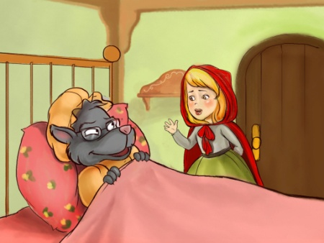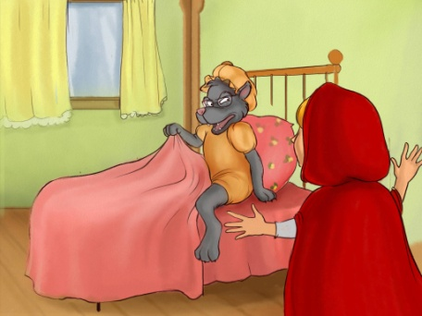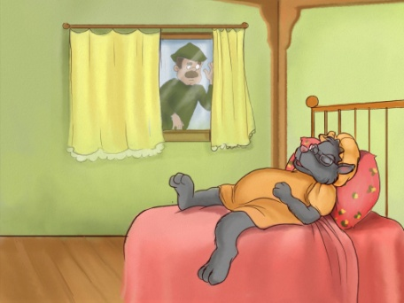

Worksheet #2-2

Reading “Stuart Little”

When Mrs. Frederick C. Little’s second son arrived, everybody noticed that he was not much bigger than a mouse. The truth of the matter was, the baby looked very much like a mouse in every way. He was only about two inches high; and he had a mouse’s sharp nose, a mouse’s tail, a mouse’s whiskers and the pleasant, shy manner of a mouse.

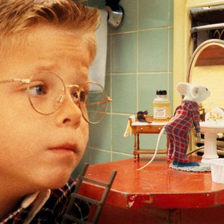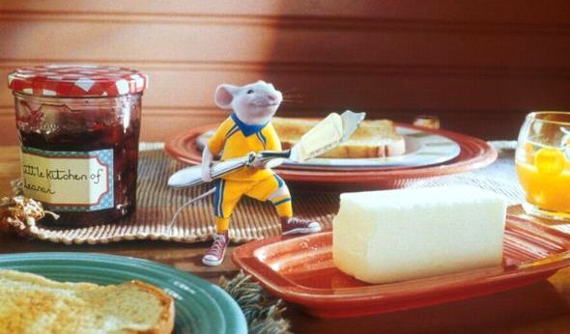

Worksheet #2-3

Reading “Harry Potter and the Sorcerer’s Stone”

Before he could say or think anything else, the dormitory door was flung
open and Fred and George Weasley bounded in. Harry stuffed the cloak
quickly out of sight. He didn't feel like sharing it with anyone else yet.
"Merry Christmas!"
"Hey, look -- Harry's got a Weasley sweater, too!"
Fred and George were wearing blue sweaters, one with a large yellow F on
it, the other a G.
"Harry's is better than ours, though," said Fred, holding up Harry's
sweater. "She obviously makes more of an effort if you're not family."
"Why aren't you wearing yours, Ron?" George demanded. "Come on, get it
on, they're lovely and warm."

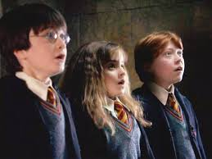

Worksheet #2-4 (Guiding question list)

- Guiding question list -

(Examples)
Reader’s Questions  How would you feel if…  Are you like any of the characters in….?  Have you ever seen someone…?  Have you ever been to…?  Is this story fiction or nonfiction?  What do you think will happen next?  Do you think ….. will be a good guy or bad guy?  What was the most important thing that happened?  What happened the next?  Have you ever read another book like this/about..?  Did this story teach us a lesson? | Listener’s questions  I wonder why……?  Why did…..?  What does….. mean?

Worksheet#3(SOS Activity-Instruction cards)

1  - Write the word BAT.  - Write the word again, adding an O after the first letter.  - Draw a picture of your word. | 2  - Draw a small square.  - Draw a larger square around the first one.  - Shade the space between the squares.
3  A) Write the third letter of the alphabet.  B) Write the number 10 to the left of the letter.  C) Draw a line under the letter only. | 4  A) Draw a triangle.  B)Add a line inside the triangle from one bottom corner to the opposite side.  C)Write the number that tells how many small triangles there are.  D)Circle the number.
5  - Write the word MAY backwards.  - Write the word again, changing the letter on the left to an S.  - Draw a star on the right letter. | 6  - Draw a rectangle that is wide and short.  - Draw three circles inside the shape.  - Make a hole in the right circle.

Vocabulary Pictures : Whisker, Sorcerer

