**Realia (Tarot card)**

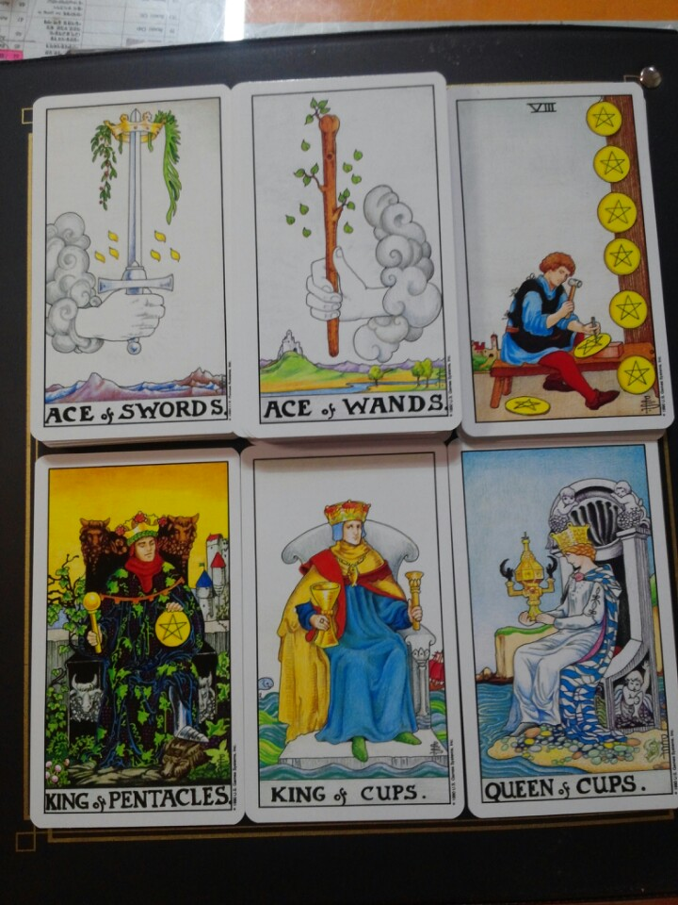

**Visual aid**

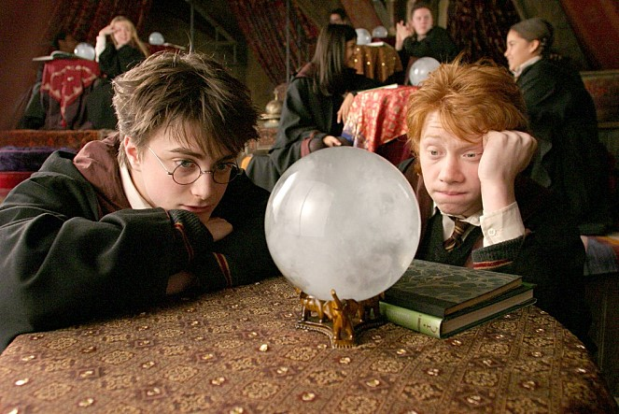

Picture2#

Picture1#

[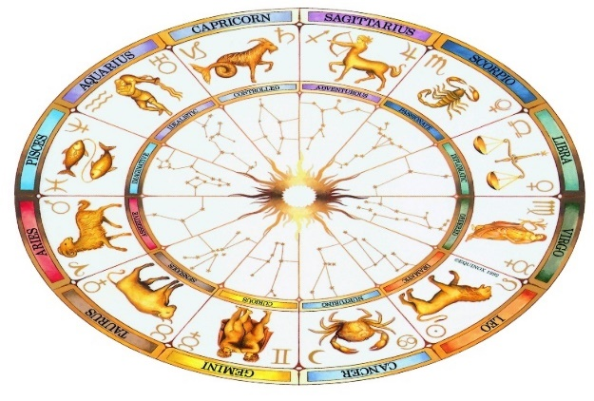](http://www.google.co.kr/url?sa=i&rct=j&q=&esrc=s&source=images&cd=&cad=rja&uact=8&ved=0ahUKEwis69mg09_QAhVGmJQKHQyAB7oQjRwIBw&url=http://chinaquest.weebly.com/task-4-chinese-new-year.html&psig=AFQjCNGczYjl_tbIl2cFEZDUY35MdWLgdQ&ust=1481116274784420)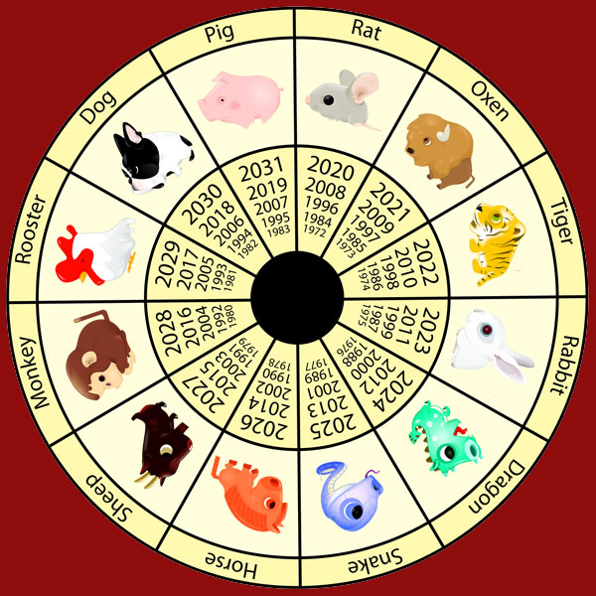

Picture4#

Picture3#

[](http://www.gettyimagesbank.com/i/186474085)p

picture#6 picture#7



picture#8