☐ Listening ☐ Speaking ☐ Reading ☐ Grammar ☐ Writing

Topic: Breathtaking Festivals Around The World

Instructor:  Lea, Jasmin, James | Level:  Upper Intermediate (Adult) | Students:  15 | Length:  30 Minutes

Materials:

▶ White board and marker
▶ Work Sheet #1 : Breathtaking Festivals Around The World (15 copies) (pre-activity)
▶ Visual aid #1, #2, #3, #4, #5 – pictures (main-activity)
▶ Work Sheet #2 #3 #4 #5: Breathtaking Festivals Around The World (15 copies)
( main-activity)
▶ 2 (O & X) Sticks ( main-activity)
▶ True / False Questions & Answers ( For Teacher ) ( main-activity)
▶ Worksheet #6: Find the evidence (15 copies) (SOS activity)
▶ Worksheet #7: Find the evidence - Answers (SOS activity)

Aims:

▶Main aim: Ss will be able to get the main idea by skimming the reading text.
▶Second aim: Ss will get the excitement about various world festival.
▶Personal aim: Ss will improve speaking and listening skills by sharing ideas in groups

Language Skills:

▶Speaking: Discussion from given information.
▶Listening: Listening to classmates’ idea.
▶Reading: Articles on the festival.
▶Writing: Taking notes on group discussion.

Language Systems:

▶Function: Sharing ideas on the festival.
▶Lexis: Depart, Procession, Replica, Bank Holiday
▶Discourse: Discussion and pair, group work

Assumptions:

▶Ss enjoy with interesting topics and physical activities.
▶Ss have done discussions before.
▶Ss already know how the class is set up and runs.

Anticipated Errors and Solutions:

▶When Ss aren’t doing it right, or having a hard time with the activity.
-Give them hint or more information to figure out themselves.
▶If some Ss keep quiet, during discussion.
-Encourage them to speak, or let other Ss help by asking.

References:

▶Work Sheet #1 #2 #3 #4 #5: Breathtaking Festivals Around The World: https://goo.gl/2pheXa
▶Visual aid #1: https://goo.gl/DY3OOc
▶Visual aid #2: https://goo.gl/3rKzRZ
▶Visual aid #3: https://goo.gl/g5737n
▶Visual aid #4: https://goo.gl/x5pSHC
▶Visual aid #5: https://goo.gl/D9sjTU
▶Work Sheet #6 #7 : Find The Evidence : https://goo.gl/jSwoSj

Lead-In
Materials: White board & Marker

Time | Set Up | Student Activity | Teacher Talk
2min | Whole class | Listening and answering to teacher’s questions. | Greeting  T: Hello everyone. How is your day?  Eliciting  T: Christmas is coming! Do you have special plans for winter vacation?  I would like to go somewhere warm, how about you?  (Ss response)  T: Today, we will talk about festivals around the world.  (Write down on the board: “Breathtaking Festivals Around The World”)  T: Do you know any festivals around the world?  (See if Ss have ideas about the festival)

Pre-Activity
Materials: White board and marker
Work Sheet #1 : Breathtaking Festivals Around The World (15 copies)

Time | Set Up | Student Activity | Teacher Talk
1min  3min  2min | Whole class  Pairs  Whole class | Listening to the instruction.  Discussing in pairs, and writing down their ideas.  Share the ideas | <Hand out work sheets #1>  Instruction  T: I will give each of you a worksheet. Please have a look at the 4 pictures in your work sheets. I want you to guess the name of each festival, and also write what people might do at the festival. I want you to discuss in pairs. The names are below the pictures. If you already know about the festival, or the names, share it and write down in the blank. You have 3mins  ICQ  Are you working individually?  How much time do you have for pair work?  T: Let’s start.  Monitoring  (See if Ss are doing well)  T: You have 1min left.  (Give a time warning)  T: Okay, guys! Time’s up!  Share  T: Now, let’s share it.  (Ask few Ss for what they have written, from their discussion)

Main Activity
Materials: Visual aid #1, #2, #3, #4, #5 – pictures
Work Sheet #2 #3 #4 #5: Breathtaking Festivals Around The World (15 copies)
2 (O & X) Sticks
White board & Marker

Time | Set Up | Student Activity | Teacher Talk
5min  6min  5min | Whole class  Individually  Group as a team | Get information from vocabularies.  Listening teacher’s talk and answering the question  .  .  Reading the given articles  Participating in the game | Vocabulary  T: Let’s go over some vocabularies, for you to understand better while reading.  (Write down the vocabularies on the board)  Eliciting  <Show Ss pictures, Visual aid #1,2,3,4,5 while explaining>  (First, elicit the words. Then explain.)  (Visual aid #1, #2)  Depart: From where do you depart, for traveling to Japan?  -It means to leave or go off, but it is also used to avoid of saying “dead”.  (Visual aid #3)  Procession: Where or when do you see procession?  -It is the act of moving along, in a formal, as a line of people.  (Visual aid #4)  Bank Holiday: Is it a holiday for banks?  -It is a public holiday.  (Visual aid #5)  Replica: Have you seen any replica?  It is an exact reproduction of something. It is copied, and made.  Instruction  (Write down on the board: “True of False”)  T: Now we are going to play a fun game. Let’s divide into 2 teams.  (Set 2 teams)  (Also name the team, and write down on the board)  T: We are going to play True or False from the 4 pictures which you named.  This time we will give you the information about the pictures.  <Hand out work sheets #2 #3 #4 #5>  T: I want you to all read 4 of these about the festival, and try to get the information in your mind while reading. I will give you 6mins to read. Work by yourself.  ICQ  What should you do, while reading?  How much time do you have?  Are you working in the group?  T: Let’s start.  (Give them time to read with festival music)  Monitoring  (Go around the class and monitor the Ss)  T: You have 1 min left.  (Give a time warning)  Instruction  T: Now I want 1 person from each team to come out. I will give you a statement, and you need to choose if it’s true or false. There are 2 sticks. 1 is O, and the other is X. You should think and quickly grab the right answer.  ICQ  Which O/X sticks are you holding up for?  T: Let’s start.  Progressing the game

Post Activity
Materials: White board & Marker

Time | Set Up | Student Activity | Teacher Talk
1min  3min  2min | Whole class | Listening to the instruction.  Discussion in groups  Listening teacher’s talk and answering the question. | Instruction  T: Now, as you have the information about the festivals, I want you to discuss in groups, and talk about which festival you would want to join. Think of a reason, why you would choose that festival. I will give you 3mins.  ICQ  What are you going to discuss?  How much time do you have?  T: Let’s start.  Monitoring  Monitor discreetly and answer students if they have a question.  (Ask if they need more time. If so, give them 1 more minute.)  T: Now, let’s share what you have.  (Ask each group which festival they would like to join in)  Feedback  Did you enjoy today’s activity?  Have a nice day.  Good bye.

SOS Activity
Materials: White board & Marker, Worksheet #6 , Crayons

Time | Set Up | Student Activity | Teacher Talk
2min  3min  2min | Whole class  Pairs  Whole class | Ss will be listening to the instruction.  Reading and underlining the answers with crayons.  Students check the answer | <Hand out worksheet # 6 >  Instruction  T: Please have a look at the questions below on the worksheet. There are colors for each question. I want you to read about the “Wright Brothers” and underline the answers with crayons for each given colors of question. Work with your partners. I will give you 3 mins to read.  ICQ  Are you going to write down the answers in a sentence?  How much time do you have?  T: Let’s start.  (Give them time to read, and tell them to start underlining the answer after 3mins)  Monitoring  Assist students if they need any help. Give a time warning “1 minute left”.  Answer check

Worksheet #1 Match pictures with the festival name below. Also, write down what people would do at the festival. Discuss in pairs.
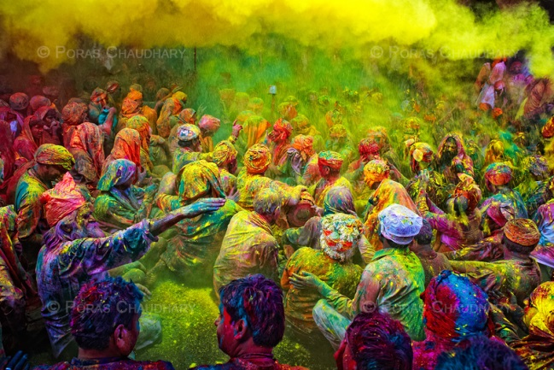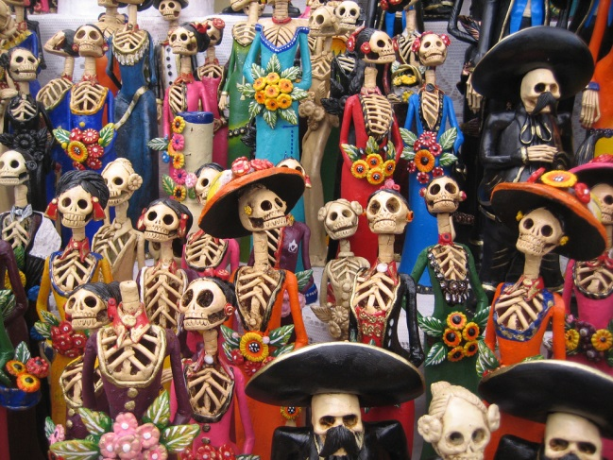
(Festival name: ) (Festival name: )
(Purpose: ) (Purpose: )
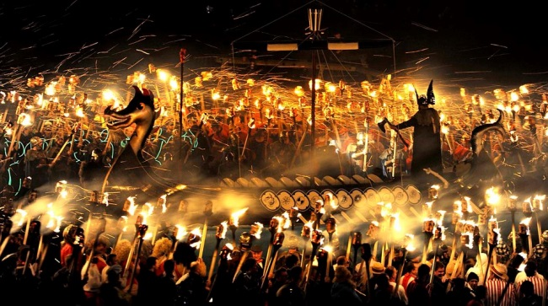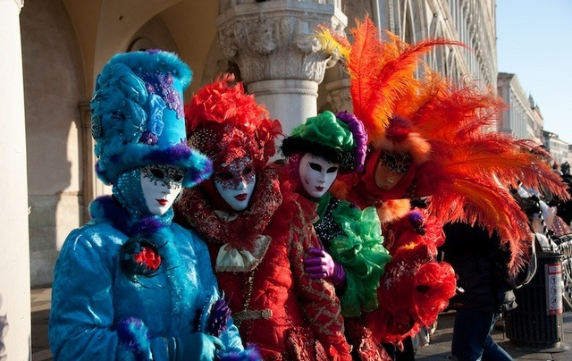
(Festival name: ) (Festival name: )
(Purpose: ) (Purpose: )

<Festival Name>
* New Year's Eve *Boryeong Mud Festival *White Nights Festival *Day of the Dead
*Harbin Ice& Snow Festival *Full Moon Party *Battle of the Oranges
*Carnival of Venice *Holi *Up Helly Aa Fire Festival
Visual aid #1 – pictures (Depart 1)
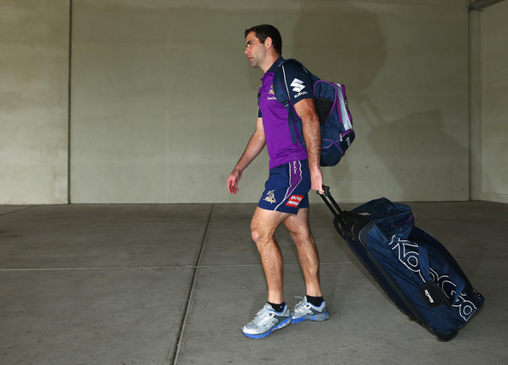

Visual aid #2 – pictures (Depart 2)

Visual aid #3 – pictures (Procession)
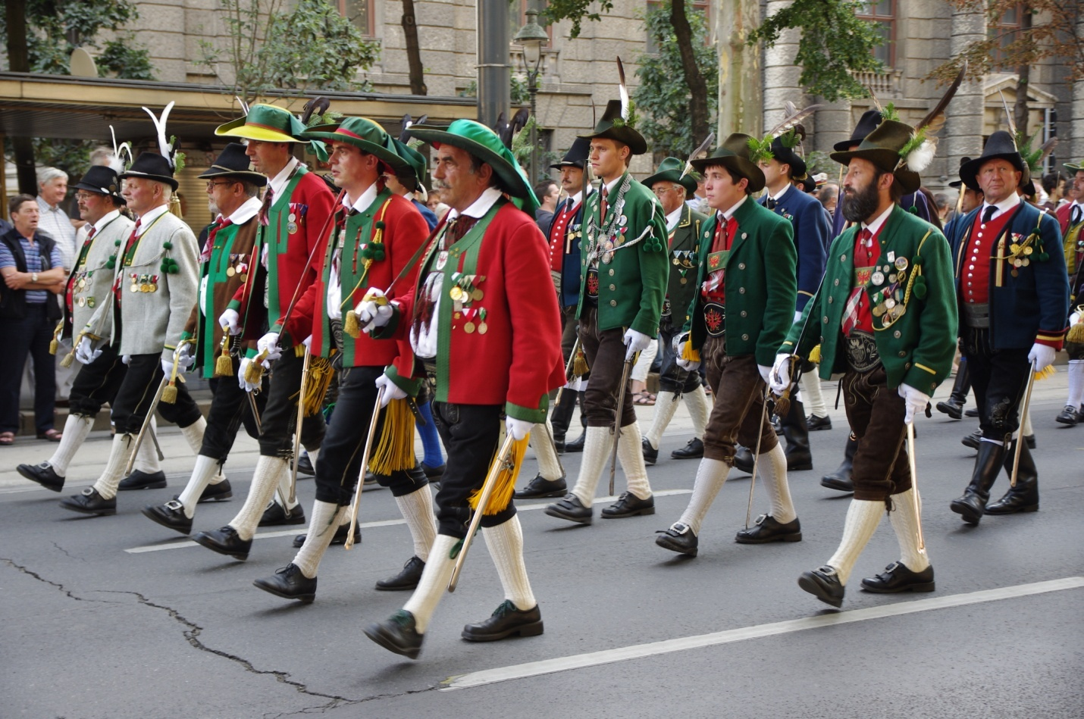

Visual aid #4 – pictures (Bank Holiday)

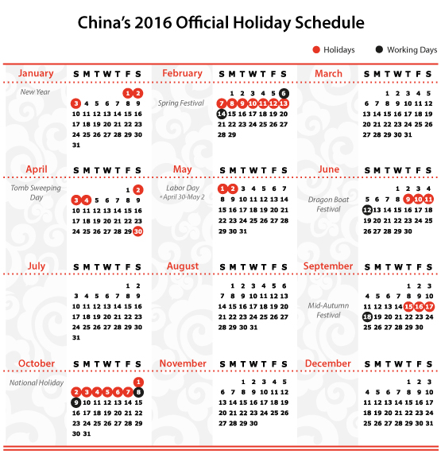
Visual aid #5 – pictures 5 (Replica)

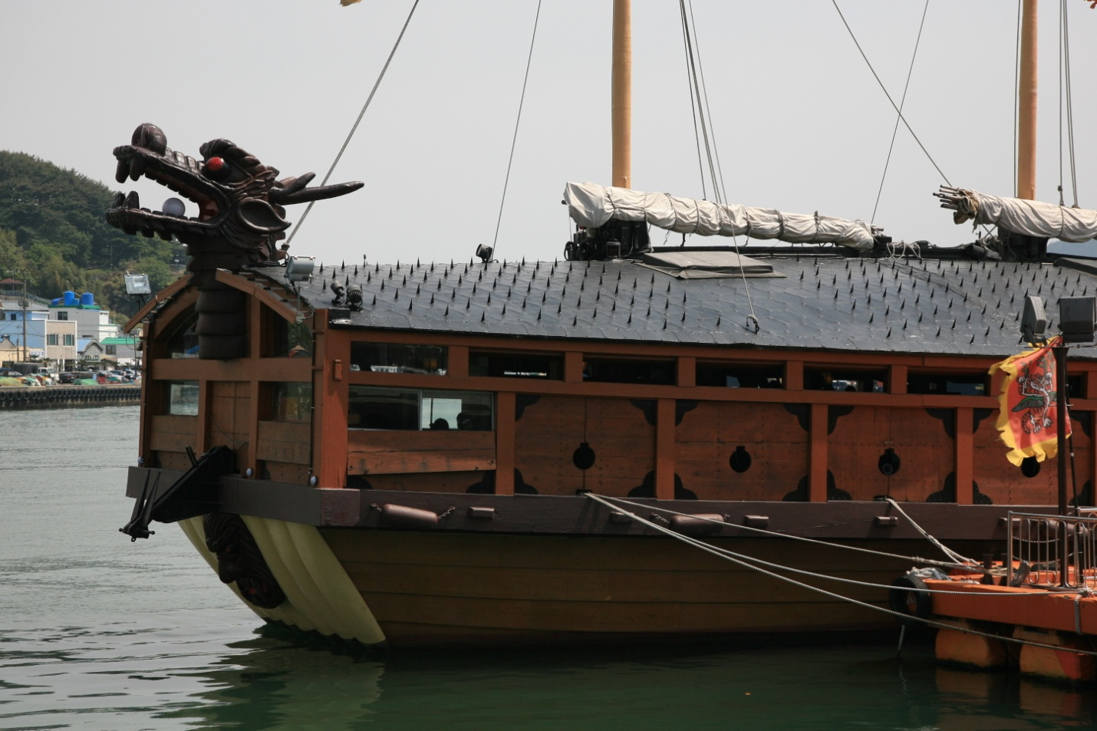

Worksheet #2

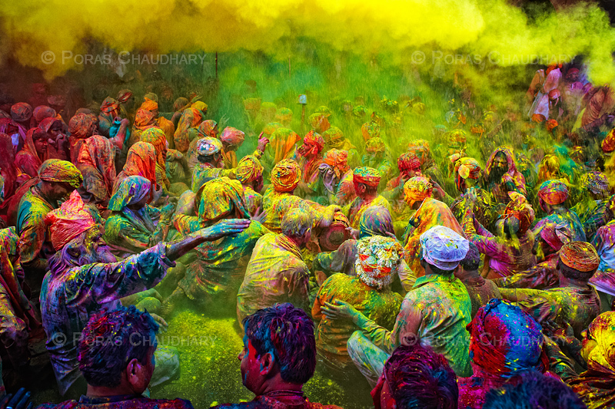

Holi is a spring festival also known as the festival of colors. It is an ancient Hindu religious festival which starts with a Holika bonfire on the night before Holi where people gather, sing and dance. The next morning is free for all carnival of colors, where everyone plays, chases and colors each other with dry powder and colored water, with some carrying water guns and colored water-filled balloons for their water fight. Anyone and everyone is fair game, friend or stranger, rich or poor, man or woman, children and elders. Groups carry drums and musical instruments, go from place to place, sing and dance.
Worksheet #3

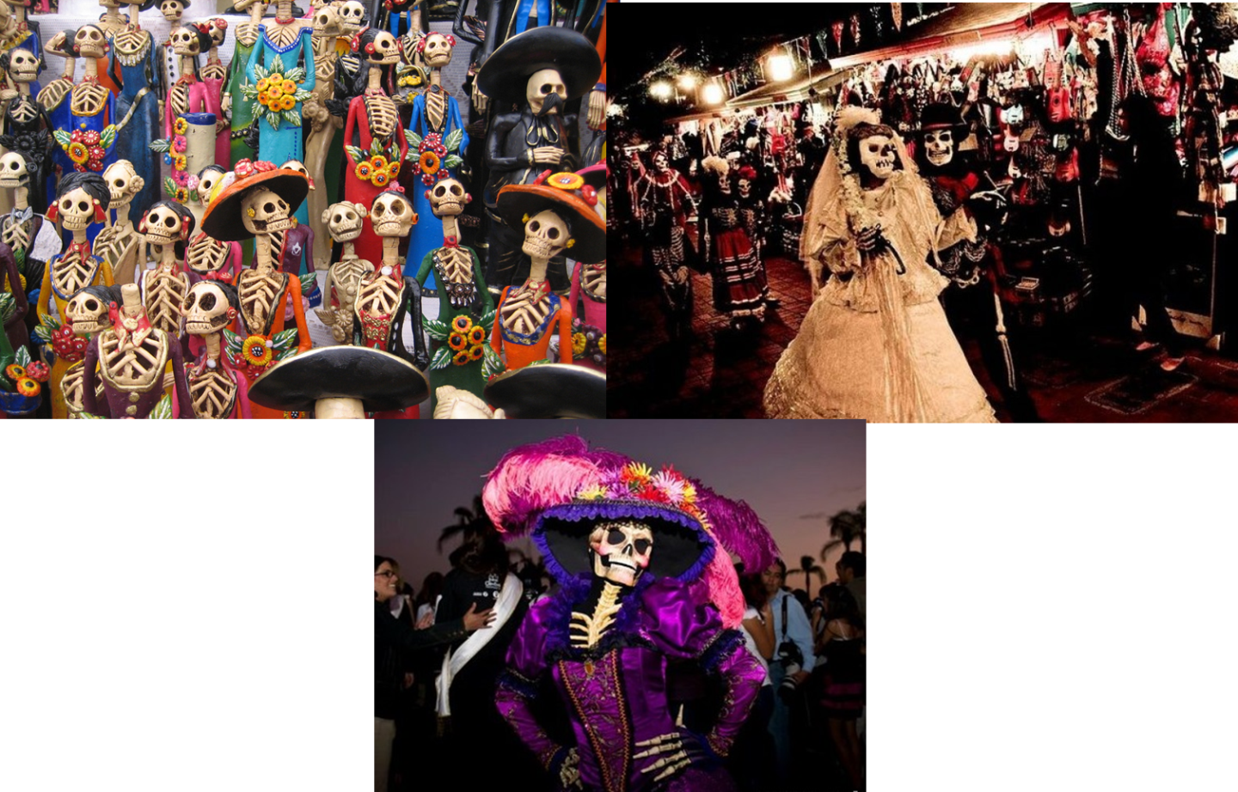

Dia de los muertos (Day of the Dead) is a Mexican holiday celebrated throughout Mexico and around the world in other cultures. The holiday focuses on gatherings of family and friends to pray for and remember friends and family members who have died. It is particularly celebrated in Mexico where the day is a bank holiday. Traditions connected with the holiday include building private altars called ofrendas, honoring the deceased using sugar skulls, marigolds, and the favorite foods and beverages of the departed, and visiting graves with these as gifts.
Scary indeed!

Worksheet #4

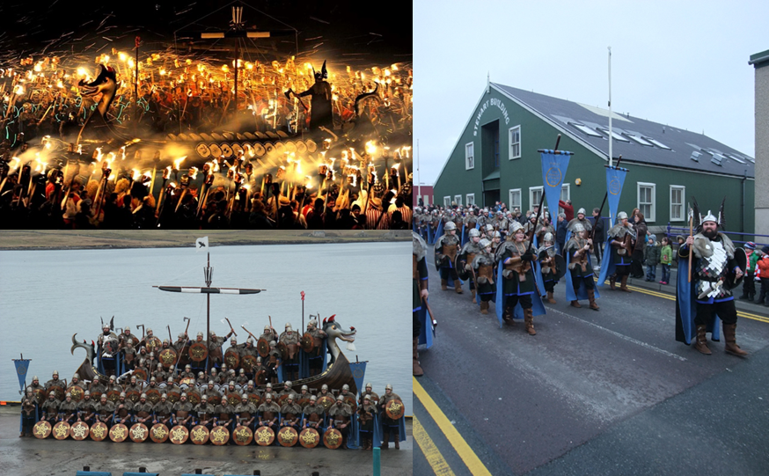

It takes place in Lerwick, Shetland, on the last Tuesday in January every year. Up Helly Aa day involves a series of marches and visitations, culminating in a torch-lit procession and the burning of a galley. This is followed by hours of performing acts and dancing in halls throughout Lerwick. There is a main guizer who is dubbed the "Jarl". There is a committee which a person must be part of for 15 years before one can be a jarl, and only one person is elected to this committee each year. The procession culminates in the torches being thrown into a replica Viking longship or galley.

Worksheet #5

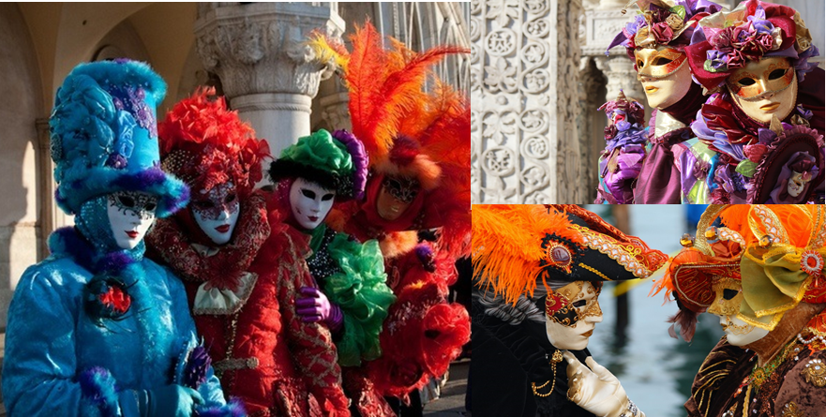

The tradition of carnival dates back over 900 years. It was the one time during the year when there were no bounds. Everybody was free to do things desired all year without any guilt thanks to the masks. During the carnival, Venice comes alive with masked Venetians and tourists. Bands, jugglers and entertainers are everywhere and the canals are full of colorful boats. The nights are also full of parties and masked balls. It gives you a feeling as if fairy tales are coming alive!

True / False Questions ( For Teacher )

- Holi festival exhibiting the most exquisite ice and snow sculptures in the world. ( T / F )
- Day of the Dead holiday focuses on gatherings of family and friends to pray for and remember friends and family members who have died. ( T / F )
- Holi is a spring festival also known as the festival of colors. ( T / F )
- During Holi, Anyone and everyone is fair game, friend or stranger, rich or poor, man or woman, children and elders. ( T / F )
- Carnival of Venice involves a series of marches and visitations, culminating in a torch-lit procession and the burning of a galley. ( T / F )
- In the ‘Up Helly Aa Fire Festival’, Participants throw tomatoes at each other and ride down those tomato-streaked slides having the time of their lives. ( T / F )
- The Running of the Bulls is a part of the famous Carnival of Venice. ( T / F )
- Day of the Dead holiday commemorates Saint Patrick and the arrival of Christianity in Ireland . ( T / F )
- During the Carnival of Venice, Venice comes alive with masked Venetians and tourists.
( T / F )
- ‘Up Helly Aa Fire Festival’ takes place in Lerwick, Shetland, on the last Tuesday in January every year. ( T / F )

True / False Questions Answers ( For Teacher )

- Holi festival exhibiting the most exquisite ice and snow sculptures in the world. ( T / F )
Harbin Ice& Snow Festival
- Day of the Dead holiday focuses on gatherings of family and friends to pray for and remember friends and family members who have died. ( T / F )
- Holi is a spring festival also known as the festival of colors. ( T / F )
- During Holi, Anyone and everyone is fair game, friend or stranger, rich or poor, man or woman, children and elders. ( T / F )
- Carnival of Venice involves a series of marches and visitations, culminating in a torch-lit procession and the burning of a galley. Up Helly Aa Fire Festival ( T / F )
- In the ‘Up Helly Aa Fire Festival’, Participants throw tomatoes at each other and ride down those tomato-streaked slides having the time of their lives. La Tomatina ( T / F )
- The Running of the Bulls is a part of the famous Carnival of Venice. Spain ( T / F )
- Day of the Dead holiday commemorates Saint Patrick and the arrival of Christianity in Ireland . Mexico ( T / F )
- During the Carnival of Venice, Venice comes alive with masked Venetians and tourists.
( T / F )
- ‘Up Helly Aa Fire Festival’ takes place in Lerwick, Shetland, on the last Tuesday in January every year. ( T / F )

Worksheet #6 < SOS Activity >
Find the Evidence 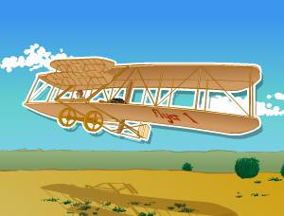 Can you find the PROOF for your answers? Use a crayon in the color shown to underline where you found each answer in the text.

The Wright Brothers
When you hear a plane fly overhead, it may not seem like a big deal, but just over 100 years ago, airplanes were a novel idea. Wilbur Wright was born on April 16, 1867. On August 19, 1871, his little brother Orville Wright was born. The pair paved the way for human flight. When the two boys were young, their father brought home a toy “helicopter” for Orville and Wilbur. The foot-long toy was made of paper, bamboo, cork, and a rubber band. When the toy broke, Wilbur and Orville built their own. Building the toy interested them in flying.
The two boys opened a bicycle shop in 1892, but still remained interested in aviation. Wilbur began creating plans based on observations of birds and the work of other scientists. The Wright Brothers began testing their theories about flight with kites. Finally, the brothers traveled from Ohio to Kitty Hawk, North Carolina because the wind would be perfect for testing their new glider. On December 17, 1903, Orville piloted the Wright Flyer to the world’s first controlled, powered human flight. Orville and Wilbur Wright proved that humans could fly in airplanes!

Who piloted the first successful flight?
What spurred the Wrights’ interest in flight?
Where did they test their new glider?
Why did they take the glider to Kitty Hawk?
How did Wilbur get ideas for his plans?
When did the Wrights open their bike shop?
Worksheet #7 - Answers < SOS Activity >
Find the Evidence
Can you find the PROOF for your answers? Use a crayon in the color shown to underline where you found each answer in the text.

The Wright Brothers
When you hear a plane fly overhead, it may not seem like a big deal, but just over 100 years ago, airplanes were a novel idea.
Wilbur Wright was born on April 16, 1867. On August 19, 1871, his little brother Orville Wright was born. The pair paved the way for human flight.
When the two boys were young, their father brought home a toy “helicopter” for Orville and Wilbur. The foot-long toy was made of paper, bamboo, cork, and a rubber band. When the toy broke, Wilbur and Orville built their own. Building the toy interested them in flying.
The two boys opened a bicycle shop in 1892, but still remained interested in aviation. Wibur began creating plans based on observations of birds and the work of other scientists. The Wright Brothers began testing their theories about flight with kites. Finally, the brothers traveled from Ohio to Kitty Hawk, North Carolina because the wind would be perfect for testing their new glider. On December 17, 1903, Orville piloted the Wright Flyer to the world’s first controlled, powered human flight. Orville and Wilbur Wright proved that humans could fly in airplanes!

Who piloted the first successful flight?
What spurred the Wrights’ interest in flight?
Where did they test their new glider?
Why did they take the glider to Kitty Hawk?
How did Wilbur get ideas for his plans?
When did the Wrights open their bike shop?
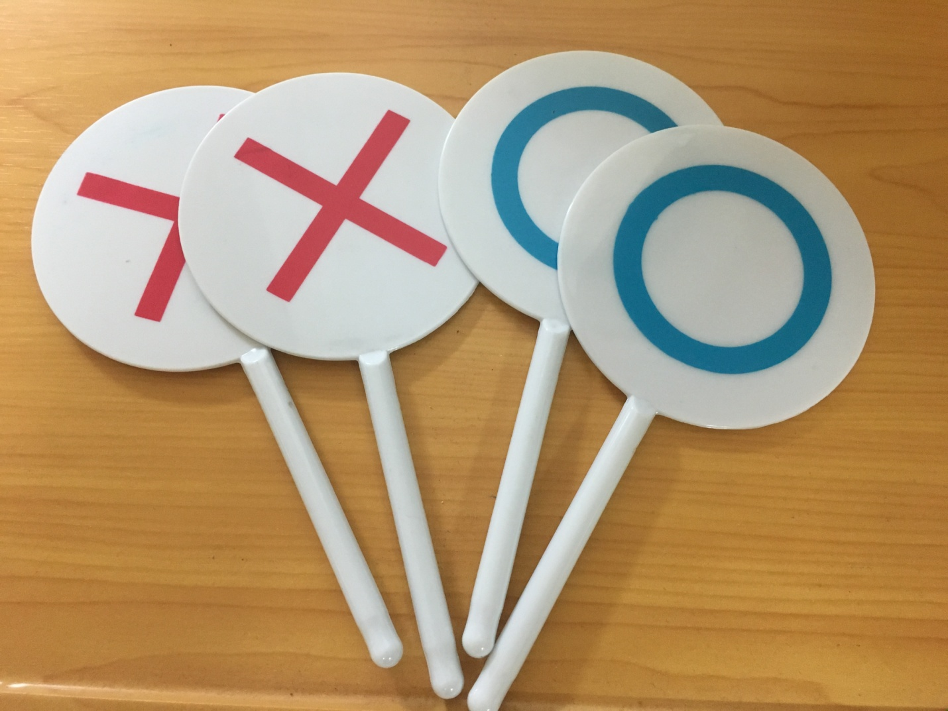
- 2 O/X Sticks

