Background Information Sheet – Complete all sections accurately.
Name & Class |  | Date & Place | Lesson Type |  |  | Plan |  | Topic |  |  | Length | Level
(Helen)  144WD |  | 30/11/2016  Gangnam | Listening |  |  | PPP |  | How children acquire language – empirical model |  |  | 45min | Intermediate
Class profile
Number of students:10 Age:20-30 Nationality: Korean
Motivations: To become a English teacher, learning how to teach the listening
Individual or class hobbies and interests: Every students well educated in high school.
Special considerations: Students are not a fluent speaker, make sure if they understand instructions or main idea.
Main aim
- Students will practice their listening comprehension skills by bottom up model.
Subsidiary aims
- Students will practice their oral fluency during the productive stage.

Description of any language skills specifically used/practiced:  - Listening – Listening the mp3 files, Listen others opinions  - Speaking – Group talking, answer the question.  - Writing –Write down the answer on the work sheets  - Reading – Vocabulary Worksheet |  |  |  |  |  |  | Description of any language systems specifically used/practiced:  - Phonology : By speaking, learners can learn pronunciation/self-correct  - Lexis : Learners can learn new vocabulary in the listening text.  - Function : Group talking and listening text  - Discourse : Through group talking, learn many expressions

Anticipated difficulties with lesson activities and classroom management:
-Time is not enough.
-Listening text will be hard for students.
-Students may not participate in activities.
How I can deal with these difficulties:

-Flexible with context and time.
-pose the listening files, and check the students whether understand or not.
-motivate them, such as ask their goal.
Assumptions:
Students will be focus on the listening. They will learn one theory of language acquisition. Also, practice their pronunciation.

Material(s) needed:
Listening mp3 files, computer, projector, power point, White board and markers, Speaker, pronunciation video(https://www.youtube.com/watch?v=h5LO0hHGfQg)

Checklist. Mark down those included in this lesson plan (or N/A)
v | model sentences for target language |  |  |  | concept questions for target language |  |  |  |  | analysis sheet for target language
 | stages clearly titled and separated |  |  |  | purpose of each stage indicated |  |  |  |  | anticipated timing included
 | interaction pattern marked |  |  |  | a board plan (if relevant) |  |  |  |  | examples of all tasks used
 | answer sheet to all exercises |  |  |  | Tape or text script |  |  |  |  | all materials labelled and numbered
Personal aim :What I most hope to demonstrate in this lesson is the ability to interact with students and do not nervous while in the class. Make confidence.

Stage 1:_Lead-in  The purpose of this stage is to ease into the topic, relaxing both teacher and students by focusing their attention on an interesting subject and encouraging the class to share their opinions freely, thus increasing STT and participation. This stage may be used to create a basis from which to elicit ideas and lexis relating to the text. | Inter  action | Time | Instructor’s comments
Procedure :  Greeting and asking some questions about pictures.  Good morning, guys. The weather is really chilly, Isn’t it?  Ok. Have you ever heard about the words nature and nurture?  (Show PPT)  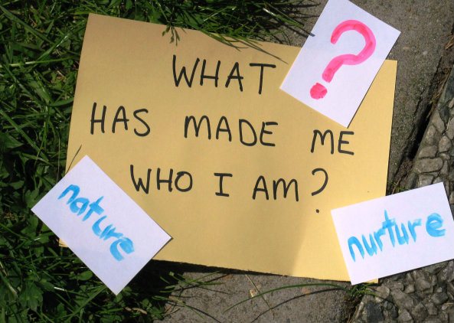  (answer will be no… )  Why boys like a car and why girls like a doll?  Does boy like a car from birth?  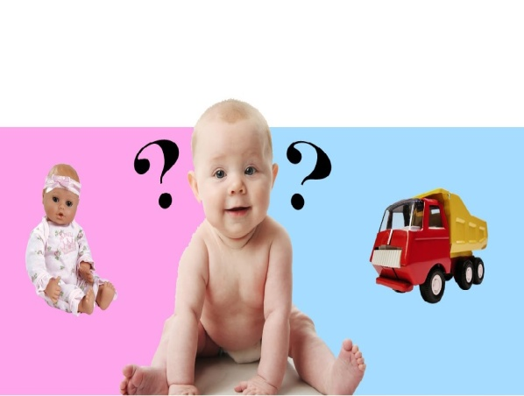  (Make students interest)  Twins looks like almost same and their behaviours are similar too.  But… what if twins lived in different environment, do their habit will be same as well?  Talk with your partner.  Monitor the student. (Time limit)  Ok, What do you thing? What was your answer? | T-S  S-S  T-S | 1  1  1

Stage 2: Presentation  The purpose of this stage is to make the listening less challenging to the students by making use of guiding questions which help predict expected content; answers to these questions may be guessed during this stage and checked later in the lesson; pre-teaching keywords and phrases from the text. Knowledge of the purpose of the text, form and style could be highlighted to further aid comprehension. Thus, schema is activated. | Inter  action | Time | Instructor’s comments
Procedure:  Pre-teach Vocabulary  acquisition  Eliciting  I guess everyone knows a word ‘require’  If we switch spell ‘r’ to ‘a’, how we pronunciation it? (acquire)  Do you know what’s the word ‘acquisition’ mean? (no/ synonym of require/ The process of getting something)  What’s this word as a noun? (acquisition)  Can you spell it? (write down the spell on the board, inspire the students to tell correct spelling)  Drill  Please, repeat me. Acquisition. (speak 5 times and students will be follow me)  If you are struggling to pronunciation it, speak separately.  Ac/qui/si/tion/  CCQ  The word ‘acquire’ is synonym of require?(no)  The word ‘acquisition’ is a noun?(Yes)  theorize  Eliciting  Aristotle’s ( ) of universals (write down on the board)  Can you put a word in the blank?( theory)  What is ‘theory’ as a verb? (theorize)  Can you guess what’s that mean? (set a theory for certainly, To develop a set of ideas about something)  What is the spell of ‘theorize?(write down the word on the board)  Drill  Repeat me, pleas. Theorize (speak five time and students will be repeat it)  Kim, can you say it? (She will reply it, but not familiar with ‘th’ sounds, the student can be stuck)  I heard that many students were hard to speak ‘th’  Watch this video  (Show the video that how to pronunciation ‘th’)-> 1:30  https://www.youtube.com/watch?v=h5LO0hHGfQg  So, when you practice pronunciation , best way is exaggerate.  It means make sounds super strong.  To make a ‘th’ sound, your tongue will be like this. (demonstrate it)  Can everybody copy me? (encourage them to practice)  Kim, can you say the word again? (She will say the word ‘theorize’ much fluency)  CCQ  Can we count ‘theorize’? (No)  Can we count ‘theory’? (Yes)  What’s the form of ‘theorize’? (verb)  Guiding Question  (Show PPT)  Have you ever think about the differences between adult and children when they acquire language? If so, what’s the difference?  Talk with your partner.- Monitor  Feedback.  What was your answer? | T-S  T  S-S  T-S | 8  30”  1  1

Stage 3: Practice - Listening for gist comprehension  The purpose of this stage is to allow the students to practice gist skills to identify the main idea of the text. Specific and authentic exercises designed to encourage this skill should be used in a natural way. Students draw on their world-knowledge (top-down) to make an initial impression and general sense of the text and perhaps comparing the accuracy of their guesses to the guiding questions used for the text. | Inter  action | Time | Instructor’s comments
Instruction:  Finally, we’ll listen a lecture.  I’ll give you simple questions after the listening.  Listen carefully.  (Play the audio for 1 minute.. Ss listen)  When lecture is end, ask students.  - What is the professor talking about?  - Language acquisition/ Empirical model  - How many theories the professor mentioned?  - Two.  Allow students silent time.  Feedback:  Ask students individually, but other students can add more answer or different opinion. | T  S  T-S  S  T-S | 10”  1  10”  10”  1

Stage 4: Practice - Literal comprehension  The purpose of this stage is for students to focus on literal understandinge.g. of facts, ideas etc. A variety of exercises may be used and should be constructed for short responses e.g. objective questions. The information highlighted should, ideally, be of significance to the next stage. | Inter  action | Time | Instructor’s comments
Instruction :  Now listen again and write down answer of ‘Exercise 1’. (Hand out paper)  - Did professor explain theory of universal grammar?  - No, he explained empirical model  - Who made a empirical model?  - B.F Skinner  - What is a slate in the empirical model?  - Children’s mind  Answer the question alone.  I.C.Q  -Can you talk with your partner while listening?(No)  -Are you ready to listen?(Yes)  (Play the audio for 1 minute. Ss listen.)  Ss work individually to complete answering the questions.  “Talk with your partner.” Monitor.  Feedback.  Ask student and if the answer is wrong, ask other student. | T  T-S  S  S-S  T-S | 1  10”  1  1:30  2

Stage 5: Practice - Interpretive comprehension  The purpose of this stage is to allow student to listen intensively for inference. Discriminating between fact and opinion and understanding the writer’s true thinking are possible considerations during this stage. Contrasting ideas may be highlighted, and use of certain language which affects meaning can be analysed in context. | Inter  action | Time | Instructor’s comments
Instruction :  Write down your answer of ‘Exercise 2’ questions.  - Why he mentioned cookie, and how the child added new vocabulary?  - He mentioned cookie to explain stimuli. When a child said  ‘want cookie’, his mom corrected him to say ‘ I want cookie’. So the child could add new vocabulary.  - How child can fill in the slate?  - Child has to producing intelligible sounds with intelligent meanings.  Can you answer it right now? Or do you want to listen again?(Yes or No)  (Play the audio for 1 minute. Ss listen).  Check the answers with your group. (One group will be 5 people) – Monitor.  Feedback  Ask in a group. | T  S  S-S  T-S | 30”  1  1:30  2

Stage 6:_Production - Applied Comprehension  The purpose of this stage is to complete the final step in reading comprehension by getting students to apply to themselves the information from the text and which was focused on during the practice stages. The task should take into account your students’ background information in order to be suitable as an applied task. Speaking or writing skills may be practiced here. This stage is an important part of language acquisition. | Inter  action | Time | Instructor’s comments
Instruction :  Discuss ‘Exercise 3’ with your group.  - Between the two words nurture and nature, which do you think is associated with the empirical model? Why?  - Nurture, because empiricism holds that all knowledge comes from a person’s experiences, so nurture relates to the empirical model.  - Do you agree the theory of empirical model? Why?  - Agree : Similar experience when they young.  - Disagree : Memorizing is more important.  - Do you have effective way to learn a new language?  - Share there experiences.  Group discussion – Monitor.  By monitoring, check the students understand the listening text.  Feedback.  Each group presents their answer.  Other group can ask. | T  S-S  S-S | 1  8  4

Stage 7:_Wrap-up  The purpose of this stage is to end the lesson with some positive feedback about the lesson and the students’ participation. Review the ideas from the production stage if possible, and perhaps offer error correction. Classroom management should be considered, such are collecting worksheets, giving homework, stimulate interest in the next class or arranging the desks etc. | Inter  action | Time | Instructor’s comments
Summarise the listening and ask students how was the lesson.  All right, you did so well.  Today, we learned a theory that how children learn a language.  I hope you improved your listening skill as well.  - How was the listening?  - What was the most difficult part for you?  - Did you like the topic? If not, what can you recommend?  - What do you want to add in our class? Such as activity or homework.  Thank you for your feedback.  Here is a home work.  Practice the pronunciation which we learned today.  Also make 3 sentences with the words.  This is one of good way to memorise the word.  Do not late for the class! See you tomorrow!!  Class dismissed.  Prepare next class. | T  T-S  T | -  3
Instructor’s Final Comments
Overall strengths of this lesson (planning and teaching) | Areas to work on

Overall comment

For this stage of the course, your lesson today was

- Above standard

- To standard

- Below Standard

Instructor: …………………………… Date: …………/……………/…………

