Background Information Sheet
Name & Class | Date & Place |  | Lesson |  | Plan |  | Topic |  |  | Length | Level
144th WD  Jeannie JungHa Park | 2016/12/14 |  | Grammar |  | PPP |  | Comparative and Superlative |  |  | 40 min | Elementary
Class profile
Number of students: 8 Age: 20-40 Nationality: Korean
Motivations: Students will have high confidence to describe things using comparative and superlative.
Individual or class hobbies and interests: women love drinking coffee.
Special considerations: all women
Main aim (language focus / skills)
- Students practice and learn to improve and use comparative and superlative in various situations with grammatical accuracy and fluency.
Subsidiary aims (language focus / skills)
- Students will be able to use comparatives and superlatives more properly and accurately.
Description of language skills specifically used/practiced:  - Speaking – sharing ideas (pair/group work)  - Listening – listening to peers  - Reading – worksheet instruction  - Writing – writing answers on the worksheet |  |  |  |  |  | Description of language systems specifically used/practiced:  - Grammar – Comparative and Superlative  - Lexis – (more) –er/ier than/ the(most) -est/-iest  - Discourse – communicative talking /sharing ideas  - Function – description

Anticipated difficulties with lesson activities and classroom management:
Students overuse the target language – more cute, most cheapest…etc.
There is no co-teacher so a teacher needs to stand beside the computer.

How I can deal with these difficulties:

Show substitutional table to understand the structure clearly.
Try to have more eye contact with students instead of looking at a screen.
Assumptions: (That which provides insight about your choice of material, selection of target language etc.)
Students are familiar with using present simple tense.
Some students may know the knowledge of comparative and superlative.
Material(s) needed:
Board, markers, worksheets, realia(disposable cups), crayons,

Checklist. Tick those included in this lesson plan (or N/A)
model sentences for target language |  |  |  | concept questions for target language |  |  |  |  | analysis sheet for target language
stages clearly titled and separated |  |  |  | purpose of each stage indicated |  |  |  |  | anticipated timing included
interaction pattern marked |  |  |  | a board plan (if relevant) |  |  |  | N/A | examples of all tasks used
answer sheet to all exercises |  |  |  | tape script |  |  |  | N/A | all materials labelled and numbered
Personal aim :
What I most hope to demonstrate in this lesson is the ability to use the target language without failure or unclear.

Stage 1:_Lead-in  The purpose of this stage is to relax both teacher and students by focusing their attention on an interesting subject and encouraging the class to share their opinions freely, thus increasing STT and participation. This stage should be used to create an appropriate situational context. | Inter  action | Time | Instructor’s comments
Procedure: (Separated into titled stages with inclusion of target language, instructions, concept questions, answers to tasks etc., where appropriate)  Target Language: “A Grande is bigger than a Tall. What is the biggest size?”  Instruction:  - Good morning everyone. How are you? good, tired, okay, fine……etc.  - Let’s look at this picture (pic1), what do you see here? cups, Starbucks, different size……..etc.  - Hmm, do you know the name of each size? Talk to your partner for 30 seconds.  - What you think? Do you know the names? Use realia (portable cups)  Nominate 1 student to make an order.  A is Short, B is Tall, C is Grande, D is Venti.  - Great! Where do you see these? at the café  - Then let’s look at this dialogue (pic2). Nominate 2 students to read.  A: Good morning! Can I take your order?  B: Can I have a Latte?  A: What size would you like to have?  C: Oh, medium please.  A: Tall or Grande?  B: Oh, which one is bigger?  A: A Grande is bigger than a Tall.  B: I see, what is the biggest size?  A: It is a Venti.  B: Oh, I will take a Grande Latte, please.  CCQ:  - Where are they? in the café  - What is B ordering? Grande Latte, Latte,  - Can you guess what are we learning today? comparison  - Can you find comparison word? bigger/biggest  - Great!! Let’s get started!  Feedback: nominate 1 or 2 students for answers. | T-S | 3’30”

Stage 2: Presentation  The purpose of this stage is to teach the target language deductively, referring to the situational context from the lead-in. Meaning, form and pronunciation should be covered with appropriate methods such as a model sentence, CCQs, timelines, substitution tables and indication of phonology etc. | Inter  action | Time | Instructor’s comments
So, today we not only learn comparative but also superlative. They are related each other.  Meaning :  What’s comparative? compare two things / what’s superlative? compare the best in a large group  Form : so, the form of (show pic3)  Comparative is and Superlative is  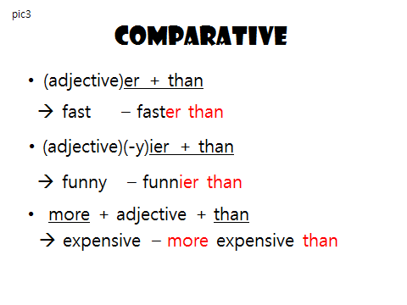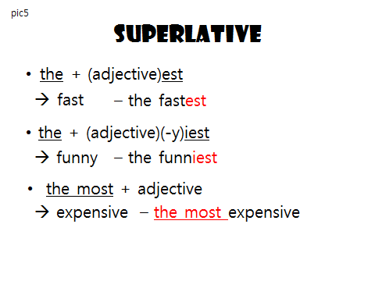  Look at the worksheet 1 or 2 and can you write down 5,10 and 12  Pronunciation  - er/ier than /ɜːr ðən/,/iɜːr ðən/ the est/iest /ðə ist  faster than/ heavier than the fastest/ the heaviest  - more than / mɔːr ðən/ the most /ðə moust/  more expensive than the most expensive  Substitution table  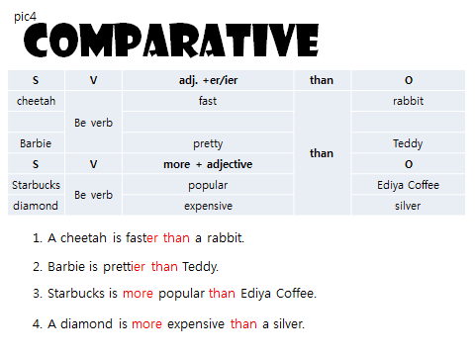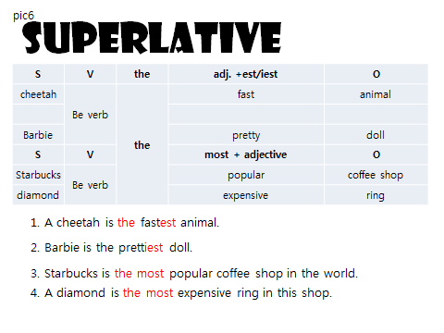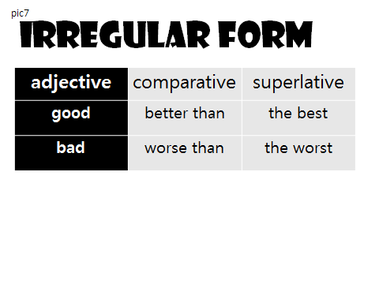 | T-S | 7’

Stage 3: Controlled Practice  The purpose of this stage is to allow the students to accurately practice working with the target language by doing easy, or controlled tasks. This helps build confidence before trying something more challenging. Students should apply the rules that were presented in a meaningful way whenever possible. Peer-checking before feedback is important in these practice stages. | Inter  action | Time | Instructor’s comments
Controlled task  - Gap filling exercises (deliver form) worksheet 1and 2  Let’s practice now! Can you complete worksheet 1 and 2? yes.  Please fill the gap and talk to your partner to check answers.  I will give you 4.30 minutes.  ICQ: How much time do you have? 4.30 minutes  How many papers should you complete? 2 pages  Students complete the worksheet and talk to peers.  Teacher is monitoring  Feedback nominate the whole class checking answers  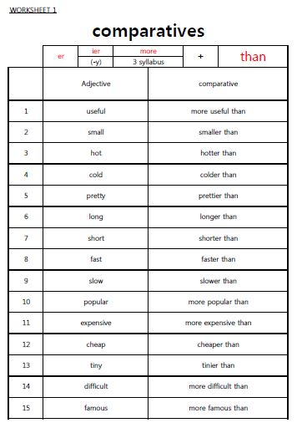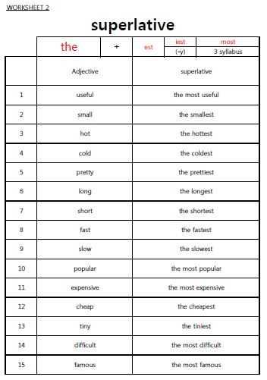 | T-S  S  T-S | 1’  4’30”  1’30”
Stage 4: Less controlled practice  The purpose of this stage is to allow students to practice the target language more thoughtfully, in terms of either structure manipulation, meaning, function or other aspects of language. Accuracy is checked before moving to the next stage. | Inter  action | Time | Instructor’s comments
Less controlled exercises  - Deliver meaning with some exercises: STT increases.  Let’s make sentences using comparative and superlative  Can you complete worksheet 2 and 3? yes.  Please complete and write down the sentences with your partner to check answers.  I will give you 5 minutes.  ICQ: How much time do you have? 5 minutes  How many papers should you complete? 2 pages  Do you work alone? no, we work with pairs  Students complete the worksheet and talk to peers.  Teacher is monitoring  Feedback nominate the most of class checking answers  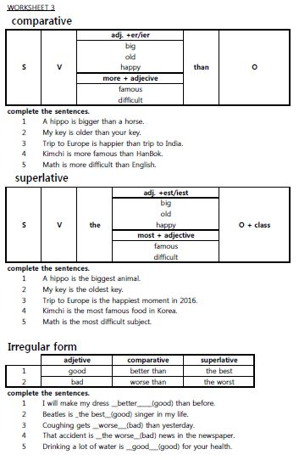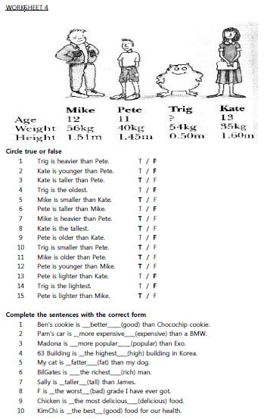 | T-S  S  T-S | 1’  5  1’30”

Stage 5:_Freer Practice  The purpose of this stage is to allow student to practice using the target language productively in an authentic way. The focus is to encourage fluency, not accuracy, therefore errors should be monitored and only addressed if necessary. Correction should be given during the next stage. | Inter  action | Time | Instructor’s comments
Not accuracy fluency checking  Let’s play Bingo  Give instruction by demonstrating.  Students may know how to play the Bingo game.  Demonstration takes place on the board. (nominate one student for help)  ICQ:  - How much time you have? 8 minutes  - How many bingos you have to make? 5 bingos  - What do you say when you pick one word? comparative and superlative  Students will start the game in groups.  Teacher is monitoring and taking notes for error correction if needed.  Teacher lets students know the how much time left. (3mins, 1min)  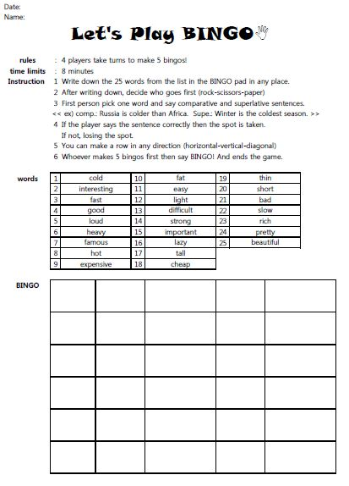 | T  S | 2’  8’

Stage 6:_Wrap-up 5mins  The purpose of this stage is to end the lesson with some positive feedback about the lesson and the students’ participation. Review the main points briefly, either deductively or inductively, or perhaps during error correction. Classroom management should be considered, such are collecting worksheets, giving homework, stimulate interest in the next class or arranging the desks etc. | Inter  action | Time | Instructor’s comments
Write down 2 sentences on the board. error correction  - Summer is hoter than winter.  - Silver is more cheaper than gold.  - Thomas is the most laziest boy in the class.  Look at the board.  Do you find any incorrect word? yes  Can you make it correctly? Talk to your partner in 30 seconds.  What is the correct answer?  - Summer is hotter than winter.  - Silver is cheaper than gold.  - Thomas is the laziest boy in the class.  Great! You all have learned so hard! Great job!  The homework is describing your house with 5 sentences using comparative and superlative.  For example, my room is the biggest in my house.  Thank you for attending and I will see you tomorrow guys!  Bye-bye.  Class dismissed. | T-S  T | 4’  1’
Instructor’s Final Comments
Overall strengths of this lesson (planning and teaching) | Areas to work on

Overall comment

For this stage of the course, your lesson today was

- Above standard

- To standard

- Below Standard

Instructor: …………………………… Date: …………/……………/………… Student/s: ……………………….. .…………………………..

Language Analysis Sheet - Grammar
Item: A Grande is bigger than a Tall | Anticipated Problems | Possible solutions
Meaning: A Grande is bigger than a Tall.  A Tall size cup is small and a Grande size cup is big.  When we use comparative, we compare between 2 things.  We use comparative adjectives or adverbs. | Students may confuse with “–er” and “more” at every adjectives.  Ex) My doll is more cheaper than yours.  My doll is more pretty than yours.  Students may be able to use “more” effectively with long syllables because there are not many.  Ex) Mc You is more popular than Exo. | S V more adj. adj. er/ier than O  - Use a substation table  - CCQs  - Do you put (-er) for every word? (no)  - Do you put than after the adjective? (yes)  - Do you change “y” to “i” when you use comparative? (yes)  - Where do you put “more”? (in front of the long word-more than 3 syllables)
Form: adj.-er/ier than/ more adj. than  adjective –er/ier than  - General adj. +er than fast-faster than  - Ends with y adj. changes to ier than  - happy-happier than  - more than 3 syllables more adj. than  - expensive-more expensive than | - Difficulty deciding when to use “more”  3 syllables are difficult to understand  - Difficult to understand single vowel and single consonantdouble consonant | - Substitution table. (Refer to a lesson plan.)  - Memorize : hot-hotter-hottest  Big-bigger-biggest
Pronunciation:  /bɪgər ðən / | - Weak sentence stress  - Schwa /ə/  - Weak sound /ð/ | Board the model sentence.  Indicate the /ə/ and /ð/ to pronounce accurately.  Drill them to use correctly.

Language Analysis Sheet - Grammar
Item: A Venti is the biggest. | Anticipated Problems | Possible solutions
Meaning:  A Venti is the biggest.  Nothing is bigger than a Venti.  We use superlative when we indicate the highest level of the things.  We use superlative adjectives and adverbs. | Students may confuse with “–est” and “most” at every adjectives.  Ex) My doll is most cheapest.  My doll is the mostprettyest.  Students may be able to use “the” effectively with because they already know it indicates only one.  Ex) You JeaSeok is the best MC in Korea. | - Use a substation table  S V the most adj. adj. est/iest O  - CCQs  - Do you put (-est) for every word? (no)  - Do you put than after the adjective? (no)  - Do you change “y” to “i” when you use superlative? (yes)  - Where do you put “the most”? (in front of the long word-more than 3 syllables)
Form: the adj.-est or iest / the most adj.  adjective –er/ier than  - general adj. +est fast-fastest  - Ends with y adj. changes to ier  - happy-happiest  - more than 3 syllables the most adj.  - expensive- the most expensive | Difficulty deciding when to use “most”.  Long syllables are difficult to understand.  Difficult to understand single vowel and single consonantdouble consonant | - Substitution table. (Refer to a lesson plan.)  - Memorize : hot-hotter-hottest  Big-bigger-biggest
Pronunciation:  /ðə bɪgɪst/ | - Weak sentence stress  - Schwa /ə/  - Weak sound /ð/ | Board the model sentence.  Indicate the /ə/ and /ð/ to pronounce accurately.  Drill them to use correctly.

