Background Information Sheet – Complete all sections accurately.
Name & Class |  | Date & Place | Lesson Type |  |  | Plan |  | Topic |  |  | Length | Level
Hannah, 144WD |  | 12/19/2016 | Reading |  |  | PPP |  | Wind Sculptures |  |  | 60min | Intermediate
Class profile
Number of students: 7 Age: Adult Nationality: Korean
Motivations: Sharing deep conversations with Foreign friends in English.
Individual or class hobbies and interests: Most students are interested in traveling around the world, inspiring ideas, music, etc.
Special considerations: Difference in students’ reading comprehension processing time/speed (Learning differences).
Main aim
- Students practice reading comprehension skills by answering some detailed and thought provoking questions regarding the reading passage.
Subsidiary aims
- Students practice/learn How to work cooperatively in a group by sharing their ideas and thoughts freely.
- Students may bring out their diverse view points and able to expand their perspectives.
Description of language skills specifically used/practiced:  - Listening: Students will listen to their partner’s opinions and ideas.  - Reading: Students will read the reading passage and worksheets.  - Writing: Students will write down their answers and opinions on the worksheets.  - Speaking: Students will have conversations during pair-checking and group-discussions. |  |  |  |  |  |  | Description of language systems specifically used/practiced:  - Lexis: Students will learn some keywords from the reading; Sculpture, Wind.  - Discourse: Group-discussions.  - Phonology: Students will practice correct pronunciation of keywords/vocabularies.

Anticipated difficulties with lesson activities and classroom management:
-Instructional equipment problems, such as computer, projector, projection screen, etc.
-Students may not actively engage in group-discussion.
How I can deal with these difficulties:

- All necessary materials and equipment for the lesson should be prepared beforehand.
- Encourage shy students and create an enjoyable learning environment that students can engage and participate.
Assumptions:
-Students may want to share their ideas, thoughts, opinions freely.
Material(s) needed: Computer, Projector, Projection Screen, Whiteboard, Markers, 7 Copies of worksheets, PPT file.

Checklist. Mark down those included in this lesson plan ( or N/A)
 | model sentences for target language |  |  |  | concept questions for target language |  |  |  |  | analysis sheet for target language
 | stages clearly titled and separated |  |  |  | purpose of each stage indicated |  |  |  |  | anticipated timing included
 | interaction pattern marked |  |  | N/A | a board plan (if relevant) |  |  |  |  | examples of all tasks used
 | answer sheet to all exercises |  |  |  | Tape or text script |  |  |  |  | all materials labelled and numbered
Personal aim: What I most hope to demonstrate in this lesson is the ability to deliver clear instructions in each stage and increase STT and decrease TTT.

Stage 1:_Lead-in  The purpose of this stage is to provoke students’ interests and grab their attention to an inspiring subject and encourage them to share their ideas and opinions freely. Eliciting their ideas, increase STT and their participations. | Inter  action | Time | Instructor’s comments
- Greetings  - “Good Morning everyone? How’s your final week going so far?” Are you ready for this Christmas holiday?  - Eliciting  #1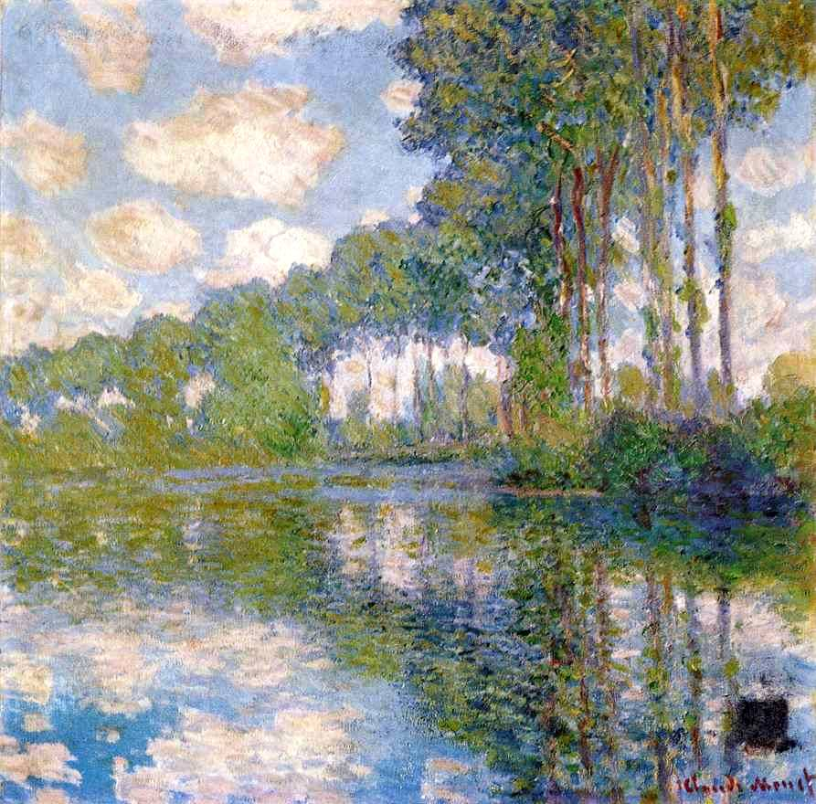 #2 #3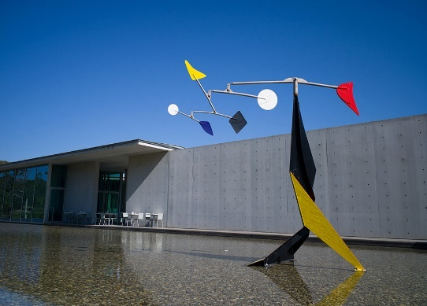  - After showing visual aids, “Please take a look at these pictures”  - Ask Eliciting Questions:  - “What do you think about these pictures?” “Have you ever seen these before?  - Then, “Please share your ideas freely with your partner about these pictures for a minute.”  - Monitor while students share their thoughts and ideas  3) Feedback  - Let students bring their ideas and answers freely.  -Write down some of students’ keywords and answers on the board.  -Nominate one student and ask, “Can you guess what this is?” (Student’s response)  -“Is there anyone who is interested in art or artworks?”  - Ask another student “Do you have any favourite artists or artworks?”  - Inspire and encourage students to extend their ideas and thoughts freely. | T-S  T-S  S-S  T-S | 1  1  1  2

Stage 2: Presentation  The purpose of this stage is pre-teaching some of keywords from the reading passage through the Bottom-Up Model. Also, providing some guiding questions, which will help students to predict about the topic/content of reading passage; Students can get a glimpse and clue about the main idea of text by using pictures and clues. They are able to guess about what they are going to be reading. Also, recalling students’ background knowledge, schema is activated. | Inter  action | Time | Instructor’s comments
- “Now, before we start to read an interesting passage, I want you to bring some background knowledge.”  - Pre-Teaching Vocabulary (Sculpture, Wind, Encourage, Creativity)  <Keyword 1. Sculpture>  - (1) Eliciting:  Visual aid #4 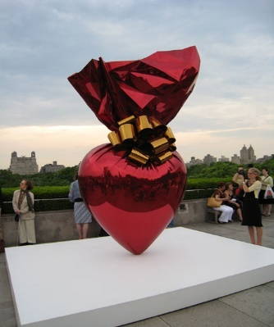 After showing this picture,  - “What can you see?” (gift? artwork? sculpture, etc.)  - “What type of artwork is this? What kind of art form is this? (Sculpture)  - Write the students’ answers on the board.  (2) CCQ:  - Is sculpture three-dimensional artwork? (Yes)  - Do you prefer paintings or sculptures? (depends, paintings/ sculptures)  - Have you ever seen famous sculptures before? And where? (Yes, museums)  (3) Drill  -Teacher says the word first and then students repeat after the teacher.  -“Ok, this group here, please repeat after me, Sculpture” “Then, another group”  -Students practice the pronunciation of target language about seven times, drilling from groups to individuals.  (4) Write the word on the whiteboard.  - [skuhlp-cher] /ˈskʌlp·tʃər/ Meaning, Pronunciation, Form for analyzation  <Keyword 2. Wind>  - Eliciting: #5 After showing this picture,  -“What do you see?” (nature, sky, wind power generator, etc.)  - “What can you feel from this pictures?” (fresh, wind, etc.)  (2) CCQ:  -How does wind power generator work? (Because of wind)  -Does too much cold wind make you shiver or sick? (Yes)  -Can trees be destroyed because of wind? (Yes, it is possible)  (3) Drill  -Teacher say the word “Wind” first and then students repeat after the teacher.  - “Ok, this group here, please repeat after me, Wind” groups to individual students.  - Students practice the pronunciation of target language, Wind.  - Drilling from groups to individuals about seven times.  (4) Write the word on the whiteboard.  /wɪnd/ Meaning, Pronunciation, Form for analyzation.  - Guiding Questions  - “Have you ever seen moving sculptures before?”  - “Do you know America’s one of the most important sculptors?”  -“Please discuss with your partner about your ideas and thoughts freely to these questions.” | T  T-S  T-S  T-S  T  T-S  T-S  T-S  T  T  S-S | 1  1  1  1  30sec  1  1  1  30sec  1  1

Stage 3: Practice - Skimming and scanning for gist comprehension  The purpose of this stage is recognizing the main idea of the reading passage only through skimming and scanning the text (including passage’s picture and titles). | Inter  action | Time | Instructor’s comments
- Introduction  - “Now, I am going to pass out the reading passage, and please start with looking at the pictures and titles first.  - “Then, I want you to get a feel for what you are going to be reading about ok?”  - Hand out the reading passage  - “After that, please quickly read, just skim and scan this passage for about one minute.”  - “Just focus on finding the main idea from this reading and answer the following questions.”  - Hand out the worksheet.  Gist questions:  - Q1) “What is the reading passage mainly about?”  Expected Answer: (This passage is about Alexander Calder, the inventor of mobile in America.)  - Q2) “Can you summarize this passage in one sentence?”  Expected Answer: (Alexander Calder is one of the most important American Sculptor, who invented a new art form called the mobile.)  - Students read the passage and answer the questions individually first.  - Pair-checking  -“Ok now, please discuss about your answers with your partner.”  -Group-discussion, students share their opinions about the main idea of passage.  4) Feedback  - Nominate some students and ask “what was your answers for the questions?”  (Students’ responses)  - Then, confirmation of the correct answers.  - “Yes, this passage is about Alexander Calder, the inventor of mobile in America. He is one of the most important Sculptor in America, who invented a new art form called the mobile.” | T  T  S  S-S  T-S | 1  1  1  1  1

Stage 4: Practice – Detailed/Literal comprehension  The purpose of this stage is to focus on literal understanding of the reading passage, such as facts, details and main information; what is actually stated and focus on surface understanding only. | Inter  action | Time | Instructor’s comments
- Introduction  - “This time, read the passage carefully again and answer the following questions on the worksheet (Hold up the worksheet). You need to choose either the below sentences about this passage are true of false.”  - “You have two minutes to work on these questions.”  - ICQ: Are you going to work individually first? (Yes)  How much time do you have? (2 minutes)  - Hand out the literal comprehension question worksheets.  Literal Comprehension Questions:  True of False Questions  - Alexander Calder is the inventor of the mobile. (T / F)  - Alexander Calder’s new sculptures have shapes hanging from wires. (T / F)  - Alexander Calder’s mobiles are all small. (T / F)  - Alexander Calder’s parents encouraged him to draw and make things. (T / F)  - Alexander Calder filled hundreds of notebooks with drawings. (T / F)  - Some of Calder’s big mobiles looked like a truck. (T / F)  - His artworks have shapes and moves in the wind. (T/ F)  - Students read individually and complete the literal comprehension questions for two minutes.  - Pair-checking  - “Now, please check your answers with your partner”  - Feedback  - Nominate some students and ask their answers and confirm the correct answers. | T  T  S  S-S  T-S | 1  30sec  2  1  1

Stage 5: Practice - More detailed/Interpretive comprehension  The purpose of this stage is to focus on more detailed and interpretive understanding of the reading passage. Distinguishing the writer’s true intention and what is implied or meant, rather than what is stated in the context. Students may need some thinking process to answer the interpretive questions. | Inter  action | Time | Instructor’s comments
- Introduction  - Ok, this time, you need to answer some questions in details. Please think little deeply before you write down your answers. You will have five minutes to write down your answers.  - ICQ: Do you need to write your own answers for these questions? (Yes)  Do these questions require your thinking process? (Yes)  How much time do you have for answering these questions? (five minutes)  - Hand out the Interpretive comprehension question worksheets.  Interpretive Questions:  - Why did Calder mention that making his mobiles was like “drawing in space”? What does it mean by drawing in space?  Expected Answer: (“Drawing in space” means Calder could draw and create his artworks in three dimensional that he was able to touch and his canvas was plenty of open spaces in empty areas.)  - What does it mean by Calder’s artwork had shapes and “moves in the wind”?  A: (Calder’s artwork was able to move freely by the wind.)  - How could Alexander Calder invent a new art form and able to create unique and beautiful artwork compare to other artists?  A: (Every artists is not able to get support from their parents. However, Calder got supported by his parents. They encouraged Calder to build his creative ability and let him draw and make new things.)  - What could be a message to parents?  A: (A message to parents could be support your children’s dreams and make a suitable environment that children can promote their creative abilities.)  - Students write down their answers individually for five minutes.  - Pair-checking  - “Ok now, please share & discuss your opinions and thoughts regarding the answers with your partner.”  - Feedback  - Nominate some students and ask their answers. “What did you write down for question 1?” (Student responses) Ask another student for next questions.  - Confirmation of correct answers. | T  T  S  S-S  T-S | 1  30sec  5  2  1

Stage 6:_Production - Applied Comprehension  The purpose of this stage is to extend students’ ideas and concepts further and move beyond the situation by producing an applied task, which is based on previous reading comprehension tasks. Student will practice their speaking and writing skills during this stage. | Inter  action | Time | Instructor’s comments
- Introduction  - Instruction: This time, we are going to have a group-discussion about “Creativity”. Please ruminate about one’s creative ability and brainstorm your ideas first. Then, you can write down your thoughts and opinions. After you write down all your thoughts and points about applied question, you are going to discuss about your thoughts and ideas with your group (group-discussion).  - ICQ: Do you need to brainstorm first? (Yes)  Do you need to come up with your own ideas and opinions after thinking deeply? (Yes)  - Hand out the Applied comprehension question worksheets.  Applied Question/Topic for Group-discussion:  Q1)-What do you think creativity is? Are some people just born with creative ability or can it be built?  -What matters most for this capability of creative? Do you think creatively?  Q2) -Have you ever made your own mobile, sculptor, or artwork? Please explain about it.  - Students brainstorm ideas and write down their opinions individually first.  - Group-discussion  - “Ok, now please discuss your opinions with your group, group-discussion be held about 10 minutes”  - I want you to bring out diverse view points from your group and broaden your perspectives.  Teacher’s role: monitoring students and take notes on error-corrections.  - Feedback  -Nominate 2-3 students and ask “Did you find out any new or interesting ideas about this topic from group-discussion?” (Students’ responses) | T  T-S  T  S  S-S  T-S | 1  30sec  30sec  5  10  2

Stage 7:_Wrap-up  The purpose of this stage is to review the ideas of reading lesson and share positive feedback about today’s lesson, activities and their participations. Also, giving assignment for next class and further studies. | Inter  action | Time | Instructor’s comments
- Summarize and Review of the Lesson  - “Today, we had a reading lesson that we read about Alexander Calder & moving sculptor, and answered some thought provoking questions.”  - “We also practiced our speaking skills by holding group-discussions.”  - Feedback  “Did you like sharing your ideas and opinions with your partner?” (Students’ response)  “Did you have any difficulty understanding the instructions?” (Students’ response)  “Did you like the thought provoking questions? (Students’ response)  “Did you get a change to broaden your perspective?” (Students’ response)  - Wrap-up  - Giving Writing assignment about today’s group-discussion topic. “Based on our group-discussion topic/applied questions, I want you to write an essay about one page.”  - Class dismissed | T  T-S  T | 1  1  1
Instructor’s Final Comments
Overall strengths of this lesson (planning and teaching) | Areas to work on

Overall comment

For this stage of the course, your lesson today was

- Above standard

- To standard

- Below Standard

Instructor: …………………………… Date: …………/……………/…………

Visual Aid #1
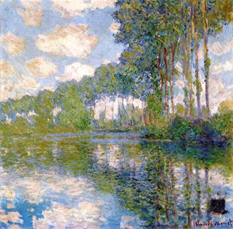 #2 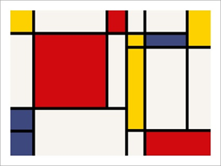
#3 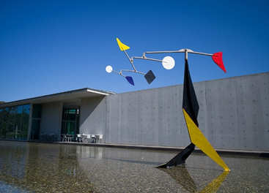
#4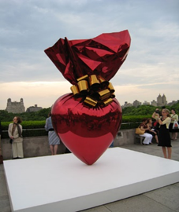 #5

