Worksheet #1
Write a tip about meditation that you can guess from these pictures

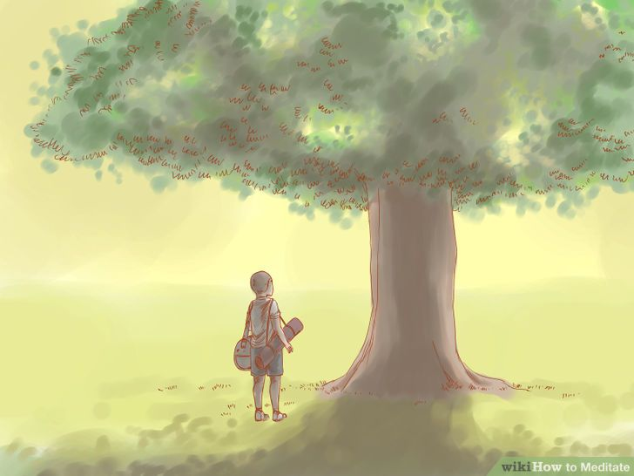

__________________________________________________________________________________________________________________________________________________________________________________________________
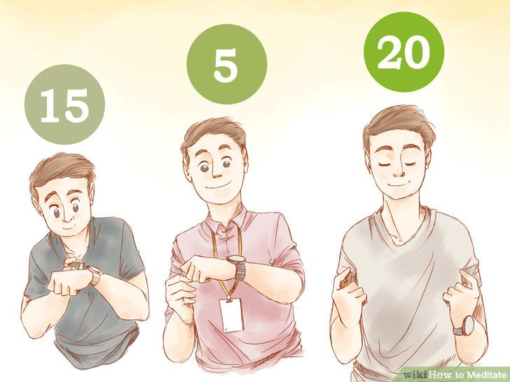
__________________________________________________________________________________________________________________________________________________________________________________________________

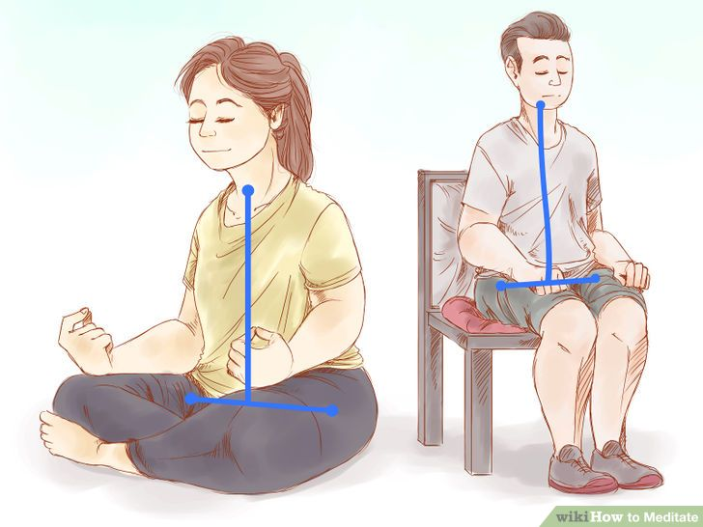
__________________________________________________________________________________________________________________________________________________________________________________________________

Worksheet #2

Draw a line to match words with definitions.

1 enable a) the line of bones down your back

2 interrupt b) relating to all or the whole

3 private c) go aimlessly; unfocused

4 cross-legged d) to make able, possible or easy

5 spine e) personal and not publicly expressed

6 universal f) having one leg placed across the other

7 wander g) cause or break in the middle of something

Answer sheet (for worksheet #2)

1 enable: d) to make able, possible or easy.
2 interrupt: g) cause or break in the middle of something.
3 private: e) personal and not publicly expressed.
4 cross-legged: f) having one leg placed across the other.
5 spine: a) the line of bones down your back.
6 universal: b) relating to all or the whole.
7 wander: c) go aimlessly; unfocused.

Worksheet #3

How to Meditate

The goal of meditation is to focus and quiet your mind, eventually reaching a higher level of awareness and inner calm. This article will introduce you to the basics of meditation, enabling you to begin your journey on the path of mental peace.

1. Choose a peaceful environment.
Try to find a plan when you will not be interrupted for the duration of your meditation. The space does not need to be very large. Your room or even your office can be used for meditation, as long as it ‘s somewhere private.

2. Decide how long you want to meditate.
Before you begin, you should decide how long you are going to meditate, while many seasoned meditators recommend twenty minutes sessions twice a day, beginners can start out doing as little as five minutes a day.

3. Sit in a comfortable position.
It is very important that you are comfortable while you meditate.
Traditionally, meditation is practiced by sitting crossed-legged on a cushion on the ground. The most important thing is that you are comfortable, relaxed and your spine supports all of your weight from the waist up.

4. Close your eyes.
Meditation can be performed with the eyes open or closed however as a beginner it may be best to first try meditating with your eyes closed.

5. Follow your breathing.
The most basic and universal of all meditation technique, breathing meditation is a great place to start your practice. Try to focus on your breathing and only your breathing. Don’t worry if your mind starts to wander, just refocus your mind on your breathing and try to think of nothing else.

From: Wikihow. How to Meditate. http://www.wikihow.com/Meditate

Worksheet #4

Let’s talk about meditation and you with a partner or two.

1. Do you feel you need mental peace in your everyday life?

2. Do you have peaceful environment you can meditate in?

3.How long do you think you can meditate?

4. what is the most comfortable meditating position for you?

5.Does yourmind wander much in your life?

Worksheet #5

Rank the items in order. What makes you most relieved? (1) Least? (10)
_____ Sleep  _____ Meeting friend  _____ Go hiking  _____ meditation  _____ Reading book | _____ Dancing  _____ Singing  _____ Yelling  _____ Watching television  _____ Exercise

