Listening Speaking Reading Grammar Writing
Topic: How Fashionable Are You?

Instructor:  Euna | Students Competency Level Intermediate | Number of Students: 14 | Lesson Length:  60 minutes
Materials: (List the Names of all materials used in the lesson. Materials must be shown at the end of this document)

- White Board and Markers
- “How Should You Dress and Why?” Worksheet
- “It’s the Best Thing to Wear!” Worksheet
- “What We Learned Today?” Worksheet
- Screen Projector
- The Conventional Dresser Images
- The Sloppy Dresser Images
- The Casual Chic Dresser Images
- The Designer Dresser Images
- The Goth Dresser Images
- The Athletic Dresser Images
- Suit Images
- Jeans and T-shirt Images
- Pajamas Images
- Sportswear Images
- Restaurant Images
- School Images
- Hotel Images
- Swimming pool Images
- Mountain Images
- Church Images
- Expressions to Agree/Disagree Slide
Aims: (What students will be able to achieve by participating in the activities of the lesson. (Ss gain or get by doing…)

- The students will be able to improve their listening skills by interacting with other students through a group discussion.
- The students will build up their own idea to support their role that they choose in the role play
- The students will learn and become comfortable to express their own opinion in the role play through learning expressions and the new vocabularies
Language Skills: (Lists what language systems students will be using by participating in the activities of the lesson.)

- Reading: The students will read questions, and role-play descriptions of “How Should You Dress and Why?”, “It’s the best thing to wear!” Worksheet
- Listening: The students listen to other students’ opinion through the group discussion
- Speaking: The students will discuss their ideas to support their role that they choose
- Writing: The students write their opinion on the worksheet “How Should You Dress and Why?” Worksheet, and “It’s the Best Thing to Wear!” Worksheet
Language Systems: (Lists what language systems students will be using by participating in the activities of the lesson.)

- Lexis: New vocabularies of the dress styles(sloppy, goth, grunge)
- Function: Convincing others (why the thing to wear is the best)
- Discourse: A pair/ group discussions
Assumptions: (What students must already be able to do and what concepts must already be mastered before the lesson in order to achieve the aims of the lesson.)

- The students are actively participating in the class
- How the class is set up and run (Ss will sit with their partners for pair work)
- The teacher’s teaching style and the pace of the course
- Four language skills(Listening/Reading/Grammar/Speaking)
Anticipated Errors and Solutions: (What things might go wrong in the lesson and what the solution will be. An SOS activity should also be included)

- The students may need more time to complete the post-activity role-play discussion
Skip the last step of sharing “what we learn today”
(if necessary, assign for homework)
- The students may finish their tasks earlier than anticipated
Share their answers or ideas with a different partner
- The students may not know the answers to questions
Ask different students for the answer, encourage students to be creative and expressive
- If the students do not want to participate in class
Ask a few questions regarding the topic so that they can pay attention to the class better
- Students who don’t understand in lesson or wrong answer
Encourage them that they can do it
References:

Breaking News English: http://www.breakingnewsenglish.com/1511/151104-pets.html
http://www.styleflair.com/what-is-the-relationship-between-clothes-and-personality/
http://happygirlsaretheprettiest.me/best-workout-clothes/)
https://www.aliexpress.com/grunge-outfit_reviews.html)
https://madamekeke.blogspot.kr/2013/04/you-are-what-you-wear-farfetch-guest-post.html
https://www.jcrew.com/kr/mens_feature/TheSuitShop.jsp)

Lead-In or Pre-Task Part (Warm-Up Part to activate and create interest in the lesson.)
Materials: (List the Names of all materials used in the Lead-In or Pre-Task Part of the lesson. Materials must be shown at the end of this document)

Screen Projector
The Conventional Dresser Images
The Sloppy Dresser Images
The Casual Chic Dresser Images
The Designer Dresser Images
The Goth Dresser Images
The Athletic Dresser Images

Time: | Classroom Set Up: | Student Activity and Goals: | Teacher Procedure & Instructions:
2min  3min  2min  3min | Whole class | Listen to/answer teacher’s questions  Look at the image and choose their fashion style  Listen to/answer teacher’s questions  Listen to teacher | Step1: Lead in student’s attention by asking about relationship between clothes and personality. “Have you ever wondered how clothes and personality are linked? What’s the connection between the two?  Step2: Show students 6 types of dressers and let them choose their fashion styles  Step3: Identify who choose each type of the dresser  Who chose The Conventional Dresser?  The Sloppy Dresser?  The Casual Chic Dresser?  The Designer Dresser?  The Goth Dresser?  The Athletic Dresser?  Step4: Tell them typical personality that each dresser represents

Pre-Activity or Task Familiarization Part (Presentation Part Presenting the language structure to be covered in the lesson. Prepares students for the communication activity.)
Materials: (List the Names of all materials used in the Pre-Activity or Task Familiarization Part of the lesson. Materials must be shown at the end of this document)

“How Should You Dress and Why?” Worksheet
Screen Projector
Suit Images
Jeans and T-shirt Images
Pajamas Images
Sportswear Images
Restaurant Images
School Images
Hotel Images
Swimming pool Images
Mountain Images
Church Images
Time: | Classroom Set Up: | Student Activity and Goals: | Teacher Procedure & Instructions:
3min  2min  5min  5min | Whole class  Whole  Class  Pair  Whole  Class | Guess a word of the image  Guess the clothes to be appropriate for each occasion  Write answers on the worksheet (1) and share what they wrote with their partner | Step1: Show images of the clothes  For example: show the image of a swimsuit and ask  “What is this?”  “Where do we wear this?”  Step2: Show the image of places  For example: show the image of the restaurant  “Would you wear swimsuit to go to the restaurant?”  “Which clothes is the most appropriate for this place?”  Step3: “How Should You Dress and Why?” Worksheet Activity  “How should these people dress and why?”  “Complete this table with your partner(s)and share what you wrote”  After the activity, share students’ opinion

Main Activity or Task Realization Part (Practice to Production Part Teacher lead practice of the language presented and move to communication based more student centered activity)
Materials: (List the Names of all materials used in the Main Activity or Task Realization Part of the lesson. Materials must be shown at the end of this document)

“It’s the Best Thing to Wear!” Worksheet
Screen Projector
Suit Images
Jeans and T-shirt Images
Pajamas Images
Sportswear Images
Expressions to Agree/Disagree Slide
Time: | Classroom Set Up: | Student Activity and Goals: | Teacher Procedure & Instructions:
2min  3min  5min  10min  10min | Whole class  Individual  Whole class  Whole  Class  Whole  class | Introduce a role play and running activity  Listen and see teacher’s demonstration  Discuss with group members and write answers on worksheet (2)  Present their opinion and raise an objection if they disagree with other group’s opinion | Step1: Explain about the role play in details.  Step2: Students are going to choose the dress style that they are interested in among (1)Role A :Suit (2) Role B: Jeans and T-shirt (3)Role C :Pajamas (4)Role-D: Sportswear  Step3: Teacher’s Demonstration  Step4: A group discussion (10 minutes) As a group, the students should support that the dress style that they chose is the best thing to wear by  (1) Giving three specific reasons why it is the best thing to wear,  (2) Telling the others things that are wrong with their clothes.  (3) Telling the others which is the worst of these to wear (and why): jeans and T-shirts, a suit or sportswear.  Step 5: Present their opinion  “For the group for the suit, why do you think that the suit is the best thing to wear?”  While the students are presenting their opinions, other groups also can defense their dress style by raising an objection  Let the students know rules about raising the objection ; Do not cut off when your class mate is speaking” “You can raise the objection after your classmate done his/her speaking”

Post Activity or Post Task Part (Wrap-Up Part Close the Lesson on a high note to and consolidate language learned in a communication based activity new situation.)
Materials: (List the Names of all materials used in the Post Activity or Post Task Part of the lesson. Materials must be shown at the end of this document)

Worksheet#3 “What we learned today?”

Time: | Classroom Set Up: | Student Activity and Goals: | Teacher Procedure Instructions:
2min  3min | Individual | By sharing what they learn in the class, reinforce their language skill after the activity. | ①After the role play, give students a work-sheet and let them write down what they learn in the class,  - could be vocabularies/expression/etc.  ② By sharing what they learn in the class today, reinforce their language skills

“How Should You Dress and Why?” Worksheet
WARM-UPS
How should these people dress and why? Complete this table with your partner(s). Change partners often and share what you wrote.
 | What? | Why?
10-year-olds at school
Teenagers
University students
Convenience store staff
Wedding guests
Grandparents

“It’s the Best Thing to Wear!” Worksheet

ROLE PLAY
Role A – Suit
You think a suit is the best thing to wear. Tell the others three reasons why. Tell them things that are wrong with their clothes. Also, tell the others which is the worst of these to wear (and why): jeans and T-shirts, pyjamas or sportswear.
Role B – Jeans and T-shirt
You think jeans and T-shirts is the best thing to wear. Tell the others three reasons why. Tell them things that are wrong with their clothes. Also, tell the others which is the worst of these to wear (and why): a suit, pyjamas or sportswear.
Role C – Pajamas (USA)
You think pyjamas are the best thing to wear. Tell the others three reasons why. Tell them things that are wrong with their clothes. Also, tell the others which is the worst of these to wear (and why): jeans and T-shirts, a suit or sportswear.
Role D – Sportswear
You think sportswear is the best thing to wear. Tell the others three reasons why. Tell them things that are wrong with their clothes. Also, tell the others which is the worst of these to wear (and why): pyjamas, jeans and T-shirt or a suit.

“What We Learned Today?” Worksheet

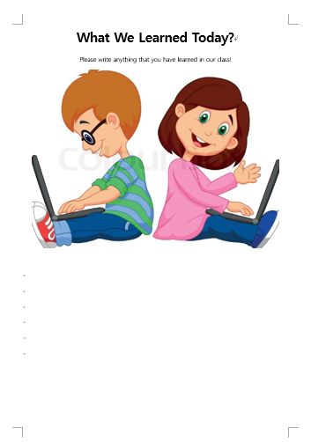
The Conventional Dresser Images

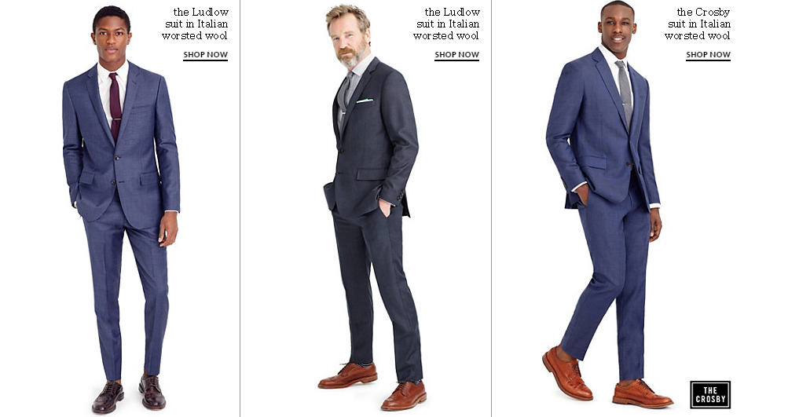

The Sloppy Dresser Images

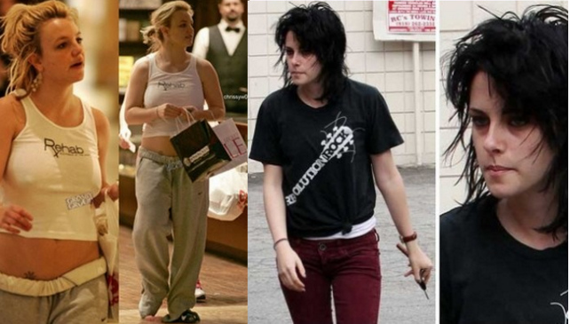

The Casual Chic Dresser Images

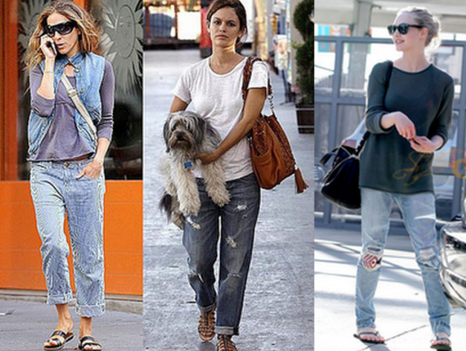

The Designer Dresser Images

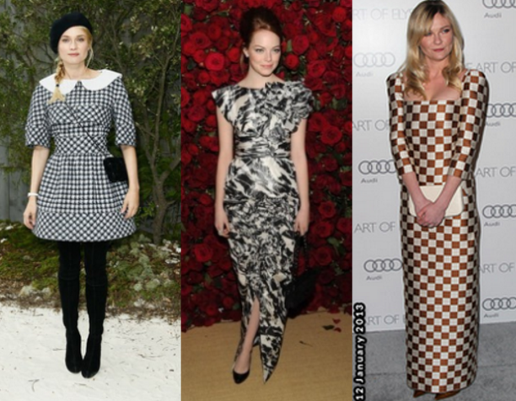

The Goth Dresser Images
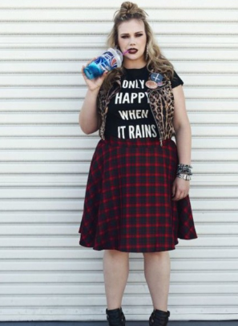

The Athletic Dresser Images

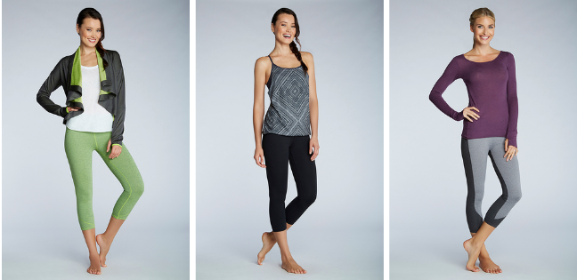
Suit Images
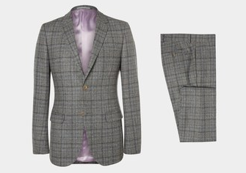

Jeans and T-shirt Images
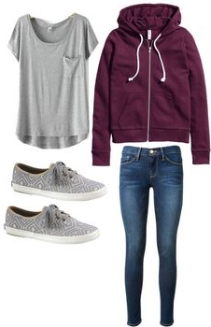

Pajamas Images
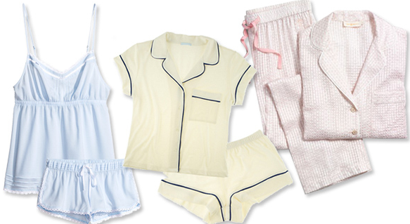

Sportswear Images
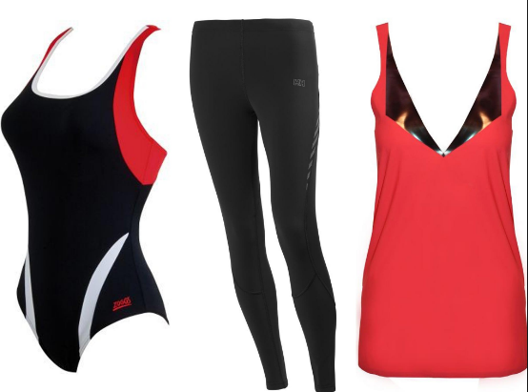

Restaurant Image

School Image

Hotel Image

Swimming pool Image

Mountain Image

Church Image

