Listening Speaking Reading Grammar Writing
Topic: Achievement
Subtitle: what will I achieve after 10 years from now?

Instructor:  Eve | Students Competency Level  Pre-intermediate | Number of Students:  8 | Lesson Length:  60 mins
Materials :( List the Names of all materials used in the lesson. Materials must be shown at the end of this document)
'Find Someone Who' Worksheet
Teacher’s Storytelling Sheets
-Family
-Kindergarten
-Money
-Travel
Storytelling Forms
-Plan Sheet
-First Keyword/Picture
-Second Keyword/Picture
-Third Keyword/Picture
-Fourth Keyword/Picture
White Board and Markers

Aims: (What students will be able to achieve by participating in the activities of the lesson. (Ss gain or get by doing…)
- Improve speaking skills by storytelling, doing lead-in activity and answering teacher
- Improve self-planning skills by preparing for Ss’ storytelling.
- Activate, increase interest, and participate with fun in an English communication activity by sharing stories of teacher and students
- Improve listening skills by storytelling, doing lead-in activity and responding to teacher.
- Improve interaction and communication skills by doing lead-in activity with other students and discussion as a whole class.

Language Skills: (Lists what activities language skills students will be using by participating in the activities of the lesson.)
- Reading: (Where did reading occur in the lesson?)
Situation cards, Worksheets
- Listening: (Where did listening occur in the lesson?)
Teacher talk, listening to other Ss’ storytelling, discussion
- Speaking: (Where did speaking occur in the lesson?)
Storytelling, class discussion, answering teacher
- Writing: (Where did writing occur in the lesson?)
Notes, planning for storytelling
Language Systems: (Lists what language systems students will be using by participating in the activities of the lesson.)
- Phonology: (sound)
Storytelling, discussion, lead-in activity, teacher talk
- Function: (situation)
Introduction, respect, dream
- Lexis: (meaning)
Vocabulary about future dreams and goals
- Grammar:(language structure)
Future tense, present tense and description
- Discourse: (communication)
Discussion, responding the teacher, lead-in activity

Assumptions: (What students must already be able to do and what concepts must already be mastered before the lesson in order to achieve the aims of the lesson.)
- All Ss understand the basis of storytelling and will enjoy telling Ss’ future.
- All Ss probably have thought about their future.
- All Ss have opinions about their goals
- All Ss have opinions about how to achieve the goals
Anticipated Errors and Solutions: (What things might go wrong in the lesson and what the solution will be. An SOS activity should also be included)
- If Ss may not have many ideas.☞Solution: T gives them little examples
- If activity lasts too long ☞Solution: T cuts the unnecessary parts or shorten the task (Main activity can reduced to three keywords rather than four)
- If activity finished too soon ☞Solution: T makes suggestions and shares ideas.
- If Ss may not understand ☞Solution: T shows demonstration
- If certain Ss are shy: ☞Solution: T encourages them, gives positive feedback, and helps presentation of them.
- If certain Ss makes negative feedbacks towards other Ss☞Solution: T warns them, stops them and finally punished them.
References:

Lead-In or Pre-Task Part (Warm-Up Part to activate and create interest in the lesson.)
Materials: (List the Names of all materials used in the Lead-In or Pre-Task Part of the lesson. Materials must be shown at the end of this document)
'Find Someone Who' Worksheet

Time: | Classroom Set Up: | Student Activity and Goals: | Teacher Procedure & Instructions:
1 min | Whole | Ss greet the teacher | Greeting
3 min | T | Ss listen what T says. | Introduce the activity: “Find Someone Who…”.
4 min | Ss | Ss do activity worksheet. | Ask Ss to walk around, talk to other Ss, and write down right person’s name next to the question.  Ss can only use other Ss ’name once.  Please only give 3 mins.
2 min | T | Ss listen what T says. Ss share the answers | Ask who write down the most answers.  Check if the answers are right and used at most twice.  Announce the winner.  Winner may rewarded.

Pre-Activity or Task Familiarization Part (Presentation PartPresenting the language structure to be covered in the lesson. Prepares students for the communication activity.)
Materials: (List the Names of all materials used in the Pre-Activity or Task Familiarization Part of the lesson. Materials must be shown at the end of this document)
Teacher’s Storytelling Sheets
-Family
-Kindergarten
-Money
-Travel

Time: | Classroom Set Up: | Student Activity and Goals: | Teacher Procedure & Instructions:
6 min | Whole | Ss listen what T says | Tell T’s stories about introductions of “Teacher’s achievement after 10 years”
3 min | Ss | Ss talk their stories | T simply asks “what are you going to be after 10 years today?”  Elicit the stories from Ss.  Let’s do a story telling about “After Ten years from now on…

Main Activity or Task Realization Part(Practice to Production Part Teacher lead practice of the language presented and move to communication based more student centered activity)
Materials: (List the Names of all materials used in the Main Activity or Task Realization Part of the lesson. Materials must be shown at the end of this document)
Storytelling Forms
-Plan Sheet
-First Keyword/Picture
-Second Keyword/Picture
-Third Keyword/Picture
-Fourth Keyword/Picture

Time: | Classroom Set Up: | Student Activity and Goals: | Teacher Procedure & Instructions:
3 min | T | Ss listen what T says | T gives instructions of storytelling.  Hand out storytelling form to each Ss.
10min | Ss | Ss prepare for storytelling | Ask Ss to prepare for storytelling. T facilitates. Make notes to help plan storytelling.  Transition now time to present storytelling.
1 min | whole | Ss get ready for storytelling with using the form. | T gives instruction for each Ss to come to front and present and enjoy storytelling and starts activity.  Ss can’t use notes.
8x | Ss | Everything below happens 8 (student no.) times | Everything below happens 8 (student no.) times
2 min | Ss | Ss do activity. One Ss at a time other Ss watches listens and enjoys | T monitors storytelling. Gives encouragement to each Ss and facilitates class feedback to the storyteller.
1 min | Whole | Ss listen what T says. Ss applaud other students | Give Ss positive Feedback, and comments. Facilitates class members’ feedback.

Post Activity or Post Task Part (Wrap-Up PartClose the Lesson on a high note to and consolidate language learned in a communication based activity new situation.)
Materials: (List the Names of all materials used in the Post Activity or Post Task Part of the lesson. Materials must be shown at the end of this document)
-White Board and Markers
Time: | Classroom Set Up: | Student Activity and Goals: | Teacher Procedure Instructions:
3min | Whole | Ss talk their opinions (discussion) | T asks question “what is important keys to achieve your goal?”  T discusses with Ss and write down onto the whiteboard.
 |  | Ss listen | Tell student it is important to try out your dream and hope Ss and achieve their goals after 10 years.  Close by giving Ss feedback about their accomplishment and improvement.

“Find Someone Who…” Worksheet
Ask your classmates what she/he will be after ten years. Please write down the person’s name inside the relevance sentences/phrases box. Remember you can only write down person’s name once!!

After Ten years, she/he will (be)…

In his/her 40s | In his/her 30s
Have a job | Have no job
Have daughter(s) or son(s) | Have no child
Married | Not married
Famous | Rich
Have a building(s) in Gangnam | Grant a university scholarship
Have a boyfriend/girlfriend | Go to university
Win an award/medal | Go shopping
Travel around | Have a grandchildren
Divorced | Office worker
Housewife | High salary

Storytelling Forms

Plan Sheet
Think what you are going to become in the future. Brainstorm in your plan sheet.
This is a few question you can think of:
- What is your dream?
- What is your goal?
- Will you get married? If yes, any children?

Now based on your brainstorm, pick the four main keywords. Briefly plan underneath. You may draw or write down your keywords. Also you may write down a short sentence what you are going to talk about.

After 10 years, I will (be)______  (1) | After 10 years, I will (be)______  (2)
After 10 years, I will (be)______  (3) | After 10 years, I will (be)______  (4)

You can start your final draft! Do not write down any sentences in your final draft and you cannot use any notes when you present to the class!!

Teacher’s Storytelling sheet
-Family

After Ten years, I will….
FAMILY

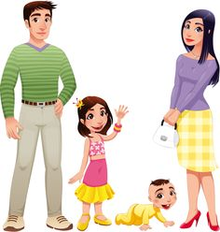

Teacher’s Storytelling sheet
-Money

After Ten years, I will….

MONEY

Teacher’s Storytelling sheet
-kindergarten

After Ten years, I will….
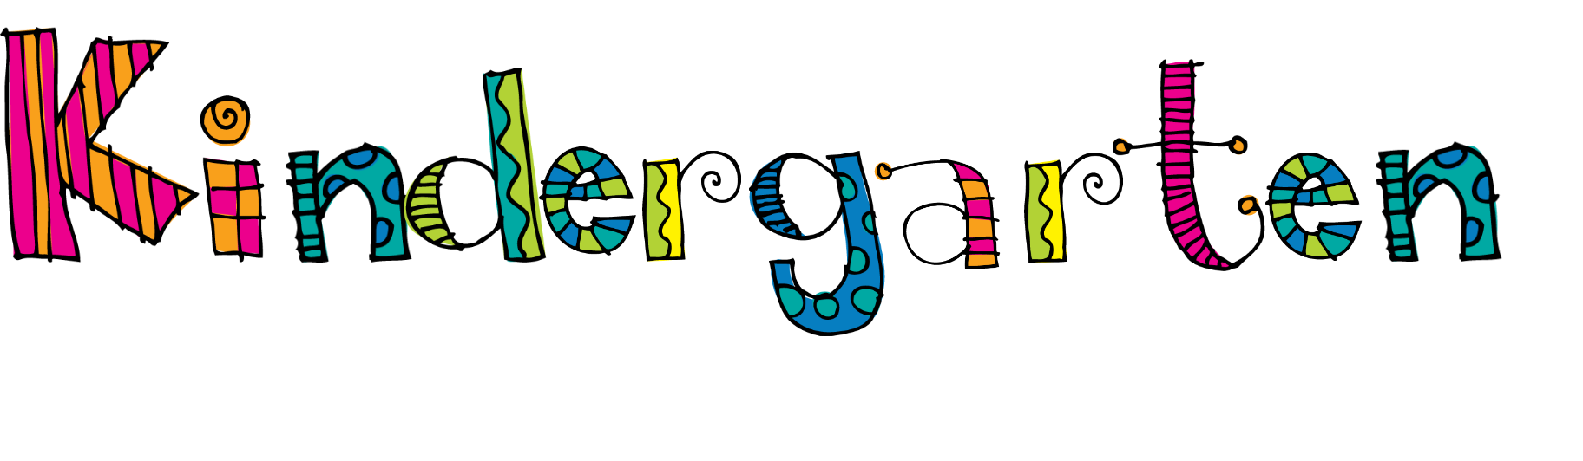

Teacher’s Storytelling sheet
-Travel

After Ten years, I will….

Storytelling Forms
-First Keyword/Picture

After Ten years, I will

Storytelling Forms
-Second Keyword/Picture

After Ten years, I will….

Storytelling Forms
-Third Keyword/Picture

After Ten years, I will….

Storytelling Forms
-Fourth Keyword/Picture

After Ten years, I will….

