- Vocabularies exercise
Read the five vocabularies and definitions in word bank. Write the word and mark on the correct area on the face below. You may draw if needed to describe the word.
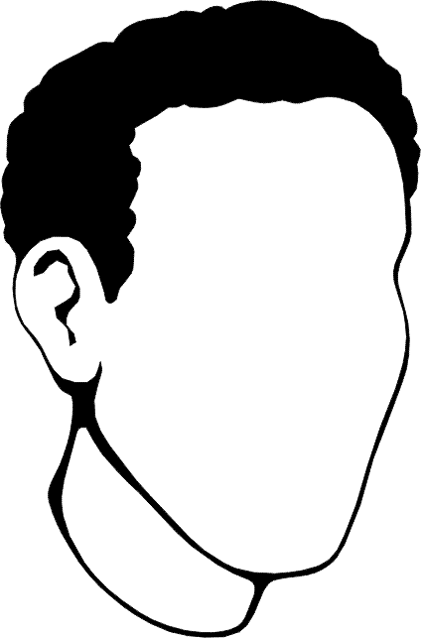
*Example- Neck:
the part of the body of an animal or human being that connects the head and the trunk.

1. Chin n.the lower extremity of the face, below the mouth.
2. Jaw n.the part of the face covering these bones, the mouth, or the mouth parts collectively:
3.Freckles n.one of the small, brownish spots on the skin that are caused by deposition of pigment and that increase in number and darken on exposure to sunlight.
4.Forehead n.the part of the face above the eyebrows; brow.
5.Cheek n.either side of the face below the eye and above the jaw.

Draw a line to correct definition with the words below.
- H
- H
- H
- H

- Describe
- Protrudes
- Impact
- Prominent

to have an effect on; influence;

to thrust forward;cause to project.

standing out so as to be seen easily; conspicuous; particularly noticeable:

to tell or depict in written or spoken words; give an account of:

- Blank Script [Dove Real Beauty Sketches]
[Gil Zamora – FBI Trained Forensic Artist] I’m a forensic artist, worked for the San Jose Police Department from 1995 to 2011.
[Florence] I showed up to a place I’ve never been and there was a guy with a drafting board.
[Melinda]We couldn’t see them, they couldn’t see us.
[Gil Zamora] Tell me about your hair.
[Florence]I didn’t know what he was doing, but then I could tell after several questions that he was drawing me.
[Gil Zamora] Tell me about your 1)______.
[Olivia] It kind that 2)__________ a little bit. Especially when I smile.
[Gil Zamora] Your jaw? [Florence] My mom told me I had a big 3)____.
[Gil Zamora] What would be your most 4)__________ feature.
[Olivia] Kinda have fat, rounded face.
[Shelly] The older I’ve gotten the more 5)___________ I’ve gotten.
[Kela] I would say I have a pretty big 6)________.
[Gil Zamora] Once I get a sketch, I say “thank you very much” and then they leave. I don’t see them.
[Florence] All I have been told before the sketch was to get friendly with this other woman: Chloe.
[Gil Zamora] Today I’m gonna ask you some questions about the person you met earlier and I’m gonna ask you some general questions about their face.
[Chloe] She was thin, so you can see her 7)______ bones. And her chin was a nice, thin chin.
[Man] She had nice eyes. They lit up when she spoke. [Chloe] Cute nose.
[Man] She had blue eyes. Very nice blue eyes.
[Gil Zamora] So here we are. [Florence] Ok…
[Gil Zamora] This is the sketch you helped me create. And that’s a sketch that somebody 8)_________ you.
[Florence] Yeah, that’s…
[Woman / Cloe] She looks closed off and fatter. Sadder too. [Gil Zamora] Uh huh
[Woman / Cloe] The second one looks more open. Friendly and happy.
[Florence] I should be more grateful of my natural beauty. It 9)______ the choices in friends that we make, the jobs we apply for, how we treat our children. It impacts everything. It couldn’t be more 10)_______ to your happiness.
[Gil Zamora] Do you think you’re more beautiful then you say? [Florence] Yeah… yeah…
[Woman / Cloe] We spend a lot of time as woman analyzing and trying to fix the things that aren’t quite right and should spend more time appreciating the things we do like.
YOU ARE MORE BEAUTIFUL THAN YOU THINK.

- Script [Dove Real Beauty Sketches] (Answering Sheet)
[Gil Zamora – FBI Trained Forensic Artist] I’m a forensic artist, worked for the San Jose Police Department from 1995 to 2011.
[Florence]I showed up to a place I’ve never been and there was a guy with a drafting board.
[Melinda]We couldn’t see them, they couldn’t see us.
[Gil Zamora] Tell me about your hair.
[Florence]I didn’t know what he was doing, but then I could tell after several questions that he was drawing me.
[Gil Zamora] Tell me about your chin.
[Olivia] It kind that protrudes a little bit. Especially when I smile.
[Gil Zamora] Your jaw?
[Florence] My mom told me I had a big jaw.
[Gil Zamora] What would be your most prominent feature.
[Olivia] Kinda have fat, rounded face.
[Shelly] The older I’ve gotten the most freckles I’ve gotten.
[Kela] I would say I have a pretty big forehead.
[Gil Zamora] Once I get a sketch, I say “thank you very much” and then they leave.I don’t see them.
[Florence] All I have been told before the sketch was to get friendly with this other woman: Chloe.
[Gil Zamora] Today I’m gonna ask you some questions about the person you met earlier and I’m gonna ask you some general questions about their face.
[Chloe] She was thin, so you can see her cheek bones. And her chin was a nice, thin chin.
[Man] She had nice eyes. They lit up when she spoke. [Chloe] Cute nose.
[Man] She had blue eyes. Very nice blue eyes.
[Gil Zamora] So here we are. [Florence] Ok…
[Gil Zamora] This is the sketch you helped me create. And that’s a sketch that somebody described of you.
[Florence] Yeah, that’s…
[Woman / Cloe] She looks closed off and fatter. Sadder too. [Gil Zamora] Uh huh
[Woman / Cloe] The second one looks more open. Friendly and happy.
[Florence] I should be more grateful of my natural beauty. It impacts the choices in friends that we make, the jobs we apply for, how we treat our children. It impacts everything. It couldn’t be more critical to your happiness.
[Gil Zamora] Do you think you’re more beautiful then you say? [Florence] Yeah… yeah…
[Woman / Cloe] We spend a lot of time as woman analyzing and trying to fix the things that aren’t quite right and should spend more time appreciating the things we do like.
YOU ARE MORE BEAUTIFUL THAN YOU THINK.

- Vocabularies exercise (Answering Sheet)
Read the five vocabularies and definitions in word bank. Write the word and mark on the correct area on the face below. You may draw if needed to describe the word.
*Example- Neck:
the part of the body of an animal or human being that connects the head and the trunk.

1. Chin n.the lower extremity of the face, below the mouth.
2. Jaw n.the part of the face covering these bones, the mouth, or the mouth parts collectively:
3.Freckles n.one of the small, brownish spots on the skin that are caused by deposition of pigment and that increase in number and darken on exposure to sunlight.
4.Forehead n.the part of the face above the eyebrows; brow.
5.Cheek n.either side of the face below the eye and above the jaw.

forehead

cheek

cheek

freckles

jaw

chin

Draw a line to correct definition with the words below.
- Describe
- Protrude
- Impact
- Prominent

- H
- H
- H
- H

to have an effect on; influence;

to thrust forward;cause to project.

standing out so as to be seen easily; conspicuous; particularly noticeable:

to tell or depict in written or spoken words; give an account of:

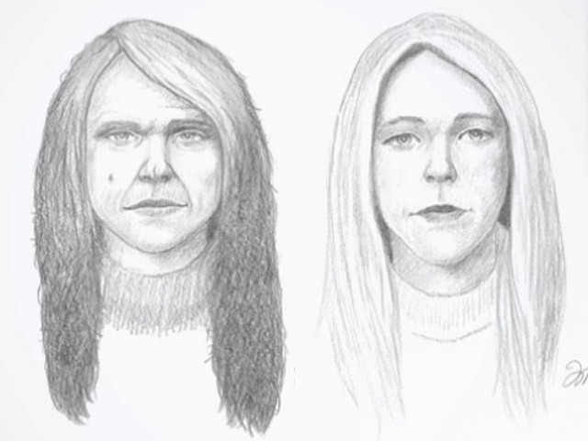Picture A

Picture 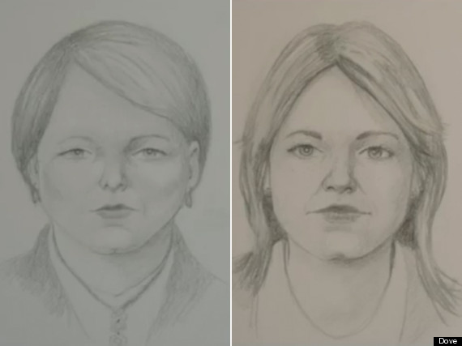B
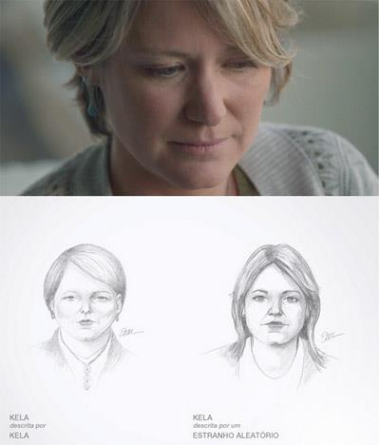Picture C
Picture 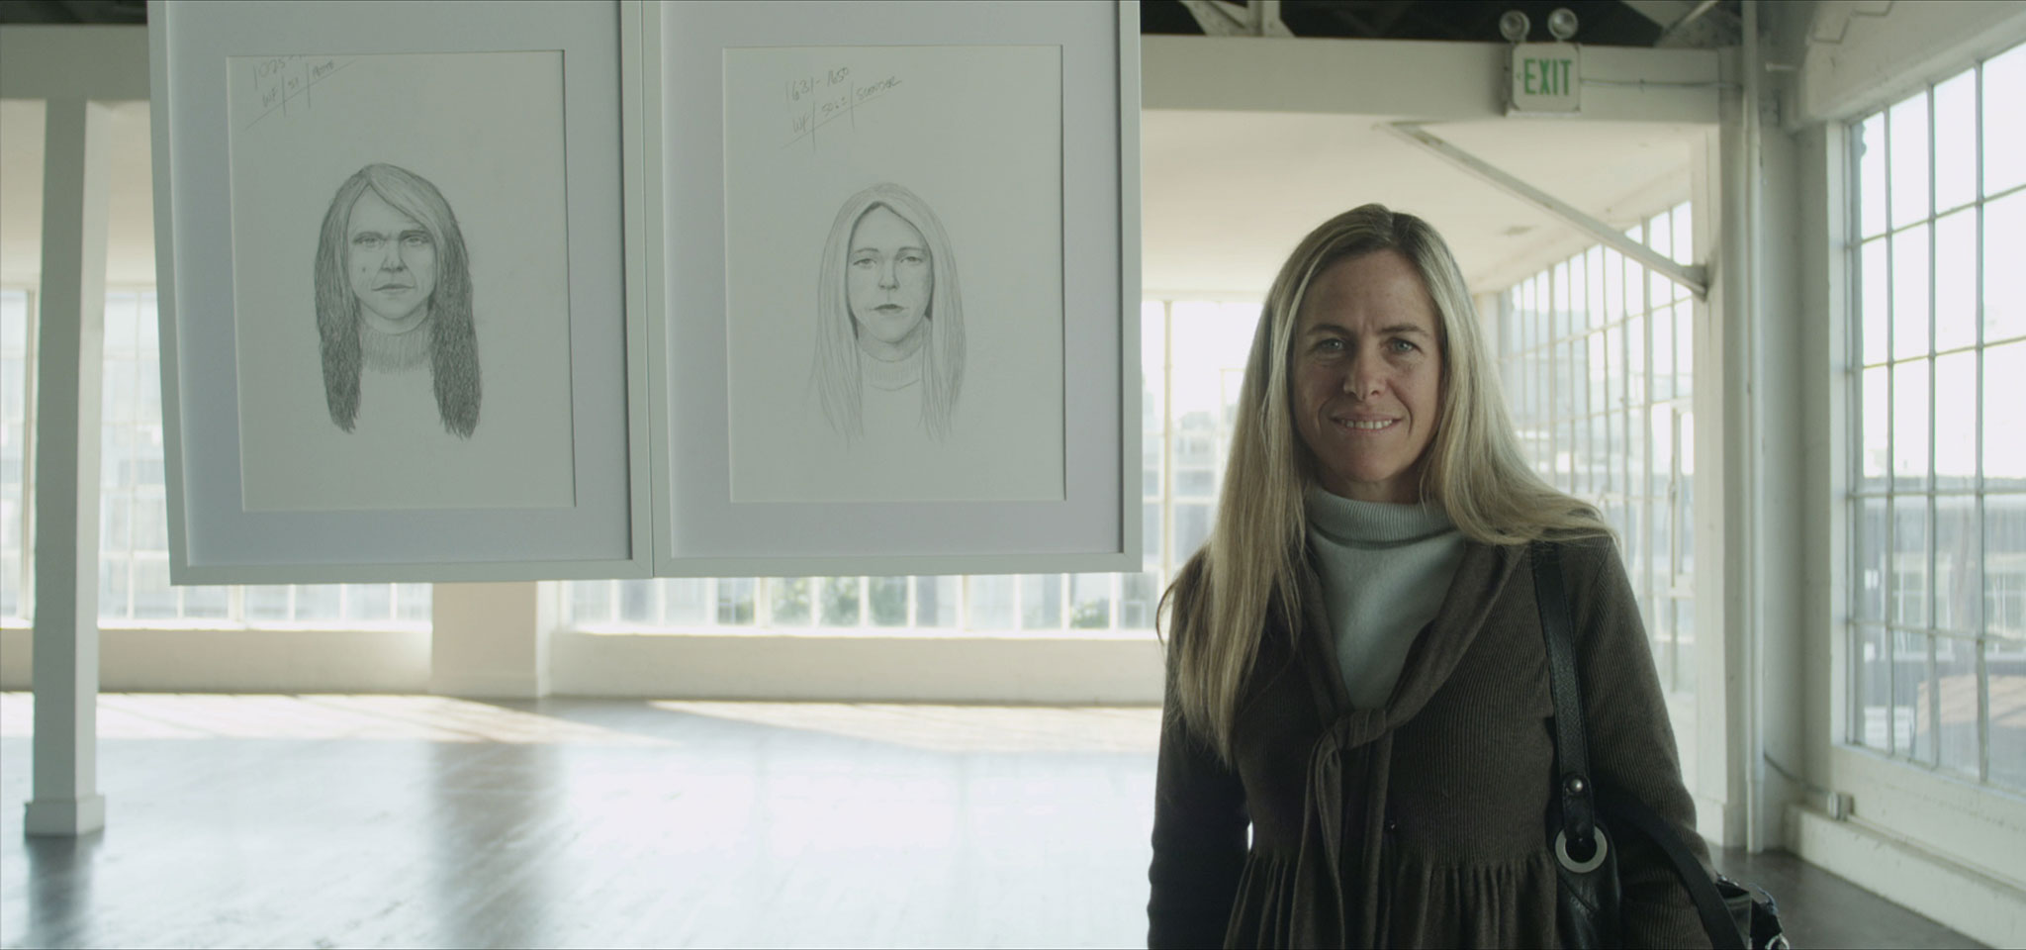D

