Listening Speaking Reading Grammar Writing
Topic: A Perfect Day
(Target: Reported Speech)
Instructor:  Gowoon  Sarah | Students Competency Level  Upper Intermediate | Number of Students:  12 | Lesson Length:  60min
Materials: (List the Names of all materials used in the lesson. Materials must be shown at the end of this document)
Board and Markers
If I Become ‘Situation’ Card
Drilling Wall Chart ‘Direct – Indirect Speech’
Aims: (What students will be able to achieve by participating in the activities of the lesson. (Ss gain or get by doing…)
- Improve Ss listening skill by listening to T’s introduction, questions and ICQ-CCQs and listening to other Ss statements during activity and group discussion.
- Improve Ss speaking skill by responding to T’s questions, participating in group discussion and presenting.
- Improve Ss reading skill by reading the board and the ‘Situation’ Card.
- Improve Ss writing skill by filling in the ‘Situation’ Card

Language Skills: (Lists what activities language skills students will be using by participating in the activities of the lesson.)
- Reading: (Where did reading occur in the lesson?)
Worksheet
- Listening: (Where did listening occur in the lesson?)
T instruction and explanation, discussion
- Speaking: (Where did speaking occur in the lesson?)
Ss respond to T’s questions, CCQs and questions, presentation and discussion
- Writing: (Where did writing occur in the lesson?)
Completing the worksheet

Language Systems: (Lists what language systems students will be using by participating in the activities of the lesson.)
- Phonology: (sound)
Discussion, S-S talk, S-T talk
- Function: (situation)
Reporting what other people said
- Lexis: (meaning)

- Grammar: (language structure)
Direct Speech, Indirect speech
Discourse: (communication)
Discussion in pairs and CCQ, ICQ

Assumptions: (What students must already be able to do and what concepts must already be mastered before the lesson in order to achieve the aims of the lesson.)
- All Ss would like to share their everyday life.
- All Ss understand everything written on the ‘Situation’ card.
- All Ss are willing to speak out in class.

Anticipated Errors and Solutions: (What things might go wrong in the lesson and what the solution will be. An SOS activity should also be included)
- If Ss may not understand the target grammar
Solution: Provide more drilling and example sentences.
- If some Ss are too shy to participate during the group discussion.
Solution: Encourage Ss to participate and give positive feedback
- If Ss make many grammatical mistakes
Solution: Correct errors by reformulating and Mouthing.
- If activity finishes too soon.
Solution: Give Ss more time for discussion

References:

Lead-In or Pre-Task Part (Warm-Up Part to activate and create interest in the lesson.)
Materials: (List the Names of all materials used in the Lead-In or Pre-Task Part of the lesson. Materials must be shown at the end of this document)
Board and Markers

Time: | Classroom Set Up: | Student Activity and Goals: | Teacher Procedure & Instructions:
4 min  3 min  1 min | Whole  S-T  S-T | Ss listen carefully  Ss answer to T’s questions  Ss listen | <Lead in>  One teacher talks about a fun day she had.  The other teacher reports it to class using ‘reported speech’, target grammar.  Ask Ss about their daily life.  T Rephrases it by using ‘reported speech’  Introduce the topic and targeted grammar.

Pre-Activity or Task Familiarization Part (Presentation Part Presenting the language structure to be covered in the lesson. Prepares students for the communication activity.)
Materials: (List the Names of all materials used in the Pre-Activity or Task Familiarization Part of the lesson. Materials must be shown at the end of this document)
Board and Markers
Drilling Wall Chart ‘Direct – Indirect Speech’
If I Become ‘Situation’ Card

Time: | Classroom Set Up: | Student Activity and Goals: | Teacher Procedure & Instructions:
6min  3 min  1 min | Whole  Whole  Ss | Ss read, listen, speak and drill to learn and become familiar with reported speech  Listen to Ts and observe what Ts are doing  Receive Situation Card.  Get in pairs | Put drilling wall charts on the board  Do drilling with Ss.  T introduces a pair activity and shows examples.  Give out ‘Situation’ Card. Put Ss in pairs

Main Activity or Task Realization Part (Practice to Production Part Teacher lead practice of the language presented and move to communication based more student centered activity)
Materials: (List the Names of all materials used in the Main Activity or Task Realization Part of the lesson. Materials must be shown at the end of this document)
Board and Markers
If I Become ‘Situation’ Card

Time: | Classroom Set Up: | Student Activity and Goals: | Teacher Procedure & Instructions:
4min  3min  3min  6min  1min | Whole  Pair  Group/  Individual  Group/  Individual  Whole | Write down on the ‘situation card’ individually. Ask Ts questions if needed.  Practice Direct- Indirect speech with their partners.  Happens twice  Group A to come to front.  Ss read what they have written on their cards. Ss listen carefully.  Happens twice  Remember and tell what other Ss said. Use reported speech.  Listen to teacher. Give back situation cards. | Instruct Ss to write down 3 sentences on the ‘situation card’. Answer Ss’ questions.  Instruct Ss to practice direct – indirect speech with their partners.  Happens twice  Divide into 2 groups. Call group A to the front. Ask Ss to read what they have written on their ‘situation card’.  Happens twice  T selects one S and asks him/her to tell what others wrote on their cards in the target language. Ask every S.  Appreciate participation. Collect situation cards.  Move on to the last activity.

Post Activity or Post Task Part (Wrap-Up Part Close the Lesson on a high note to and consolidate language learned in a communication based activity new situation.)
Materials: (List the Names of all materials used in the Post Activity or Post Task Part of the lesson. Materials must be shown at the end of this document)
Board and Markers
If I Become ‘Situation’ Card

Time: | Classroom Set Up: | Student Activity and Goals: | Teacher Procedure Instructions:
2min  5min  4min  1 min | Whole  Group  Whole  Whole/ groups | Each group picks 6 situation cards. Listen to T.  Each group makes a ‘Perfect Day’ story using every sentence on the cards.  Happens twice  Each group comes up and tells stories they made.  Ss listen to T closing the activity. Thank teacher and say goodbye. | Divide Ss into two groups. Ask each group to pick 6 situation cards. T explains how to come up with a story of ‘Perfect day’ using all the cards. Guide Ss to activity complete “perfect day” using 6 situation cards.  T monitors Ss and responds. Make sure Ss use target language.  Happens twice  T listens and corrects errors if needed. Elicit positive feedback from the other group.  Thank all the Ss for actively participating in the lesson. Give feedback and say good-bye.

z
Drilling Wall Chart

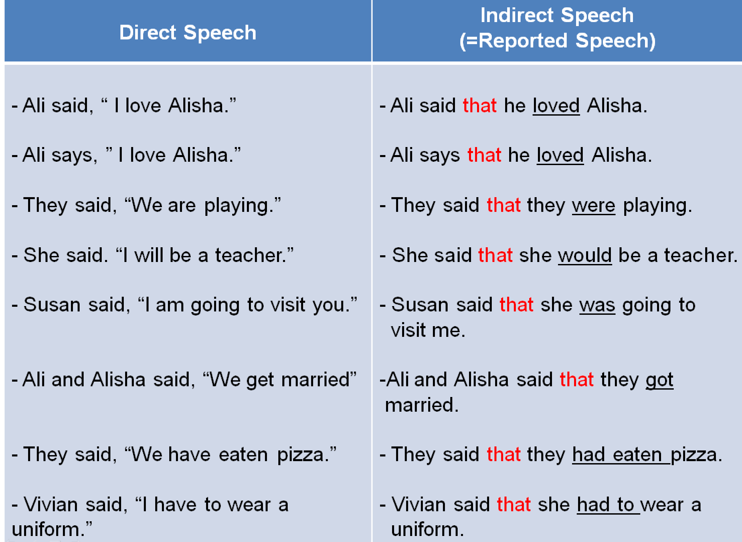

If I Become ….

If I become a superhero for a day…  _______________________  ________________________  ________________________  ________________________  ________________________ | If I become a Richie Rich for a day….  ___________________________  ____________________________  ____________________________  ____________________________  ____________________________ | If I become an infant for a day …  ________________________  ________________________  ________________________ | If I become a dog for a day …  _____________________________  _____________________________  _____________________________  _____________________________  _____________________________
If I become invisible for a day…  _____________________  _____________________  _____________________  ______________________ | If I can change one thing in the world…  _____________________________  _____________________________  _____________________________  _____________________________ | If I become CEO of Apple for a day….  _____________________________  _____________________________  _____________________________ | If I become the most beautiful woman/  handsome man in the world for a day…  _____________________________  _____________________________  _____________________________  _____________________________

If I can fly for a day…  _____________________________  _____________________________  _____________________________  _____________________________  _____________________________ | If I can live anywhere in the world for a day…  _____________________________  _____________________________  _____________________________  _____________________________  _____________________________ | If I can become a Harry Potter for a day…  _____________________________  _____________________________  _____________________________  _____________________________  _____________________________

