If I Become ….
If I become a superhero for a day…  _____________________________  _____________________________  _____________________________  _____________________________  _____________________________  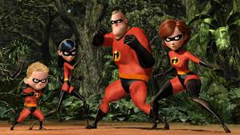 | If I become a Richie Rich for a day….  _____________________________  _____________________________  _____________________________  _____________________________  _____________________________  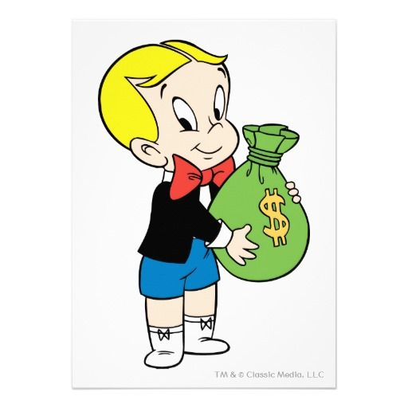 | If I become an infant for a day …  _____________________________  _____________________________  _____________________________  _____________________________  _____________________________  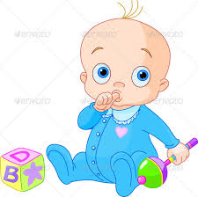 | If I become a dog for a day …  _____________________________  _____________________________  _____________________________  _____________________________  _____________________________  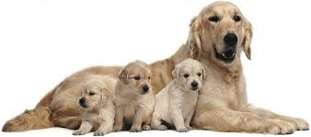

If I become invisible for a day…  _____________________________  _____________________________  _____________________________  _____________________________  _____________________________  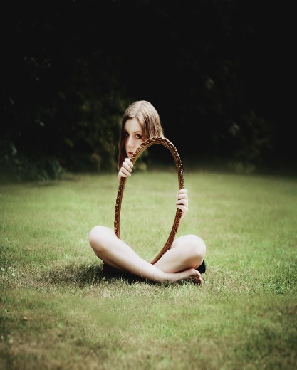 | If I can change one thing in the world…  _____________________________  _____________________________  _____________________________  _____________________________  _____________________________ | If I become CEO of Apple for a day….  _____________________________  _____________________________  _____________________________  _____________________________  _____________________________ | If I become the most beautiful woman/  handsome man in the world for a day…  _____________________________  _____________________________  _____________________________  _____________________________  _____________________________  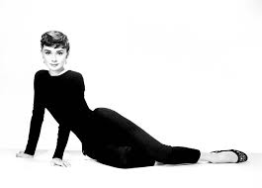

If I can fly for a day…  _____________________________  _____________________________  _____________________________  _____________________________  _____________________________  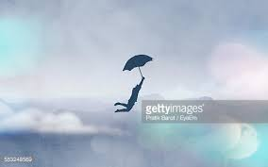 | If I can live anywhere in the world for a day…  _____________________________  _____________________________  _____________________________  _____________________________  _____________________________  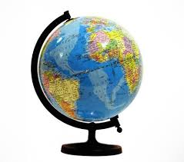 | If I can become a Harry Potter for a day…  _____________________________  _____________________________  _____________________________  _____________________________  _____________________________  