Listening Speaking Reading Grammar Writing
Topic: Raising Unique Pets

Instructor:  Gamin Kim | Students Competency Level: High-Intermediate | Number of Students:12 | Lesson Length:  60 minutes
Materials:(List the Names of all materials used in the lesson. Materials must be shown at the end of this document)
- Introducing 5 Unusual Pets Video
- Computer
- Projector
- Overhead Screen
- The 5 Unusual Pets Worksheet
- Flashcards:
  - Sugar Gliders
  - Capybara
  - Fennec Fox
  - Wallaby
  - Squirrel Monkeys
- A3 Paper, Color Pens and Pencils, Tapes
Aims:(What students will be able to achieve by participating in the activities of the lesson. (Ss gain or get by doing…)
- Improve listening skills by trying to catch the vocabularies from the video
- Improve speaking and listening skills by doing a discussion as a group as well as writing skills to plan for the main activity, “How Will You Raise Your Pet?”
- Be creative by doing the main activity
Language Skills:(Lists what activities language skills students will be using by participating in the activities of the lesson.)
- Reading: (Where did reading occur in the lesson?)
Worksheets, note taking, during the main activity
- Listening:(Where did listening occur in the lesson?)
Teacher’s speech, during the pre and main activity, discussion
- Speaking: (Where did speaking occur in the lesson?)
During the main activity, discussion, answering the teacher
- Writing: (Where did writing occur in the lesson?)
Note taking, Planning, during the main activity

Language Systems: (Lists what language systems students will be using by participating in the activities of the lesson.)
- Phonology: (sound)
Presenting group work, discussion, teacher talk
- Function:(situation)
Raising unique pets
- Lexis: (meaning)
Vocabularies about characteristics of animals
- Grammar:(language structure)
Adjectives and descriptions
- Discourse: (communication)
Discussion, responding the teacher, group work (main activity)
Assumptions:(What students must already be able to do and what concepts must already be mastered before the lesson in order to achieve the aims of the lesson.)
- All Ss’ English levels are high-intermediate
- All Ss have experience encountering animals or pets
- All Ss probably like animals and pets
Anticipated Errors and Solutions:(What things might go wrong in the lesson and what the solution will be. An SOS activity should also be included)
- Ss may not have many ideas → T gives them examples
- The activity lasts too long → T suggests the students to speed up or cuts the
unnecessary parts
- The activity ends too soon → T suggests Ss to do discussions and share ideas
- Ss may not have understood clearly → T shows demonstration
References:
https://www.youtube.com/watch?v=WLRXJeTMnrs

Lead-Inor Pre-Task Part (Warm-Up Part to activate and create interest in the lesson.)
Materials: (List the Names of all materials used in the Lead-Inor Pre-Task Partof the lesson. Materials must be shown at the end of this document)

Time: | Classroom Set Up: | Student Activity and Goals: | Teacher Procedure &Instructions:
1min  4min  3min  3min | Whole  Whole  Ss  Whole | Ss greet the T  Ss listen to the T  Ss tell their stories  Ss answer the T | Greeting, Do you like pets?  T tells the students an interesting story of a pet. The story can be funny / sad / touching etc  Elicit stories from the Ss  ex) Story of a pet they owned  We mostly talked about very common pets that we can encounter easily around us. This time, let’s think of the unusual pets.  →Elicit student’s answers about the unusual pets

Pre-Activity or Task Familiarization Part (Presentation PartPresenting the language structure to be covered in the lesson. Prepares students for the communication activity.)
Materials: (List the Names of all materials used in the Pre-Activity or Task Familiarization Part of the lesson. Materials must be shown at the end of this document)
- Introducing 5 Unusual Pets Video
- Computer
- Projector
- Overhead Screen
- The 5 Unusual Pets Worksheet
- Flashcards:
  - Sugar Gliders
  - Capybara
  - Fennec Fox
  - Wallaby
  - Squirrel Monkeys
Time: | Classroom Set Up: | Student Activity and Goals: | Teacher Procedure &Instructions:
1min  3~6min  5min  5min  1min | Whole  Whole  Ss  Whole  Whole | Ss listen to T’s instructions  Ss watch the video  Ss work on their worksheet (do pre-activity)  Ss and T interact to check the answers of the worksheet  Ss listen to the T | I have come up with the 5 most unusual and sweet at the same time, pets that you can ever think of ~  →Introduce the pre-activity, “The Five Unusual Pets”  Show students the video, “The Five Unusual Pets” (If necessary, ask Ss “Do you want to hear it again?” and repeat for 2 times max)  T monitors Ss if they are working on their worksheet properly. If a S is lost, give simple hints.  T suggests answers for the worksheet and Ss react, making discussions about the answer. When doing this, use flash cards.  T gives Ss positive feedback and comments

Main Activity or Task Realization Part(Practice to Production PartTeacher lead practice of the language presented and move to communication based more student centered activity)
Materials: (List the Names of all materials used in the Main Activity or Task Realization Partof the lesson. Materials must be shown at the end of this document)
- The 5 Unusual Pets Worksheet
- Flashcards:
  - Sugar Gliders
  - Capybara
  - Fennec Fox
  - Wallaby
  - Squirrel Monkeys
- A3 Paper, Color Pens and Pencils, Tapes, Drawing
- Students Drawings
  - Sugar Gliders
  - Capybara
  - Fennec Fox
  - Wallaby
  - Squirrel Monkeys

Time: | Classroom Set Up: | Student Activity and Goals: | Teacher Procedure &Instructions:
3min  15min | Whole  4 Groups | Ss listen to the T  Ss do the main activity | T introduces the main activity, “How will you raise your pet?” and show an example using wallabies.  Divide students into 4 groups and assign each group with one animal from the previous activity (sugar glider, capybara, fennec fox, squirrel monkey)  Give Ss materials (A3 paper, Color pens and pencils) and time to discuss and prepare for the group activity

Post Activity or Post Task Part (Wrap-Up Part Close the Lesson on a high note to and consolidate language learned in a communication based activity new situation.)
Materials: (List the Names of all materials used in the Post Activity or Post Task Part of the lesson. Materials must be shown at the end of this document)

Time: | Classroom Set Up: | Student Activity and Goals: | Teacher Procedure Instructions:
10min  2min | 4 Groups  Whole | Ss share their ideas  Ss listen to the T | Ss share their product from the activity  Close by giving Ss feedback and their accomplishment for participation
Flash Cards
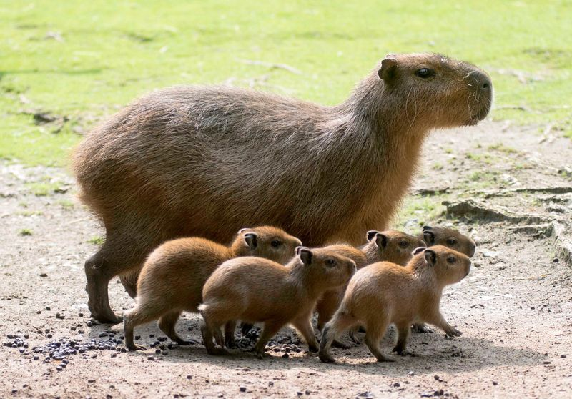
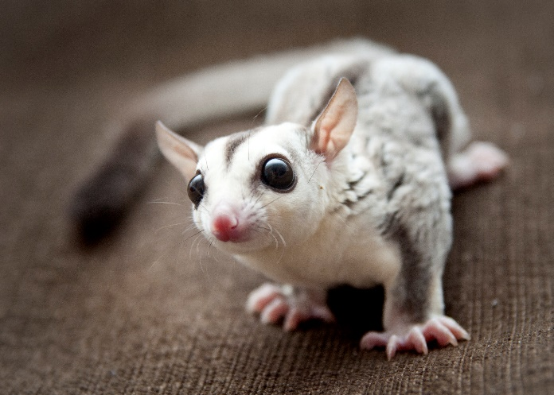
Sugar Gliders Capybara

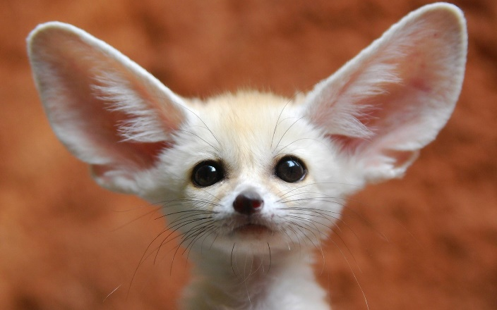
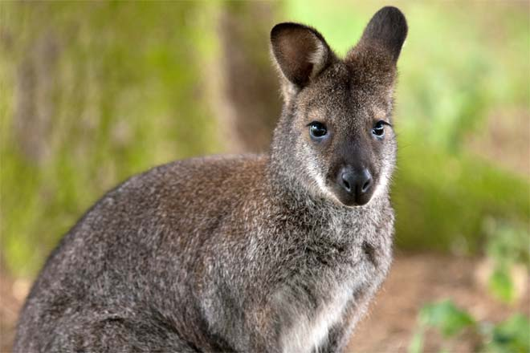
Fennec Fox Wallaby

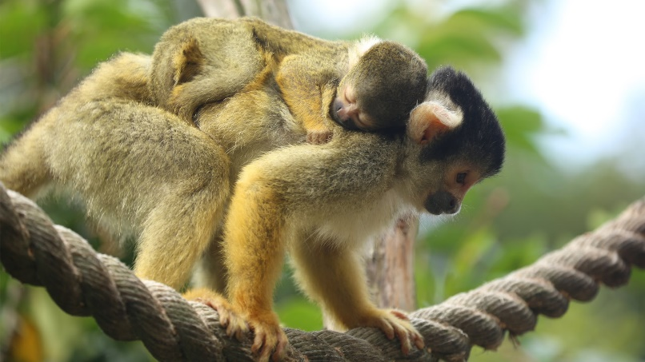
Squirrel Monkeys

