Background Information Sheet
x Listening Speaking Reading Grammar Writing
Topic: Precautions traveling to South Africa
Instructor:  Jiseon, Timo | Students Competency Level  Intermediate | Number of Students:  8 | Lesson Length:  40 min
Materials:(List the Names of all materials used in the lesson. Materials must be shown at the end of this document)
White Board & Markers
Pencils and Paper
Pictures
Computer

Aims:(What students will be able to achieve by participating in the activities of the lesson. (Ss gain or get by doing…)

Main Aim
-Ss will practice their listening comprehension by using top-down method.
- To provide students with listening practice for the gist(skimming) and details(scanning).
-Ss will practice vocabulary related travelling to South Africa.
-Improve listening skills by listening to other group and discussion, responding to teacher.

Subsidiary Aim
-Ss will practice their oral fluency during the productive stage.
-Ss may get some useful information for traveling to South Africa.

Language Skills:(Lists what activities language skills students will be using by participating in the activities of the lesson.)
- Reading: (Where did reading occur in the lesson?)
discussion, note taking
- Listening:(Where did listening occur in the lesson?)
Teacher talk, Listening the audio(video clip), during the discussion
- Speaking: (Where did speaking occur in the lesson?)
discussion, small group discussion, answering teacher
- Writing: (Where did writing occur in the lesson?)
dictation

Language Systems: (Lists what language systems students will be using by participating in the activities of the lesson.)
- Phonology: (sound)
discussion, teacher talk
- Function:(situation)
Students do not know which side they will have to prepare
- Lexis: (meaning)
Vocabulary about preparations and precautions for traveling to South Africa.
- Grammar:(language structure)
Be verbs and description, positive and negative sides
- Discourse: (communication)
Discussion in group, responding to the teacher

Assumptions:(What students must already be able to do and what concepts must already be mastered before the lesson in order to achieve the aims of the lesson.)
- All students have preferences to which countries want to visit to travel.
- All Ss probably have interests to get tips when visiting Africa Continent.
- All Ss have basic background knowledge about Africa.

Anticipated Errors and Solutions:(What things might go wrong in the lesson and what the solution will be. An SOS activity should also be included)
- If ss may not have many ideas. > Solution: T gives them little examples.
- If activity lasts too long > Solution: T cuts the unnecessary parts.
- If ss finished too soon > Solution: T makes suggestion and shares ideas.
- If Ss may not understand > Solution: T shows the demonstration
- If Ss are shy > Solution: T encourages them and gives positive feedback.
References:
http://blog.naver.com/PostView.nhn?blogId=bluebird5519&logNo=120108286164&parentCategoryNo=&categoryNo=6&viewDate=&isShowPopularPosts=false&from=postView

https://m.youtube.com/watch?v=I4HQTUMnNdY

Listening Lesson Plan
Lead-In or Pre-Task Part (Warm-Up Part to activate and create interest in the lesson.)
Materials: (List the Names of all materials used in the Lead-In or Pre-Task Part of the lesson. Materials must be shown at the end of this document)
- Africa Continent Map

Time: | Classroom Set Up: | Student Activity and Goals: | Teacher Procedure &Instructions:
1 min  1 min | T-Ss  T-Ss | T-Ss greet each other teacher.  See the picture and answer about what it is | Greeting.  Elicit the word of related to Africa from the picture.

Pre-Activity or Task Familiarization / Presentation Part (Presentation Part Presenting the language structure to be covered in the lesson. Prepares students for the communication activity.)
Materials: (List the Names of all materials used in the Pre-Activity or Task Familiarization Part of the lesson. Materials must be shown at the end of this document)
- White Board & Markers.
- Pencils and paper
- Pictures for words

Time: | Classroom Set Up: | Student Activity and Goals: | Teacher Procedure &Instructions:
2 min  3 min  8 min | Ss  T-Ss  T-Ss | Ss match between the country and each capital.  Ss know of the answers for the activity they’ve done.  Ss understand the three key words for the listening paragraph. | Let’s match the capitals for the right countries.  Divide two teams, team A and team B.  Come out in front of the board and match these. You have 1 min to work and then we check the answers.  Ok. Let’s see the answers together.  What is the answer for this country? (Keep going on like this for every single country to the last one.)  1. Safari  - Elicit : (Show picture) A journey to overland where many wild animals lives.(Especially in Africa) Visitors normally driving through.  - CCQ : Can we enjoy doing this South Africa? (A) Yes  - CCQ : Will you walk around in Safari? (A) No. (Y, if you want to die.)  - Drill : Special shops have a safari look.  - Board : Check spelling, syllables, stress.  2. Precaution  - Elicit : (Show picture) It’s careful action someone makes in advance before bad things happen (especially diseases)  - CCQ : Is it helpful to prevent sickness?  - CCQ : Do we take this action after bad things happen?  - Drill : Put the signboard as a precaution.  - Board : Check spelling, syllables, stress  3. Vaccination  - Elicit : (Show picture) How do we call it?  (Stts’ Pause, Give a hint) It is to prevent disease infection by improving immune system.  - CCQ : Is it bad for health? (A) No  - CCQ : Is it compulsory for traveler to get this in order to enter South Africa? (A) Yes, especially about Yellow Fever must do.  - Drill : If you don’t want to have a cold, then you may get a vaccination.  - Board : Check spelling, syllables, stress

Main Activity or Task Realization Part / Gist, Literal, Interpretive comprehension (Practice to Production Part Teacher lead practice of the language presented and move to communication based more student centered activity)
Materials: (List the Names of all materials used in the Main Activity or Task Realization Part of the lesson. Materials must be shown at the end of this document)
- White Board & Markers
- Papers and Pencils
- Computer

Time: | Classroom Set Up: | Student Activity and Goals: | Teacher Procedure &Instructions:
1 min  3 min  1 min  3 min  3 min  3 min | Whole  Ss  T  Ss  S-S  T-Ss | Ss get the worksheet and scan it.  Ss listen carefully the audio and write down the answers in worksheet.  Ss give the response to the teacher  Ss listen carefully the audio again.  Ss write down and review the answers in worksheet.  Ss discuss their answers in pair and make it right  Ss check their answers | T gives worksheets for listening.  OK. Get this hand-out individually.  T monitors and the students whether they are doing alright for three comprehensions; gist, literal, and interpretive questions.  T asks the students of any missing questions. And play the audio one more time.  So, do you have all answers?  Let’s listen one more time.  T monitors and the students whether they are doing alright and have all answers or not.  T walks around the classroom in listening about what the students talk about.  T asks the answers to each pairs and makes to share their answers. T gives rise to an agreement about their answers.  What is your answer? Do you agree with this?

Post Activity or Post Task Part (Wrap-Up Part. Close the Lesson on a high note to and consolidate language learned in a communication based activity new situation.)
Materials: (List the Names of all materials used in the Post Activity or Post Task Part of the lesson. Materials must be shown at the end of this document)
White Board & Markers
Pencils and Papers

Time: | Classroom Set Up: | Student Activity and Goals: | Teacher Procedure Instructions:
1 min  3 min  5 min  2 min | T  S  Ss  T | Ss watch and see the topic what they think about.  S thinks individually about the topic.  Ss discuss in pair of their answers and thought to improve their speaking skills.  Ss listen teacher’s saying. | T gives the topic and instruction.  (See below materials)  T moves around and checks that S is doing okay or if any has no ideas. T gives to help.  Do you need any help? Lets’ think like this …  T monitors the discussion. Giving encouragements to each group and facilitates the class feedback.  Ok, you have the right point. How about you?  T concludes the class what they did today and asks what they learned and gives the directions for next class.

Lead-in (Board Work) – Match with making the line
Team A Team B
Country Capital Country Capital
Ghana Abuja Kenya Harare
Nigeria Pretoria Egypt Nairobi
Republic of South Africa Akra Zimbabwe Cairo

Africa Continent Map
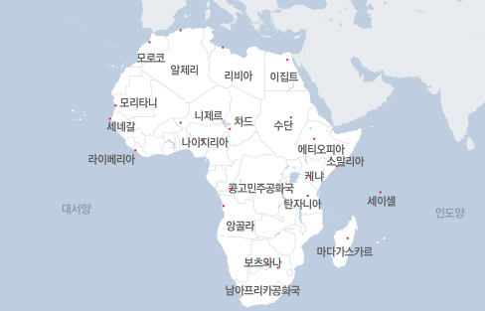

Elicit Vocabulary
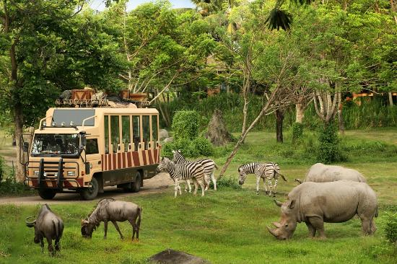
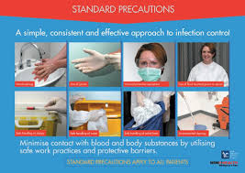
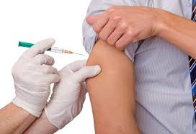

Listening Worksheet – Comprehension questions

( Gist comprehension - Guiding Question )
- What country does the speaker talk about?
- South Africa

( Literal comprehension )
- How many parks and reserves are in South Africa?
A) over 600
- What items did they mention about “the right gear”?
- Sunscreen and hats, dress in layers, a pair of binoculars

( Interpretive comprehension )
- Why does the speaker say that the proper precaution is crucial?
- No matter the quality of your accommodations, a Safari means plenty of time outdoors.
- How can you pass the custom when you enter a WHO designated Yellow Fever country?
A) Be sure to pack your original Yellow Fever card in your carry on luggage, as copies of the certificate will not be accepted by customs authorities.
.
Post-activity – Applied comprehension
- What advices do you give the person who wants to go to South Africa?
- What are you going to do if you meet the people who have the virus even if vaccinated?

Script

From outdoor adventures, surfing, and Safari, to vibrant cities boasting an energetic nightlife, both South Africa’s natural beauty and urban scene are sure to impress any visitor. It’s hard to imagine a trip to South Africa that does not include a Safari in one of the country’s many game parks. Indeed, South Africa has over 600 parks and reserves. So travelers can find any type of experience they desire, from complete isolation, to a group trip through Kruger National Park, the largest game reserve in the world. In this park, you will have the opportunity to see the big-five-lions, elephants, buffalo, leopards, and rhinos.
Regardless of the specific park into which the Safari takes you, it is essential to bring the right gear. Sunscreen and hats are a must for daytime travel and adventure. But dawn Safaris can be surprisingly cold. Make sure to dress in layers that you can shed as the sun and temperatures go up. Be sure to pack a pair of binoculars as well, so that you don’t miss out on any of the animals. Remember, you are not allowed to leave your vehicle at any point.
No matter the quality of your accommodations, a Safari means plenty of time outdoors. So it is crucial to take the proper precautions against insect-borne diseases during your trip. Malaria, Dengue Fever, and West Nile Virus may be uncommon to travelers from the United States, but all are common in South Africa. Using the appropriate treated mosquito nets at night will help you avoid bites. And be sure to spray your clothes and skin as well.
Check in with your Passport Health travel specialist. They’ll advise you on the numerous strategies you need to take for the proper precautions. Finally, a range of pre travel vaccinations will ensure that you have the safest trip possible. Chief among these, Yellow Fever vaccine.
The Yellow Fever vaccine certification is required for entrance into South Africa for all travelers who have passed through a WHO designated Yellow Fever country, even if your transit in that country was as brief as a layover on a plane. Be sure to pack your original Yellow Fever card in your carry on luggage, as copies of the certificate will not be accepted by customs authorities.
Make the most of your time in South Africa. Consult with a Passport Health travel medicine specialist to determine your strategy for staying well abroad. Call 888-499-7277 or visit passporthealthusa.com to find the Passport Health clinic nearest to you.

