Transcript for Lesson plan; Anna Lee
POOR POSTURE
Yesterday in my math class I found out my posture is bad. The teacher wanted to measure how tall each students is. When it was my turn, he measured me. “105 CENTIMETES?” he said. “Stand up straight.” I stood up straight.
“See, now you are 110 centimeters,” he said. “If you stand up straight, you are taller.”
Then he turned to the class. “Everyone. We should remember to stand up straight. Don’t hunch your shoulders. When you sit at your desk, put your back against the backrest. And put your feet flat on the floor.”
Then he turned back to me. “Make sure to relax your shoulders, okay” he said. “If you do, you’ll all have better posture.”

I will give some tips for Good Posture When Using a Computer
- Sit in your chair with your back against the backrest.
- 2. Use a chair with armrest.
- 3. Put your feet flat on the floor.
- Take regular breaks to relax.
- Make sure your shoulders are not hunched up.
Remember to take care of your back when using a computer.

Work sheet for ’Poor posture’
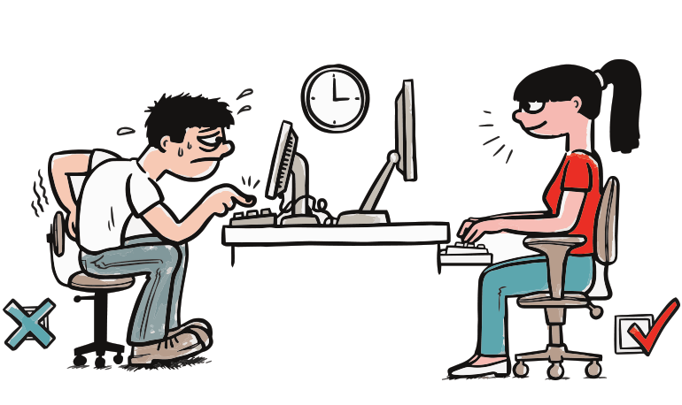
Find the differences between the two pictures and fill the blank.
Tips for Good Posture When Using a Computer
- Sit in your chair with your back against the backrest.
- 2. Use a chair with . (armrest)
- 3. Put your feet on the floor. (flat)
- Take regular breaks to . (relax)
- Make sure your shoulders are not up. (hunched)

