“Ancient Egyptian Mathematics” text

Ancient Egyptian Mathematics

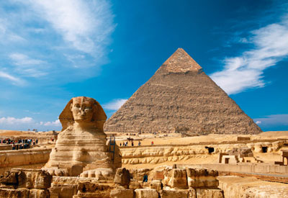
The Ancient Egyptians are well known for their many great structures. For example, they built the pyramids. These are huge structures built of brick or stone, and they were the tombs of the Egyptian Kings. The Egyptians also made the Great Sphinx, a great statue with a lion’s body and a woman’s head. These works show that the ancient Egyptians were probably the first people to use mathematics in construction.

How were the ancient Egyptians able to create mathematics in the first place? By about 3,000 BC, Egyptian society had reached a very high level. There was peace and prosperity. This allowed enough time for science to grow. Also, there was a system of picture writing. This helped preserve their mathematical knowledge. All of these conditions might have resulted in Egyptian mathematics.

In ancient Egypt, math was used for many purposes. For instance, the Egyptians used for many purposes. For instance, the Egyptians used math to measure distances and count money. Thy also calculated the number of days in a year, and they created a calendar. Due to math, they could even predict the flooding of the Nile River. The Egyptian math system ultimately contributed to the creation of huge structures such as the pyramids and the sphinx.

It is clear that the ancient Egyptians made great accomplishments in mathematics. Common people even used math in their daily lives, allowing Egypt to grow into an incredible state. The ancient Egyptians used math to build the pyramids and the Sphinx. Their ability to build great structures is still a mystery to science today!

“Ancient Egyptian Mathematics” Worksheet
Gist comprehension Task - Part 1

- Complete the main idea of each paragraph.
[Paragraph 1]
The ancient Egyptians built • • a. and it made mathematics developed.

[Paragraph 2]
The ancient Egyptians enjoyed • • b. and this affected modern society.
peace and prosperity

[paragraph 3]
Math was used in various areas • • c. many great works using math.

[paragraph 4]
The ancient Egyptians made • • d. such as calculating and constructing.
Great accomplishments in math

- Choose the main idea of the passage.
a. The ancient Egyptian society was peaceful and prosperous.
b. The ancient Egyptians developed mathematics despite poor conditions.
c. The ancient Egyptians were rich due to many structures.
d. The ancient Egyptians created many great works with mathematics.

X | Sphinx is a giant statue with lion’s body and tigers face. | X | Only people of high rank could use math.
X | Pyramids are huge structures built of brick or stone, and they were the palace for the kings. | X | Egyptian Math prevented flooding of the Dead Sea.
o | By about 3,000 BC, Egyptian society had peace & prosperity for science to grow. | X | The Great Sphinx was built accidently
O | The Egyptians used math to measure distances and count money. | O | The Egyptians used math to measure distances.
O | The Egyptians created a calendar calculating the number of days in a year. | O | The Egyptians are the first people who used mathematics in construction
x | The ancient Egyptians has no writing systems. | x | The largest pyramid is the Great Pyramid of giza and it was built some 3,000 years ago.
O | Mathematics was used to build the pyramids and Sphinx. | O | The Great Pyramid of Giza is one of the 10 wonders of the ancient world.
“Ancient Egyptian Mathematics” Worksheet
Literal comprehension Task – O,X game

*Teacher gives the text to different students to read it aloud.

Pictures for Lead-in(Stage 1) Activity

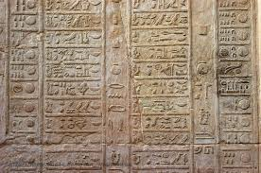
(Pic 1)

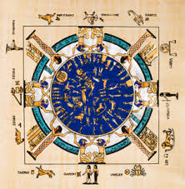
(Pic 2)

Picture 1 for Presentation(stage 2) Activity

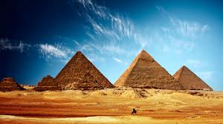

Picture 2 for Presentation(stage 2) Activity

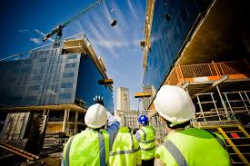

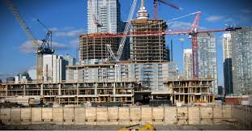

Picture 3 for Presentation(stage 2) Activity

