Listening Speaking Reading Grammar Writing

Topic: A role play in the hospital situation by speaking medical vocabulary

Instructor:  Sophie Kim  Daeun | Level:  Intermediate(Adult) | Students:  12 Students | Length:  30 Minutes

Materials:

- White board and board markers
- Worksheet #1: Drill and Information Gap A, B (12 copies)
- Worksheet #2: Role Play (12 copies)
- Visual Aid: A patient and a doctor

Aims:
- Main aim: Students will be able to improve their speaking skills by speaking in the hospital situation role play
- Secondary aim: Students will be able to learn about medical vocabulary
- Personal aim: I want to speak clearly in front of the students and manage my time well with my partner

Language Skills:
- Reading: Students will read symptoms and prescriptions of the worksheets
- Listening: Students will listen to their partner and group member when playing a role play
- Speaking: Students will ask and answer when playing a role play
- Writing: Students will write down medical vocabulary for information gap activity

Language Systems:
- Phonology: pronunciation for nausea [|nɔ:ziə], diarrhea [dàiərí:ə], ointment [|ɔɪntmənt], crutch [krʌtʃ], nasal [|neɪzl], injection [ɪn|dƷekʃn], fluid [|flu:ɪd]
- Lexis: medical vocabulary such as ‘stye’ ‘nausea’ ‘diarrhea’ ‘diarrhea’’ rash’
- Function: asking (question and answer)
- Grammar: Imperatives (Drink, Put, Get) Interrogatives (How, What, When, Why)
- Discourse: role play, script

Assumptions:
- How to class is set and run (U-shaped seating arrangement)
- Four language skills and language systems
- Students will be able to speak and play in front of the students

Anticipated Errors and Solutions:
- If students need linguistic help to express their opinions during discussion
give them linguistic support by providing definitions and some examples
- If some students keep quiet for fear of upsetting other people during discussion
encourage them to speak and advise them to be clear about their point
- If certain students dominate the discussion
ask them to give other students a chance to speak
- If students are reluctant to speak in front of the students
give a lot of courage and make positive environments that is okay for mistakes

References:
- English definitions: vocabulary
www.dictionary.com
- Clip art for symptom: Google Image
- Visual Aid for a patient and a doctor: Google Image

Lead-In
Materials: None
Time | Set Up | Student Activity | Teacher Talk
1 min | Whole class | Answering teacher’s questions | Good morning, everyone! How are you today? How is the weather? It is so cold, right? I have a fever, so I went to the hospital yesterday. How are you feeling?

Pre-Activity
Materials: Board, Board makers, Visual Aid, Worksheet #1
Time | Set Up | Student Activity | Teacher Talk
2 min  5 min  2 min | Whole  class  Pairs | Answering teacher’s questions.  Students answer ICQ questions.  Students write down answers and work in pairs  Students check answers. | Procedure:  1. Warm-up activity  Elicit  (Show the students picture of the doctor and patient)  “There are two people who are doctor and patient. What they are doing?  Why did patient visit doctor? What kinds of symptom patient have?  Additional explanation  “If we are sick, we go to the hospital and we see a doctor, right?  And then what do we have to do?”  Model  Write down the subject “Hospital: symptom and prescription”  on the board.  “Today, we are going to discuss symptom and prescription in the hospital situation”  CCQ  Which hospital do you often go to?  What kind of diseases did you have before?  What do you have to do after you get the prescription from a doctor?  2. New vocabulary  Instruction  “Today, we are going to learn medical vocabulary and how can we explain the pain.”  (hand out the worksheet #1A, B)  “Did everyone get worksheet #1?  I gave you a different part of worksheet #1 which are A and B. For this information gap activity, you need to pair with your partner then ask questions about symptom and prescription to fill in the blanks”  Demonstration  “Look at the worksheet, we will do the first one together”  Look at the number one. I will show you the demonstration with a partner.  What seems to be the problem?  His eyes are…  He has …  Here’s your prescription.  Go get….  I will give you 5 min.  ICQ  What do you write in the blanks?  Who are you working with?  How much time do you have?  “Okay. Let’s start!”  Monitoring  Monitor discreetly by walking around the class. Get close to students. Listen and answer to students if they ask questions.  Give time warning:  1 minute; 30 seconds left  (Be flexible with time. Give 1 more minute if they need it.)  “Time’s up”  After sharing to check the answer with you partners, we will check together.  Check answers  “Let’s check the answers together.”  Error and Pronunciation correction  Please be careful of these vocabulary  Nausea, Diarrhea….

Main Activity
Materials: Worksheet #2
Time | Set Up | Student Activity | Teacher Talk
3 min  10min | Group | Students answer ICQ questions.  Students will make a script for the hospital situation  Students will do the presentation (role play)  Students will answer the questions | 1. Role play activity preparation  “Now, we are going to have a role play activity.”  Instruction  I will give you another worksheet. Make a group of 3 people, then take each role for the hospital situation.  For the first situation…  One person will be a doctor…  Ask questions about …  Make a script for this disease situation. I’ll give you 3 min to do.  (Distribute the worksheet #2)  ICQ  Who do you work with?  How do you have to make?  How much time do you have?  Monitoring  Monitor discreetly by walking around the class. Get close to students. Listen and answer to students if they ask questions.  “Okay, everyone. The time is up.”  2. Role play activity presentation  Instruction  “Now, we are going to have a group presentation. Each group will be come out and present their play.”  Presentation  (Pay attention on students’ speaking)  “Great job! You did very well.”  Evaluation  What do you like about this activity?  What do you like about other group’s presentation?  What can be improved?

Post Activity
Materials: Worksheet #2
Time | Set Up | Student Activity | Teacher Talk
5 min  2min | Individual | Students will write down  Students will speak out | 1. Free production  (Voice message to a friend in the hospital)  Instruction  “Now, your best friend is in a hospital right now. So you want to leave a voice message to your friend. Write down the message for comfort and cheer. Then we are going to read it loud”  ICQ  Who is in the hospital?  What do you write?  Monitoring  Monitor discreetly by walking around the class. Get close to students. Listen and answer to students if they ask questions.  Presentation  Okay. Who wants to read it loud?  Everyone did very well!  2. Conclude Lesson  Summarize today’s lesson by checking new vocabulary and the contents in the text.  Give positive feedback about the student activities.  Ask if students have any question.  “Everyone did a great job today! Now, when you are sick or if you get any disease, you will be able to speak confidently in the hospital!”

SOS Activity
Materials: Worksheet #3
Time | Set Up | Student Activity | Teacher Talk
4 min  4 min  4 min | Pair | Speak loudly by reading the script | 1. Switch the role play  Instruction  “Now, we are going to play other group’s situation. Take the situation that you haven’t play and make a script in the group.”  ICQ  Who are you working with?  What do you have to do?  Monitoring  Monitor discreetly by walking around the class. Get close to students. Listen to their pronunciation and give help if needed.  (If you need more time do following activity)  More Activity  Let’s play other situation again. (We have total 3 situation)  Let’s practice speaking difficult words together. (Drill practice)  Conclude  “Great job, everyone. How was the activity? Even if you are sick in the other country, don’t worry because you are able to speak about symptoms! Have a good day!”

Worksheet #1 Drill and Information Gap A

Discuss with your partner for the information about the prescriptions and symptoms in order to fill in the blanks

Doctor: What seems to be the problem? How are you feeling?
Patient: I have _______________________.
Doctor: Here’s your prescription. __________________________.

I have a stye in my eye  Put two eye drops in each eye three times a day | 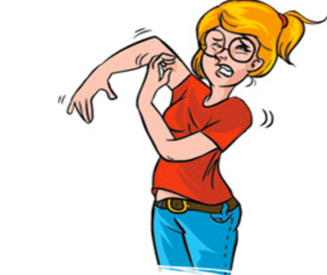  ___________________  ___________________  ___________________ | I have nausea  Drink one spoon of Pepto Bismol two times a day
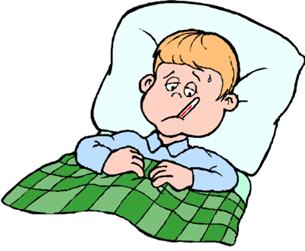  _________________  _________________ | 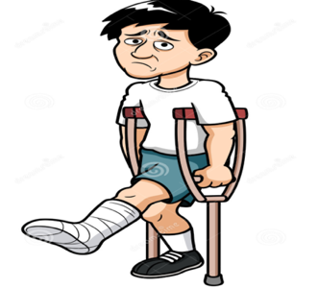  I broke my leg  Put on a cast, Walk with crutches | ________________  ________________
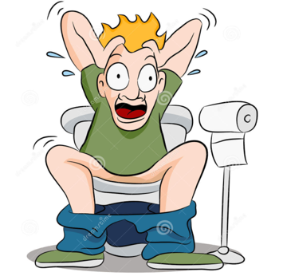  I had diarrhea  Get an injection, Take three pills after a meal three times a day | _________________  __________________ | 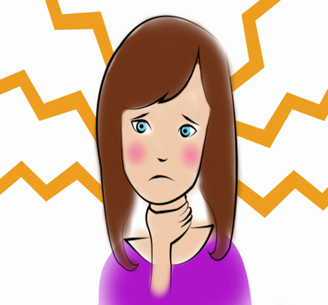  I have a sore throat  Gargle with warm salt water, take cough drops
Worksheet #1 Drill and Information Gap B

Discuss with your partner for the information about the prescriptions and symptoms in order to fill in the blanks

Doctor: What seems to be the problem? How are you feeling?
Patient: I have _______________________.
Doctor: Here’s your prescription. __________________________.

_________________  _________________  _________________ | 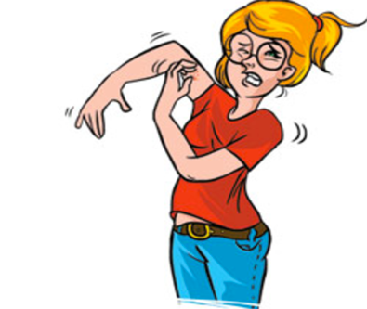  I have a rash; itchy  Put on skin ointment three times a day | _________________  _________________  ________________
I have a fever  Drink plenty of fluids and rest as much as possible | 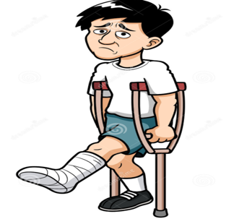  ___________________  ___________________ | I have a runny nose  Use a nasal spray three times a day
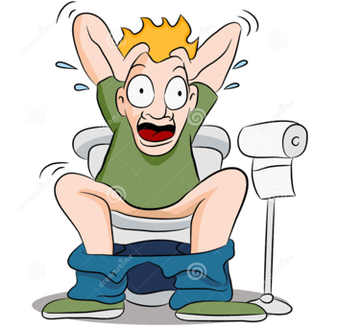  _________________  _________________  _________________ | I have a cramp in my leg  Stretch and massage the muscle gently | 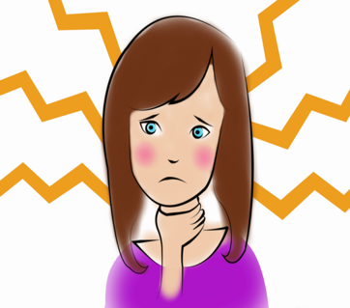  _________________  _________________
Worksheet #2 Role Play

Divide into groups and role play the following situations with your group members.

<Situation 1>

- Location: 1) at ophthalmologist (Eye Doctor) clinic
2) at the pharmacy
- Characters: Patient, Doctor, Pharmacist
- Symptom: have pink eye, have a stye in his/her eye, itchy
- Prescription: put two drops in each eye three times a day
Refrain from touching your eyes and sanitize your hand

<Situation 2>

- Location: 1) at dermatologist (Skin Doctor) clinic
2) at the pharmacy
- Characters: Patient, Doctor, Pharmacist
- Symptom: have a rash, it is red and swollen,
have an allergic reaction to …
- Prescription: put on skin ointment two times a day
Take 3 pills after a meal three times a day

<Situation 3>

- Location: 1) at the hospital to see a GP (General Practitioner)
2) at the pharmacy
- Characters: Patient, Doctor, Nurse, Pharmacist,
- Symptom: Because of indigestion … , have nausea, had diarrhea
- Prescription: nurse will give you an injection
drink two teaspoons of Pepto Bismol three times a day
don’t consume alcohol while taking this medication

