Amazing animals A Sheet
Use this dialogue to talk about amazing animals
Where does _____ live? |  | It lives in _____.
How does it look? |  | It has (a/an) ______.
What does _____ eat? |  | It eats ________. It is a/an__________.
Let me get this straight: It lives in ____, it has (a/an) ____ and it is a/an _________. |  | That’s right/correct.
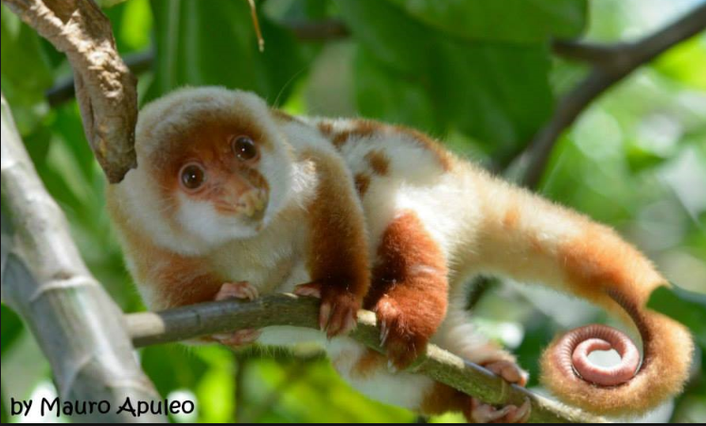 | 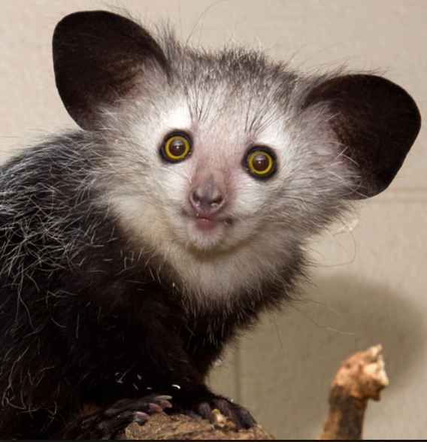 |  | 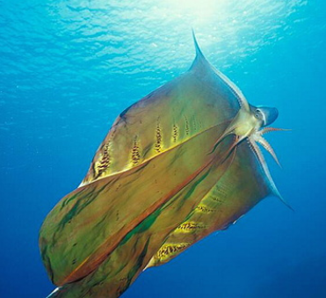
Name: Cuscus  Habitat: Tropical rain forest  Features: Long tail and strong toes  Prey: Plants, fruits (Herbivore) | Name: Aye Aye  Habitat: __________________  Features : ______________  Prey:__________________  ( ) |  | Name: Blanket octopus  Habitat: Tropical ocean  Features: long webs  Prey: Crabs, fish (Carnivore)
 | 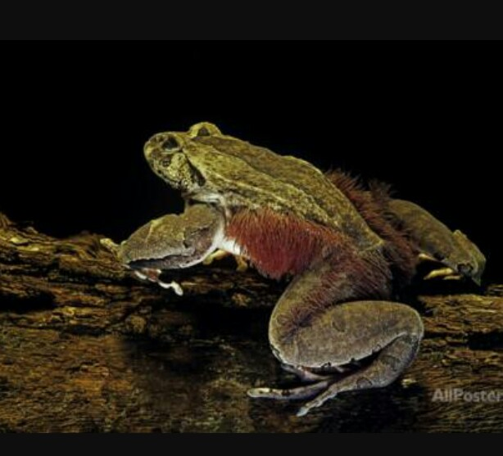 |  | 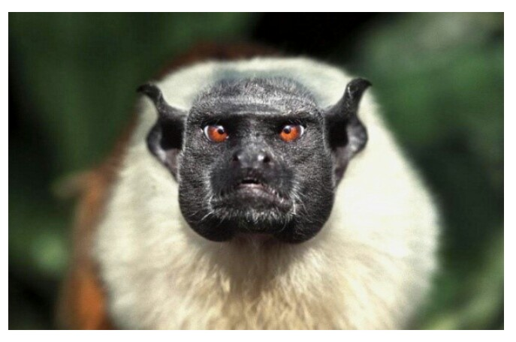
Name: River dolphin  Habitat: _________________  Features: ________________  Prey: _________( ) | Name: Hairy frog  Habitat: Tropical rain forest  Features: Sharp bony claws  Prey: grasshoppers, spiders, slugs (Carnivore) |  | Name: Pied Tamarin  Habitat: _________________  Features: ________________  _______________________  Prey: _________( )
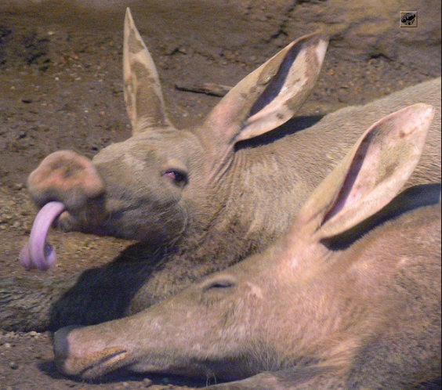 | 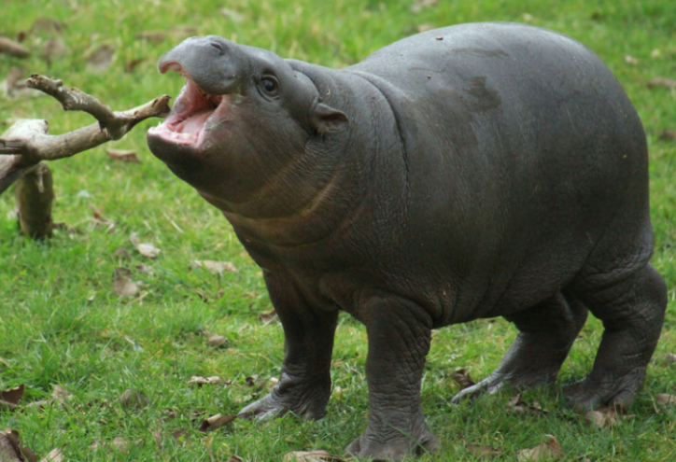 |  | 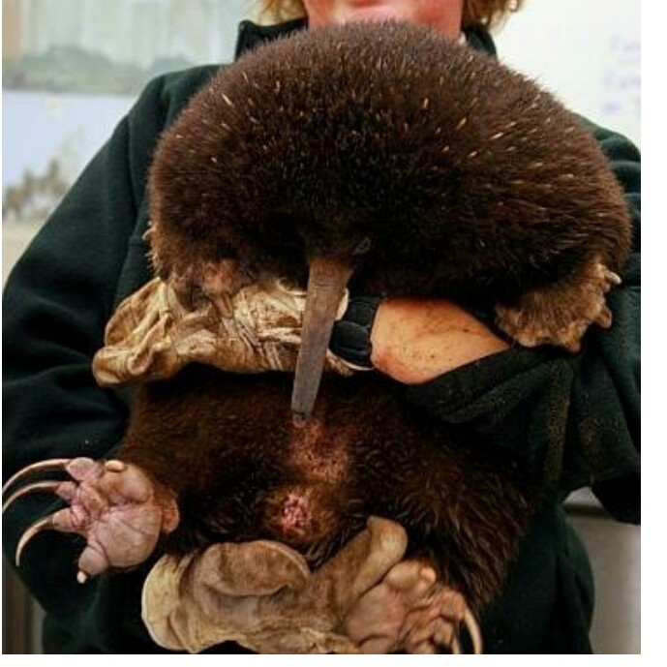
Name: Aardvark  Habitat: Grassland and forest  Features: Very sticky tongue Prey: ants (Insectivore) | Name: Pigmy hippo  Habitat: ________________  Features: _______________  Prey: ________( ) |  | Name: Long - beaked Echidna  Habitat: Tropical forest  Features: long beak  Diet: soft insects (Insectivore)
Amazing animals B Sheet
Use this dialogue to talk about amazing animals
Where does _____ live? |  | It lives in _____.
How does it look? |  | It has (a/an) ______.
What does _____ eat? |  | It eats ________. It is a/an __________.
Let me get this straight: It lives in ____, it has (a/an) ____ and it is a/an _________. |  | That’s right/correct.
Name: Cuscus  Habitat: Tropical rain forest  Features: Long tail and strong toes  Prey: Plants, fruits (Herbivore) | Name: Aye Aye  Habitat: Tropical rain forest  Features : Yellow big eyes  Prey: Fruit, insect, eggs  (Omnivore) |  | Name: Blanket Octopus  Habitat: _________________  Features: ________________  _______________________  Prey: _______( )
Name: River dolphin  Habitat: Large tropical river  Features: pink skin  Prey: sea animals (Carnivore) | Name: Hairy frog  Habitat: ________________  Features: _______________  Prey:_________( ) |  | Name: Pied Tamarin  Habitat: Rain forest  Features: Black face, red eyes  Prey: fruits, insects, bird eggs, (Omnivore)
Name: Aardvark  Habitat: _________________  Features: ________________  ________________________  Prey: _________( ) | Name: Pigmy hippo  Habitat: Forest and swamp  Features: small body  Prey: plants (Herbivore) |  | Name: Long - beaked Echidna  Habitat: ________________  Features: _______________  _______________________  Prey: __________( )
Amazing animals Answer Sheet
Use this dialogue to talk about amazing animals
Where does _____ live? |  | It lives in _____.
How does it look? |  | It has (a/an) ______.
What does _____ eat? |  | It eats ________. It is a/an__________.
Let me get this straight: It lives in ____, it has (a/an) ____ and it is a/an _________. |  | That’s right/correct.
Name: Cuscus  Habitat: Tropical rain forest  Features: Long tail and strong toes  Prey: Plants, fruits (Herbivore) | Name: Aye Aye  Habitat: Tropical rain forest  Features : Yellow big eyes  Prey: Fruit, insects, eggs  (Omnivore) |  | Name: Blanket octopus  Habitat: Tropical ocean  Features: long webs  Prey: Crabs, fish (Carnivore)
Name: River dolphin  Habitat: Large tropical river  Features: pink skin  Prey: sea animals (Carnivore) | Name: Hairy frog  Habitat: Tropical rain forest  Features: Sharp bony claws  Prey: grasshoppers, spiders, slugs (Carnivore) |  | Name: Pied Tamarin  Habitat: Rain forest  Features: Black face, red eyes  Prey: fruits, insects, bird eggs, (Omnivore)
Name: Aardvark  Habitat: Grassland and forest  Features: Very sticky tongue  Prey: ants (Insectivore) | Name: Pigmy hippo  Habitat: Forest and swamp  Features: small body  Prey: plants (Herbivore) |  | Name: Long - beaked Echidna  Habitat: Tropical forest  Features: long beak  Diet: soft insects (Insectivore)

