Amazing animals
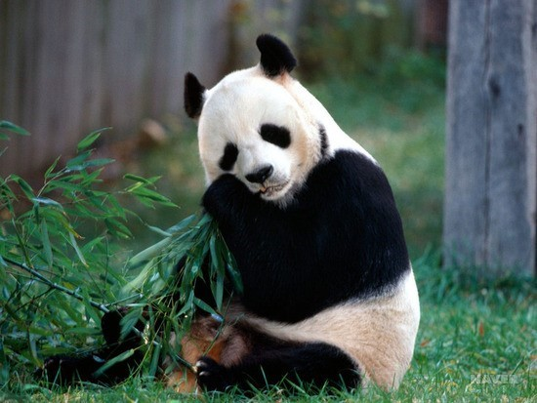
<questions>
- What is this animal?
- Where is it now?
- How does the panda look?
- What is the panda eating now?

Herbivore
Carnivore
Insectivore
Omnivore

<Amazing animals>
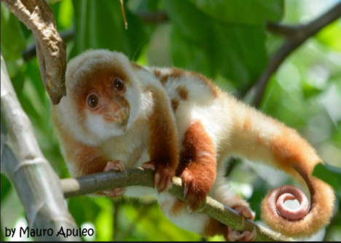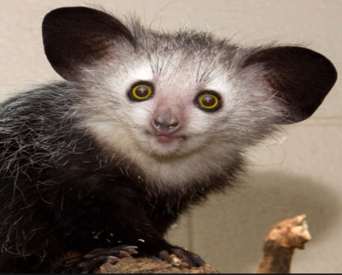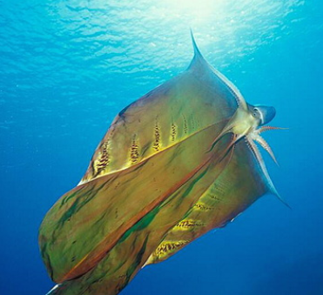
Cus Cus Aye Aye Blanket Octopus

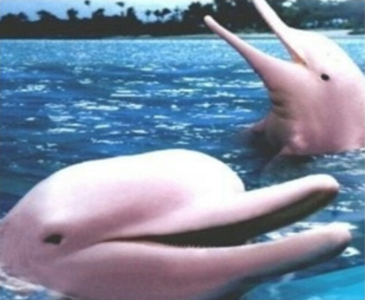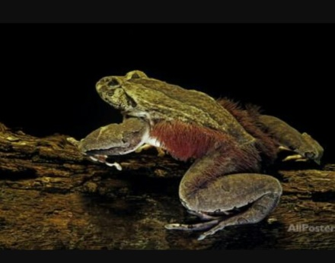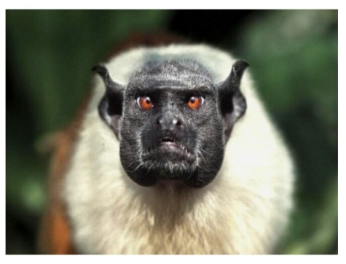
River Dolphin Hairy frog Pied Tamarin

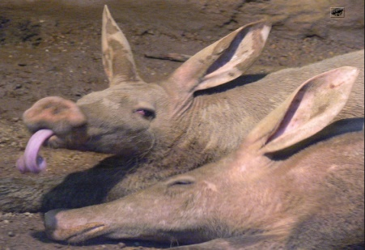
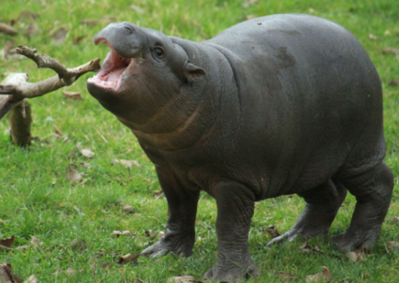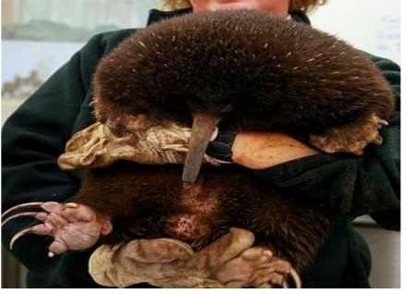
Aardvark Pigmy Hippo Long-beaked Echidna
Questions for review

- If animal eats meat, it is a ___________.
- If animals eat insects, it is an ___________.
- If animals eat plants, fruits, it is a ____________.
- If animals eats all kinds of foods,
It is an ____________.

