Background Information Sheet
Name & Class | Date & Place |  | Lesson |  | Plan |  | Topic |  |  | Length | Level
Sook Hee Kim | Feb. 8th. 2017 |  | Grammar |  | PPP |  | A Holiday in 2007 |  |  | 35min | Elementary
Class profile
Number of students: 8 Age: Adult Nationality: Korean
Motivations: personal advancement
Individual or class hobbies and interests:
Special considerations:
Main aim
- Students learn about the past simple
Subsidiary aims
- Students practice their speaking fluency by discussion
Description of language skills specifically used/practiced:  - Reading : reading worksheets to answer questions.  - Listening : Listening to the teacher’s instructions, explanation and classmates’ ideas  - Speaking : drilling, practice activities  - Writing : worksheet answers and doing homework. |  |  |  |  |  | Description of language systems specifically used/practiced:  - Phonology : drilling –ed (/id/ /d/ /t/)  - Grammar : use of past simple  - Function : describing finished situation

Anticipated difficulties with lesson activities and classroom management:
- Students may have difficulty in understanding the meaning
- Students may have a hard time drilling.
How I can deal with these difficulties:

Teacher will handle it in the way of peer correction
- Teacher gives the students more chances to practice.
Assumptions: (That which provides insight about your choice of material, selection of target language etc.)
Students already have learned the present simple tense.

Material(s) needed:
White Board, Board Marker, Board Eraser, 3 worksheets (8 copies), some stuff including a few pictures. a backpack.

Checklist. Tick those included in this lesson plan (or N/A)
model sentences for target language |  |  |  | concept questions for target language |  |  |  |  | analysis sheet for target language
stages clearly titled and separated |  |  |  | purpose of each stage indicated |  |  |  |  | anticipated timing included
interaction pattern marked |  |  |  | a board plan (if relevant) |  |  |  |  | examples of all tasks used
answer sheet to all exercises |  |  |  | tape script |  |  |  |  | all materials labelled and numbered
Personal aim : What I most hope to demonstrate in this lesson is the ability to give a clear instruction

Stage 1:_Lead-in  The purpose of this stage is to relax both teacher and students by focusing their attention on an interesting subject and encouraging the class to share their opinions freely, thus increasing STT and participation. This stage should be used to create an appropriate situational context. | Inter  action | Time | Instructor’s comments
T : Hello everyone, how are you today? ( Ss greet back)  (showing a backpack) Take a look at this, everyone. Yesterday, I found this bagpack in my closet.  It is definately my bag, but It looks unfamiliar to me. That’s because I haven’t used it for about 10 years.  Listen. I have a problem. The thing is, I can’t remember what I did with this bag  So I need your help. Could you please help me?  Ss : Sure  T : Thank you guys. Fortunately, there is some stuff in it. All you have to do is making a full sentence while I’m taking stuff out of this bag. Okay. You got it?  Ss : Yes  T : ( showing Ss some photos and stuff in order. i.e. a nice dress, a beautiful beach, horse-riding picture, a Koala, the Sydney Opera House, a guitar and an airline ticket (it says departure date: May 10 2007)  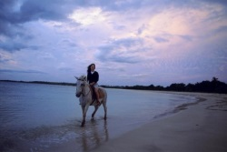  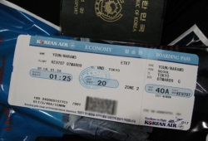  T : Hey guys tell me what I did.  Ss : (looking at a nice dress) You wore a nice dress.  Ss : (looking at a beautiful beach) You lay down on the beach wearing a swimming suit.  Ss : (looking at a horse-riding) You rode a horse or You went on a horse ride  Ss : (looking at a koala) You saw a koala.  Ss : (looking at the Sydney Opera House) You visited the opera house in Sydney.  Ss : (looking at a guitar) You played the guitar  Ss : (looking at an airline ticket that Ss can see the exact departure, arrival date and year ) : You bought an airline ticket.  T : Oh did I? When did I buy it?  Ss : in 2007  T : is it now? Or before (pointing finger to back over my shoulder)? How many years ago?  Ss : before. 10 years ago.  T : great job, Everyone. Could you please tell me what I did by making it into only one sentence?  Ss : You went on a holiday to Australia.  T : Ohhh . I went on a holiday in 2007. Is it right? So how many days did I spend in Australia?  Ss : 10 days.  T. : ummm I spent 10 days in Australia in 2007. Is it right? Thank you so much. | T  S  T-S | 1min  2min  2min | Ss might say “You were lying down on the beach.  If then, Teacher will say “I want to know what I did, not what I was doing”

Stage 2: Presentation  The purpose of this stage is to teach the target language deductively, referring to the situational context from the lead-in. Meaning, form and pronunciation should be covered with appropriate methods such as a model sentence, CCQs, timelines, substitution tables and indication of phonology etc. | Inter  action | Time | Instructor’s comments
T : Everybody, say again “ What did I do in 2007?” ..  (Writing on the white board) “ I spent 10 days in Australia in 2007” is it right?  Ss : (reading the model sentence) “ I spent 10 days in Australia in 2007”  CCQs : Do I still stay in Australia now? (N)  Did I visit Australia in 2007? (Y)  Have I ever been to Australia before? (Y)  Draw a Timeline :  T : Is there any volunteer to mark the time actions happened? (nominating one of students) Draw a timeline !!  S : (a nominated student comes up to the board and marks the time on the timeline )  T : do you agree, everyone?  S : Yes..  T : Why don’t you marking here (marking above the now on the timeline)?  S : No. Because the action happened before.  T : Oh.. was the action finished in 2007?  S : yes  T : Good. We learned present Simple tense last class, right?  What about today’s tense? How do you call this tense?  S : ,,,,,,..  T : Does anybody know? When we talk about the action was already finished, we call “Past Simple” .  T : which expressions can we use this tense? You guys have any ideas?  Ss : When we talk about yesterday, last night, ……. ( Ss keep coming up their idea about simple past)  T : (Drawing mind map “past simple related expressions below ) Perfect!! Good job.. guys  Timeline : past time expressions : 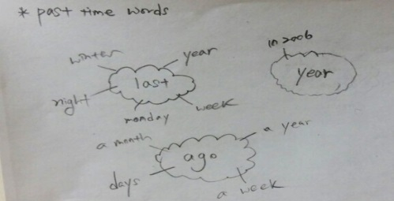  A Board Plan :  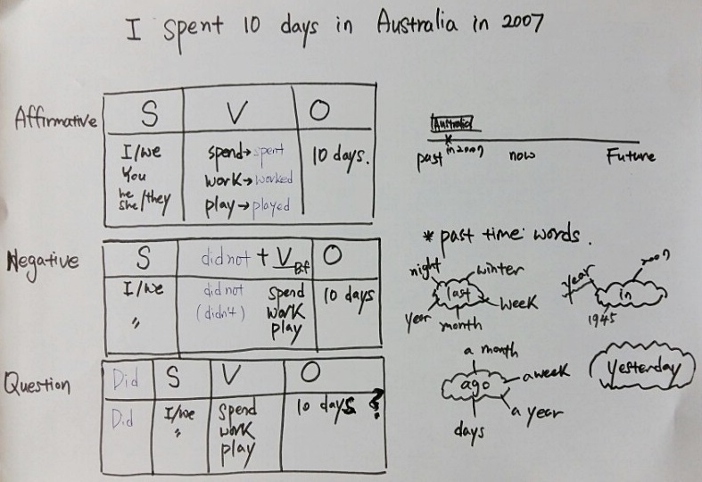  ( Make a table (affirmative, negative, Question forms) with Ss together)  Form  T : What letters were used to make the verb into past simple tense?  Ss : “–ed”  T : Good. Where?  Ss : At the end of the verb.  T : We usually put –ed at the end of the verb. Right?  Ss : Yes  T : But how about spend? Why do we use “Spent” instead of “ Spended” in the past form?  Ss : Those verbs changed the form.  T : Good. Those verbs change their forms. Exactly!  (pointing to the verb “ worked” on the board) how about this?  Ss : it is only added –ed  T : oh. There are two kinds of verb in the past form. Changeable verb and “–ed” added verb, Right?  Ss : yes  T : good job. Thanks everyone. You are such smart students  Drilling (Pronounciation) : (including stress, intonation)  I Spent 10 days in Australia in 2007  T : Listen twice “ I spent 10 days in Australia in 2007  T : Everybody repeat after me.. ( first Cordially , Second individually  Ss : I Spent 10 days in Australia in 2007.  T : (pointing to the verbs in the board plan and making Ss repeat after Teacher.)  (Spent/t/ , Lived /d/ Worked /t/ Exercised /d/, if time permitted)  Perfect! Any questions? Good job, everyone !! | T-S  T-S  T-S  T-S  T-S | 1min  2min  4min  3min  1min

Stage 3: Controlled Practice  The purpose of this stage is to allow the students to accurately practice working with the target language’s form by doing easy, or controlled tasks. This helps build confidence before trying something more challenging. Students should apply the rules that were presented in a meaningful way whenever possible. Peer-checking before feedback is important in these practice stages. | Inter  action | Time | Instructor’s comments
Controlled Practice :  Instructions : (hand out worksheet #1) Look at this paper. This is the story about “Kate and Will’s argument”  They argued each other yesterday.  Fill the correct answers in the blank individually.  I’ll give you 2 minutes  After you finish, you guys can check the answers in pairs.  I’ll give you extra 1 minute  ICQ : How much time do you have?  Do you fill in the blank with others?  (run task)  Ss check the answers in pairs.  Feedback : Do you need more time?  If yes, give 30 seconds extra time.  If no, let Ss check answers in pairs  Monitoring : Quietly walking around the classroom. Check to see if all Ss are on track  And also check the right or wrong answer while Ss are checking answers in pairs  If any student has wrong answers, ask other students to correct them.  Instructions : Finally check the right answer together | T  S  S-S | 1min  2min  2min

Stage 4: Less controlled practice  The purpose of this stage is to allow students to practice the target language more thoughtfully, in terms of either structure manipulation, meaning, function or other aspects of language. Accuracy is checked before moving to the next stage. | Inter  action | Time | Instructor’s comments
Less Controlled Practice  Instructions : We will do a board game “ What did you do yesterday?”  (Hand out Worksheet #2)  I’ll give you a dice, first roll the dice and then move as much as the number you get. You can make the answer by making a the full sentence based on the pictures on the board game.  For example, if you are on number 18, you can say “I went to a restaurant or I had lunch in a restaurant or I ate out. Anything is ok, but be careful you should say in past tense. If you don’t, you should go back to the start. You have to start it again from the beginning.  You can work with your partner  I’ll give you 5 minutes  ICQ  - What do you have to do? Making a full sentence or one word?  - How much time do you have?  - Which tense do you have to say ?  ( Run Task ) | T  S-S | 1min  5min

Stage 5:_Freer Practice  The purpose of this stage is to allow student to practice using the target language productively in an authentic way. The focus is to encourage fluency, not accuracy, therefore errors should be monitored and only addressed if necessary. Correction should be given during the next stage. | Inter  action | Time | Instructor’s comments
Freer Practice : write about your unforgettable trip by describing questions below.  Where were you?  How was your trip?  Who were you with?  What did you do there?  Were you bored or excited?  Instructions: Now let’s make your own story. (hand out worksheet # 3)  Please write about your unforgettable trip.  You have 5 minutes and then you are going to exchange yours with your partner’s  It’s time for you to be a teacher.  While you are looking through the partner’s story, please find some errors and correct it.  (Run Task )  Monitoring : Quietly walk around the classroom. Check to see if the Ss are on track and  And also check which students made errors when they are writing.  Teacher will take note about the errors and will correct them with Ss together in the wrap-up stage.(peer correction needed) | S  S-S | 5min  1min

Stage 6:_Wrap-up  The purpose of this stage is to end the lesson with some positive feedback about the lesson and the students’ participation. Review the main points briefly, either deductively or inductively, or perhaps during error correction. Classroom management should be considered, such are collecting worksheets, giving homework, stimulate interest in the next class or arranging the desks etc. | Inter  action | Time | Instructor’s comments
T : Did you have fun today? I hope you enjoyed today’s lesson.  You did really well today. Good job guys.  But I heard you guys (writing on the board “I have been to Jeju island last year” )  Is it right? What’s wrong?  S : you should say “ I went to Jeju island last year “ or “I have been to jeju island “  T : Why?  S : because the expression” last year” always comes with simple past..  T : great job everyone.. Thank you very much  Next time we will talk about the future. have a nice day !! | T-S | 2min
Instructor’s Final Comments
Overall strengths of this lesson (planning and teaching) | Areas to work on

Overall comment

For this stage of the course, your lesson today was

- Above standard

- To standard

- Below Standard

Instructor: …………………………… Date: …………/……………/………… Student/s: ……………………….. .…………………………..

Worksheet # 1

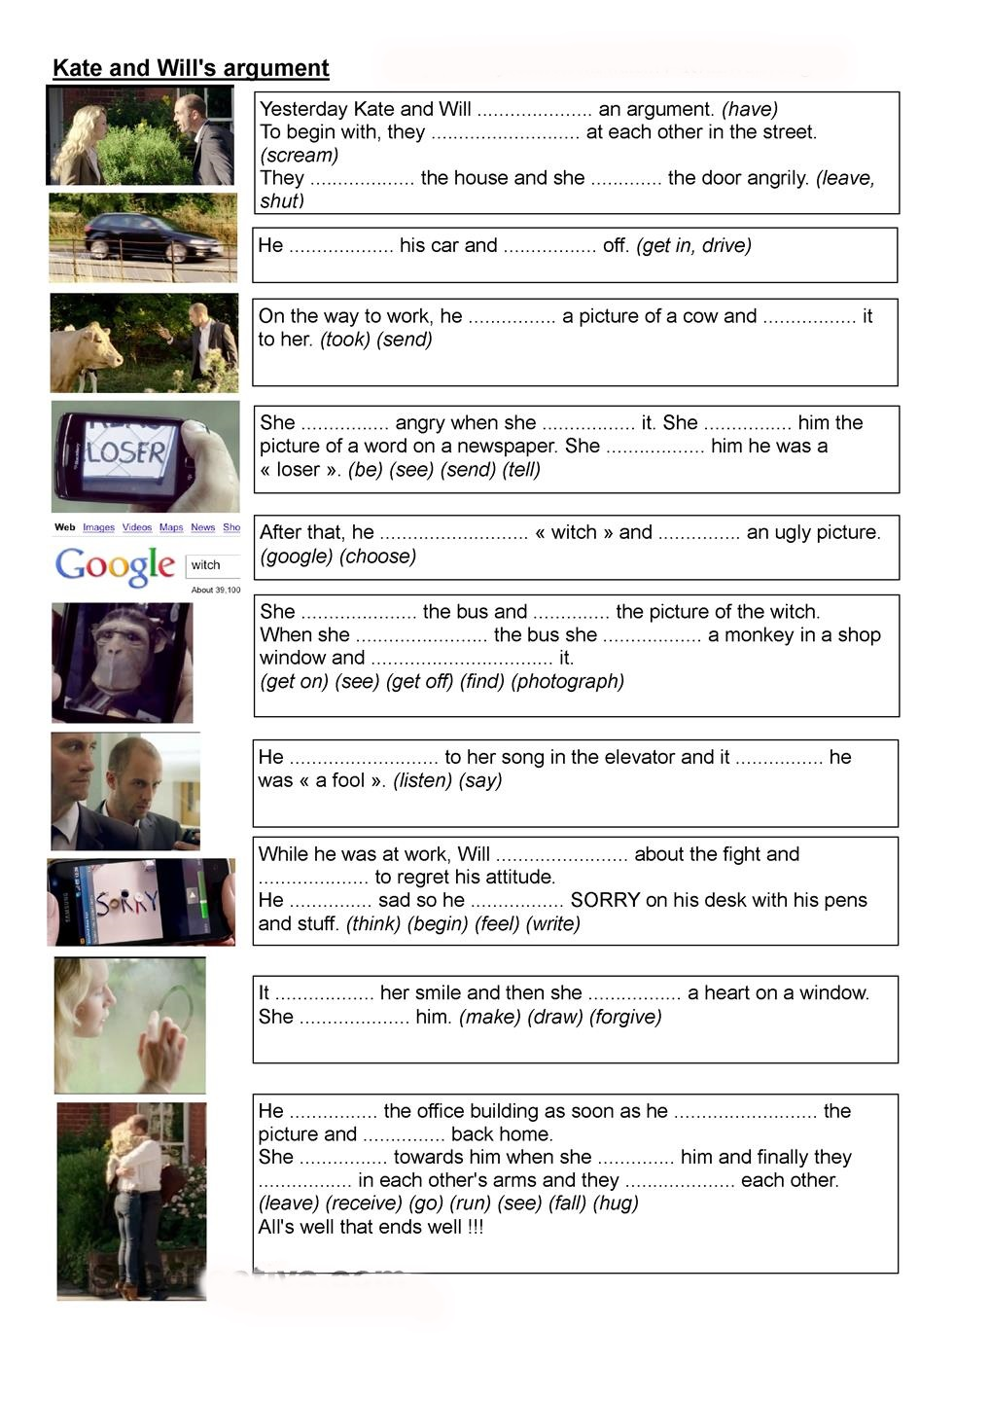

Worksheet #1 (answer)

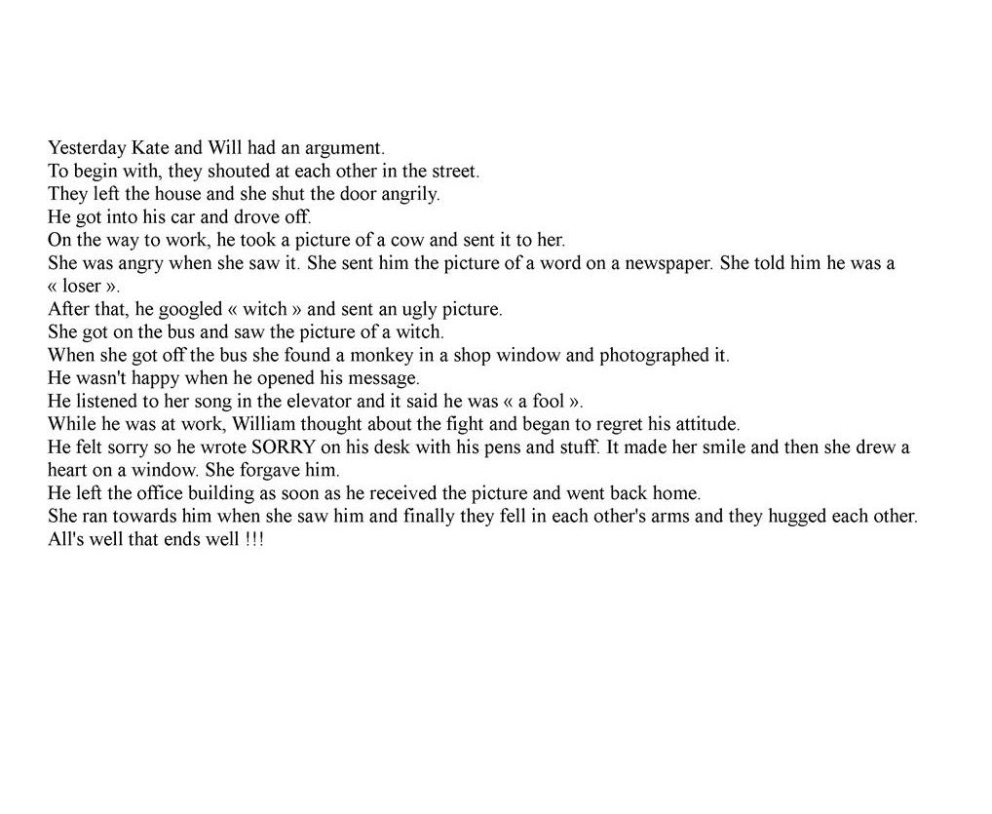

Worksheet # 2

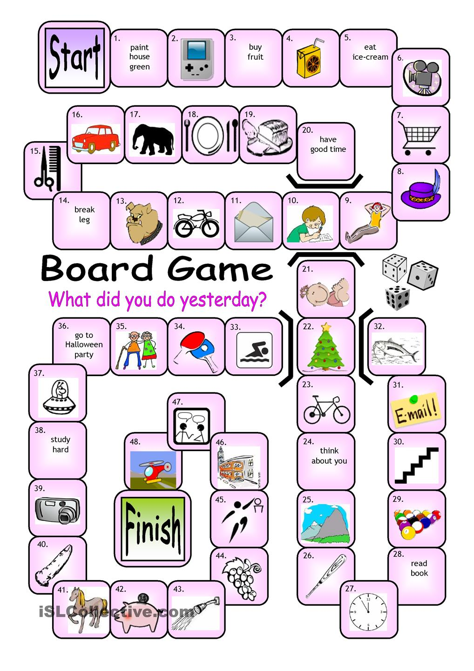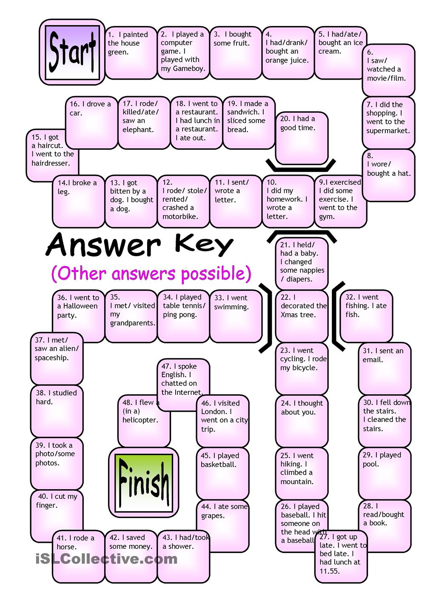

Worksheet # 3

Write about it

Question : Please write about your unforgettable trip by describing question below.

Where were you?
How was your trip?
Who were you with?
What did you do there?
Were you bored or excited?

