Background Information Sheet
Name & Class | Date & Place |  | Lesson |  | Plan |  | Topic |  |  | Length | Level
Amy Kim | 8th. Feb. 2017 |  | Grammar |  | PPP |  | What was happening in the park? (past progressive) |  |  | 35 | Elementary
Class profile
Number of students: 8 Age: Adult Nationality: Korean
Motivations: To understand the past progressive tens
Individual or class hobbies and interests: like to do activity
Special considerations: confusing tens with past simple or present progressive
Main aim
- Students learn this grammar skills
Subsidiary aims
- Students practice how they speak with this grammar skills

Description of language skills specifically used/practiced:  - Writing: make sentence by themselves  - Reading: can read what happened to understand  - Speaking: speak what they were doing  - Listening: listen to understand exactly |  |  |  |  |  | Description of language systems specifically used/practiced:  - Grammar: apply proper grammar what happening was  - Function: order to proper sentence  - Lexis: understand what was happening in the past  - Discuss: have conversation what I was doing in the past

Anticipated difficulties with lesson activities and classroom management:
1. Students might feel difficulties to apply in proper tenses.
2. Students may not understand what tense is for.
How I can deal with these difficulties:

1. Give more time to have a conversation with a partner.
2. Give students more exercise to apply easier.
Assumptions: (That which provides insight about your choice of material, selection of target language etc.)
1. Some students already know how to distinguish the past progressive and other tenses.
2. Students may feel bored when they learn with work sheets.
Material(s) needed: White board, board maker, board eraser, work sheets1 (8 copies - questions), work sheets2 (8 copies-picture)

Checklist. Tick those included in this lesson plan (or N/A)
model sentences for target language |  |  |  | concept questions for target language |  |  |  |  | analysis sheet for target language
stages clearly titled and separated |  |  |  | purpose of each stage indicated |  |  |  |  | anticipated timing included
interaction pattern marked |  |  |  | a board plan (if relevant) |  |  |  |  | examples of all tasks used
answer sheet to all exercises |  |  |  | tape script |  |  |  |  | all materials labelled and numbered
Personal aim : Help to students approaches new grammar skills easily.

Stage 1:_Lead-in  The purpose of this stage is to relax both teacher and students by focusing their attention on an interesting subject and encouraging the class to share their opinions freely, thus increasing STT and participation. This stage should be used to create an appropriate situational context. | Inter  action | Time | Instructor’s comments
Instruction  Topic: What was happening in the park?(past progressive)  Hello everyone. Welcome back to grammar lesson!  How was the weekend?  Are you going a park sometimes for spending time on weekend?  The town I living, there is a huse park called lisan hosoo gonwon.  I am going to the park to ride a bicycle often.  When I went the park last Sunday, some people were enjoying their Sunday happy time with family.  What do you think what the people was doing in the park?  (Listen Ss answers)  Good. Maybe Somebody was running or eating snacks. Right?  Okay. Today. Let’s talk about “What was happening in the park?”  (was , happening – red maker)  (Write topic “What was happening in the park?” on the board) | T-S | 2min

Stage 2: Presentation  The purpose of this stage is to teach the target language deductively, referring to the situational context from the lead-in. Meaning, form and pronunciation should be covered with appropriate methods such as a model sentence, CCQs, timelines, substitution tables and indication of phonology etc. | Inter  action | Time | Instructor’s comments
Instruction  Before make sentences with past progressive,  Teach and explain to students how they can use proper grammar in the past tens.  Eliciting  Let’s imagine we just came in the park to meet my friend. It’s a girl.  What do you think what she was doing when I came?  (Listen Ss answers. Ex) She waits, she was waiting, she was drinking a coffee.)  Good! And I guess she was walking when I came in the park.(model sentence)  (write the model sentence on the board and ask Ss to read the sentence)  CCQ  1. I can see her now? (Y)  Good.  2. Was she finished the walking when I came? (N)  Right. I saw she was still walking.  (Ss have to say “walking” by themselves)  Timeline  Okay. Is this happening in the present? Right. In the past.  Let’s think with a timeline  (Draw a timeline or explain using arm miming)  Form  Than let’s make more sentences.  (use a form on the board and drilling the sentences to make at the same time) | T-S  T-S  T-S | 1min  4min  4min

Stage 3: Controlled Practice  The purpose of this stage is to allow the students to accurately practice working with the target language’s form by doing easy, or controlled tasks. This helps build confidence before trying something more challenging. Students should apply the rules that were presented in a meaningful way whenever possible. Peer-checking before feedback is important in these practice stages. | Inter  action | Time | Instructor’s comments
Instruction  Do the worksheet 1 to understand what students learned.  Good. Guys. Ill give you some questions now.  (Explain what Ss have to do with worksheet 1)  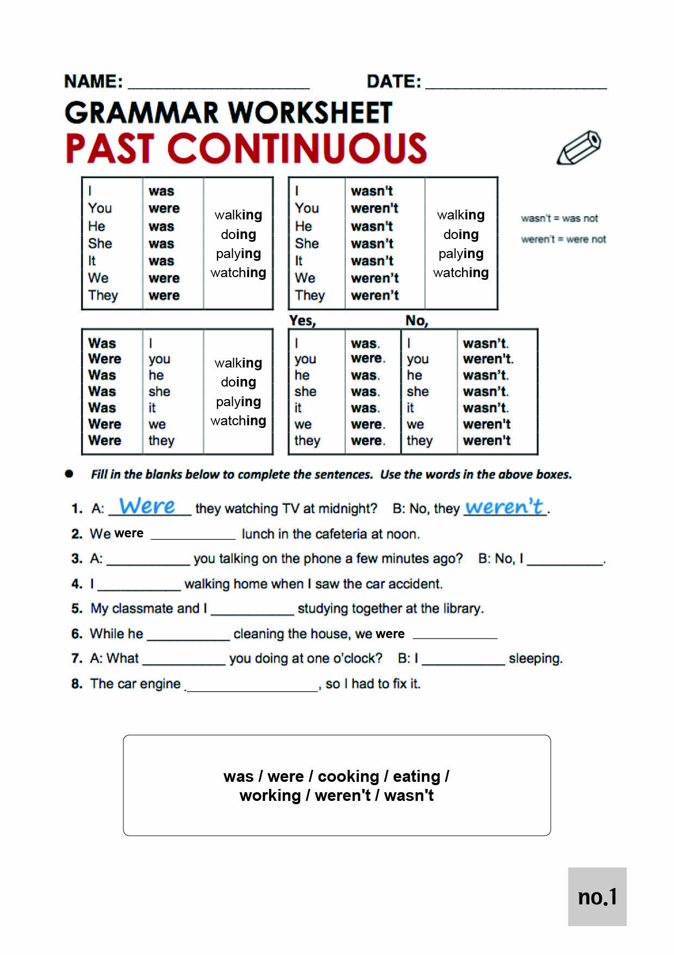  Look at this worksheet. You can see what we just learned on the top.  And write the answer of these 8 questions by yourself.  Ill give you 2min and let’s check up the answers after you did together.  (after explain, hand out worksheet 1)  Feedback  Do you need more time?  Yes-okay. Ill give you 30 sec more.  No- Good. Than let’s check the answer together  (ask the answers to Ss to check together) | T  S  T-S | 1min  2min  2min

Stage 4: Less controlled practice  The purpose of this stage is to allow students to practice the target language more thoughtfully, in terms of either structure manipulation, meaning, function or other aspects of language. Accuracy is checked before moving to the next stage. | Inter  action | Time | Instructor’s comments
Instruction  Do the worksheet 2 to apply sentences using past progressive grammars with picture.  Good. Guys. Ill give you a picture now.  (Explain what Ss have to do with worksheet.)  Look at this picture.  You can see what people or animals are doing in the park in this picture. But this picture is last Saturday.  And than you can say what they were doing when you came in the park on last Saturday, right?  Talk with your partner and note the answers on the paper as possible as you can in 3mis.  CCQ  1. Are you working individually?  2. Should we use “was or were ~ing” form to make sentences?  (after CCQ, hand out the worksheet2)  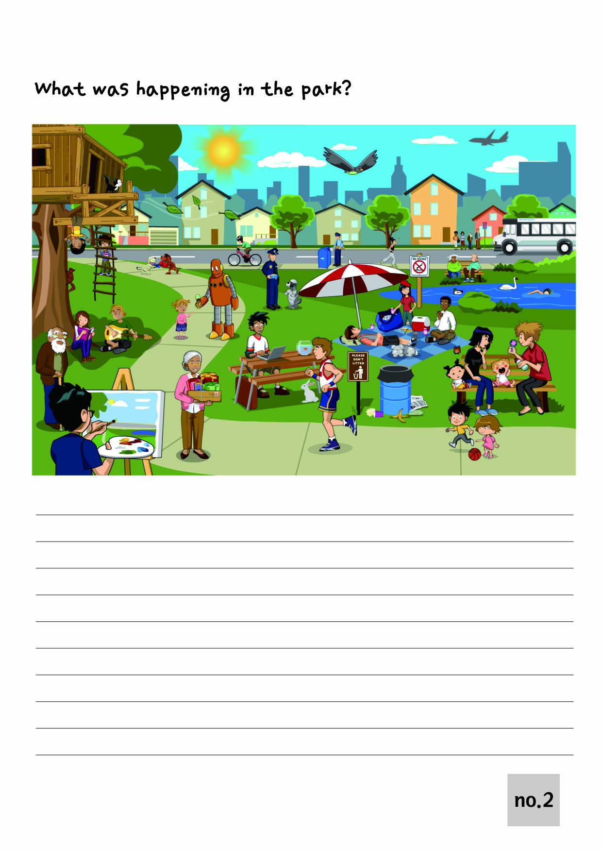  Okay. Had found what were they doing? Do you need more time to note?  Yes-> give them 30sec more.  No-> Good. Let’s share what we talked.  Feedback  Okay. Good job guys.  What were you looking in the park Dave? Any other answers?  (give a chance to every students talk their opinion)  (If someone can’t make a sentence, help to be make it.)  Ex) okay. Look the bird in the sky. What do you think what is doing the bird now?  Right. Than if you saw the bird yesterday, then you can say it was~~. Right. Okay. let’s make whole sentence.  When I came the park, the bird ______ ________. | T-S  S  T-S | 1min  3min  2min

Stage 5:_Freer Practice  The purpose of this stage is to allow student to practice using the target language productively in an authentic way. The focus is to encourage fluency, not accuracy, therefore errors should be monitored and only addressed if necessary. Correction should be given during the next stage. | Inter  action | Time | Instructor’s comments
Instruction  Play Alibi game for apply the grammar skills with discussion  (Explain how to they paly the game)  Okay. Great job everyone.  This time let’s paly a fun game to use what we learned!  Divide two groups.  (Divide two groups in four).  I lost my cellphone on 10:00am. Before 10:00, somebody stole my cellphone I guess.  I need your help to find a person who were stolen my phone.  Have you heard mafia game? This game is almost same with the game.  If somebody knows, please let other people know how to play after I explain.  Okay. Ill pick a suspect without anyone knowing. But the suspects never can say I am the suspect.  The suspect have to hide it till the end! And everyone should ask and make excuses each other.  During we doubting each other, what we have to talk is ask “what were you doing on 9-10?”  to someone who a doubting person, and the suspect should make a Alibi using “I was doing blah~ or when I came the classroom she was doing blah~”. Okay?  At the end, pick a person in the group who guess a suspect and vote with your thumb to take the person or let the person go. Understand?  Okay. Everyone down on the desk.  (Pick two suspects) I picked the suspects.  ICQ  What we ask to the suspect? What were you doing? Right.  What should you say about someone picked as a suspect? Right. Make alibi with “I was , or I saw she were doing something”  Okay. Let’s play. (if they need , do demonstrate once in short time)  (During they are playing, walking around them to monitoring and helping) | T  S | 3min  8min

Stage 6: Wrap-up  The purpose of this stage is to end the lesson with some positive feedback about the lesson and the students’ participation. Review the main points briefly, either deductively or inductively, or perhaps during error correction. Classroom management should be considered, such are collecting worksheets, giving homework, stimulate interest in the next class or arranging the desks etc. | Inter  action | Time | Instructor’s comments
Instruction  Review and close  Good job guys. Who was stolen my phone?  What was your alibi?  Who were the real suspects I picked?  (If they didn’t get as a suspects)-> Good job. You guys are really good at lie!  Well done everyone. Had you fun with today’s lesson?  Thank you. See you in next time. Have a good day, bye! | T-S  T | 40sec  20sec
Instructor’s Final Comments
Overall strengths of this lesson (planning and teaching) | Areas to work on

Overall comment

For this stage of the course, your lesson today was

- Above standard

- To standard

- Below Standard

Instructor: …………………………… Date: …………/……………/………… Student/s: ……………………….. .…………………………..

