Background Information Sheet
Name & Class | Date & Place |  | Lesson |  | Plan |  | Topic |  |  | Length | Level
Jiseon | 2/8/2017 |  | Grammar |  | PPP |  | He Studies English. |  |  | 35 min | elementary
Class profile
Number of students: 8 Age: elementary Nationality:
Motivations:
Individual or class hobbies and interests:
Special considerations:
Main aim
- Students understand present simple tense
Subsidiary aims
- Students practice speaking by doing discussion

Description of language skills specifically used/practiced:  - Speaking by discussion  - Writing by doing the worksheet  - Listening by focusing on others |  |  |  |  |  | Description of language systems specifically used/practiced:  - grammar  - function

Anticipated difficulties with lesson activities and classroom management:
Sts may have difficulties with doing activity.

How I can deal with these difficulties:

Instruct the sts one on one.
Assumptions: (That which provides insight about your choice of material, selection of target language etc.)
Ss have comfort to do activity with writing and speaking.
Ss have the knowledge of descriptive words.

Material(s) needed: board, marker, paper, pen

Checklist. Tick those included in this lesson plan (or N/A)
model sentences for target language |  |  |  | concept questions for target language |  |  |  |  | analysis sheet for target language
stages clearly titled and separated |  |  |  | purpose of each stage indicated |  |  |  |  | anticipated timing included
interaction pattern marked |  |  |  | a board plan (if relevant) |  |  |  |  | examples of all tasks used
answer sheet to all exercises |  |  |  | tape script |  |  |  |  | all materials labelled and numbered
Personal aim : What I most hope to demonstrate in this lesson is the ability to make sentence by using present simple tense.

Stage 1:_Lead-in  The purpose of this stage is to relax both teacher and students by focusing their attention on an interesting subject and encouraging the class to share their opinions freely, thus increasing STT and participation. This stage should be used to create an appropriate situational context. | Inter  action | Time | Instructor’s comments
Hello, everyone.  Look at this picture. What does this look like? > Ice cream.  Who does like ice cream? Ok. Anna likes ice cream.  What does he do? Study English.  (Gesture, make it longer) > He studies English.  Good job, everyone. | T  T-S  T-S | 1 min  1 min

Stage 2: Presentation  The purpose of this stage is to teach the target language deductively, referring to the situational context from the lead-in. Meaning, form and pronunciation should be covered with appropriate methods such as a model sentence, CCQs, timelines, substitution tables and indication of phonology etc. | Inter  action | Time | Instructor’s comments
Here are two answers you did.(attach the sentences on the board.) She likes ice cream.  (Point the first image) Is it false? No. / Is it true? Yes. (Write down “Fact” on the board.)  (Point the second image) Is this happening regularly? Or only one time?  Is it routine/ “habit”? Yes. (Write down “Habit” on the board.)  Look at these verb form.(make highlight under the verbs.)  Timeline :  Present simple  Past now future  (Write on the board: He studies English< Model sentence. ) / base form & -s form  S V  I / You / We / They study English  He / She / It studies  I / You / We / They have a dog  He / She / It has  I / You / We / They run every morning  He / She / It runs  (Elicit each subject forms, verb forms from sts. w/ pointing for drills)  (Distribute the printout worksheet.)  Let’s see each verb when and how it changes.  Look at the fist column. Most verbs plus –s. Let’s read the verbs together.  Look at the second column. Thank you. And the third column. (Read the verbs together) | T-S  T-S  T-S  T-S | 2 min  1 min  2min  2min

Stage 3: Controlled Practice  The purpose of this stage is to allow the students to accurately practice working with the target language’s form by doing easy, or controlled tasks. This helps build confidence before trying something more challenging. Students should apply the rules that were presented in a meaningful way whenever possible. Peer-checking before feedback is important in these practice stages. | Inter  action | Time | Instructor’s comments
Let’s see the worksheet page from 1 to 2 and answer the questions for 2 min.  ICQ) What pages you answer? 1 and 2.  How many minutes do you have? 2 min  (Sts do worksheet)  Now, check your answers in pair for 2 min.  Ok, let’s check the answers. (Distribute the answer sheet.)  (Check the answers individually) | T  S  Ss  T  S | 1min  2 min  2 min  1 min  1 min

Stage 4: Less controlled practice  The purpose of this stage is to allow students to practice the target language more thoughtfully, in terms of either structure manipulation, meaning, function or other aspects of language. Accuracy is checked before moving to the next stage. | Inter  action | Time | Instructor’s comments
Let’s see the next page of worksheet.  Answer those questions letter D, E for 2 min.  Let’s check the answers. Please write your answer on the board.  (Take Anna, Jessica, Amy, Sookhee, Timo turns from D 1-5.)  #1. Is this right?  #2. Is this right?  #3. How about this?  #4. This?  #5. And this?  Okay, everyone is doing great.  Let’s move on next question letter E. Emma, please let us know 4 wrong verbs in the question.  Okay, how do you make it right? (T writes the answers on the board.)  Emma, please read full passage correctly. | T  S  S  T-S  T  T-S | 1 min  2 min  2 min  1 min  2 min

Stage 5:_Freer Practice  The purpose of this stage is to allow student to practice using the target language productively in an authentic way. The focus is to encourage fluency, not accuracy, therefore errors should be monitored and only addressed if necessary. Correction should be given during the next stage. | Inter  action | Time | Instructor’s comments
Now, we’re going to practice to make a sentence with this worksheet in pair.  Make two sentences as many as possible in taking turns, using only present simple tense for 3 min.  It is okay to imagine based on the picture.  ICQ) How many sentence you make each turn? 2  How much time do you have? 3 min  (Sts Activity)  Okay. Let’s share the sentences what you got.  We are going to round 3 totally. In every round, each team member speaks 1 sentence. And take 2 more rounds. It is not allowed to say the same sentence.  Also, when is your turn, point your descriptive part in order to recognize where it is.  I start first. (point the somewhere of the picture)  A bike has a ribbon.  (After 3 rounds), Well done everyone. | T  T  S  T  Ss  T | 1 min  1 min  3 min  1 min  4 min

Stage 6:_Wrap-up  The purpose of this stage is to end the lesson with some positive feedback about the lesson and the students’ participation. Review the main points briefly, either deductively or inductively, or perhaps during error correction. Classroom management should be considered, such are collecting worksheets, giving homework, stimulate interest in the next class or arranging the desks etc. | Inter  action | Time | Instructor’s comments
(Show the second picture.) What does he do again? He studies English. Excellent.  You guys are so good today. Remember changing form of verb about “present simple tense” for the third singular subject.  In next class, we’re going to talk about negative and question form of present simple form.  Thank you. Have a good day.  . | T-S | 2 min
Instructor’s Final Comments
Overall strengths of this lesson (planning and teaching) | Areas to work on

Overall comment

For this stage of the course, your lesson today was

- Above standard

- To standard

- Below Standard

Instructor: …………………………… Date: …………/……………/………… Student/s: ……………………….. .…………………………..

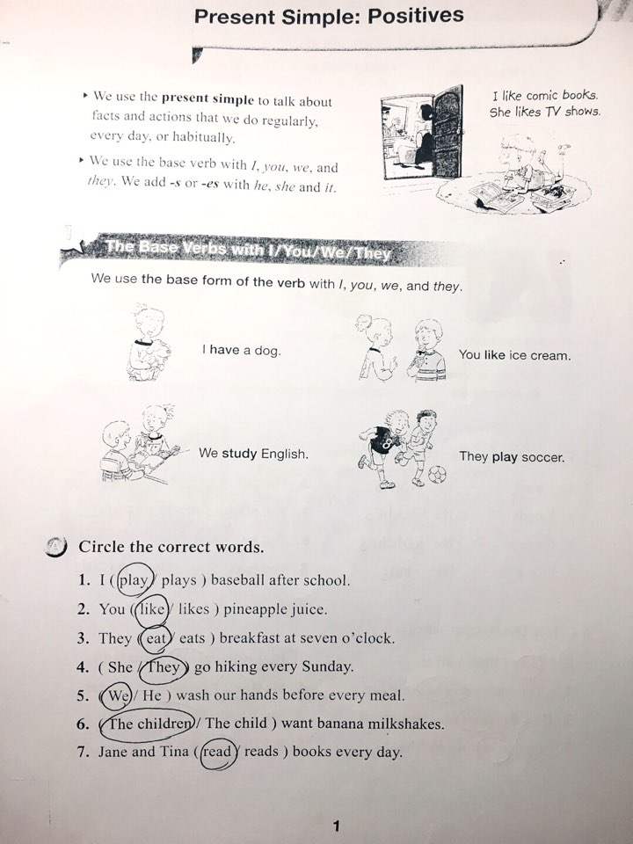
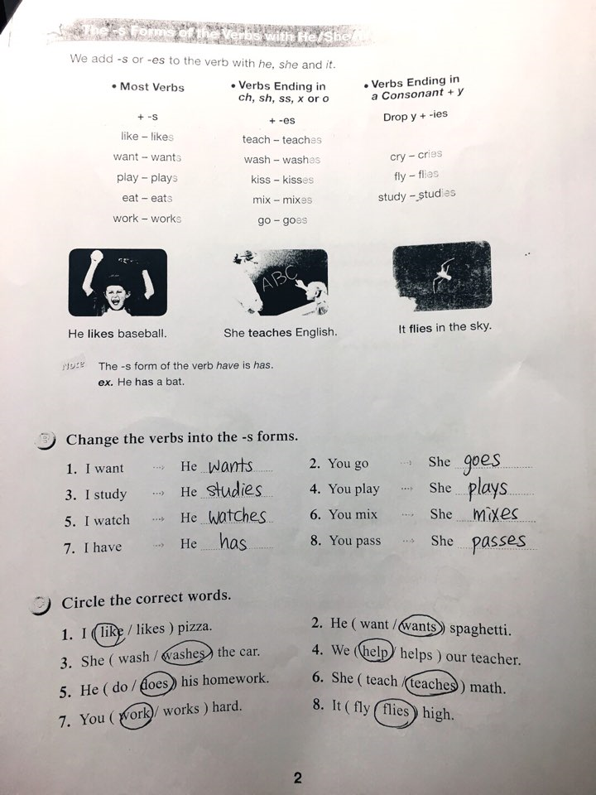
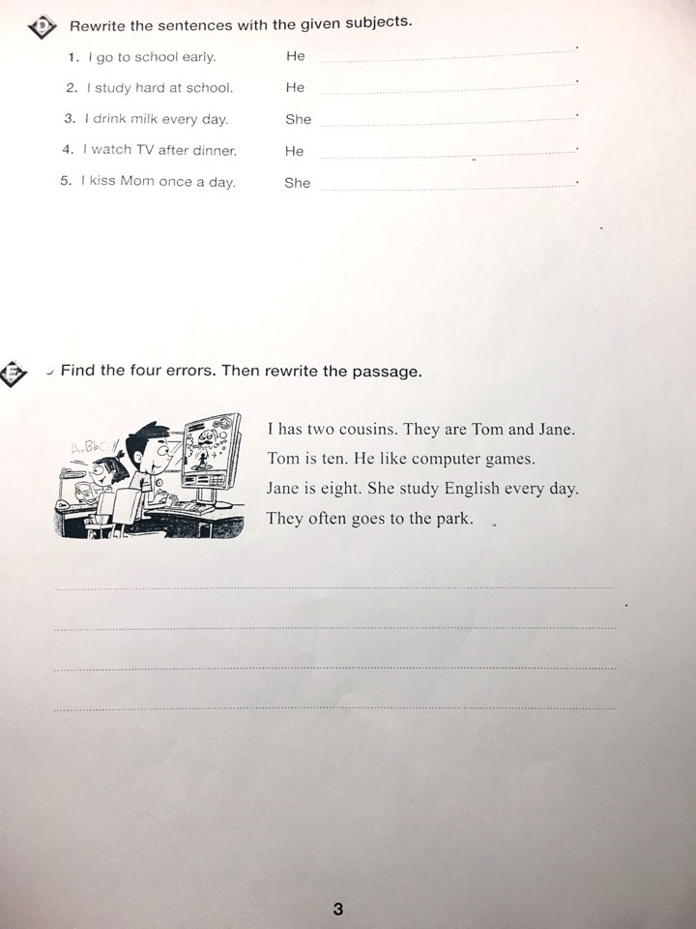 (Picture 1)

She likes ice cream.
Fact

(Picture 2)
He studies English.
Habit

