(Picture 1)

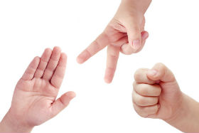

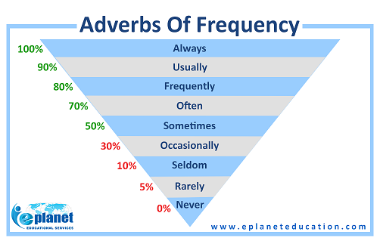

Adverbs of frequency come after the verb ‘be’.
She is sometimes late.
The students are never bored.

Adverbs of frequency usually come before other verbs.
She often checks her answers.
He usually pays attention in class.

(worksheet 1) A. Discover the Grammar
Read the paragraph about Josh Wang. Find and circle the 10 adverbs of frequency.
Josh Wang has an active life. He usually gets up at 6:00 A.M. He always runs 2 or 3 miles with his dog. Sometimes he feels tired, but he still runs. When he gets home from running, he has breakfast. He often has eggs, juice, toast, and coffee, but sometimes he has cereal and fruit. Then Josh goes to work, and he’s never late. He works from 9:00 until 5:00 pm. He rarely stays late. In the evenings, Josh sometimes reads. Josh is also an artist, so sometimes he paints. He’s always in bed by 10:30.

B. Working together
Work with a partner. Look at the pictures. Say what you never, sometimes, or often eat.
Example: A : I never eat carrots.
B : Really? I often eat carrots. I never eat red meat.
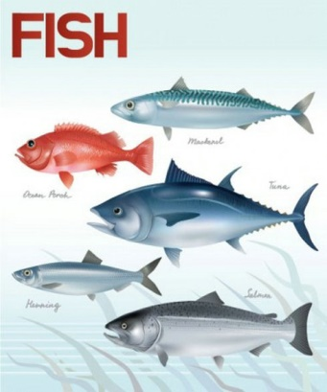
Doughnuts red meat Ice cream
(worksheet 2)
* Write true statements about yourself. Use the words in parentheses and an adverb of frequency. (2mins)

always, - usually, - often, - sometimes, - seldom, - rarely, never

- (get up at seven o’clock)
_________________________________________________________________________________
- (exercise on weekends)
_________________________________________________________________________________
- (play computer games in the evening)
_________________________________________________________________________________
- (eat breakfast)
_________________________________________________________________________________
- (sleep till noon on Saturday)
_________________________________________________________________________________
- (play tennis or soccer)(choose one)
_________________________________________________________________________________
- (watch TV before I go to bed)
_________________________________________________________________________________
- (get enough sleep)
_________________________________________________________________________________

* After completing the sentences, share it with your partner. (2mins)
* Then tell the class 2 things about your partner. (2mins)
(worksheet 3)
C. (Daily activities)
Look at the pictures. Make a full sentence using adverbs of frequency.
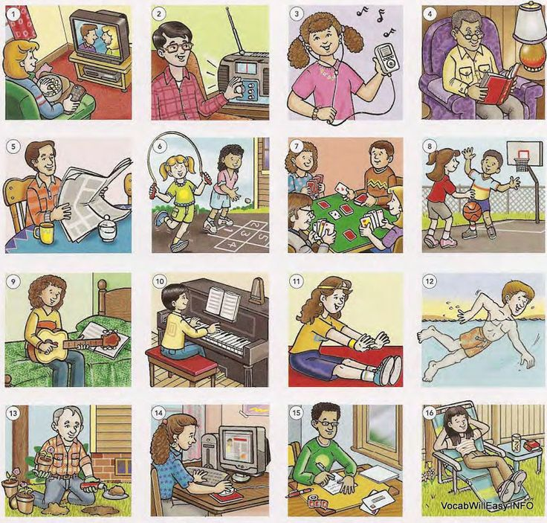
1)________________________________________________________________________
2) ________________________________________________________________________
3) ________________________________________________________________________
4) ________________________________________________________________________
5) ________________________________________________________________________
6) ________________________________________________________________________
7) ________________________________________________________________________
8)________________________________________________________________________
9) ________________________________________________________________________
10)________________________________________________________________________
11)________________________________________________________________________
12)________________________________________________________________________
13) ________________________________________________________________________
14)________________________________________________________________________
15)________________________________________________________________________
16)________________________________________________________________________

D. Tell about your daily routine using adverbs of frequency.
(group activity)

