Listening Speaking Reading Grammar Writing

Topic: Negative Question and Answer

Instructor:  Sophie Kim  Jen Kim | Level:  Intermediate(Adult) | Students:  12 Students | Length:  30 Minutes

Materials:
- Realia: A song called Aren’t You Glad, a video file for listen and repeat practice, a small power point lecture to explain the grammar
- Worksheet #1: Lyric fill-in-the-blanks (12 copies)
- Worksheet #2: Negative question and answer practice (12 copies)
- Worksheet #3: SOS activity for negative Q&A practice (12 copies)
- Pictures: Speed game to ask negative questions (more than 50 different pictures)
- ‘Yes’ and ‘No’ panel: Speed game to answer negative questions
- Computer for presentation and music play
- White board and board markers

Aims:
- Main aim: Students will be able to improve their grammar skills by learning how to ask and answer negative questions.
- Secondary aim: Students will be able to ask and answer negative questions as quickly as possible because it is totally different than the Korean grammatical structure. This different way of thinking should come out quickly and naturally.
- Personal aim: I want to speak clearly in front of the students and manage my time well in each section.

Language Skills:
- Reading: Students will read the power point lecture and worksheets
- Listening: Students will listen to the song lyrics and their partner
- Speaking: Students will communicate with their partners from the worksheet activities and the speed game
- Writing: Students will write song lyrics and fill out worksheets

Language Systems:
- Phonology: Practice pronunciation of contractions
- aren’t, weren’t, wasn’t, isn’t, don’t, doesn’t, didn’t
- Lexis: New words from the lyrics and worksheets
- feeling bold: confident and determined
- court, subscribe, refuse, trial, fencer
- Function: Asking and answering
- Grammar: Negative question and answer
- Discourse: Lyric and conversation

Assumptions:
- How the class is set and run (U-shaped seating arrangement)
- Four language skills and language systems
- Students are willing to speak with their partner

Anticipated Errors and Solutions:
- If students need linguistic help to express their opinions during discussion
give them linguistic support by providing definitions and some examples
- If some students keep quiet for fear of upsetting other people during the discussion
encourage them to speak and advise them to be clear about their point
- If certain students dominate the discussion
ask them to give other students a chance to speak

References:
- Visual aid: A video file of grammar exercise
https://www.youtube.com/watch?v=YICtrmYTJl0
- Visual aid: A music file of “Aren’t you glad”
https://www.youtube.com/watch?v=lM6wdxCIook
- Pictures: Google Images

Lead-In
Materials: None
Time | Set Up | Student Activity | Teacher Talk
1 min | Whole class | Answering teacher’s questions | Good afternoon, everyone! How are you today? Didn’t you have fun during the weekend? Aren’t you tired now?

Pre-Activity
Materials: Board, Board makers, Visual Aid, Worksheet #1
Time | Set Up | Student Activity | Teacher Talk
2 min  3 min  1 min  3min  3min | Whole  class  Individual  Whole  Class  Whole  Class  Whole  Class | Answering teacher’s questions.  Fill in the blanks on the worksheet #1  Speak answers together  Speak answers together  Listen and repeat together | Procedure:  1. Warm-up questions  Elicit  Don’t you like the class? Didn’t you learn a lot? We only have 2 weeks left. Aren’t you happy?  Additional explanation  (Pause) Didn’t you catch anything? How have I been asking questions so far? Did I ask in a positive or negative manner? Yes, that’s right. I’m using negative questions.  Model  Write down the subject “Negative question and answer” on the board.  “Today, we are going to learn about negative questions and how to answer them because they are quite different than Korean grammar”  CCQ  To answer negative question, is it different than Korean grammar?  Did I use contraction when asking negative question?  2. Pre-Activity: fill-in-the-blanks of the song lyric  Instruction  “Let’s listen to the song and try to fill in the blanks with the correct lyrics while listening. You will do it individually.”  (Distribute the worksheet #1)  “Did everyone get worksheet #1?”  ICQ  What do you write in the blanks?  Do you work in groups?  (Play the song)  Monitoring  Monitor discreetly by walking around the class. Get close to students. Listen and answer to students if they ask questions.  Check answers  “Let’s check the answers together.”  (Check the answers with the class)  After checking the answers, compliment the students.  3. Small Grammar Lecture  Instruction  “Let’s look at the power-point. We are going to learn about negative question and answer. Please answer them together”  “Let’s look at number 1.  What word should go first?”  (Fill the blanks with students)  CCQ  Do you understand the pattern?  Model  (Show the power-point slide)  “Remember. in English, when you answer a question, yes is always yes and no is always no.”  “The answer to positive and negative questions are the same!”  4. Video: Listen and Repeat  Instruction  “Now, let’s look at the video for grammar exercise. Listen and repeat.”  (Play the video file (2:35))  Compliment students  “Great Job!”

Main Activity
Materials: Worksheet #2
Time | Set Up | Student Activity | Teacher Talk
3 min  3 min | Pairs  Whole class | Students will do the worksheet #2 with their partner. | 1. Main activity  CCQ  Aren’t the answers to negative and positive questions the same?  Instruction  I will give you another worksheet. You are going to work in pairs. You need to write down the right word for the questions. We will give you 3 minutes.  (Distribute the worksheet #2)  Demonstration  We are going to do the number one together.  “What is ….?  Yes, that’s right”  ICQ  Are you working in pairs?  How much time do you have?  Monitoring  Monitor discreetly by walking around the class. Get close to students. Listen and answer to students if they ask questions.  “Okay, Time is up”  Check answers  “Let’s check the answers together.”  (Ask each team for the answer)  After checking the answers, compliment the students.

Post Activity
Materials: Pictures for speed game
Time | Set Up | Student Activity | Teacher Talk
10 min  1min | Pairs | Students are playing the game | 1. Free production  (Speed Game)  Instruction  “Now, we will do a speed game together. You will make a team with your partner. One person will make a question and the other person will answer the question while looking at the picture. Answer the question using the Yes or No panel”  “You will have only 1 minute to ask and answer as many questions as possible. The group that answers the most questions wins the game”  Demonstration  We will show the demonstration first.  (Look at the picture)  Q: Isn’t she tall?  A: Yes. She is.  ICQ  Are you working with partners?  What does one person do?  What does the other person do?  “Okay, can the first group come out?”  (Each group will come out in front of the class and play the game)  Monitoring  Monitor discreetly. If a student is making a mistake, correct it with nice manner.  Feedback  “Okay, everyone. Who has the most pictures? Great job! Wasn’t it fun?”  2. Conclude Lesson  Summarize today’s lesson.  “Everyone did a great job today! Today, we learned about negative questions and how to answer it. Wasn’t it easy? Didn’t you have fun? Can’t you answer positive and negative sentences differently?  Great. Have a good day.”

SOS Activity
Materials: Worksheet #3
Time | Set Up | Student Activity | Teacher Talk
4 min  3min  3 min | Individual  Pairs | Students are working individually  Students are answering the questions  Students are speaking with their partners | 1. Grammar Worksheet: Make negative question and answer  Instruction  “Okay. Let’s practice negative questions more. Look at the worksheet #3.  (Distribute worksheet #3)  You need to make a sentences using the given words. You will do it individually. You will have 4 minutes to complete the worksheet.  Demonstration  Let’s do number 1 together.  ICQ  Are you working alone?  Monitoring  Monitor discreetly by walking around the class. Get close to students. Help them if they are having a difficulty.  Check Answers  Ask each student to check answers together.  (If you need more time, do following activity)  More Activity  “Let’s read the sentences with your partner. Ask question and answer them”  Conclude  “Great job, everyone! Don’t forget how to answer negative questions!”
Visual Aid: Small Power-point Lecture
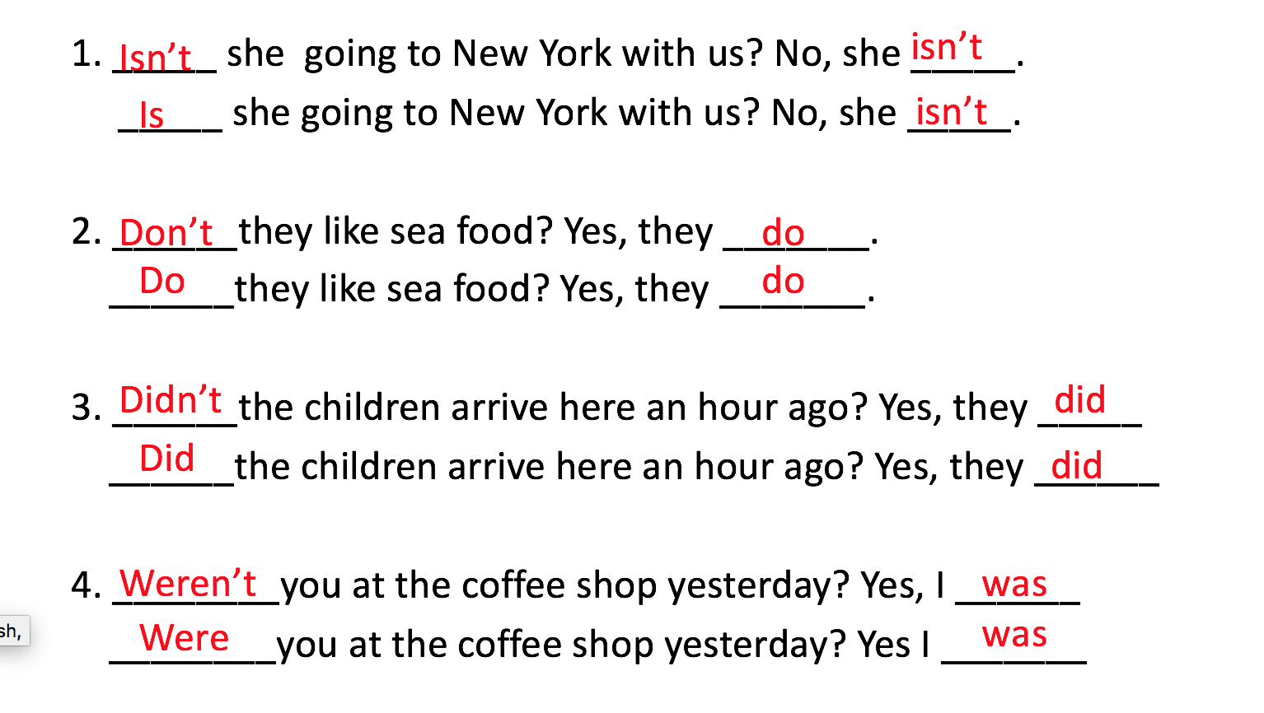

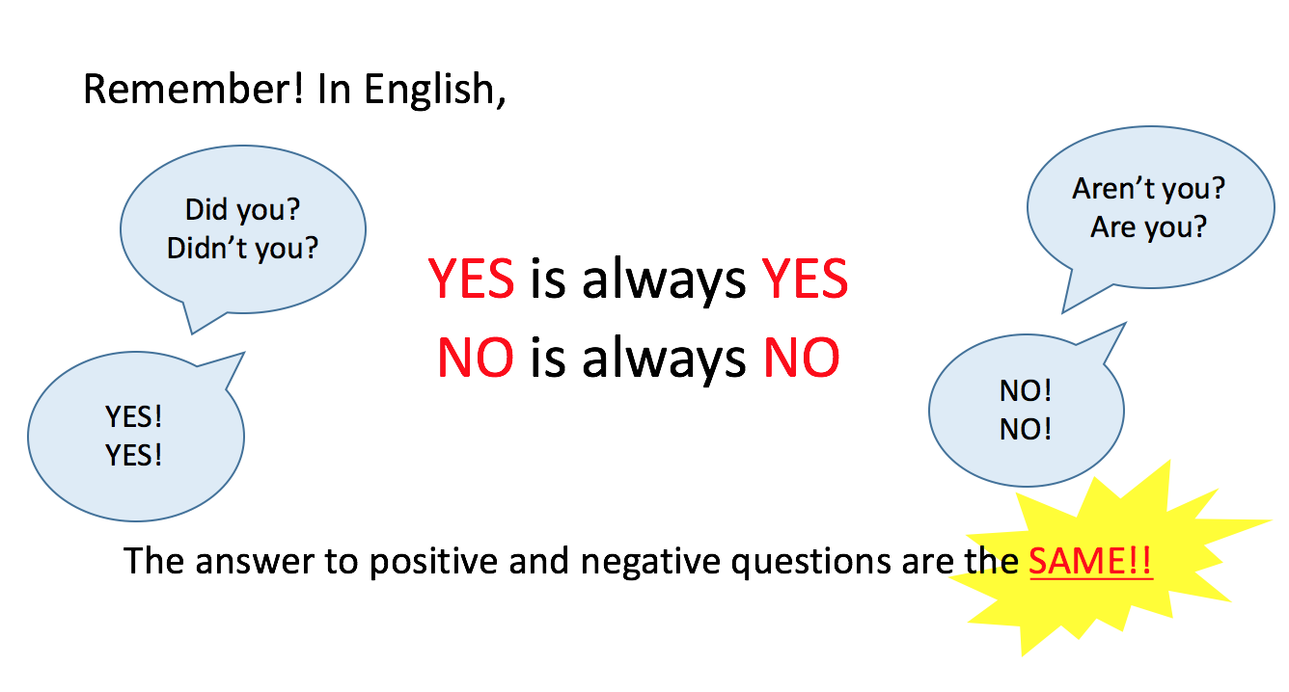

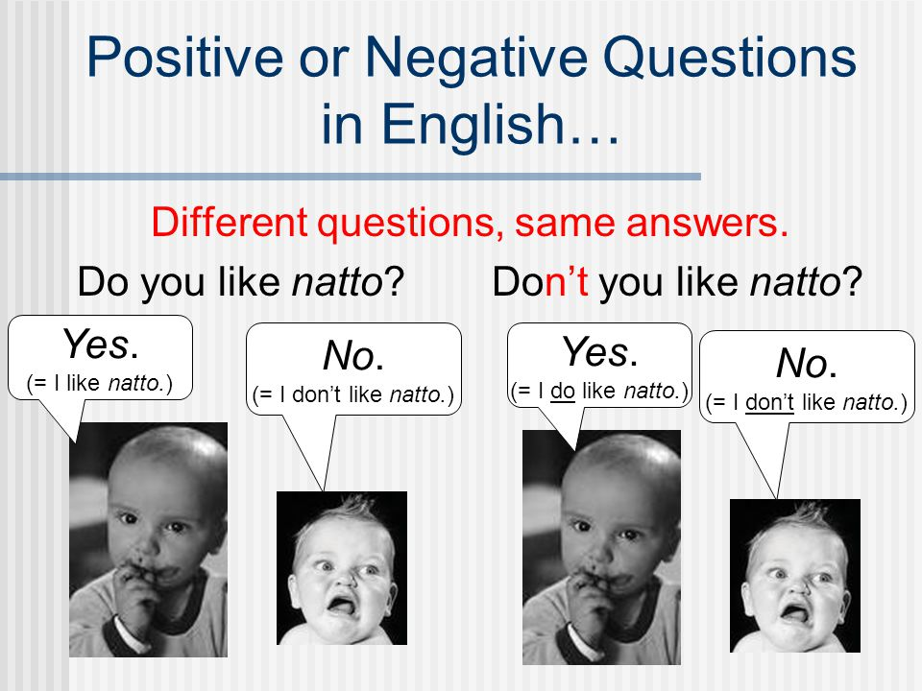

Worksheet #1
Fill in the blanks while listening to the song

Aren't You Glad

Spirit [California]

__________ _______ glad you're glad you're glad baby
________ ________so glad I'm that baby
________ ________know you know baby
_______ _____ ________it's so baby
Heard you say you needed _____________
But in your house the word is _____________
__________ _______ glad you're glad you're glad baby
________ ________so glad I'm that baby
________ ________know you know baby
_______ _____ ________it's so baby
Streets are yours _________ feeling much bolder
But summer has gone ________ all a bit older
now

Worksheet #1 Answer
Fill in the blanks while listening to the song

Aren't You Glad

Spirit [California]

Aren’t you glad you're glad you're glad baby
Yes I’m so glad I'm that baby
Don’t you know you know baby
Yes I know it's so baby
Heard you say you needed direction
But in your house the word is correction
Aren’t you glad you're glad you're glad baby
Yes I’m so glad I'm that baby
Don’t you know you know baby
Yes I know it's so baby
Streets are yours you’re feeling much bolder
But summer has gone we’re all a bit older
Now
Worksheet #2
Negative Questions and Answers

Choose the correct words from the box to make negative questions

Doesn’t Didn’t Wasn’t Weren’t Don’t

1. _________ you at court yesterday?
2. _________ you think I should subscribe to a newspaper?
3. _________ Keunhae look different than 4 years ago?
4. _________ Soonsil refuse the trial last time? She refused the trial again.
5. _________ Youngtae a fencer before?

Look at the pictures and choose the correct answer (Yes or No)

Picture | Question | Answer
 | Didn’t she drink the wine?  Did she drink the wine? | _____, she ________.  _____, she ________.
 | Isn’t the pot blue?  Is the pot blue? | _____, it ________.  _____, it ________.
 | Weren’t we playing on the beach?  Were we playing on the beach? | _____, we ________.  _____, we ________.

Make your own negative sentences and practice with your partner
1. Weren’t you ____________________________? Yes, __________ No, __________
2. Wasn’t she ____________________________? Yes, __________ No, __________
3. Doesn’t he ____________________________? Yes, __________ No, __________
4. Didn’t we ____________________________? Yes, __________ No, __________
Worksheet #2 Answer
Negative Questions and Answers

Choose the correct words from the box to make negative questions

Doesn’t Didn’t Wasn’t Weren’t Don’t

1. Weren’t you at court yesterday?
2. Don’t you think I should subscribe to a newspaper?
3. Doesn’t Keunhae look different than 4 years ago?
4. Didn’t Soonsil refuse the trial last time? She refused the trial again.
5. Wasn’t Youngtae a fencer before?

Look at the pictures and choose the correct answer (Yes or No)

Picture | Question | Answer
 | Didn’t she drink the wine?  Did she drink the wine? | Yes, she did.  Yes, she did.
 | Isn’t the pot blue?  Is the pot blue? | No, it isn’t.  No, it isn’t.
 | Weren’t we playing on the beach?  Were we playing on the beach? | Yes, we were.  Yes, we were.

Make your own negative sentences and practice with your partner
1. Weren’t you ____________________________? Yes, __________ No, __________
2. Wasn’t she ____________________________? Yes, __________ No, __________
3. Doesn’t he ____________________________? Yes, __________ No, __________
4. Didn’t we ____________________________? Yes, __________ No, __________
Worksheet #3: SOS Activity
Make negative questions and answers by using given words

1. | win/baseball match/did/yes
 | Didn’t she win the baseball match? Yes, she did.

2. | stop/the baby from/shouting/Will you/no

3. | give/money to the robber /is going to/no

4. | Normally take out/rubbish/does/no

5. | get married/September/are/yes

6. | catch/a fish/did/no

7. | finish/dinner/have/no

Worksheet #3: SOS Activity Answer
Make negative questions and answers by using given words

1. | win/baseball match/did/yes
 | Didn’t she win the baseball match? Yes, she did.

2. | stop/the baby from/shouting/Will you/no
 | Won’t you stop the baby from shouting? No, I won’t.

3. | give/money to the robber /is going to/no
 | Isn’t he going to give money to the robber? No, he isn’t.

4. | Normally take out/rubbish/does/no
 | Doesn’t he normally take out the rubbish? Yes, he does.

5. | get married/September/are/yes
 | Aren’t they getting married in September? Yes, they are.

6. | catch/a fish/did/no
 | Didn’t he catch a fish? No, he didn’t

7. | finish/dinner/have/no
 | Haven’t they finished dinner? No, they haven’t

