|  |
| --- |
| Listening Speaking Reading ▪Grammar Writing |
| **Topic: How to use proposition** |

|  |  |  |  |
| --- | --- | --- | --- |
| Instructor:  Ji Soo Kim (Jisoo)    Da Eun Na (Daeun) | Level:  **Intermediate (Adult)** | Students:  **12 students** | Length:  **30 Minutes** |

|  |
| --- |
| Materials:  ▪ Realisa: Drama poster (1ea), Picture(1ea)  ▪ White board and board markers  ▪ Worksheet# 1,2,3,4 (each of 12 copies) |

|  |
| --- |
| Aims:  ▪ Main aim: Ss will be able to improve their grammar skills by talking &writing and  understanding how to use propositions during the lesson.  ▪ Secondary aim: Ss will be able to learn about using propositions when talking  about time, direction, position & movement in their every life.  ▪ Personal aim: I want them to enjoy talking with that proposition can used to show  relationships between the object and other world in sentence as naturally. |

|  |
| --- |
| Language Skills:   * Reading: Ss will read meanings of world when they read the article. * Speaking: Ss will discuss with partner & sharing personal opinion when describing of pictures. * Listening: Ss will listen to each other conversation * Writing: Ss will write the location & movement vocabulary from the list on Proposition. |

|  |
| --- |
| Language Systems:   * Phonology : pronunciation of word the Vincent van Gogh * Lexis : New vocabularies in the article.(stability, Gauguin, distinctive etc) * Function : Statement of personal opinion * Grammar : Prepositions and present tense * Discourse : New article |

|  |
| --- |
| Assumptions:  Students already know   * How the class is set up and run (there will be 12 students who already know each other) * Four language skills and language systems * Basic structure of proposition in sentence |

|  |
| --- |
| Anticipated Errors and Solutions:   * If students need linguistic help to express their opinions during discussion * Give them linguistic support by providing definitions and some examples * If some students keep quiet for fear of upsetting other people during discussion * Encourage them to speak and advise them to be clear about their point. * If certain students dominate the discussion * Ask them to give other students a chance to speak |

|  |
| --- |
| References:  --English dictionary  www.dictionary.com  https://www.easypacelearning.com/all-lessons/grammar/1317-prepositions-examples-in-a-sentence-with-pictures-learning-english  -Picture-  https://www.aliexpre​ss.com/item/Road-Wit​h-Cypress-and-Star-V​incent-Van-Gogh-artw​ork-oil-Painting  https://www.overstoc​kart.com/painting/ro​ad-with-cypress-and-​star |

|  |  |  |  |
| --- | --- | --- | --- |
| **Lead-In** | | | |
| Materials: | | | |
| Time | Set Up | Student Activity | Teacher Talk |
| 2 min | Whole class | Answering teacher’s questions | Good morning! How are you today?  Rachel, How long have you been working as English teacher?  Anna, Where do you live?  Christina, what time did you go to bed last night?  Helen, When is your wedding anniversary?  Ok. Thank you for sharing about your dairy life.  Did you notice that which part of grammar can be used in sentences when they reply about time?  Today we're going to learn about preposition. |

|  |  |  |  |
| --- | --- | --- | --- |
| **Pre-Activity** | | | |
| Materials: Worksheet #1 | | | |
| Time | Set Up | Student Activity | Teacher Talk |
| 5 min | Pairs | Students describe the picture after they looked at the picture | Procedure  **1. Brainstorming**  Elicit  (Show the students poster of drama)  There are two people in the picture.  What are they doing?  where are they now?  Can you describe the situation with their gesture in the picture?  (Additional explanation can be added)  She is sitting crossed-legged on the beach and holding the cake, she's turning her head to the left side and looking at the man after blowing out the candles. On the right side the man is standing with some flowers and looking at her. They are staring at each other.  Additional explanation / Model  “Today, we are going to learn about how to use propositions in sentence  in English.  CCQ  What is the proposition?  (It's a word or phrase the describe the relationship between the object and word. for example: Jayme is in Taipei. The proposition "in" shows the relationship between "Jayme and Taipei)  How many prepositions are in the English language?  (There are about 60 common propositions and combines with a noun, pronoun to show location, time, or movement) |
| 3min | Pairs | Students start writing down the words. | Model  Write the subject “how to use propositions in sentence" on the board  **1.describe using proposition of movement**  Instruction  "Before we start, We should learn some common type of prepositions. I will give you list of prepositions from A to Z. they can be used when describing pictures.  Please read this first, then use as reference when you task.  And I will give another worksheet.  Look at the pictures carefully and describe using proposition of movement and talk about the situation in the picture with your partner and then write the sentence in the space with right the preposition.  Let’s do this job in pair.  (Teacher instruct the partner for each)  Work together with your partners. I will give you 5 minutes to finish.  (Distribute the worksheet #1, reference  list of propositions)  Look at the paper, and we slove #1 together  Demonstration  Look at #1.....Right, it means....  ICQ  What do you write in the blanks?  Are you working in groups or pairs?  How much time do you have?  “Let’s get it started” |
| 2min | Whole class | Students start writing down the word.  Students check answers | **Monitoring**  Monitor discreetly. Answers students if they ask questions.  After monitoring & watching how much Ss filled in blanks, give time warning:  1 minute: 30 seconds left.  (Be flexible with time. Give 1 more minute if they need it.)  “Time’s up”  **Check answers**  Let’s check the answers together.  Please look at the screen for the answer, And check with your partner together.  (Answer key will appear on the screen)  (After checking, Teacher can ask some question to the students.) |

|  |  |  |  |
| --- | --- | --- | --- |
| **Main Activity** | | | |
| Materials: Picture + Worksheet #2 (12 copies) | | | |
| Time | Set Up | Student Activity | Teacher Talk |
| 5min  4min  1 min | Individually  Pair  Whole class | Students describe the picture after they looked at the picture  Students fill in the blank on worksheet.  Students check answers | **1. Prediction**  Elicit  (Show the students picture on the board)  There are some people, trees, houses etc  What are they doing?  What do you see?  Can you see the where it is?  Additional explanation  The small village is surround by wheat fields. Cypress tree in the centre of the painting. a couple are talking a stroll down a path with a yellow wagon with a white horse in harness.  there is old inn yellow lighted windows behind the wagon. At the bottom of the picture, two farmers are walking and wearing a hat with agricultural equipment. Moon is on the top of right side, evening star is on the left side of the painting.  Instruction  Now, we are going to learn about how to use proposition of location in sentence. I will give you worksheet. look at the picture carefully and describe using proposition of specific location and make a sentence in space with right the proposition.  (Distribute the worksheet#2)  Let’s do this job individually.  I will give you 5mins to finish.    ICQ  What do you write in the blanks?  Are you working in groups?  Are you working individually?  How much time do you have?  “Are you working in group or pair?”  “Will you try to use this worksheet when you describe of the picture?  (wait Ss answer)  “How much time do you have? (Ss answer)  Okay, let’s begin”  Monitoring  Monitor discreetly. Answers students if they ask questions.  Give time warning:  1 minute: 30 seconds left.  (Be flexible with time. Give 1 more minute if they need it.)  “Time’s up”  Check answers  Let’s check the answers together.  Please look at the screen for the answer, And check with your partner together.  (Answer key will appear on the screen)  (After checking, Teacher can ask some question to the students.)  “Okay, did you enjoy the activity?”  “(call a student’ name),  What is propositions?  Can you tell me most common 3 type of propositions?  (The Student answer it)  “Okay, good job.” |

|  |  |  |  |
| --- | --- | --- | --- |
| **Post Activity** | | | |
| Materials: Worksheet #3 **Story of the ‘Vincent van Gogh’** | | | |
| Time | Set Up | Student Activity | Teacher Talk |
| 2min  2min | Whole class  Whole class | Answering teacher’s questions    Teacher and students work  together one sentence. | **Story of the ‘Vincent van Gogh’**  Instruction  ‘“Hello everyone, now, We will do another activity which is Story of the ‘Vincent van Gogh’.  I will give you Worksheet.  (Hand Out WorkSheet#3)  T: So Let’s look at the worksheet  Can you see the pictures on the worksheet?  (Ss: Yes! Yes!)  T: do you know whose works?  (Ss: these are ‘Vincent Van Gogh’)  (cf: Ss: I do not know teacher!)  As you probably know, ‘Vincent van Gogh’ right?  He is very famous artist of the impressionism.  Now, we are going to practice preposition by Van Gogh’s life.  so, we let’s look at the 1st sentence together before we practice activity..  Q: who want read the 1st sentence?  (if someone want to read, one read.  Or if anyone does not want to read, I pointe one person)  (# reading 1st sentence)  So can you see blank?  What we write on the preposition 1st blank? You can find example box.  Ss: ‘into’  T: right!, good! And next blank is…?  Ss: it’s ‘from’  T: very good! Now we start to write on the Blank and we work with your partner and let’s check together! OK? I will give 5 min.  CCQ  How much time do you have?  Who do this one together? |
| 5min  3min  1min | Pairs  Whole class  Whole class | Students Fill in the blank with partners..  Students answer check with teacher.  Review & check together | Monitoring  Ss will fill in the blank the worksheet with partners.  Check the answer  “OK, everybody, the time is up. I think you are doing well. Then let’s check with your partners  T: did you check together finish?  (Ss: Yes)  T: OK. Now we start to check you answer together.  Is there anyone who volunteers to answer?”  (if there is none, pick some students and ask them to present that out  )  **Conclude lesson**  Review today’s lesson by checking activity how to use preposition.  Give positive feedback and opinion about today’s activities.  T: very good every one. You did a great work today, Thank you for participating. |

|  |  |  |  |
| --- | --- | --- | --- |
| **SOS Activity** | | | |
| Materials: Worksheet # 4 play game ‘Bingo’ | | | |
| Time | Set Up | Student Activity | Teacher Talk |
| 5 min | Whole class | Students play ‘Bingo’ together. | Instruction  T: Now, we have some time to review.  So. Do you remember that we study prepositions, don’t we?  T: Okay I will give you worksheet about ‘Bingo’  (Hand out worksheet #4).  T: the game is the preposition of Bingo.  There are prepositions in the box.  The winner is who makes 3 lines first.  .  I will give you 5 minutes. Please do with your partner. Let’s get it started.  (monitoring the student’s activity)  T: Everybody finished?  Who wants start?  Teacher ask student one by one and  If someone makes five Bingo first, one is a winner  Okay, we finish the class today and everyone. Thank you. |

**<Teacher’s material #1>**

[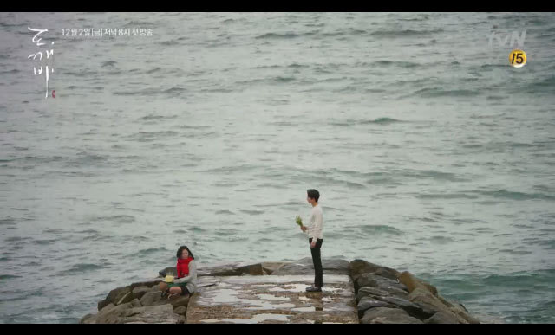](http://www.google.co.kr/url?sa=i&rct=j&q=&esrc=s&source=images&cd=&ved=0ahUKEwjUqtL6-ITSAhXIbrwKHQlrDzEQjRwIBw&url=http://9doxstar.tistory.com/19&psig=AFQjCNENuyYDLBzvxZGgYsJ0S7uUPiQ8ag&ust=1486795982046969)

**Drama 도깨비**

**Worksheet #1**

Prepositions of movement exercise

￭ *Describe* using proposition of movement & write the sentence in the space preposition.

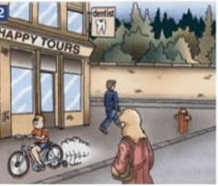 1 2 3

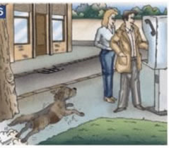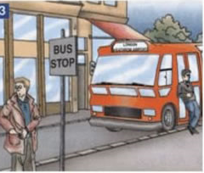

∙

∙

∙

∙

∙

∙

∙

∙

∙

∙

∙

∙

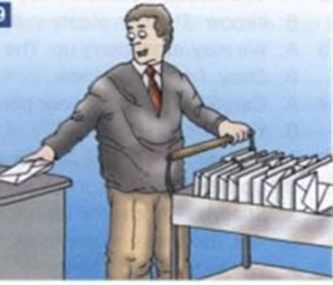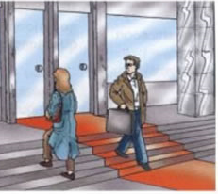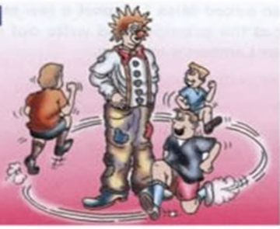

**4 5 6**

∙

∙

∙

∙

∙

∙

∙

∙

∙

∙

∙

∙



**7** **8**

∙

∙

∙

∙

∙

∙

∙

∙

★Worksheet#1 Answer Check Prepositions of movement exercise

**1** The dentist’s is above/over the travel agent’s.

The travel agent’s is below the dentist’s.

A man is walking past the travel agent’s.

A woman is walking across the street.

A boy is cycling along the pavement.

**2** The bus is going from London to Heathrow Airport.

The bus driver is leaning against the bus.

There is a man at the bus stop.

**3** He’s talking some money out of his pocket.

The man is standing in front of the woman.

The woman is standing behind the man.

The dog is running towards them

**4** The clown is standing among the children.

They are all running round/around him.

**5** The woman is going up the steps and

The man is coming down the steps.

**6.** He’s taking the letters off the trolley

And putting them onto the desks.

**7.** The knife went through his chest. (or The man is standing with

a big sword stucking in chest and she is pointing at him)

There is one light above the light side wall

**8.** They are standing in front of hall

He touches on her hair. They are standing on the floor.

List of prepositions from A to Z

|  |  |  |  |  |
| --- | --- | --- | --- | --- |
| A  aboard about above across after against along alongside amid among amongst around as aside astride at atop    B  barring before behind below beneath beside besides between beyond but by | C  circa concerning considering    D  despite down during    E  except excepting excluding    F  failing following for from | I  in including inside into    L  like    M  minus    N  near nearby next notwithstanding    O  of off on onto opposite outside over | P  past per plus    R  regarding round    S  save since    T  than through throughout till times to toward towards | U  under underneath unlike until unto up upon    V  versus via    W  with within without worth |

**<Teacher’s material #2>**

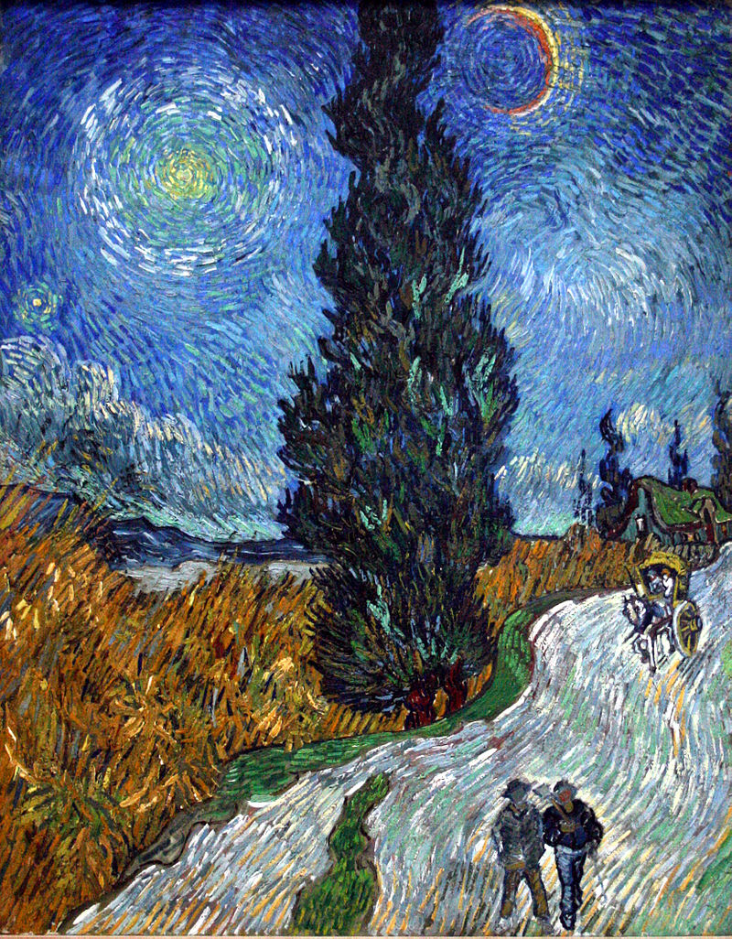

Road with Cypress and Star, May 1890

**Worksheet #2** Prepositions of Place and Location exercise

￭ *Describe Van Gogh’s bedroom using there is/ there are and prepositions (on, in, Under, above, in front of)*

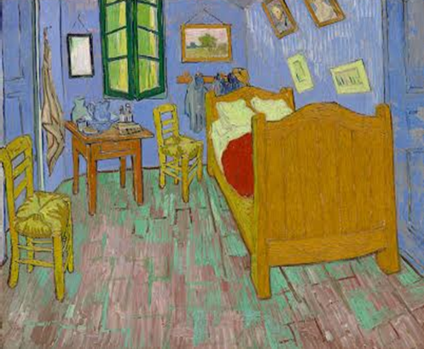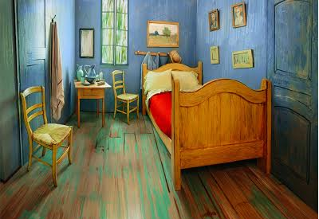

|  |
| --- |
| Pictures vases Pillows Doors Towel Chair Jug Coats |

|  |
| --- |
| 1. |
| 2. |
| 3, |
| 4. |
| 5. |
| 6. |
| 7. |
| 8. |

★Worksheet#2 Answer Check Prepositions of Place and Location exercise

￭ *Describe Van Gogh’s bedroom using there is/ there areand prepositions (on, in,*

*Under, above, in front of)*

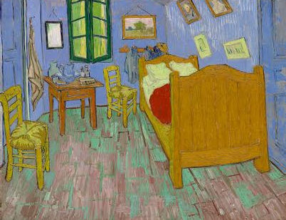

|  |
| --- |
| Pictures Vases Pillows Doors Towel Chair Jug Coats |

|  |
| --- |
| 1. There are 4 pictures on the right wall. |
| 2. There are two pillows on the bed |
| 3. There is one door on the right |
| 4. There is one chair in front of door and there is another chair is under the window. |
| 5. There is the towel hang over the floor. |
| 6. There is one jug between two vase on the table in the corner. |
| 7. There are coats in front of the bed |
| 8. There are two vases on table |

**Worksheet #3** ***Vincent van Gogh***

￭ *Read the text about Van Gogh. Your task is to put the correct prepositions in a space.*

**

with, by, up, at, over, until, on, In, as, to, of, into

Vincent van Gogh (1853–1890) was born and raised the oldest surviving son of a minister (1 )the Dutch Reformed Church,(2 ) a village in the southern Netherlands. He was trained (3 ) an art dealer (4 ) Goupil, and sent to their London branch (5 ) 1873. Although successful there, when moved (6 ) Paris, he became increasingly resentful (7 ) art being traded as a commodity, and was sacked.

He returned to England, working (8 ) an unpaid voluntary teacher, then assisting a Methodist minister. His religious zeal growing, he started studying theology (9 )Amsterdam, but failed two exams.

(10 ) 1879 he started work (11 ) a missionary in the Borinage coal-mining district of Belgium, where he began to draw and paint. He entered (12 ) study (13 ) the Académie Royale des Beaux-Arts in Brussels, but soon discontinued.

With a turbulent home and personal life, he moved to the Hague in 1882, where Anton Mauve helped him to paint (14 )oils and water color. He lived (15 ) an alcoholic prostitute for some time before moving to Nuenen in 1883, where he completed his first major oil painting. In 1885 he moved to Antwerp, where the following year he matriculated (16 ) painting and drawing from the Academy (17 ) Fine Arts. He then moved to Paris, where he studied (18 ) Cormons studio, and later shared accommodation with his brother Theo, who was an art dealer (19 ) stock of Impressionist works.

He met and befriended Paul Gauguin in 1887, then moved to Arles in early 1888, aspiring to create an art colony there (20 ) Gauguin. There he rented ‘the Yellow House’ and painted extensively. He invited Gauguin to visit him, in the hope of creating the colony, but the two clashed, van Gogh self-mutilated (21 ) slicing off part of his ear, and he ended (22 ) being committed (23 ) an asylum.

In May 1889 he entered hospital (24 ) Saint Paul de Maussole, Saint-Rémy, where he continued to paint. In May 1890 he moved to Auvers-sur-Oise, where he could be watched (25 )by Dr Paul Gachet,

a good physician, amateur painter, collector, and friend to many artists. He continued to paint avidly, but his mental state did not stabilise.

He shot himself (26 ) the chest (27 )27 July 1890, but surprisingly survived (28 ) 29 July. There remains controversy over the means of his death.

★Worksheet #3 Answer Check

***Vincent van Gogh***

￭ *Read the text about Van Gogh. Your task is to put the correct prepositions in a space.*

EMB0000271872abEMB0000271872aaVincent van Gogh (1853–1890) was born and raised the oldest surviving son of a minister in the Dutch Reformed Church, in a village in the southern Netherlands. He was trained as an art dealer with Goupil, and sent to their London branch in 1873. Although successful there, when moved to Paris, he became increasingly resentful of art being traded as a commodity, and was sacked. He returned to England, working as an unpaid voluntary teacher, then assisting a Methodist minister. His religious zeal growing, he started studying theology in Amsterdam, but failed two exams. In 1879 he started work as a missionary in the Borinage coal-mining district of Belgium, where he began to draw and paint. He entered into study at the Académie Royale des Beaux-Arts in Brussels, but soon discontinued.With a turbulent home and personal life, he moved to the Hague in 1882, where Anton Mauve helped him to paint in oils and water color. He lived with an alcoholic prostitute for some time before moving to Nuenen in 1883, where he completed his first major oil painting. In 1885 he moved to Antwerp, where the following year he matriculated in painting and drawing from the Academy of Fine Arts. He then moved to Paris, where he studied in Cormons studio, and later shared accommodation with his brother Theo, who was an art dealer with stock of Impressionist works. He met and befriended Paul Gauguin in 1887, then moved to Arles in early 1888, aspiring to create an art colony there with Gauguin. There he rented ‘the Yellow House’ and painted extensively. He invited Gauguin to visit him, in the hope of creating the colony, but the two clashed, van Gogh self-mutilated by slicing off part of his ear, and he ended up being committed to an asylum. In May 1889 he entered hospital at Saint Paul de Maussole, Saint-Rémy, where he continued to paint. In May 1890 he moved to Auvers-sur-Oise, where he could be watched over by Dr Paul Gachet, a good physician, amateur painter, collector, and friend to many artists. He continued to paint avidly, but his mental state did not stabilise. He shot himself in the chest on 27 July 1890, but surprisingly survived until 29 July. There remains controversy over the means of his death.

*In, as, to, of, into,*

With, by, up, at, over, until

**worksheet#4 -Play game ‘Bingo’**

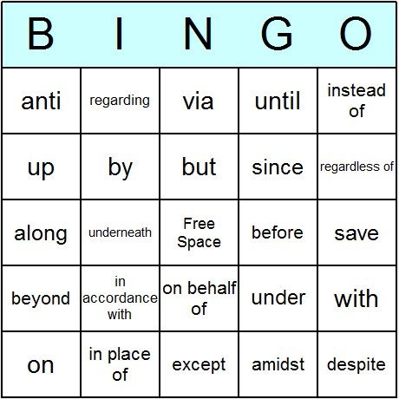

**Worksheet#4 (answer)- Paly game ‘Bingo’**

