Name & Class | Date & Place |  | Lesson Type |  | Plan |  | Topic |  |  | Length | Level
Amy Kim | 15. Feb. 2017 |  | Speaking |  | TBL |  | Oh. I should buy that! (Shopping speaking skills) |  |  | 45min | Advanced
Class profile
Number of students: 8 Age: Adult Nationality: Korean
Motivations: It is going to be useful in case of shopping in overseas
Individual or class hobbies and interests: Adults don’t want to behaving as kids in an activity
Special considerations: don’t make them have argument in the activity
Main Lesson aim
- Students practice their speaking fluency by role play
Subsidiary aims
- Students practice how to deliver their needs to get what they want
- Students practice to know what is teacher’s instruction exactly
Description of language skills specifically used/practiced:  - Speaking: improve how to make it sure in a situation  - Reading: to know what is to do of their role  - Listening: what is the response for asking from someone |  |  |  |  |  | Description of language systems specifically used/practiced:  - Discourse: have conversation to shop or sell what they want  - Function: order to proper sentence  - Phonology: ask to someone what they really want to  - Grammar: apply proper grammar in a situation  - Lexis: understand what is happening in the present

Anticipated difficulties with lesson activities and classroom management:
1. Ss might doesn’t know what they really have to do in an activity
2. Ss need more chances to have talk for improve speaking skills
How I can deal with these difficulties:

1. Give Ss time to ask and know to make it sure

2. Try to give proper chances to every Ss while I monitoring
Assumptions:
1. Some students might don’t want to participate the activities.
2. Ss already had same experience as practice with the activity.
Material(s) needed: White board, Board maker, Board eraser, Projector or Computer(for video clip), worksheets(a,b – 8copies each), Realias(to sell and buy at flea market), Fake money

Checklist. Tick those included in this lesson plan (or N/A)
model sentences for target language |  |  |  | concept questions for target language |  |  |  |  | analysis sheet for target language
stages clearly titled and separated |  |  |  | purpose of each stage indicated |  |  |  |  | anticipated timing included
interaction pattern marked |  |  |  | a board plan (if relevant) |  |  |  |  | examples of all tasks used
answer sheet to all exercises |  |  |  | tape script |  |  |  |  | all materials labelled and numbered
Personal aim : What I most hope to Ss Improve their fluency in some fun activities naturally.

Stage 1:_Pre-task  The purpose of this stage is to focus students’ attention on the lesson, introduce a topic, and involve them in an interesting task (e.g. brainstorming to the board; help complete a chart, problem-solving etc.) that encourages the class to work together sharing their ideas freely, thus increasing STT and participation. This should create the opportunity for the class to gain useful language they may need before going to the next stage. | Inter  action | Time | Instructor’s comments
INSTRUCTION  Give students the topic what they are learning today  Hello guys. How are you today?  Ill show you a funny video before we start the class today.  (Show students the video clip on Youtube “Online shopping fails”)  (The video is running for 2:27 but I should cut it off under 2min)  Was it fun? Have you ever had a failed experience on online shopping?  (expecting answers Yes or No)  Okay. Good. Have conversation with your partner about your experiences.  I guess most of people having failed experience online shopping. Right?  What about your general shopping types? Jessica?  (ask to each students and listen their answers)  Okay. Good.  How we can make it sure to buy a thing what we really want to?  Let’s practice about this today!  (Write the topic “Oh, I should buy that!” 어머, 저건 사야해! On the board) | T  T-S  T-S | 2min  30sec  2min  1min  30sec

Stage 2: Task Preparation  The purpose of this stage is for students to work communicatively in pairs or groups to prepare a communicative task (e.g. roleplay, discussion, debate etc.) which they will deliver to the class/teacher. Student’s may research the task, use dictionaries and ask the teacher for guidance. Instructions, groupings handouts/worksheets and resources, should be given at the start of this stage. Students should know exactly what is expected of them, and have enough time to prepare and practice well. Any or all of the skills may be integrated. | Inter  action | Time | Instructor’s comments
INSTRUCTION  Practice - Going to Market  Give students the worksheet to practice how they talk in shopping place  Play fill the shop list game  (Explain how to play)  Okay. Let’s make a shopping list together by a fun game.  We have to shop something in a grocery store. Ill call “In this market game”  Follow the melody with my action and you should say what they have in the market to shop.  There is a rule. One person start a word, than the next person have to remember the previous words and say that as layered.  (show them how to do with sing –  ex: in this market, there are apple/ in this market, there are apple, there are fish  During they paly the game, I write the list on the board.)  (After done it, describe about the worksheet what students have to talk with the list)  Good job guys. We made a shopping list. Now let’s go to grocery to shop those things!  Look at this worksheet. I have two worksheets a and b.  So, this time, I’ll give you these two each pair group.  One person going to be a seller and a person going to be a customer. The customer should ask  To seller what you want to find or how much is it. And the seller should answer it professionally.  (Give them a example. Ex: T- is this price for one fresh carrot 1,99? / no. it is for 1kg.)  Ill give you 3min.(hand out the work sheets)  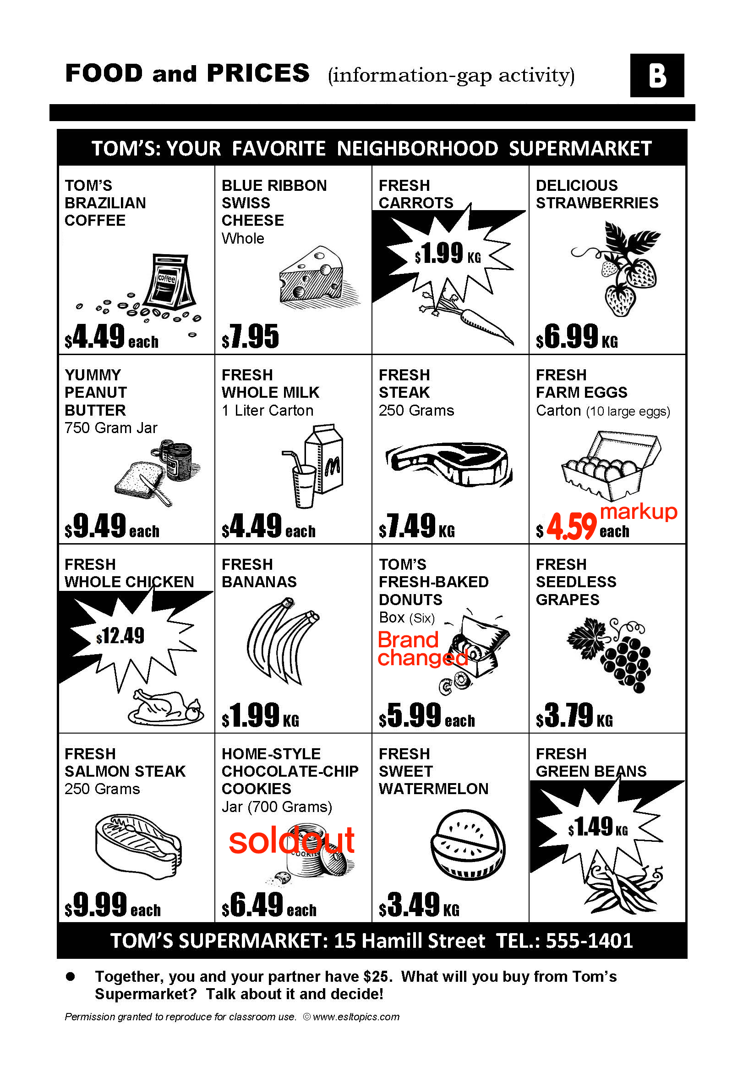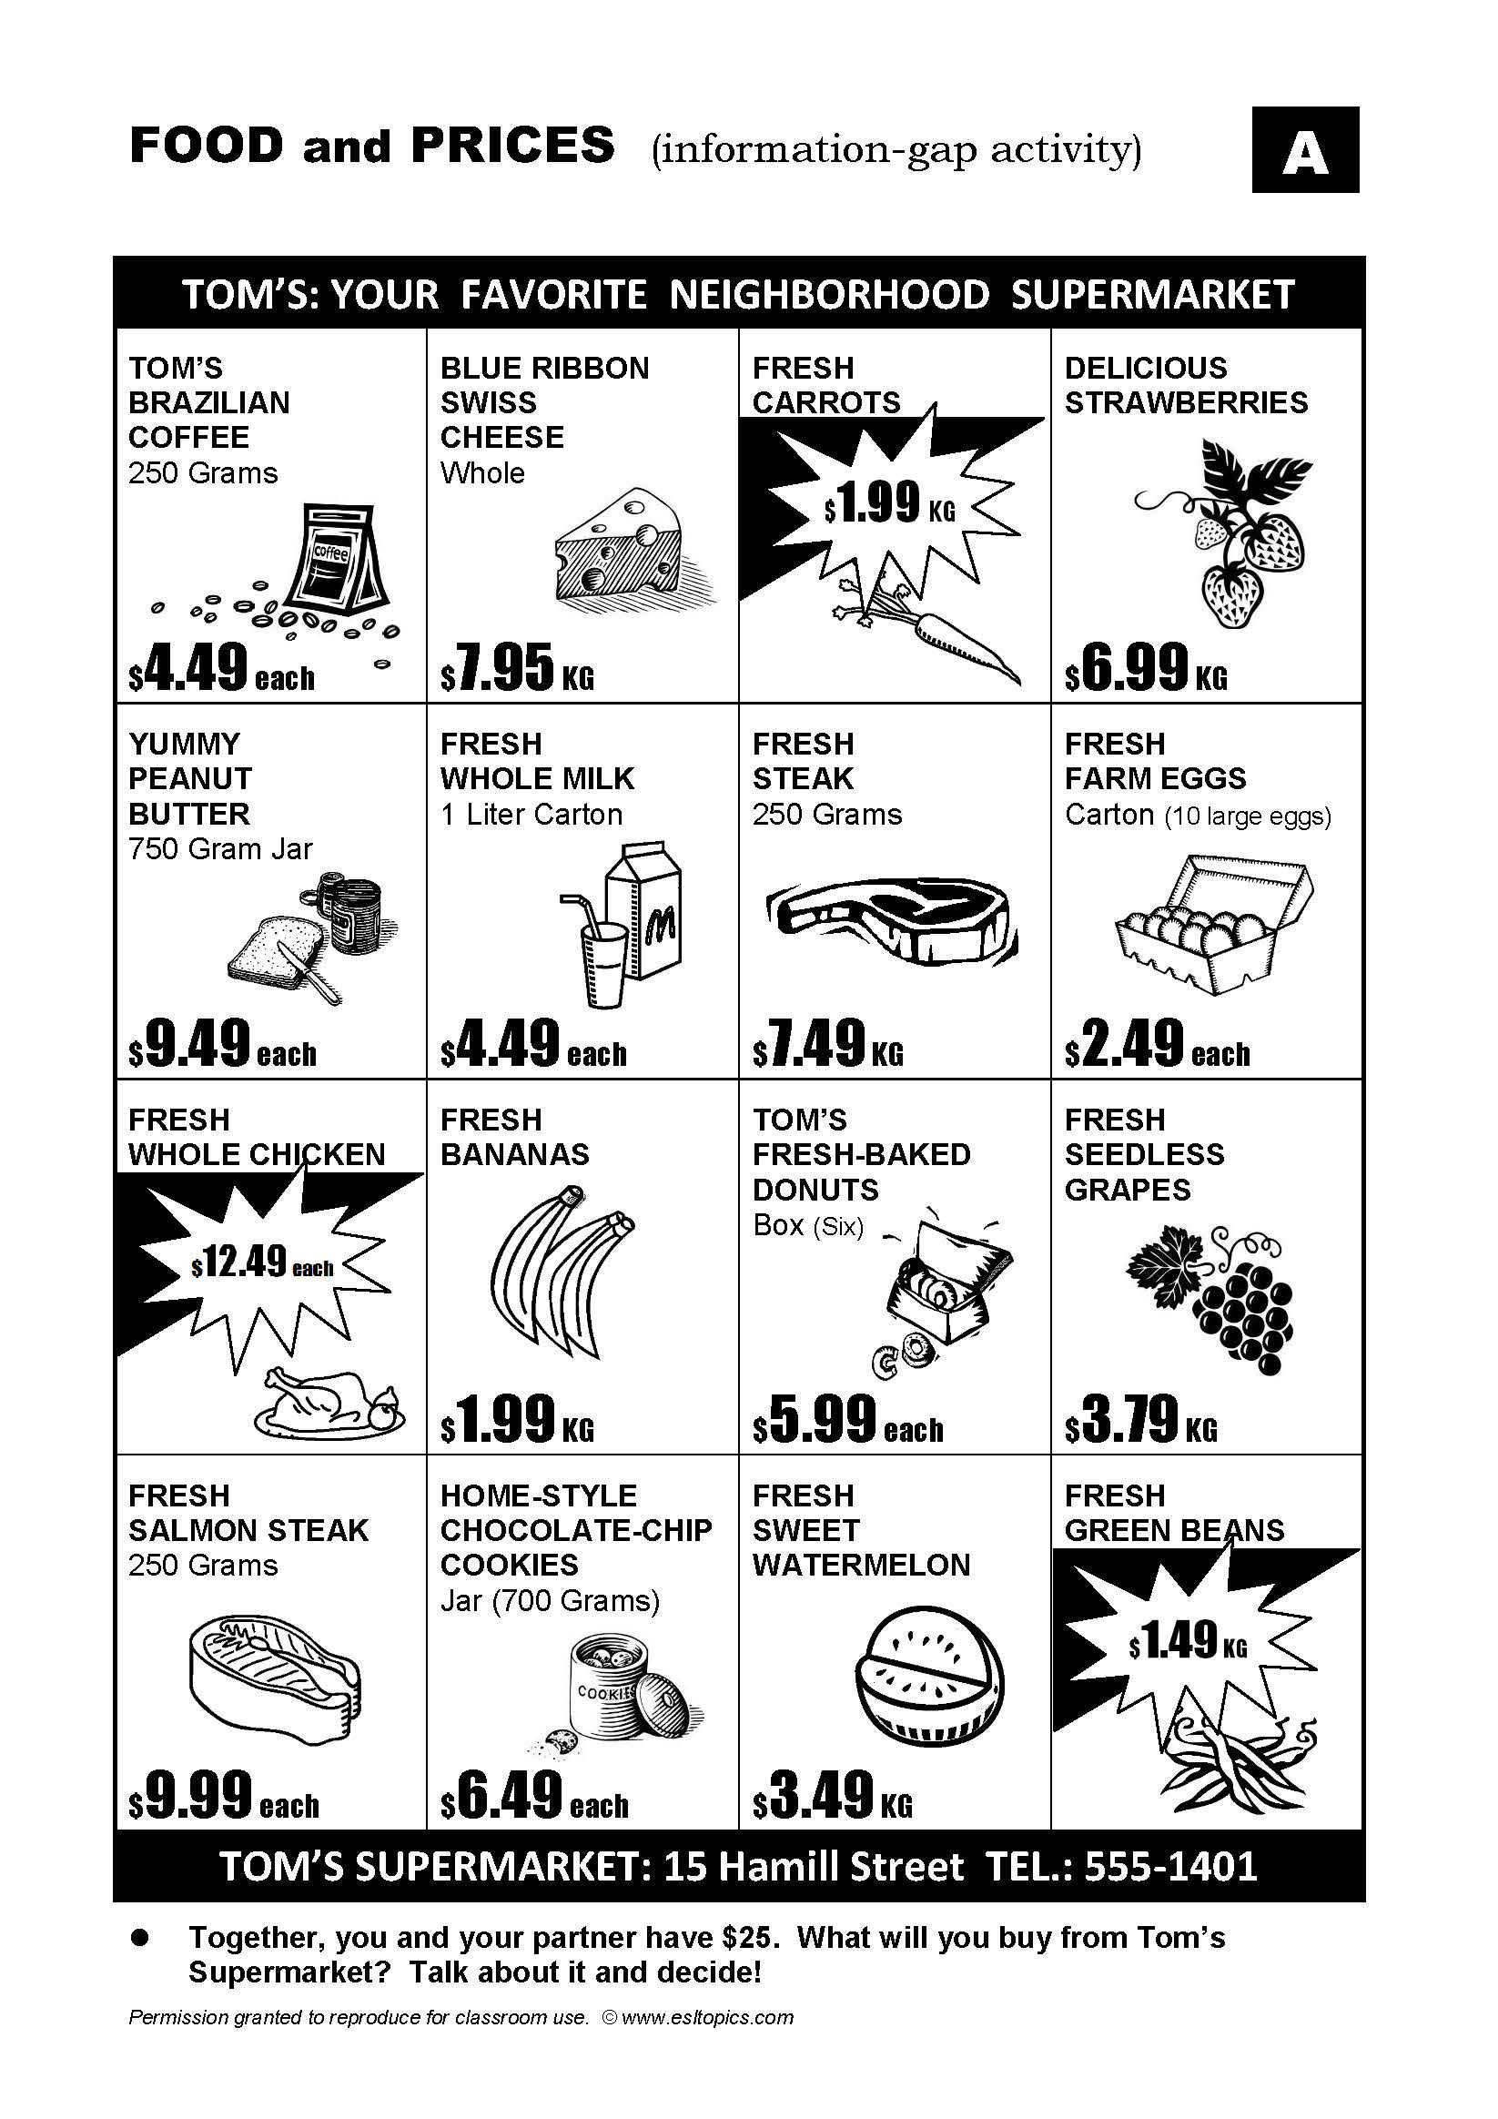 | T  S  T  S | 1min  2min  2min  5min

Stage 3: Task Realisation  The purpose of this stage is for the students to perform/deliver the task they prepared in the previous stage, focusing on their speaking skills such as fluency and pronunciation. Briefly set the students up so they may begin. The teacher should monitor from a distance, i.e. not interrupting this student-centred stage. | Inter  action | Time | Instructor’s comments
INSTRUCTION  Apply practice - Flea Market  Give time to students to apply how we speak by role play  Good job.  We just had practice how we can say when we shopping. Than, let’s go into the real now.  You are at the local park where there is a holiday flea market.  Divide two groups as Sellers and Customers.  Okay guys. Listen carefully. (ask to Ss to be seller or customer by themselves first)  Who want to be a seller? Who want to be a customer?  This group will be a seller. (to sellers group)You guys can put it on your stuffs and sell it what you have.  And this group will be a customer. you guys can get anything you want.  But here is flea market. So you guys can deal with each other for get cheaper price or a few get more.  And the customers are able to sell your stuffs to seller as well. Or if you want to exchange them, make a deal.  I’ll give you guys this role card and fake money, and please check this before you start.  If somebody wants to change the role and let me know. Anyone?  Okay. Good luck everyone to get what you want.  (Hand out role cards and fake money)  Role cards  Sellers:  You love to go to flea markets because it is a chance to sell used things you no longer need. Also, you can chat and make new friends with other sellers as well as the customers. Try to get the highest prices for what you are selling, but don't be greedy!  Customers:  You love to hunt for interesting and unusual things at flea markets. But of course, you want to get very low prices, too! You also like to chat with the sellers and other buyers. Try to buy the things on your list for the cheapest price you can get, but you can also buy other things if they interest you.  (monitoring while they are playing) | T  S | 2min  22min

Stage 4 : Post Task  The purpose of this stage is to provide meaningful feedback, error correction and suggestions for further study or homework. Another brief communicative task could be done which is designed to summarise the lesson e.g. write a report; groups vote for a winner; correct their scripts for grammar and practice saying it. | Inter  action | Time | Instructor’s comments
INSTRUCTION  Close the lesson  Feedback and reviewing  Feedback time  Good job guys. How was it?  Good. Did you get something goods what did you really want?  (ask each students) Timo? Sookhee?  What did you get? From who? How did you make it to get in the proper price?  Who were the best seller?  (Listen students answers)  Okay. Great. I hope you guys had fun with it.  See you next time. Thank you. Bye. | T-S  T | 4min  1min

Instructor’s Final Comments
Overall strengths of this lesson (planning and teaching) | Areas to work on

Overall comment

For this stage of the course, your lesson today was

- Above standard

- To standard

- Below Standard

Instructor: …………………………………….… Date: …………/……………/..……….

