Name & Class | Date & Place |  | Lesson Type |  | Plan |  | Topic |  |  | Length | Level
Emma, Jiseon | 2/15/2017 |  | Speaking |  | TBL |  | Family - To be close with family |  |  | 45 min | advanced
Class profile
Number of students: 7 Age: Adult Nationality: Korean
Motivations: People desire to have a good family.
Individual or class hobbies and interests: family, discussion
Special considerations: one-parent family
Main Lesson aim
- Students practice speaking fluently.
Subsidiary aims
- Students practice thinking how to be close with family.
- Students practice writing their own scripts
Description of language skills specifically used/practiced:  - Speaking: role play, discussion  - Listening: role play  - Writing: 2 worksheets |  |  |  |  |  | Description of language systems specifically used/practiced:  - Discourse  - Phonology

Anticipated difficulties with lesson activities and classroom management:
Students may need more time to think about the dialogs in writing persuasively.
How I can deal with these difficulties:

Be more flexible while checking the degree of completion of the task.
Assumptions:
Students have ideas of how to have better family.

Material(s) needed: board, board marker, worksheet1(writing problems & solutions), worksheet2(writing script), 2 pictures

Checklist. Tick those included in this lesson plan (or N/A)
model sentences for target language |  |  |  | concept questions for target language |  |  |  |  | analysis sheet for target language
stages clearly titled and separated |  | √ |  | purpose of each stage indicated |  |  |  | √ | anticipated timing included |  |  | √
interaction pattern marked |  | √ |  | a board plan (if relevant) |  |  |  |  | examples of all tasks used
answer sheet to all exercises |  |  |  | tape script |  |  |  |  | all materials labelled and numbered |  |  | √
Personal aim : Students to have a fun in learning the difficult lesson / Students can improve their understanding in family.

Stage 1:_Pre-task  The purpose of this stage is to focus students’ attention on the lesson, introduce a topic, and involve them in an interesting task (e.g. brainstorming to the board; help complete a chart, problem-solving etc.) that encourages the class to work together sharing their ideas freely, thus increasing STT and participation. This should create the opportunity for the class to gain useful language they may need before going to the next stage. | Inter  action | Time | Instructor’s comments
(before starting the lesson, do seat arrangements; work in pairs)  Today, you’re going to work with your partner as a team for whole lesson.  (put the pictures on the board)  ⅰ.  Look at these two pictures.  Discuss about what they’re saying to each other.  And write down their thoughts into each box.  I’ll give you 2 minutes.  (hand out the worksheet / activity )  Now, what do you guys think?  (ask one person in pair)  Could you tell us?  ⅱ.  Turn to the next page. This time think about the possible solution for each picture.  Discuss about solutions that can be persuasive and at the same time understanding each other.  And write down into each box.  I’ll give you 2 minutes.  (hand out the worksheet / activity)  Could you tell us your solutions?  (ask another person in pair) | T-S  T  T  Ss  T-S  T  Ss  T-S | 1 min  1 min  1 min  2 min  2 min  1 min  2 min  3 min

Stage 2: Task Preparation  The purpose of this stage is for students to work communicatively in pairs or groups to prepare a communicative task (e.g. roleplay, discussion, debate etc.) which they will deliver to the class/teacher. Student’s may research the task, use dictionaries and ask the teacher for guidance. Instructions, groupings handouts/worksheets and resources, should be given at the start of this stage. Students should know exactly what is expected of them, and have enough time to prepare and practice well. Any or all of the skills may be integrated. | Inter  action | Time | Instructor’s comments
We’re going to do a role-play for each picture.  Based on what we’ve talked about previously, write down two scripts following the process of problem-solution.  Decide who takes whom and write 10 lines for each person including problem and solution in persuasive way.  When you are doing persuasion, start the sentence with ‘I understand…’  After that, each team will come up and perform their plays.  ICQ  - How many lines you have to write in total?  - What do you do after writing two scripts?  Let’s do this scene first.  I’ll give you 5 minutes.  (hand out the worksheet)  Let’s do this scene then.  I’ll give you 5 minutes again.  (hand out the worksheet) | T  Ss  Ss | 2 min  5 min  5 min

Stage 3: Task Realisation  The purpose of this stage is for the students to perform/deliver the task they prepared in the previous stage, focusing on their speaking skills such as fluency and pronunciation. Briefly set the students up so they may begin. The teacher should monitor from a distance, i.e. not interrupting this student-centred stage. | Inter  action | Time | Instructor’s comments
Now everyone, let’s first perform the scene #1.  (pick out each team)  Thank you. Now, let’s then perform the scene #2.  (pick out each team) | T  Ss  T  Ss | 7 min  7 min

Stage 4 : Post Task  The purpose of this stage is to provide meaningful feedback, error correction and suggestions for further study or homework. Another brief communicative task could be done which is designed to summarise the lesson e.g. write a report; groups vote for a winner; correct their scripts for grammar and practice saying it. | Inter  action | Time | Instructor’s comments
Good job everyone. You all handle the situations well.  Let’s vote a team who had the best solution for each situation.  I’ll give you each a piece of paper.  Write down the best team and 1 reason.  You have 1 minute to do.  (hand out the papers)  I’m going to collect the papers now.  (put the papers inside the basket)  Now let’s find out the best team together.  (pick out the paper and read)  (draw a line to the team that is called out)  Did you all enjoy today’s class?  Thank you for you participation and I hope today’s lesson will help you a lot in the near future.  Let’s finish the lesson by reading a quote together.  (Write the quote down on the board. A good home must be made, not bought.) | T  S  T  T  T | 1 min  1 min  3 min  1 min

Instructor’s Final Comments
Overall strengths of this lesson (planning and teaching) | Areas to work on

Overall comment

For this stage of the course, your lesson today was

- Above standard

- To standard

- Below Standard

Instructor: …………………………………….… Date: …………/……………/..……….

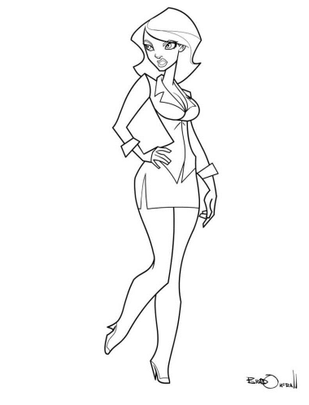

Imagine and write down their thoughts in the table.

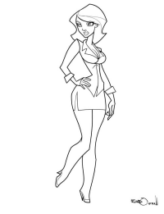

Mother | Daughter

Think about the solution and write down below.

Mother | Daughter

Imagine and write down their thoughts in the table.

Father | Son

Think about the solution and write down below.

Father | Son

Make 10 lines for each person including problem and solution in persuasive way.
When you do a persuasion, start with the sentence “I understand …”

Scene #1

Mother | Daughter

Make 10 lines for each person including problem and solution in persuasive way.
When you do a persuasion, start with the sentence “I understand …”

Scene #2

Father | Son

