[TEXT] Culture Shock in Korea via Public Bathrooms

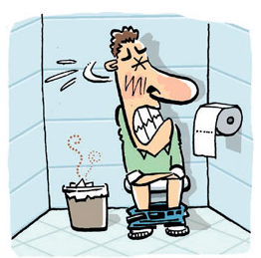
A. Garbage Cans for Used Toilet Paper
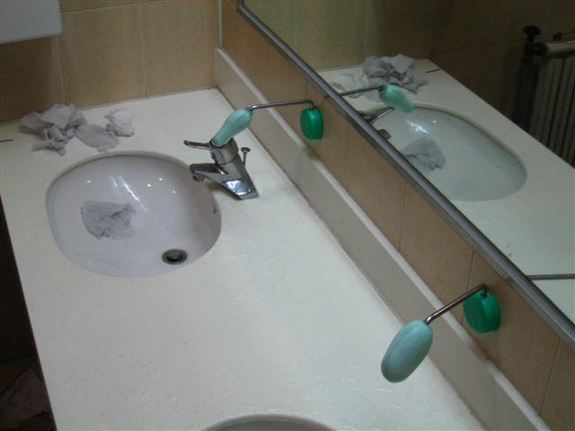
Some older buildings can’t handle flushing toilet paper as it will clog the toilets. So sometimes there will be signs attached to bathroom walls asking you to throw away your used toilet paper in a garbage can. These cans are usually to the side of the toilet and are usually filled with everyone else’s used goods for the day. This Korean culture shock is yucky, but if you don’t follow the rules, you might be the jerk that clogged the toilet.

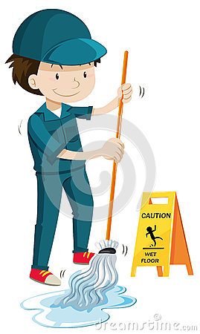B. Janitor in Men’s Bathroom
Most public bathrooms in Korea have designated janitors. The reason this is a Korean culture shock for some men is when an ajooma (older woman) comes in with a mop in hand while you’re doing your business. And although you might be worried of having an ajooma check out your junk, don’t worry. They’re just there to pick junk up! (don’t worry ladies, men won’t be cleaning your bathrooms in Korea.

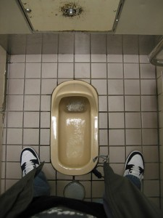
C. Squatters
Instead of having a toilet seat to do your business, you might have to do your thang in a squat toilet, or maybe more accurately described as a porcelain hole in the floor. Squat toilets are leftovers from before Korea’s rapid modernization and are commonly found in less developed areas of Korea. But you will still find these gems even in modern cities like Seoul (usually in older buildings). If you’ve never used one of these, you will feel uncomfortable.

D. Soap on a Stick
A lot of people are used to having public bathroom soap come from a dispenser instead of bar soap. That way each serving of soap is for 1 person and 1 person only. No sharing of germs and other nasty stuff that might have been on your hands. But some public bathrooms in Korea have soap on a stick. And that’s used by everyone. It’s basically the same as using bar soap, but the fact that it’s on a stick comes as culture shock to some newcomers to Korea. But if you find one these, you should feel lucky. There are many cases where you won’t find any soap in public bathrooms in Korea. Soap on a stick it is!
[Worksheet] Culture Shock in Korea via Public Bathrooms

[TEXT/ Answering Sheet] Shock in Korea via Public Bathrooms

Garbage Cans for Used Toilet Paper
Some older buildings can’t handle flushing toilet paper as it will clog the toilets. So sometimes there will be signs attached to bathroom walls asking you to throw away your used toilet paper in a garbage can. These cans are usually to the side of the toilet and are usually filled with everyone else’s used goods for the day. This Korean culture shock is yucky, but if you don’t follow the rules, you might be the jerk that clogged the toilet.

Janitor in Men’s Bathroom
Most public bathrooms in Korea have designated janitors. The reason this is a Korean culture shock for some men is when an ajooma (older woman) comes in with a mop in hand while you’re doing your business. And although you might be worried of having an ajooma check out your junk, don’t worry. They’re just there to pick junk up! (don’t worry ladies, men won’t be cleaning your bathrooms in Korea.

Squatters
Instead of having a toilet seat to do your business, you might have to do your thang in a squat toilet, or maybe more accurately described as a porcelain hole in the floor. Squat toilets are leftovers from before Korea’s rapid modernization and are commonly found in less developed areas of Korea. But you will still find these gems even in modern cities like Seoul (usually in older buildings). If you’ve never used one of these, you will feel uncomfortable.

Soap on a Stick
A lot of people are used to having public bathroom soap come from a dispenser instead of bar soap. That way each serving of soap is for 1 person and 1 person only. No sharing of germs and other nasty stuff that might have been on your hands. But some public bathrooms in Korea have soap on a stick. And that’s used by everyone. It’s basically the same as using bar soap, but the fact that it’s on a stick comes as culture shock to some newcomers to Korea. But if you find one these, you should feel lucky. There are many cases where you won’t find any soap in public bathrooms in Korea. Soap on a stick it is!

