Listening Speaking  Reading Grammar Writing
Topic: The increase of single people in Korea

Instructor: Jen | Level:  Intermediate(Adult) | Students:  11 students | Length:  20 Minutes

Materials:
- Realia: Brain Storming PPT, New Vocabulary PPT, a video clip for listening, The questions PPT for "Ring the bell" game
- Worksheet #1: Reading Comprehension (11 copies)
- Worksheet #2: Reading questions and answers practice (11 copies)
- Worksheet #3: SOS activity for reading practice (11 copies)
- Computer for presentation
- White board and board markers

Aims:
- Main aim: Ss will be able to improve their reading skills by learning vocabulary, context, and the usage of the expressions.
- Secondary aim: Ss will improve speaking and listening ability by sharing their thinking.
- Personal aim: I want to give students clear instruction and make them be able to practice speaking from presentation to the class by discussing their ideas.

Language Skills:
- Reading: Students will read the text and worksheets.
- Listening: Students will listen to the teacher’s instruction, a video clip and their partner.
- Speaking: Students will communicate with their partners from the video clip, the worksheet and game activities.
- Writing: Students will fill out worksheets.

Language Systems:
- Phonology: Practice pronunciation of new vocabularies
(chide[chahyd], groom [groom], mean [meen])
- Lexis: New vocabularies used in the reading material
(chide, groom, prohibitive, mean, opt)
- Function: Asking and answering
- Grammar: Present perfect form
- Discourse: conversation (video clip, discussion)
Assumptions: Students already know

- How the class is organized and operated (U-shaped seating arrangement)
- Four language skills and language systems
- Which team they belong to in for team work time.
- Most Ss have interested in marriage.
- How to skim and scan
- Some of the vocabularies in the text

Anticipated Errors and Solutions:

- If students need linguistic help to express their opinions during discussion
→ I will give them linguistic support by providing definitions and some examples
- If students need reading comprehension support
→ I will encourage them to look up the words in the dictionary and the context clue.
- If certain students dominate the discussion
→ I will ask them to give other students a chance to speak.

References:
Pictures for Eliciting
https://www.google.co.kr/

Video Clip : Singles trend(Solo Dining)
https://www.youtube.com/watch?v=aDDnAFZ6HFM

Definition and Phonetic Symbols of New Vocabulary
http://www.dictionary.com/

Text for Reading
http://www.economist.com/news/asia/21659768-more-women-ditch-or-delay-marriage-men-tie-themselves-knots-i-dont

Article for SOS-activity
http://news.naver.com/main/hotissue/read.nhn?mid=hot&sid1=110&cid=933879&iid=1982820&oid=044&aid=0000183803&ptype=052

Lead-In
Materials: None
Time | Set Up | Student Activity | Teacher Talk
1 min | Whole class | Answering to the teacher’s questions | Good morning, everyone!  Welcome to my class!!  How are you today?  I’ll ask some questions  Is there anyone who got married?  Is there anyone who want to stay single?

Pre-Activity
Materials: Brain Storming PPT, New Vocabulary PPT, Video clip about singles trend, Computer, Screen, Projector, white board, board markers
Time | Set Up | Student Activity | Teacher Talk
2 min  2 min  2 min | Whole Class  Whole Class  Pairs | Brainstorming about the topic of today’s class.  Students watch the video clip.  Students ask and answer with their partner. | Procedure:  - Brainstorming  Elicit  (Project Brainstorming PPT)  What does this photo look like?  (As soon as the students say “wedding” or “marriage”  Are they look happy ? (Ss answer)  Then let’s see next pictures.  What are the pictures?(Ss answer)  Yes. That’s right. These pictures are from the TV show “I live alone.”  Nowadays, there are many programs showing the lives of single people and they are very popular.  Is there anyone Who enjoys this program?  Why do you watch this program?  In Korea, singles are increasing fast recently.  Then could you guess today’s topic?  Model  Today’s topic is “The increase of single people in Korea”  (Write the topic on the board)  CCQ  Are single people increasing in Korea?  What do you think the reason is?  2. Pre-Activity: After watching the video clip, talk with your partner  I’ll show you interesting video clip about singles trend these days.  Instruction  After watching the video clip, ask and answer with your partner.  The questions are two.  You have 2 minutes to talk with your partner.  ICQ  Do you work in pairs?  How much time do you have?  Start activity  Let’s watch the video clip together.  (After 2 minutes)  Ask and answer with your partner.

Main Activity
Materials: Text for reading, Worksheet #1,2(11 copies), ppt for New vocabularies
Time | Set Up | Student Activity | Teacher Talk
1 min  2 min  1 min  2 min  1 min | Whole Class  Individual  Individual  Pairs  pairs | Students listen to instruction.  Students read the text and guess the meanings of new words  Students read aloud one by one.  Students solve worksheet#2.  Each team gives a presentation shortly | 1. Main activity  Instruction  We are going to learn new vocabularies before we move on.  Please, read this text and guess what the meanings of these words are.  You are going to do individually.  I’ll give 2 minutes.  ICQ  What will you do while reading?  Will you do in pairs?  How much time do you have?  (Hand out the text and worksheet).  (After 2 minutes)  Let’s check out the answers together while looking at the power point..  (After checking out)  You did a great job.  Instruction  Let’s read aloud this text one by one.  (After finishing reading aloud)  Let’s solve No.2 in the worksheet.  You are going to do in pairs.  I’ll give 2 minutes.  ICQ  Will you do in pairs?  How much time do you have?  Monitoring  (Quietly walk around the classroom. Check to see if the students are on track. Answer to questions.)  (After 1 minutes)  You have 1 minute left.  (After 1 minute)  Time’s up.  Let’s check out the answers of questions a and b.  Did you talk about question c with your partner?  Could you share the answers?  (After presentation)  You did a great job.

Post Activity
Materials: Questions for ‘Ring the bell game’, Bell
Time | Set Up | Student Activity | Teacher Talk
1 min  4 min  1 min | Whole Class  Groups  Whole Class | Students listen to instruction  .  Students play the game.  Students review today's lesson. | 1. Post Activity: ‘Ring the bell’ game  Instruction  Now, we will do ‘Ring the bell’ game together. We will divide into 2 teams.  One person of each team will come up and read the question. As soon as you find the answer, press the bell and answer.  I will show you the questions related to today’s lesson.  The person who pressed the bell first has the right to answer.  You should answer within 3 seconds.  The team that answers the most questions wins this game.  The team can help each member.  Demonstration  I will show the demonstration first.  Q: What's the synonym of "groom”  A: (After pressing the bell) Husband  ICQ  Are you working in groups?  Do you press the bell after the answer?  Okay, first student, come up.  (Each group will come up and play the game.)  Monitoring  Monitor discreetly. If a student is making a mistake, correct it with nice manner.  Feedback  Okay, everyone. Which team is the winner? Congratulations. Was it fun?  2. Conclusion  Everyone did a great job today!  Let’s review today’s lesson.  What are the new vocabularies?  Error Correction  - chide: [chahyd] instead of [cheed]  - groom: [groom] instead of [grom]  - mean: [meen] instead of [mean]  We read the text about the increase of singles in Korea these days.  Was it interesting?  I’m sure this will help you catch nowadays' trend.  You did a great job today. Try to keep in mind of the content and vocabulary we’ve learned. Thank you.
SOS Activity
Materials: News article Worksheet #3(11 copies)
Time | Set Up | Student Activity | Teacher Talk
5 min  1 min | Pairs  Whole class | Students read the news and find the correct order.  Students check answers | 1. Reading Worksheet: Reorder the passages of news article  Instruction  “Okay. This time, We will reorder the passages of news article. After reading this article, write the number of passages in the correct order.  You will do it with your partner. You will have 3 minutes to complete the order.  ICQ  Are you working alone?  How much time do you have?  (Distribute worksheet #3)  Monitoring  Monitor discreetly by walking around the class. Get close to students. Help them if they are having a difficulty.  Check Answers  Ask students the order and check the answer.  (If you need more time, do following activity)  More Activity  Let’s read out this article one by one.  Conclude  Great job, everyone! Keep in mind the content and order.

< Reading worksheet #1>

The increase of single people in Korea

“Have your parents chided you for wanting to live alone?” “Are you often told that a woman’s best chance of happiness is being a wife and mother?” The proportion of single people in Seoul more than doubled between 1990 and 2010, and they now account for 16% of households. Four in ten South Korean adults are unmarried, the highest share among the 34 OECD countries. In Seoul over a third of women with degrees are single.

One reason is that wedding expenses, mostly met by the groom and often including the couple’s first home, have become prohibitive for many. Another is that Korean families used to be so desperate to have sons that in the 1980s they aborted lots of daughters. Now one in seven men of marriageable age lacks a potential partner. The mean age at which women marry has risen from 25 in 1995 to 30 today. So long as South Korean wives and mothers are expected to behave like their mothers did in the 1960s, many women will opt to fly solo instead.

< Reading worksheet #2>

1. Match the words with the appropriate meaning

a. chide □ average
b. prohibitive □ man being married
c. groom □ choose
d. mean □ scold
e. opt □ excessive

2. Answer the questions.

a. What percentage of households are single people ?

b. What are the reasons of the increase in singletons ?

c. How will the increase in singletons affect our society?

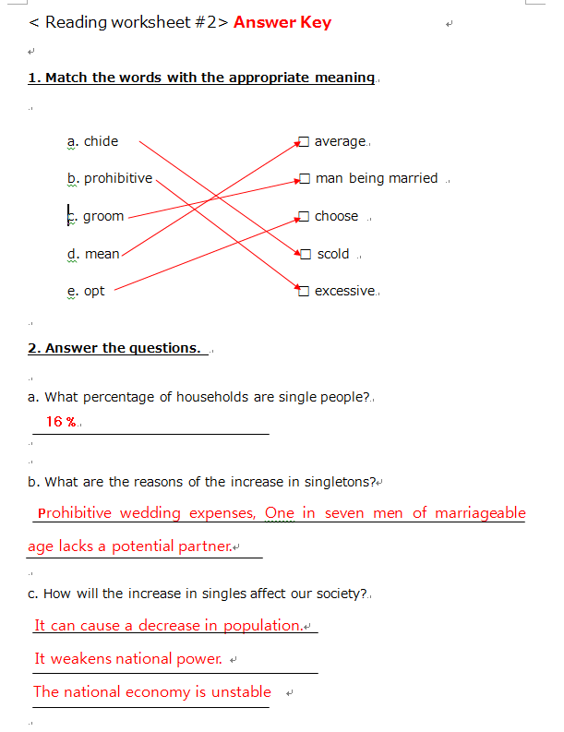
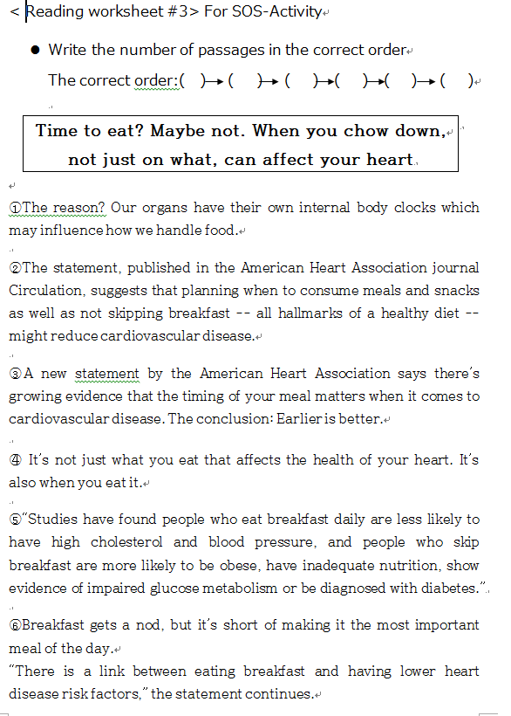

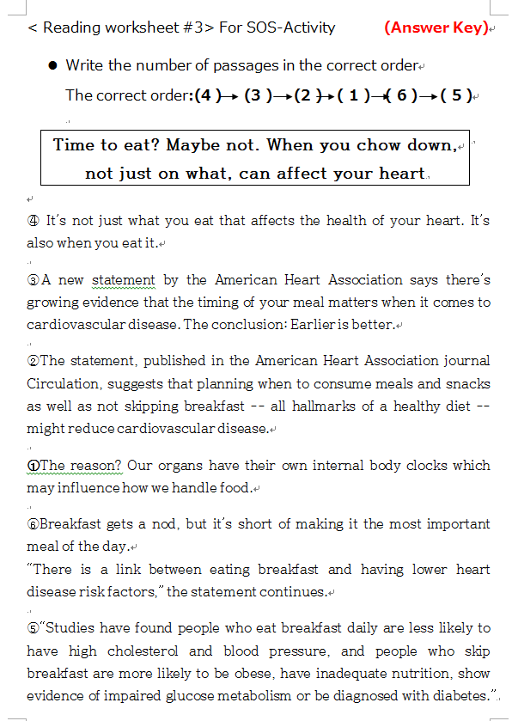
* Brainstorming ppt

PPT

* The questions ppt (Pre-Activity)

* The New Vocabulary ppt (Main-Activity)

* The questions for "Ring the bell" game (Post-Activity)

