<How to apply a temporary tattoo>
Temporary tattoos are popular amongst people of all ages, and are a less risky alternative to real tattoos. They're also great fun at parties! It takes a bit of time to apply a temporary tattoo perfectly, but with a little patience, you can rock either a transfer tattoo with pride.
===Applying a Transfer Tattoo===
#1 Start with clean, dry skin. Temporary tattoos are made with water-based ink, which means that they’re repelled by skin’s natural oils. Carefully clean the area you want to decorate with soap and water, and pat it dry with a paper towel.
#2 Pick out your tattoo. Some temporary tattoos come individually packaged, which is easy. However, if the temporary tattoo you want to wear came on a sheet with several others, you’ll need to separate it. Cut around it with sharp scissors, being careful not to clip the design itself, until you’ve separated it from the “flash sheet.”
#3 Peel off the clear backing. At this point, your tattoo is protected by a thin layer of clear plastic. Carefully pick this off. You should be able to see the brightly-colored, mirror-image version of the tattoo you’re planning to apply to your skin
#4 Place the image face side (the side with the ink) down on your skin. Confirm that you want to apply the tattoo to the spot you just cleaned, then place the face side against your skin. Don’t wiggle it around. Just hold it firmly in place while you move on to the next step.
#5 Press a damp cloth or sponge over the tattoo paper. Take a piece of fabric or a sponge that is neither bone dry nor soaking wet, and push it firmly against the backing of your tattoo. Hold it in place, and don’t let it slip around, even if it wants to.
#6 Hold for at least 60 seconds. To get the most complete image, you’ll need a bit of patience. Don’t even think about removing the cloth or the paper backing from your arm until a full minute has passed. While you’re sitting, try to move as little as possible.
#7 Gently peel off the paper. Start by lifting a single corner of the backing in order to peek at the tattoo. If the image looks weird, or isn't sticking to your skin, put the cloth or sponge back on and wait for another 30 seconds. If it does look good, then continue to slowly peel off the paper

*Write a right order.
________ -> ________ -> ________ -> ________ -> ________ -> ________ -> ________
- (B)
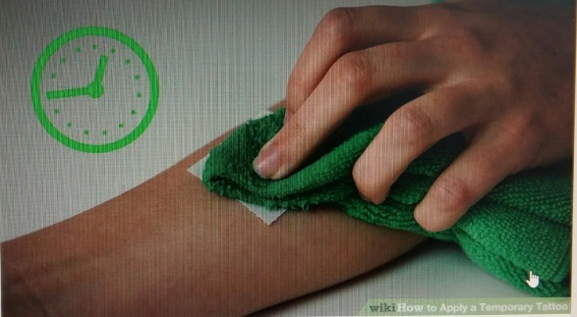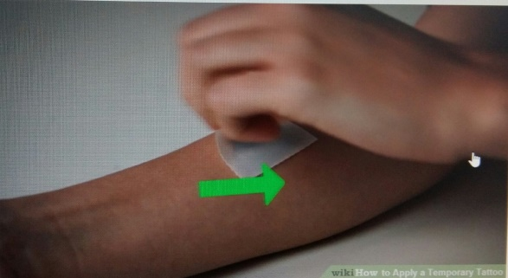
(C) (D)
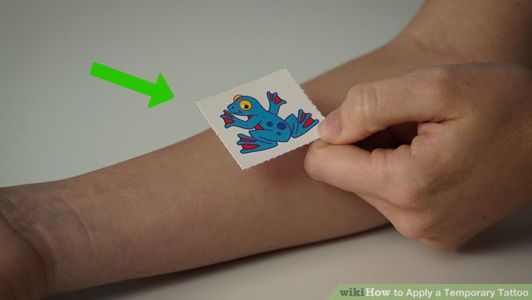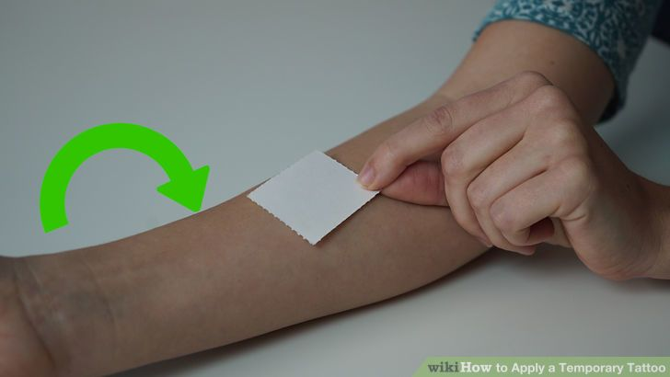
(E) (F)
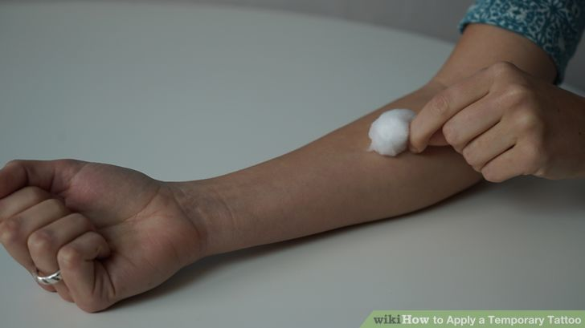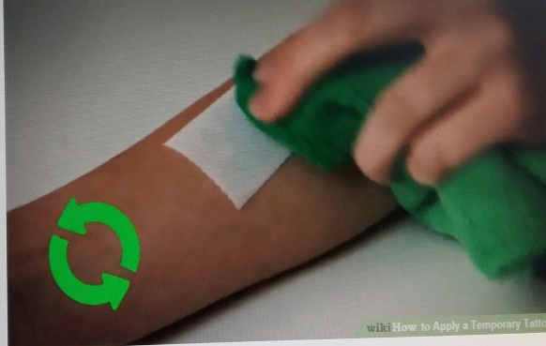
(G)
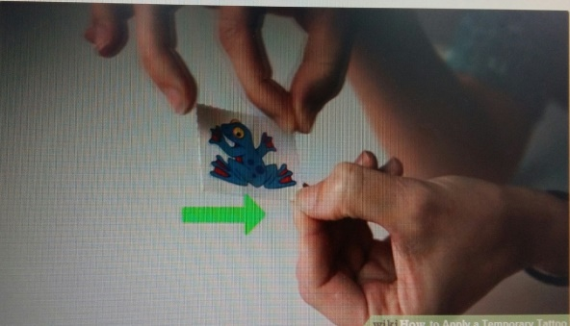
*Write a right order.
E -> C -> G -> D -> F -> A -> B
- (B)
(C) (D)
(E) (F)
(G)
<<Comprehension Questions>>
1. When do people use temporary tattoos?

2. In step#3 why is there a thin layer on it?

3. In step#4 what happen if we wiggle it?

4. In step#5 what is different between damp and soaking?

5. If you have a chance to get a real tattoo, what shape of tattoo would you get? And why? Please draw the shape of tattoo.
Shape of tattoo
drawing

6. Share your feeling with your partner.

<<Comprehension Questions>>
1. When do people use temporary tattoos?
On Halloween day, Christmas day,
When People go to a party, go on a vacation..etc
2. In step#3 why is there a thin layer on it?
To protect a tattoo
3. In step#4 what happen if we wiggle it?
The design can be ruined.
4. In step#5 what is different between damp and soaking?
Damp means slightly wet, soaking means thoroughly wet.
5. If you have a chance to get a real tattoo, what shape of tattoo would you
get? Where would you get it? Please draw the shape of tattoo.
Ex) I want get a black cross on my wrist.
Shape of tattoo
drawing
6. Share your feeling with your partner.

