Listening Speaking Reading Grammar Writing

Topic: Useful expressions at a bank

Instructor:  Sophie Kim | Level:  Intermediate(Adult) | Students:  12 Students | Length:  30 Minutes

Materials:
- Realia: Short conversation videos at the bank
- Worksheet #1: Fill in the blanks
- Worksheet #2: New vocabulary and listening comprehension question
- Worksheet #3: Listening script practice
- Worksheet #4: Make own script
- White board and board markers

Aims:
- Main aim: Students will be able to improve their listening skills by listening to the conversation video at the bank
- Secondary aim: Students will be able to make new sentences using useful expressions at the bank
- Personal aim: I want to speak clearly in front of the students and manage my time well in each section.

Language Skills:
- Reading: Students will read the power point video and worksheets
- Listening: Students will listen to the video and their partner
- Speaking: Students will speak with their partner
- Writing: Students will write down the conversation from the video and vocabulary on the worksheet

Language Systems:
- Phonology: Practice pronunciation of bank-related vocabulary
- Eg. acceptable, compatible
- Lexis: Vocabulary and expressions at the bank
- Eg. Open a bank account, write a check, use debit card, etc
- Function: Imperative, Interrogative, Suggesting,
- Grammar: Check vs. Cheque, I would like to… How would like to…
- Discourse: Script

Assumptions:
- How the class is set and run (U-shaped seating arrangement)
- Four language skills and language systems
- Students are willing to speak with their partner

Anticipated Errors and Solutions:
- If students need linguistic help to express their opinions during discussion
give them linguistic support by providing definitions and some examples
- If some students keep quiet for fear of upsetting other people during the discussion
encourage them to speak and advise them to be clear about their point
- If certain students dominate the discussion
ask them to give other students a chance to speak

References:
- Dictionary: https://www.merriam-webster.com/, Naver Dictionary
- Pictures: Google Images
- Video: https://www.youtube.com/watch?v=bqOUNlDr_yg
https://www.youtube.com/watch?v=2xOl-UB18VM

Lead-In
Materials:None
Time | Set Up | Student Activity | Teacher Talk
1 min | Whole class | Answering teacher’s questions | Good afternoon, everyone! How are you today? Do you often go to the bank?

Pre-Activity
Materials: Board, Board makers, Visual aid, Worksheet #1
Time | Set Up | Student Activity | Teacher Talk
2 min  2 min  2 min | Whole  class  Individual | Answering teacher’s questions. | 1. Warm-up questions  Elicit  “When do you go to the bank? What do you do at the bank? Do you use online banking?”  (Write down students’ answer on the board)  Eg) Transfer money  Make credit card  …  Model  “Today, we are going to learn about useful expressions at the bank”  Write down the subject “Useful expressions at the bank” on the board.  2. Pre-activity: listening to the video and fill in the blanks  Instruction  “Let’s listen to the conversation from the video clip and try to fill in the blanks on the worksheet #1. Please work individually”  ICQ  Are you working alone?  (Distribute worksheet #1)  (Play audio file 1:56 and don’t show the subtitles)  Check answers  “Let’s check the answers together.”  (Ask individual)

Main Activity
Materials: Visual aid, Worksheet #2, #3
Time | Set Up | Student Activity | Teacher Talk
3 min  1min  2 min  2 min  1min  2 min  2 min | Pairs | Students will do the worksheet #2 with their partner.  Students will listen to the clip and write down the answers for the listening comprehension questions  Discuss with partner  Watch the file  Answer the question  Practice speaking with their partner | 1. Main activity: New vocabulary and listening comprehension  CCQ  From the conversation, why does the customer go to bank? What does the teller ask?  Instruction  Now. We are going to learn new vocabulary. Let’s look up the vocabulary from the conversation with your partner. Find the meaning from your dictionary and discuss with your partner. I’ll give you 3 min.  (Distribute worksheet #2)  Demonstration  Before we start, we are going to do the first question together.  “What is ….?  Yes, that’s right”  ICQ  Are you working in pairs?  How much time do you have?  Monitoring  Monitor discreetly by walking around the class. Get close to students. Listen and answer to students if they ask questions.  “Okay, Time is up”  Check answers  “Let’s check answers together”  (Ask pairs)  Model  Check vs. Cheque (British)  (Explain the difference)  1-1. Main activity: listening comprehension  Instruction  “Let’s listen to the clip again and let’s try to answer the comprehension question. First, write down individually while listening and then compare the answer with your partner”  ICQ  “What do you do after listening?”  (Play the clip again 1:56 with subtitles)  “Okay. Discuss with your partner. I’ll give you 2 min”  Check Answers  “Let’s check answers together. Great Job”  (Ask pairs)  2. Main activity: listening to the conversation and speaking practice  Instruction  Let’s watch another video about the conversation at the bank.  (Play the clip 1:11)  CCQ  What does the customer want? What does the teller do? How does the customer receive the money?  Instruction  I’ll distribute the script of the clip. Please practice speaking with your partner.  (Distribute worksheet #3)  Monitoring  Monitor discreetly by walking around the class. Get close to students. Listen and answer to students if they ask questions.  (Compliment students)

Post Activity
Materials: Board, Board marker, Worksheet #4
Time | Set Up | Student Activity | Teacher Talk
4 min  5 min  1min | Pairs |  | 1. Free production  (Role play)  Instruction  “Now, each group will present a real play at the bank based on what we’ve learn. Use the expression and the grammar. Please make a script with your partner. You will have 4 minutes.  Model  Choose the situation either making a bank account or exchanging the currency.  (Write down “making a bank account or exchanging the currency” on the board.)  ICQ  What do you make? What is the topic? Are you working in pairs? How much time do you have?  (Distribute worksheet #4)  Monitoring  Monitor discreetly by walking around the class. Get close to students. Listen and answer to students if they ask questions.  “Okay. Time’s up. Let’s do the presentation in front of the class. First group, please come out”  (Real play of each group)  Feedback and Conclude the class  “Great job. Everyone. Remember these expressions and use it when you are at the bank in other countries. Have a good day!”

Worksheet #1

Please fill in the blanks while listening to the conversation.

Customer: I’d like to ( ) ( ) ( ) ( )

Teller: What type of account? We have several types.

Customer: I’d like an account for regular banking.

Teller: Will you be ( ) many ( )?

Customer: A few but not many.

Teller: Less than ten per month?

Customer: Yes. Definitely less than ten.

Teller: Will you be using ( ) or ( ) for purchase ( )?

Customer: I use my debit card quite a bit.

Teller: How do you pay your ( )? Through the mail or online?

Customer: Normally I bring them to the bank and pay at the teller but I would like to start paying them online.

Teller: Many customers are ( ) ( ) ( ). In fact, we recommend it. Less paper.

Customer: I see. Can I set this up with my new account?

Teller: Yes. Absolutely. I would recommend our Value checking account. It seems ( ) ( ) your needs plus the online banking is easy to set up and free to use.

Customer: That sounds good.

Teller: Alright. I’ll just need some photo identification and I can start processing your new banking ( )

Customer: Sure. Can I use my passport?

Teller: Absolutely. Any government issue ID is acceptable.

Worksheet #1 Answer Key

Please fill in the blanks while listening to the conversation.

Customer: I’d like to open a bank account.

Teller: What type of account? We have several types.

Customer: I’d like an account for regular banking.

Teller: Will you be writing many checks?

Customer: A few but not many.

Teller: Less than ten per month?

Customer: Yes. Definitely less than ten.

Teller: Will you be using cash or debit for purchase transactions?

Customer: I use my debit card quite a bit.

Teller: How do you pay your bills? Through the mail or online?

Customer: Normally I bring them to the bank and pay at the teller but I would like to start paying them online.

Teller: Many customers are paying bills online. In fact, we recommend it. Less paper.

Customer: I see. Can I set this up with my new account?

Teller: Yes. Absolutely. I would recommend our Value checking account. It seems compatible with your needs plus the online banking is easy to set up and free to use.

Customer: That sounds good.

Teller: Alright. I’ll just need some photo identification and I can start processing your new banking application.

Customer: Sure. Can I use my passport?

Teller: Absolutely. Any government issue ID is acceptable.
Worksheet #2

Useful expression
Find the following meanings from the dictionary and discuss with your partner.

1. Open a bank account:

2. Write a check:

3. Use debit card:

4. Pay bills online:

5. Need your photo identification:

6. Process your bank application:

7. It is acceptable:

8. Compatible with your needs:

Listening comprehension
Answer the following questions and discuss with your partner.

1. Will he write many checks?

2. Will he use cash or debit for purchase transaction?

3. What kind of bank account does the teller recommend?

4. Why do many customers pay bills online?

5. Do you use online banking? Why do you still need to go to the bank?

Worksheet #2

Useful expression
Find the following meanings from the dictionary and discuss with your partner.

1. Open a bank account: Open a bank account (an arrangement made with a bank where by one may deposit and withdraw money and in come cases be paid interest

2. Write a check: Write a check (a written order to a bank to pay a stated sum from the drawer’s account)

3. Use debit card: Use debit card (a card issued by a bank allowing the holder to transfer money electronically to another bank account when making a purchase)

4. Pay bills online: Pay bills (an amount of money owed for goods supplied or services rendered, set out in a printed or written statement of charges) online

5. Need your photo identification: Need your photo identification (ID card with one’s face)

6. Process your bank application: Process your bank application (a formal request to an authority for something)

7. It is acceptable: It is acceptable (able to be agreed on; suitable)

8. Compatible with your needs: Compatible (able to exist or occur together without conflict) with your needs

Listening comprehension
Answer the following questions and discuss with your partner.

1. Why does the customer visit the bank? To create a bank account

2. Will he use cash or debit for purchase transaction? Debit card

3. What kind of bank account does the teller recommend? Value checking account

4. Why do many customers pay bills online? It is easier and can save paper.

5. Do you use online banking? Why do you still need to go to the bank? DEPENDS
Worksheet #3

Take each role and read out loud with your partner
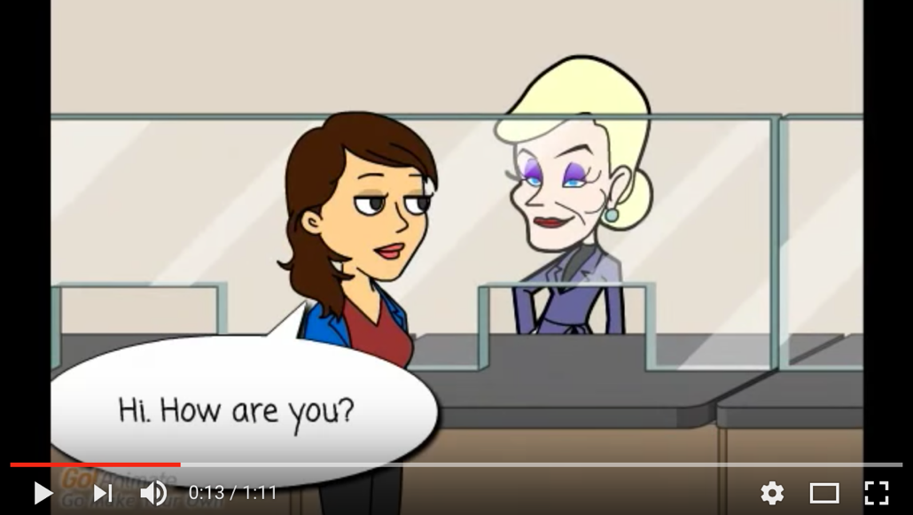
Customer: Hi. How are you?

Teller: Good. Thank you. And you?

Customer: Good too. Thank you. Can I get dollars with this Yen?

Teller: Sure. Do you have an account with us?

Customer: No. I don’t.

Teller: Can I see your ID, please?

Customer: Sure.

Teller: Thank you. With today’s rate, it will be $270.85.

Customer: Okay

Teller: 10 dollars will be charged as a transaction fee.

Customer: Okay

Teller: How would you like the cash?

Customer: Can I get 7 ten dollar bills and twenty for the rest?

Teller: Sure

Customer: Thank you.

Worksheet #4

I’d like to…
Do you have?
Will you?
Can I?
I would recommend
How would like..?

Please make your own script for the bank situation using the grammar above.

Customer: ___________________________________________________________

Teller: _______________________________________________________________

Customer: ___________________________________________________________

Teller: _______________________________________________________________

Customer: ___________________________________________________________

Teller: _______________________________________________________________

Customer: ___________________________________________________________

Teller: _______________________________________________________________

Customer: ___________________________________________________________

Teller: _______________________________________________________________

Customer: ___________________________________________________________

Teller: _______________________________________________________________

Customer: ___________________________________________________________

Teller: _______________________________________________________________

Customer: ___________________________________________________________

Teller: _______________________________________________________________

