☐ Listening ☐ Speaking ☐ Reading ☐ Grammar ☐ Writing

Topic: About feelings.

Instructor:  Sally | Level:  11~12 | Students:  12 | Length:  30 Minutes

Materials: New vocabulary flash card, face pictures, work sheets(word search),Lyrics, time watch, piece of paper,

Aims:

•Main aim- Ss will be improve feeling their vocabulary and speaking by playing feelings hints..
•Second aim- Ss to be connect word together
•Personal aim-Ss will express more clearly about their feelings.

Language Skills:
•Speaking – Ss will make situations and answer the question each other.
•Listening- Ss will listen and follow the feeling song.
•Writing- Ss will write stories with feeling card.
•Reading-Ss will reading comprehension on worksheet with feeling emotion.

Language Systems:
•Lexis-new type feeling vocabulary (sick, thirsty ,proud,afraid,confused,tired)
•Grammar-Ss write imagine story about they choose pictures with present simple sentences. (I am sad because…)
•Discourse-Ss has part of feelings to introduce and know correct vocabulary(Hi I am scary I can...).
•Function-expressing feelings.
•Phonology-y/ed.

Assumptions:
•Ss know vocabulary about basic feelings (happy,sad,angry,scary…)
•Ss already heard the feeling song.
•Ss like talk each other and they are similar level
•Ss know verb tenses. (present simple, past simple, past continuous)

Anticipated Errors and Solutions:
•Some Ss will take long time for activity.
→Let them know a time limit
•Some Ss can’t understand instructions.
→Explain more easily and keep help to understand and ICQS.
•Some Ss will shy doing front of present.
→Do the activities on their sit.

References:
•Song-https://www.youtube.com/watch?v=a1NIWCr0R-k
•Worksheet-https://kr.pinterest.com/pin/837177018201988706/

Lead-In
Materials: white board, markers(black, red)

Time | Set Up | Student Activity | Teacher Talk
2min | Whole  class | Ss listening and talking | Before start, write new vocabulary on the white board(confused, sick, tired, thirsty, proud, afraid)  Greeting  “Hello everyone listen! I had a scary dream”(look scared wait for Ss response)  “Okay, Now I want know about your feelings too!”

Pre-Activity
Materials: Flash card(confused, sick, tired, thirsty, proud, afraid), white board, markers(black, red)

Time | Set Up | Student Activity | Teacher Talk
5min | Whole  class | Answering question.  (Exited!!!!)  Look at the white board and guess situations.  Guess emotion about new words. | Elicit  “Before we start, Guess how I feel like?”(emotion excited face)  “Yes! Well done! Or try again!”  Instruction.  “Now, I’m going to explain these new words about feelings.”(Point one of word and make theatre situations.)  CCQS  “What was this emotion for?”  (make tired face)  “How am I looking like?”  (make sick emotions)  “Good jop!!!”  “Let’s do activity with using this new words”

Main Activity(Taboo)
Materials: Time watch, white board, marker

Time | Set Up | Student Activity | Teacher Talk
10min | Small group | Choose who will be start first. Sit on line and look at the board.  Think about word and answer the question.  (I feel confused!!) | Instructions.  "Sit in two lines in front of the board."  "One Ss in each team will face away from the board."  "Then I will write a word on the board."  "The other Ss who can see the word have to give clues for what it is to the Ss facing away."  "But they can't say the word."  "The first of the two Ss facing away to guess the correct word get a point."  ICQS  "How many lines are there?"(2)  "What can't you say?"  (the word on the board)  “I will write word for you who guess 6word winner”  Next! Let’s do the games.  Instruction  Each of you make sentence with words we learned also with emotion and quickly pass the time watch to next person. Time will set up 1 min who has alarm set new time.  Error  Check their sentences and correct answer.  ICQS  I am a starter, what should I say and pass this watch to next?

Post Activity
Materials: Number of pictures, half papers, glue, Music on monitor, Lyrics

Time | Set Up | Student Activity | Teacher Talk
6min | Individual  Whole class | Pick up the one of pictures and think attach pictures write story on the paper.  Ss following Ts emotion and song. | Instruction  First, Choose number and turn over check your face and attach on paper write story sentences about feelings.  Demonstrating  For example (take the number of card)  “I feel sad because my puppy die yesterday” I will give you 3min  Monitoring  Walk around check their mistakes  Drilling  Before singing the T drills the lyrics with actions. Then the Ss can look at the monitor, sing and follow along.

SOS Activity
Materials: word search work sheets.

Time | Set Up | Student Activity | Teacher Talk
5min | Whole  class | Get ready for find vocabulary. | Activity  Now we have little time be left so let’s do last activities. Take one of this work sheets and fine about feeling word.  I will give you 5 min. one of who had found a lot there is no homework for today!!! (Actually there is no homework for today.)  “Excellent!!! No homework for all of you! Thank you for hard work see you next time!”

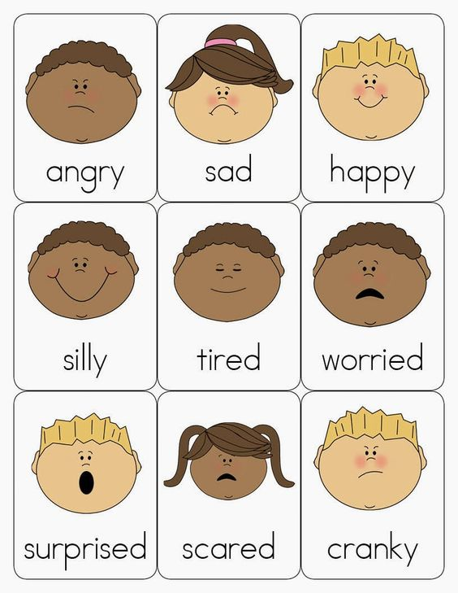

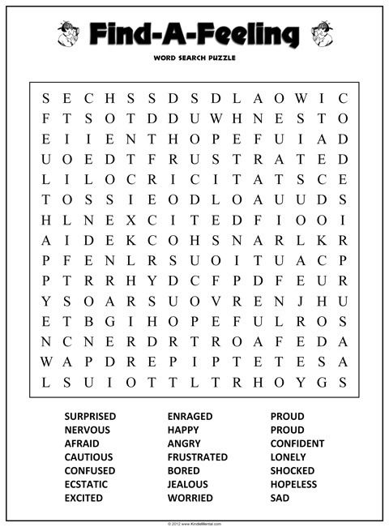

★ Lyrics - feeling song★

Happy happy. Wa ha ha!
Sad sad. Boo hoo hoo!
Angry angry. Grrrrrr!
Surprised surprised. Gee gee gee!

I laugh when I am happy.
Wa ha ha!
I cry when I am sad.
Boo hoo hoo!
I frown when I am angry.
Grrrrrr!
I jump up when I am surprised.
Oh, gee!

Hungry hungry. Grumble!
Scared scared. Brrrrrr!
Shy shy. Ings-ings!
Sleepy sleepy. Aaah!

I rumble when I am hungry.
Grumble!
I shiver when I am scared.
Brrrrr.
I hide when I am shy.
Ings-ings!
I yawn when I am feeling sleepy.
Aaah!

