Singapore
It is a city state which consists of one main island along with 62 islets. ‘Green Policy’, ‘Garden City”
Weather: It lies one degree north of the equator. And it is tropical rainforest climate. Temperatures usually range from 22 to 35 °C (72 to 95 °F). Relative humid. Averages around 79% in the morning and 73% in the afternoon.
Food: We can eat any kinds of international food in many restaurants. But especially we can enjoy food which the locals eat in ‘howker center’ which is very delicious and not expensive.
What to do: There are lots of travel package programs like’ Sentosa Tour with Singapore Cable car’, ‘Changi WW2 war trail and Museum Tour’ etc. We can join ‘Best of the Singapore Bike Tour’ And we can also visit worldly famous places like Singapore Botanic Gardens (which are free of charge), Universal Studios Singapore, Jurong Bird Park, Telok Ayer Market, River Safari, Night Safari, Underwater World, Singapore Zoo etc. And we can experience other cultures in Chinatown and Little India.
Shopping: From niche luxury boutiques (Singapore Chili crab, TWG tea, Tiger balm etc), to street side flea markets (for examples China Square Central Weekend Flea Market, Flea where ) are available.
Helpful Travel tip: 1) Official Singapore Airport Shuttle 1way Hotel Transfer: US $ 8.03 2) 4-seater or 7-seater vehicle: a 4-seater is $55, and 7-seater is $60 per trip to any destination in Singapore.
Papua New Guinea
It is an Oceanian country that occupies the eastern half of the island of the New Guinea (which is the second largest island) and its offshore islands in the Pacific Ocean. Its capital is Port Moresby. It lies between latitudes 0° and 12°S, and longitudes 140° and 160°E.
Weather: It is tropical rainfall climate. Average rainfalls are 1000mm-2000mm, but it is very diverse among the different areas. Temperatures usually range from 21 to 35 °C. June to October are called as Dry Season and November to May are called Rainy season.
Food: According to the areas, Sago, yam, taro, sweet potato is their staple. They cook food in/with Coconut cream. Their food is mild. They cook the meat by the way of ‘ mumu’
What to do: We can do Trekking ( like the famous Kokoda Track), Diving, Surfing, Fishing, Crusing, Bird Watching, Snorkeling( Papua New Guinea is surrounded by coral reefs which are under close watch), Standing up paddle. Also there are cultural events happing all year round in all parts of the county so- called ‘singsing’( See the calendar by the Papua New Guinea Tourism Promotion Authority)
Shopping: We can buy Wood carvings (in the form of plants or animals representing ancestor spirits), sea shells( which were their currency), bilum bags( They have different patterns from provinces), and Organic agriculture Coffee
Phuket, Thailand
Weather: the average temperature is 26~32 degrees Celsius with sunny sky and the cold breezes. The best time to visit Phuket is from December through March.
What to do: relaxing at the beaches, shopping at markets, snorkeling tour, scuba diving, walking tour of old Phuket city, Phang Nga nature tour, Phi Phi day tour, watching shows, etc
Food: Traditional Thai foods, International foods, etc. there are many kinds of restaurants.
Phuket is the largest Thai island and it's known for beautiful beaches. If you want more than simply surf and sun, this is also a good option. Phuket offers nightlife, shopping and adventure sports. It's also easy to get to. An island of fun and adventure, Phuket is a perfect choice for couples looking for a fun, yet thrilling holiday, or friends or solo travelers who are on a south-east Asian adventure. With so many things to do and such great food to eat, you will definitely want to keep coming back to this amazing Thai gem!
“When visiting Phuket, the one place you must visit is James Bond Island. Though the place is crowded with tourists pouring in every half hour, the view is truly breathtaking and is still worth the trip. It's a symbol of Phuket scenery, and you simply must take a picture here for the memory, and to show all of your friends and family back home!” by Donna, New Zealand
Siem Reap City, Cambodia
Weather: the average temperature is 22 ~30 degrees Celsius with sunny sky and dry periods. The months (from October through January) have nice weather with a good average temperature.
What to do: The private tour(Angkor Wat, bayon, Ta Prohm, Angkor Thom, Banteay srei, etc.), Apsaras Dance & Dinner Show, visiting the floating villages on the Tonle Sap, etc
Food: Cambodian traditional food, International foods, etc. there are many kinds of restaurants.
Siem Reap City is where you will probably stay during your visit, just 15 minutes from the temples. The town offers a large and varied choice of accommodations, from boutique hotels and 5-star resorts. But it’s the restaurants, hoping and nightlife - the amazingly varied dining choices, the vibrant night scene, and uniquely Cambodian shopping opportunities.
Lonely Planet just announced its list of the 500 best attractions on the planet, and Cambodia's Temples of Angkor took first place. While most people have heard of Angkor Wat, they don't realize that it's just one temple in a complex of more than 1,000. The complex is actually a massive 700-year old city, with canals, temples, tombs spread over 154 square miles, deep in the lush jungles of northern Cambodia. The Temples of Angkor are an iconic symbol of Southeast Asia and rightly Cambodia's top attraction.
“I was truly impressed by this temple and I'm generally not particularly impressed by temples. It is incredible and the grounds are quite interesting. I also recommend Ta Prom since it's really amazing to see massive trees growing on top of an ancient temple.” By Annie, Australia
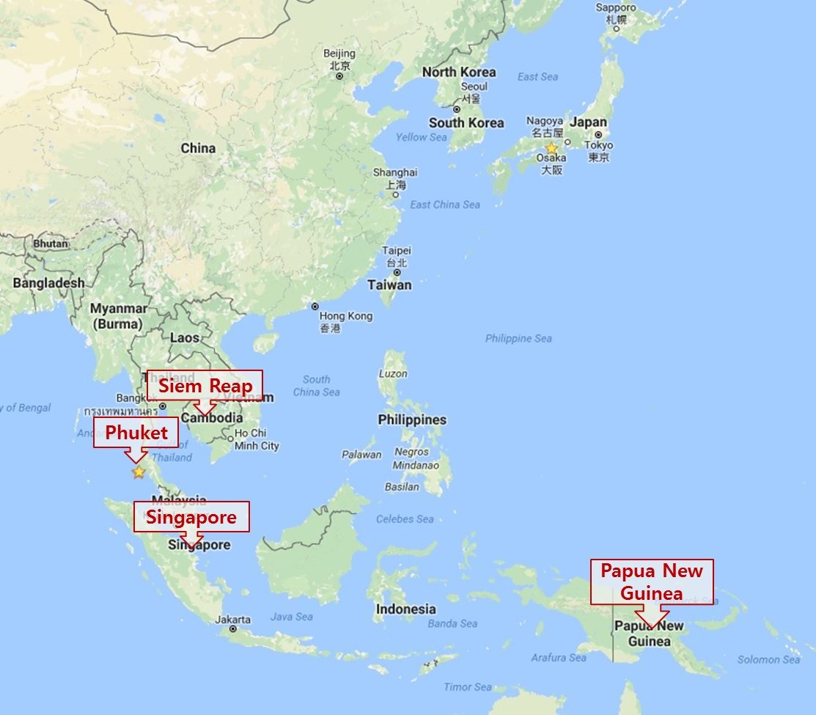
Singapore
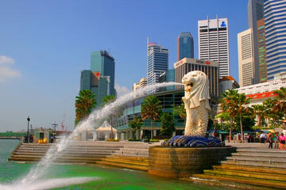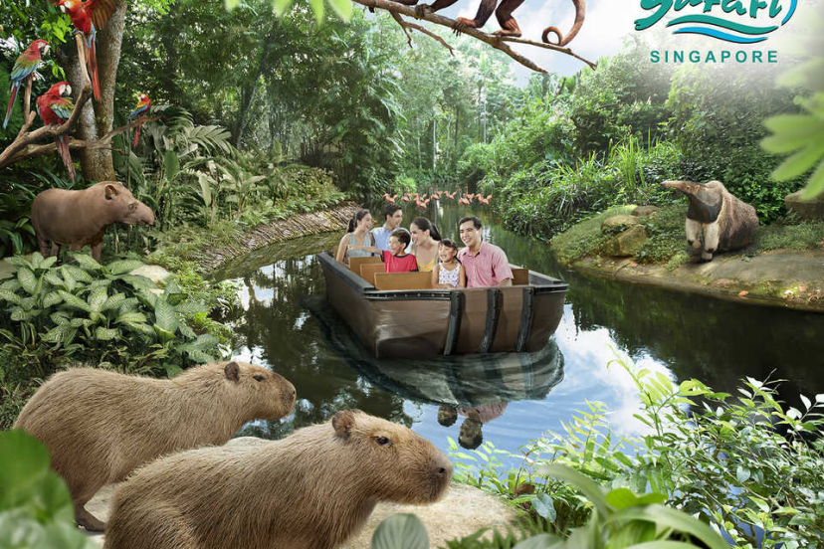
Papua New Guinea
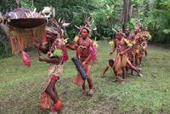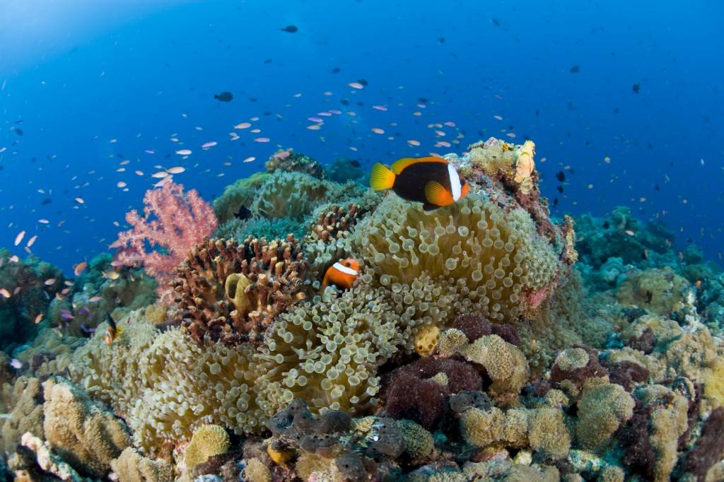
Phuket, Thailand
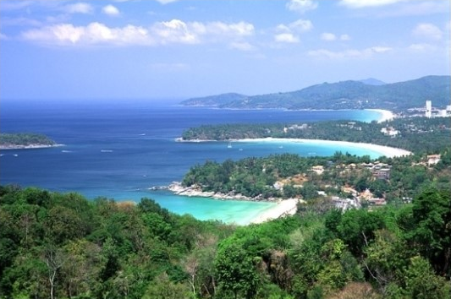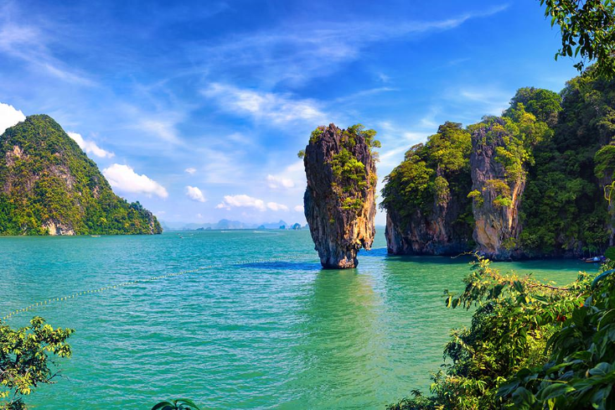

Cambodia's Temples of Angkor
