♣Take a look at two images below, and try your best to answer each questions.

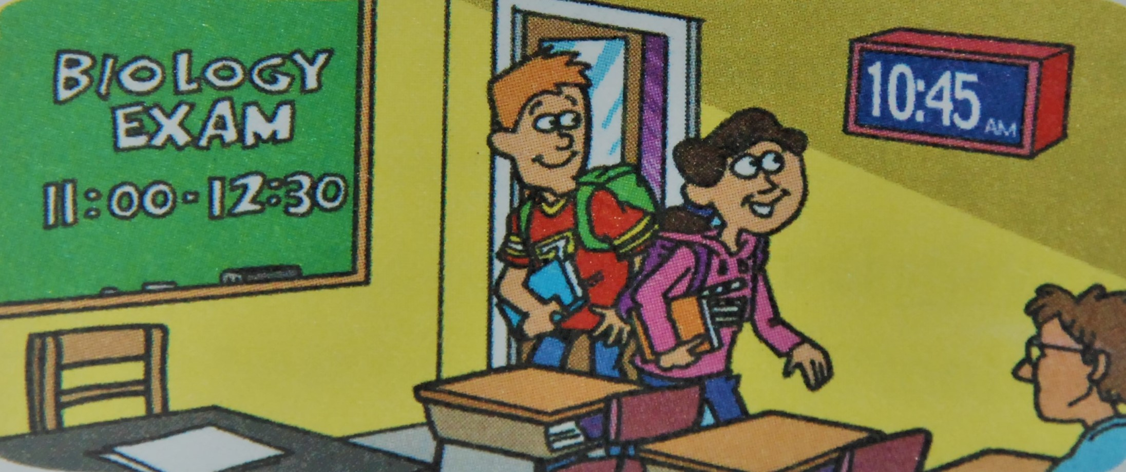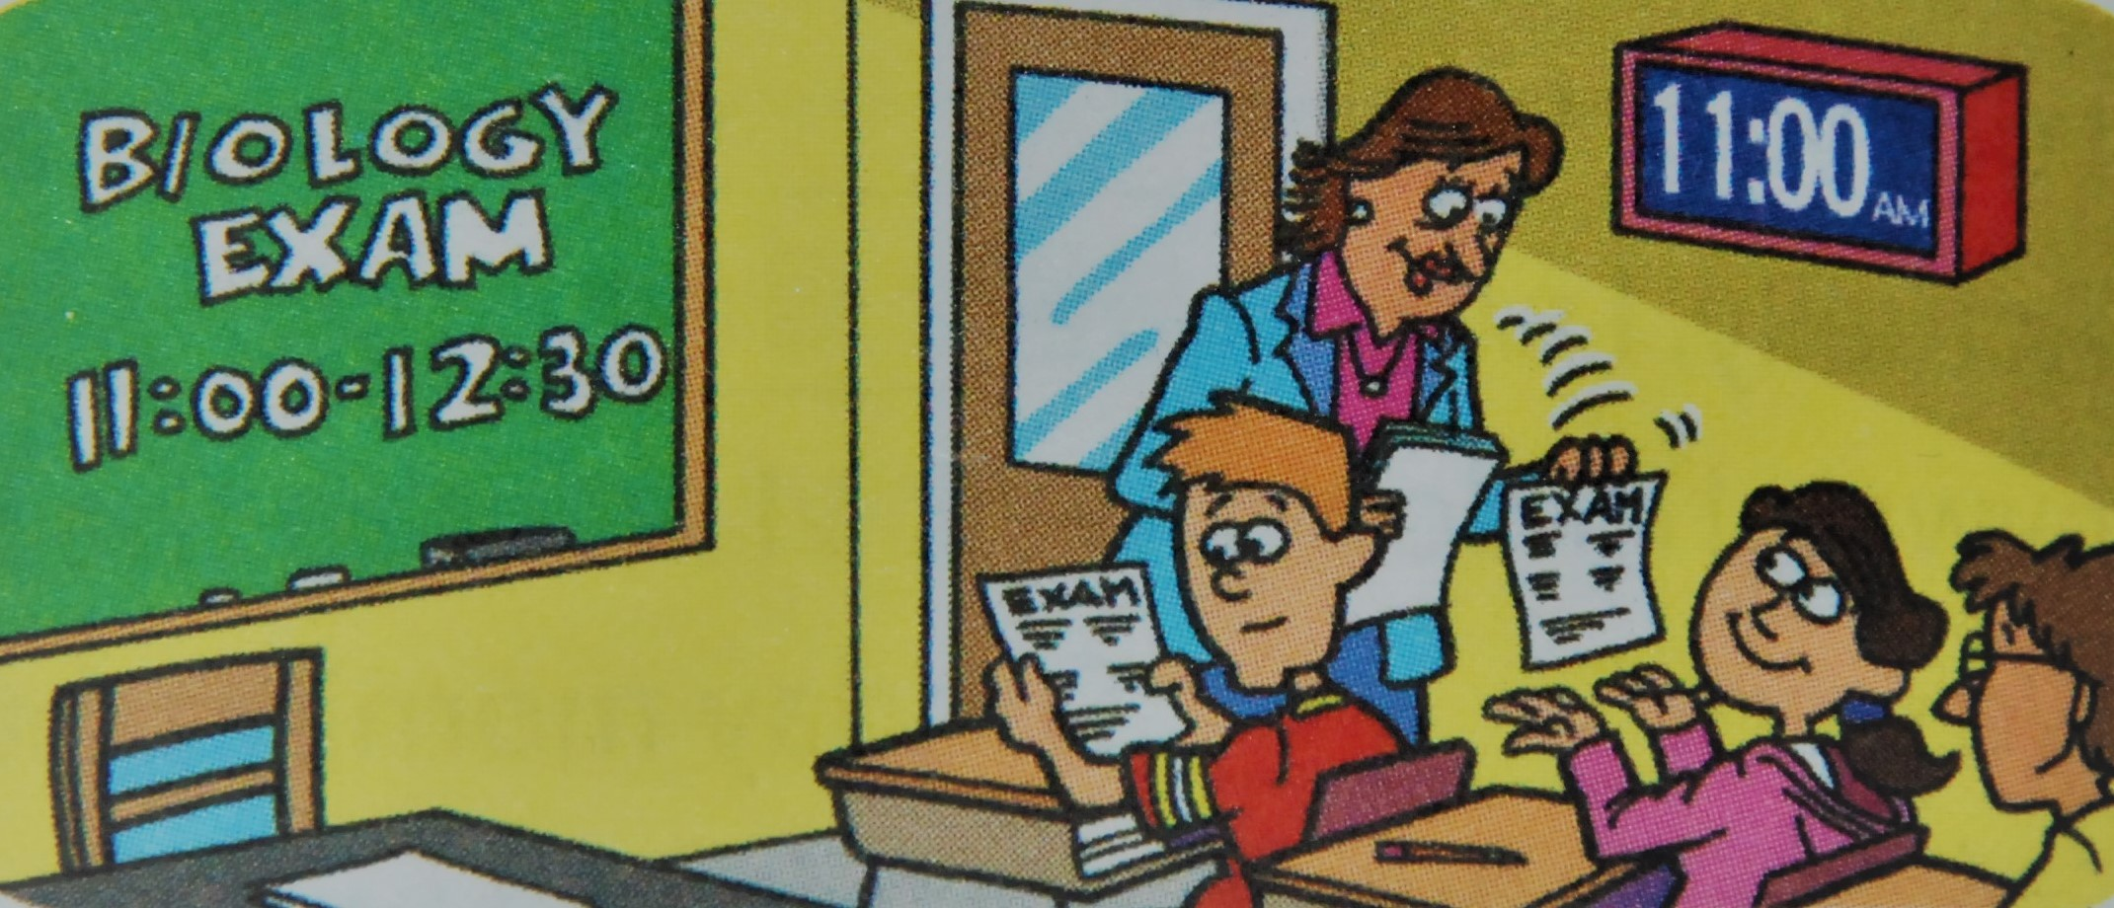

- (B)
- ( A / B ) The biology exam stared
- ( A / B ) They arrived for the biology exam.
♣With these two types of preposition, what other situations can we use it for?
- Cindy got home to cook for her guests.
- Cindy’s guests arrived for her dinner party.
- I didn’t register for the class . Now it’s full and I can’t take it.
- “Timothy isn’t .”
“He never is. We’ll have to wait again.”

♣Match each word in the left column with its definition in the right.

- In years ∙ ∙ (A) finally, after a long wait
- In advance ∙ ∙ (B) Before a time limit expires, early enough
- At last ∙ ∙ (C) During a specific time in the past
- At that time ∙ ∙ (D) For a very long time
- In time ∙ ∙ (E) Before a particular time, or before doing a particular thing

♣Complete the dialogue with the words in the box using at/on/in.
advance last that time time years

SANDY: , the exams are over!
JUSTIN: It was a tough week. But we’ll have fun at the concert tonight!
SANDY: Yes! It starts at 8, so let’s leave at 7 to get there to find our seats.
JUSTIN: There might be lots of traffic . How about 6:30?
SANDY: OK. I am so excited. I haven’t been to a concert !
JUSTIN: I haven’t, either! But we still need tickets.
SANDY: Justin, I thought you already had tickets!
You should have gotten them !

