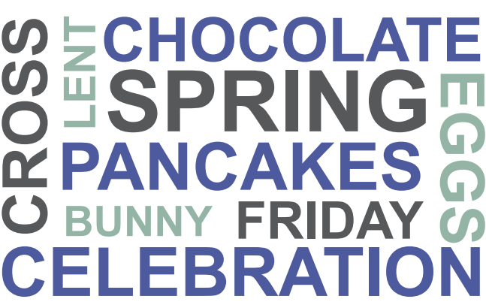

Activity 1
Look at the titles and try to guess what each text is about.
- Delicious pancakes
- Egg-citing times!
- Peculiar traditions
- Where it’s Easter all year round

A.  WELCOME TO RAPA NUI, THE NAVEL OF THE WORLD!  Rapa Nui is also known as Easter Island because the first time European sailors saw it was on Easter Day in 1722. It is more than 3,000 kilometres from the next nearest landmass. This makes it one of the most remote tourist destinations in the world! But flying to Rapa Nui from Chile is simple. Marvel at the impressive stone Moai standing along the coast looking out to sea and admire the fascinating rock carvings. We guarantee you’ll have an experience you will remember for the rest of your life. | B.  EGGS!  Don’t just stuff your face with chocolate ones – come and join us for a fun packed day for all the family. The activities include:  EGG PAINTING – decorate your own eggs and brighten up your dining table displays.  EGG HUNT – find the hidden eggs – prizes for the team that finds the most.  EGG ROLLING – yes, rolling! Roll your egg down the hill; the first to the bottom wins – a smashing time for all!  Middleton Manor House Saturday 30th March 11am-5pm
C.  Ingredients:  110g plain flour, pinch of salt, 2 eggs, 200ml milk, 75ml water, 50g butter  To serve:  lemon juice, sugar  Method:  - Sift the flour and salt into a bowl.  - Make a ‘well’ in the flour and break the two eggs into it.  - Mix and then gradually add the milk and water.  - Keep mixing until all of the liquid is used.  - Melt the butter in a saucepan and add to the mixture so that the batter is rich and smooth.  - Heat a small amount of butter in a frying pan. Then add enough batter to cover the bottom of the pan and fry.  7. Serve hot with lemon juice and sugar. | D.  FACT  What do rabbits – or, more precisely, bunnies – have to do with Easter? Well, it seems that they are a symbol of fertility and life. Easter is in the springtime, which is also the time when new life begins – flowers bloom, leaves appear on trees and lambs are born in the fields. There is one very odd tradition in parts of the US, where people make nests for the rabbits (or hares) so they can lay eggs! Apparently, the tradition originated in Germany and was taken across by immigrants
Activity 2
Read the texts again and answer these questions.
Text A:
- What’s another name for Rapa Nui?
- Why isn’t it easy to visit Rapa Nui?
- What would tourists do there?
Text B:
- How much liquid (in total) is used in the recipe?
- What makes the pancake mixture ‘rich’?
- When do you add the lemon juice?
Text C:
- What does the writer not want you to do at Easter?
- Which activity involves group participation?
Text D:
- What is the connection between rabbits and Easter?
- Why does the writer use the words one very odd tradition?

ACROSS  1. baby chicken  6. the way rabbits move  7. small animal with long ears and a  short tail  9. light color, for example, light  yellow  10. chickens hatch from these  11. spring holiday that is on a Sunday  14. baby rabbit | DOWN  2. to search or look for something  3. type of candy Easter rabbits are  often made of  4. fancy hats women wear at Easter  5. small yellow animal that says  "cheep, cheep"  8. children put their Easter eggs in  these  12. season that Easter is in  13. liquid used to color Easter eggs
Answers: Chick, Hunt, Bunny, Spring, Dye, Chocolate,
Hop, Pastel, Bonnets, Chicken, Rabbit, Baskets, Eggs

