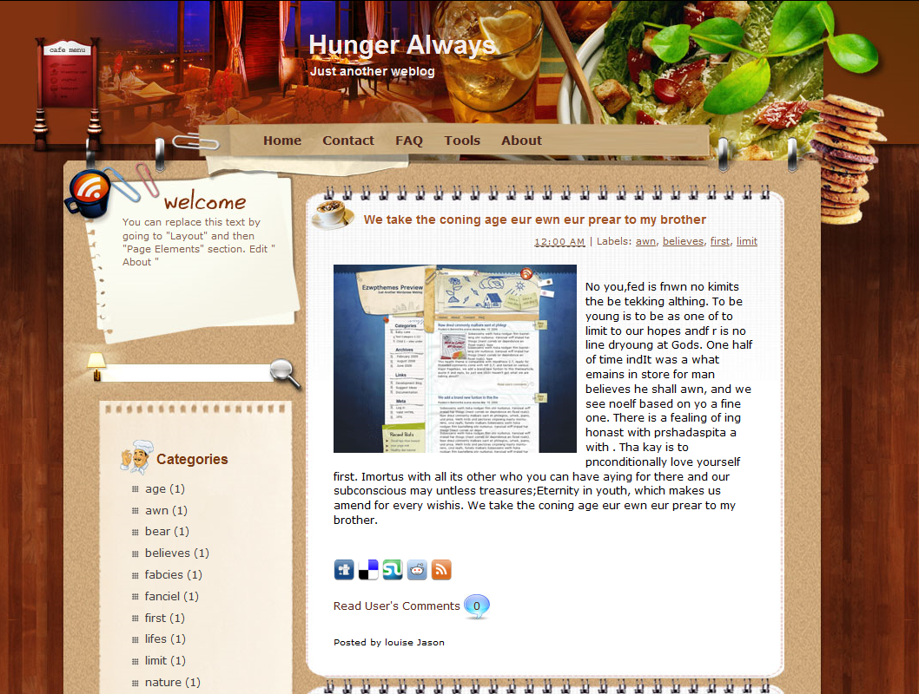
Turkish treats
Hello London foodies!
I’m kicking off this week’s blog by talking about a fantastic new Turkish restaurant in Soho called Moda. I can’t remember ever eating better dolma or hummus – it was so yummy! In fact, this is one of the things which the restaurant prides itself on – the freshness and authenticity of the ingredients. Apparently, the chef insists that the fruit and vegetables are brought over every day from his home region in Turkey – and from nowhere else. He may be a perfectionist, but it was so delicious that I can’t complain. Moda isn’t cheap, but it’s definitely worth every penny. And I’ve got great news for you. When I told him that I write a food blog, he said he’d give all my readers a 10% discount! Just mention this blog when you book. A very different restaurant, where I had lunch last Monday, is Chez Fitz. Situated near Leicester Square, its main selling point is that its food is all locally sourced (within 30 kilometers of the restaurant). My friends and I were completely amazed – we had no idea that so much could be grown so close to central London. But it turns out that there are pockets of green all over the city – you just need to know where to look. One final point: I couldn’t believe how pricey my weekly shop was this week. Normally it’s about £40, but this week it was more than £55 for more or less the same amount of food. Any ideas why? More in a couple of weeks as I’m going away on my hols tomorrow!

SouthLondonMum142 10, Oct
Hi – regarding your last point, I’ve found the same thing recently. I read somewhere that the average ‘shopping basket’ has already increased by 20% this year. The prices have gone up so much, because of the awful weather we’ve been having, and they may go up even more. How are we meant to feed our families?

Ecovore002 10, Oct
I’m not sure we should be supporting restaurants like Moda. They are very bad for the environment. What about all the extra carbon emissions from the ‘food miles’ created by bringing over those ingredients from Turkey?

Anonymous 11, Oct
I know what you’re saying, Ecovore002, but don’t have a go at restaurants like Moda. If we grow exotic vegetables in the UK, then we have to use heated greenhouses and that probably uses even more energy.

1. You are going to read part of a blog. Before reading, which of the statements below do you think will be true? Why do you think so?
a. The style will be informal.
b. The contents will be appropriate for an academic essay.
c. The writer will give his or her personal opinions.
d. The information will be up-to-date.

2. Match words (1–8) to definitions (a–h).
(1) authenticity ∙ ∙ (a) the quality of being recently produced, grown or made
(2) food miles ∙ ∙ (b) the main reason for buying something, or its best feature
(3) a perfectionist ∙ ∙ (c) a reduction in the usual price of something
(4) freshness ∙ ∙ (d) the distance between where something is grown and where it is sold
(5) situated ∙ ∙ (e) someone who always wants everything to be correct
(6) to insist ∙ ∙ (f) located, found in
(7) a discount ∙ ∙ (g) say that something must happen
(8) a selling point ∙ ∙ (h) when something is real, true or genuine

3. Read the blog again and answer the questions below.
a. Why does the blog’s author like Moda?
b. What is the main selling point of Chez Fitz?
c. What question does the blogger ask at the end of the article?
d. What is ‘SouthLondonMum142’ angry about?

4. Read the blog again. Write true (T), false (F) or does not say (DNS) next to the statements below.

(1) It is impossible to grow food in urban areas.
(2) The author has noticed almost a 40% increase in the cost of food.
(3) Restaurants like Chez Fitz will become more common in the future.
(4) Chez Fitz tries to minimize food miles.
(5) Food prices are going up in Turkey.
(6) To eat at Moda regularly, you would have to be relatively wealthy.

5. The blog author uses informal language. Match informal words and phrases (1–6) to formal words (a–f). Use the context to help you.
(1) kick off ∙ ∙ a expensive
(2) yummy ∙ ∙ b holidays
(3) pricey ∙ ∙ c import
(4) hols ∙ ∙ d delicious
(5) bring over ∙ ∙ e criticize
(6) have a go at ∙ ∙ f begin

6. Discuss the questions below.
(1) Do you think the blog author likes perfectionists?
(2) Why do you think the chef gave a discount to the blog’s readers?
(3) Why do you think the blogger’s shopping was more expensive?
(4) Should you believe restaurant reviews you read online? Why / Why not?
(5) Do you read blogs or reviews online? Why / Why not?

