Listening Speaking Reading Grammar Writing

Topic: Body Phrases

Instructor:  Sunny | Level:  Beginner | Students:  6 students | Length:  25 Minutes

Materials:
Computer, Speaker, Cards, Video clip, Paper doll

Aims:
Main aim: Ss will be able to understand body phrase by doing exercise.
Secondary aim: Ss will be able to follow the card rules when they play game.
Personal aim: I want to them to enjoy our class and able to manage class professionally
Language Skills:
Reading : Ss will read the card and presentation lyrics.
Listening : Ss will listen and watch the video.
Speaking : Ss will speak out the body phrase repeatedly during class
Writing : Ss will fill out a worksheet.

Language Systems:
Phonology : /sh/ /ch/
Lexis : shrug, scratch, tickle, wave, bend, wiggle, clap, stomp
Function : ask answer
Grammar : verbs of movement
Discourse : acting

Assumptions:
Ss already know
- Basic parts of the Body (head, nose, mouth)
- How the class is set up and run
- Teacher’s characteristic

Anticipated Errors and Solutions:
Ss have problem to memorize today’s body phrases.
- Repeat word several times in different activity.
Ss cannot understand and follow the game
- Ask question (ICQ, CCQ)

References:
Youtube https://www.youtube.com/watch?v=pTbjp3aMz-I

Lead-In
Materials:
Time | Set Up | Student Activity | Teacher Talk
1min | Whole  Class | Ss answer  Ss answer “shake hand” | Elicit  T:  Good morning everybody!  How are you today?  Can you tell me what am I doing now?  Model  T Shake hand  T: That’s right!

Pre-Activity
Materials: Paper doll (Alex)

Time | Set Up | Student Activity | Teacher Talk
5min  8min | Whole class | Ss answer the question.  Ss put a name tag on the body  Ss answer the question.  Ss put a name tag on the body.  Ss watch video and repeat after him.  Ss answer the question  Ss repeat after T  Ss answer the question  Ss repeat after T  Ss answer the question  Ss repeat after T  Ss answer the question  Ss repeat after T  Ss answer the question  Ss repeat after T  Ss answer the question  Ss repeat after T  Ss answer the question  Ss act like elephant.  Ss repeat after T  Ss watch, act, speak out together. | T:  Here is my friend ‘Alex’  What is this? (point out)  Yes, it is shoulder  Can you put the name tag?  Where is his belly?  Can you put the name tag?  Where is his back?  Can you put the name tag?  Where is his arm?  Can you put the name tag?  Where is his elbow?  Can you put the name tag?  Where is his finger?  Can you put the name tag?  Where is his knee?  Can you put the name tag?  Where is his foot?  Can you put the name tag?  Where is his toe?  Great! Can you put the name tag?  Everybody good job!  Let’s stand up and watch video!!  And repeat after him!  Model  Play video (1 time)  T:  What am I doing can you remember?  Yes, I shrug my shoulder  Shrug means,  Move your shoulder up and down.  Can you repeat after me?  Shrug, shrug I shrug my shoulders  What am I doing?  Yes, I tickle my belly  Tickle means  Touch someone with finger to make laugh  Can you repeat after me?  Tickle, Tickle I tickle my belly  What am I doing?  I scratch my back.  What is scratch?  Yes, rub your skin with nail  Can you repeat after me?  Scratch, Scratch.  I scratch my back  Can you wave your arms?  Good! When you move gently up and down, we called ‘wave’  Can you repeat after me?  Wave, Wave I wave my arms.  Can you bend your elbow?  Good When you curve the body  we called ‘bend’  Can you repeat after me?  Bend, Bend I bend my elbow.  Can you wiggle your fingers?  Yes, when you move quickly from side to side we called ‘wiggle’  Can you repeat after me?  Wiggle, Wiggle I wiggle my fingers  Okay last one  How does elephant walk?  Elephant walks around with heavy step.  We can say “Stomp”  I stomp my feet.  Can you repeat after me?  Stomp, Stomp I Stomp my Feet.  Model  Show How to walk like an elephant  Let’s watch video one more time.  Everybody stand up!  Repeat after him  Model  Play video (1time)

Main Activity
Materials: Body phrases cards, timer

Time | Set Up | Student Activity | Teacher Talk
1min  5min | Whole  Class  Pairs  Pairs | Ss listen question  Ss:  find 2 same cards and  flip 2 more cards.  We need act and speak out  Ss: no pair  Ss: 2 times  Ss: flip 2 more cards  Act and speak out a sentence.  Ss: bonus card. We can flip 2 More times.  Ss play game.  Ss: Yes, it was fun! | Let’s play Card game!  Do you know ‘Matching card game”?  I will divide into pairs.  (using website)  Instruction  - Flip 2 cards if you find 2 same cards,  Ss can flip 2 more cards.  - If Ss find 2 same cards,  Ss act and speak out body phrase.  (Ex. I scratch my back)  - Star Card is bonus card,  you can flip 2 more cards.  - Ss need to flip cards in 10sec.  T:  Here are 30 cards,  Flip 2 cards first,  When you find 2 same cards,  You can flip 2 more cards.  When you find 2 same cards we need to act and speak out the sentence.  Demonstration  T flip 2 same cards and act  CCQ  What do you need to do?  Right, Finding 2 same cards. And  we can flip 2 cards more if we find it.  T:  Good.  This is bonus card called “Star Card”.  If you find this card, you can flip 2 more cards.  You can keep star card and use when you need. Don’t forget say before when you use.  ICQ  Are you working alone? No, Pairs  CCQ  How many cards can you flip? 2  If you find 2 same cards what will you do? Flip 2 more cards.  Act and speak out a sentence.  What does Star card for?  It is a Bonus card  we can flip 2 more cards  Okay Let’s start!  Monitor  Monitor discreetly.  Answers students if they ask questions.  T:  Okay, everybody good job!  Did you enjoy?

Post Activity
Materials: Body phrase cards
Time | Set Up | Student Activity | Teacher Talk
1min  3min  1min | Group  Individually | Ss listen to instruction.  Ss choose the leader.  Ss look at the demonstration.  Ss: No  Ss: Describe word  Ss: No  Ss play game.  Ss: yes  Ss answer the question.  Ss hide card and describe.  Rest of Ss answer question. | Instruction  Divide group A, B (Draw lottery)  Start with A team first.  Leader of A team sit on a chair and  rest of members stand in front.  T show card to rest of members and they describe to leader.  Leader speak out a sentence.  .  The team got all answer faster than another team, they are winner.  T:  I will divide into 2 groups.  Please pick up paper (blue vs red)  Please choose leader.  Who is it? Okay  Leader sit in a chair and  Rest of members stand in front.  I will show you picture and you need to describe the word to leader without word. You cannot say.  Leader speaks out answer.  Then I will show you next picture.  The team got correct answer faster than another team is winner!!  Demonstration  T:  I am Ss stand in front (act)  I am a leader (answer quiz)  ICQ  Are you working alone? NO  CCQ  What will you going to do?  Yes, describe word.  Can you say to leader? No  Lets’ start!  Monitor  Monitor discreetly.  Answers students if they ask questions.  Winner is __ Team!  Congratulation!  Conclusion Lesson  Okay, did you guys have a fun?  What body phrases did you learn today?  Let’s check together body phrases that we learned today!  Instruction  Give different card to Ss  Ss hide card and act without word.  Other Ss answer together.  Good job everyone  Thank you for your participation!

SOS Activity
Materials: worksheet 1#

Time | Set Up | Student Activity | Teacher Talk
2min | Individually | Ss listen instruction  Ss: 2 mins  Ss: Yes alone  Ss read sentences together | Here is worksheet  Please look at the picture and  write down above sentence  Okay, here is a worksheet #1.  Now I want you write 6 sentence  I will give 2 minutes  (Distribute the worksheet #1)  ICQ  How much time do you have?  Are you working individually?  Monitor  Monitor discreetly. Answers students if they ask questions.  Give time warning:  20 seconds left.  (Be flexible with time.  Give 1 more minute if they need it)  Check answers  Let’s read the sentence together.
6
Alex body
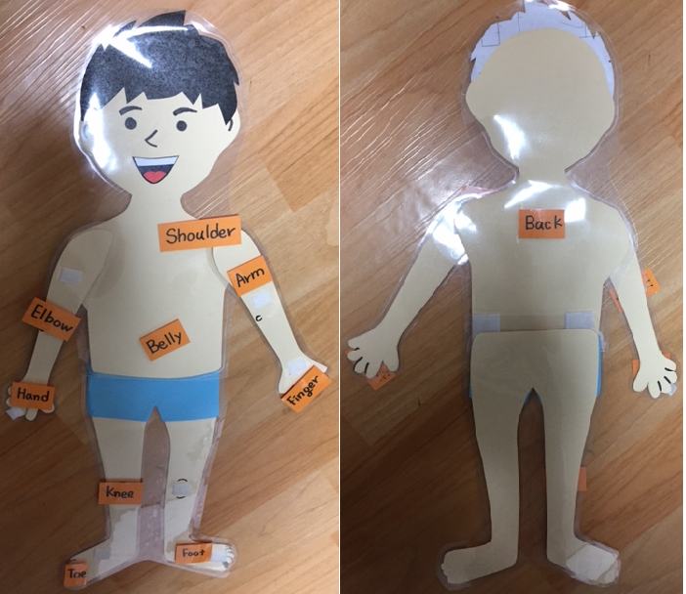
Body phrases cards (Main activity)
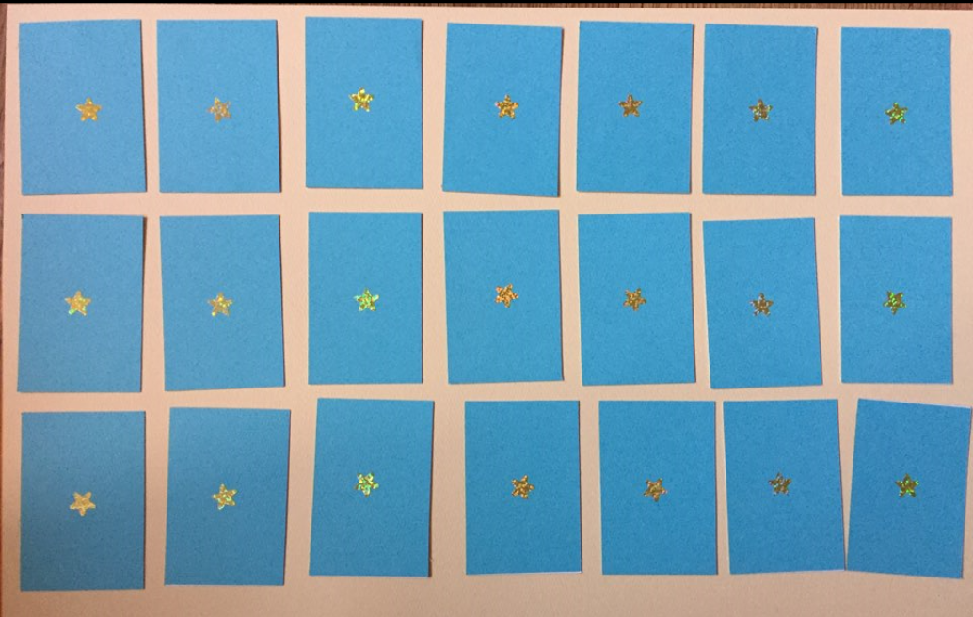
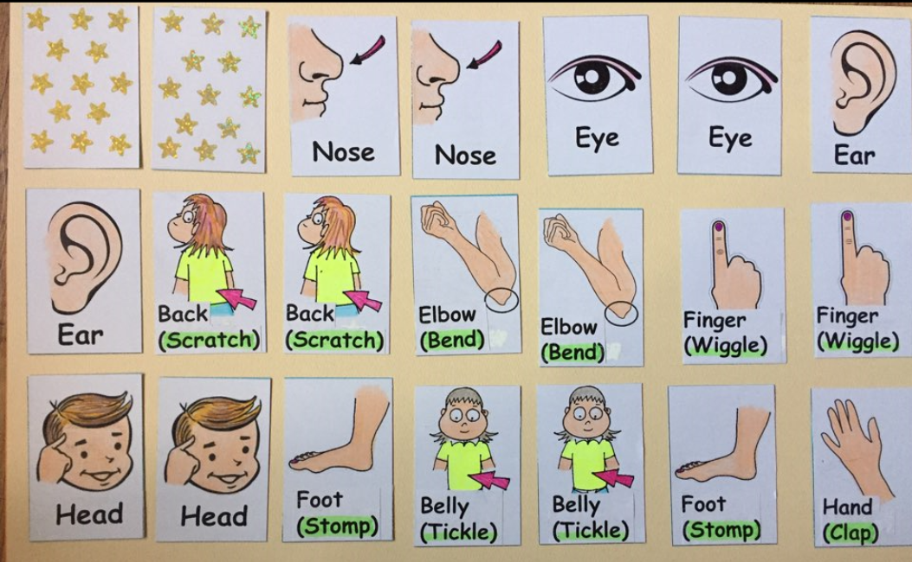
Sos worksheet


