Listening Speaking Reading Grammar Writing

Topic: Mixing Colors

Instructor:  Rachel  (Wiyeon, Park) | Level:  7-8 years old  high-beginner | Students:  6 | Length:  25 Minutes

Materials:
- Title : Mixing Colors
- Color flashcards : red, blue, yellow, purple, green, orange
- Water colors : red, blue, yellow
- 3 clear plastic cups of water
- 3 clear plastic cups
- Sticks
- 7 pieces of paper
- 4 plastic plates
- Tape
- A board
- Wet tissue
- A worksheet for tips
- Colored papers : red, blue, yellow, purple, green, orange, pink, white, black, gray
- Song : Mix the color song (0:50)
- Colored pencils(SOS)
- Worksheet(SOS)

Aims:
Main aim: Ss will be able to understand how to make secondary colors and
answer the questions.
Secondary aim: Ss will be able to make secondary colors by themselves by using
primary colors
Personal aim: I want to Ss understand primary and secondary colors.

Language Skills:
Reading : Read a title and recognize names on flashcards and a worksheet(SOS)
Listening : Listen to a song and questions, other students answer.
Speaking : Sing a song and answer questions
Writing : Draw a picture, writing names of colors(SOS)

Language Systems:
Phonology : /e/ red, yellow, gray
Lexis : color, red, blue, yellow, purple, green, orange, pink, white, black, gray
Function : identifying declarative sentences
Grammar : present simple
Discourse : Q&A sequences, song lyrics.

Assumptions:
Students have already known basic phonics words.
Students learn primary colors last class.
Students can understand simple present and basic expressions.

Anticipated Errors and Solutions:
Ss may be struggling for words.
→ give spelling of words and read them together
Ss can’t think of answers.
→ give some hints or try eliciting

References:
https://www.youtube.com/watch?v=IwfZvRuE7s8&index=3&list=RDbmquqAP2w_8
(Mix the color song)
https://www.tes.com/teaching-resource/simple-primary-colour-mixing-worksheet-6431238
(SOS worksheet)

Lead-In
Materials:
- Title : Mixing Colors
- Color flashcards : red, blue, yellow
- Tape
- A board

Time | Set Up | Student Activity | Teacher Talk
2mins | Whole Class | Greet students.  Ss may say red, blue, yellow, pink, yellow etc.  Ss say yes.  Ss there are 3.  Ss say red, blue and yellow.  Ss say mixing colors. | Greet  Hi, everyone! (Smile and eye contact) How are you today?  Elicit  There are many colors in the world.  What color do you like?  CCQs  Last class, we learned Primary Colors.  Do you remember what primary colors are?  How many primary colors are there?  What are primary colors?  (Put red, blue and yellow color flashcards on the board when Ss 3 primary colors when they say the color)  Yes, red, blue and yellow are primary colors.  Today we are going to talk about mixing colors.  (Put ‘Mixing’ on the board next to the ‘colors’)  Let’s read together.

Pre-Activity
Materials:
- Title : Mixing Colors
- Color flashcards : red, blue, yellow, purple, green, orange
- Water colors : red, blue and yellow
- 3 clear plastic cups of water
- 3 clear plastic cups
- Sticks
- Tape
- A board

Time | Set Up | Student Activity | Teacher Talk
5mins | Whole Class | Ss say three cups of water on the desk.  Ss say red.  Ss say blue.  Ss say yellow.  Ss guess.  Ss say purple.  Repeat after teacher.  Ss guess.  (Student 1 volunteers)  Ss say blue and yellow water and one clear plastic cup.  Ss say mix/pour blue and yellow together.  Ss say green.  Repeat after teacher.  Ss guess.  (Student 2 volunteers)  Ss say yellow and red water and one clear plastic cup.  Ss say mix/pour yellow and red together.  Ss say orange.  Repeat after teacher.  Ss sing a song together. | CCQs  What can you see on the desk?  Yes, there are three cups of water on the desk.  (Dissolve red in water and stir it with a stick.)  What color is it? Red.  (Dissolve blue in water and stir it with a stick.)  What color is it? Blue.  (Dissolve yellow in water and stir it with a stick.)  What color is it? Yellow.  That’s right.  There are 3 primary colors.  Red, blue and yellow.  If you mix two colors together, you can make a new one.  Let’s do it together.  What color is it when red and blue mix together?  Can you guess?  Let’s mix red and blue together.  We need red and blue water and one clear plastic cup.  First, pour red into a clear plastic cup.  Second, pour blue into the cup.  Now, mix together.  Can you see?  What color is it when red and blue mix together?  That’s right. It’s purple.  P U R P L E, purple.  (Put a purple color flashcard between red and blue on the board)  What color is it when blue and yellow mix together?  Can you guess?  Who wants to mix the colors?  Thank you.  Let’s mix blue and yellow together.  ICQs  What do we need?  (Show Ss blue and yellow water and one clear plastic cup)  What are we going to do?  (Give the volunteer blue water)  You have blue and I have yellow  Now, mix them together.  (Pour the colors into a clear plastic cup)  (The volunteer goes back.)  Can you see?  What color is it when blue and yellow mix together?  That’s right. It’s green.  (Put a green color flashcard between red and blue on the board)  G R E E N, green.  What color is it when Yellow and Red mix together?  Can you guess?  Who can help me this time?  Thank you.  Let’s mix yellow and red together.  ICQs  What do we need?  (Show Ss yellow and red water and one clear plastic cup)  What are we going to do?  (Give the volunteer blue water)  You have yellow and I have red  Now, mix them together.  (Pour the colors into a clear plastic cup)  (The volunteer goes back.)  Can you see?  What color is it when yellow and red mix together?  That’s right. It’s orange.  (Put a orange color flashcard between red and blue on the board)  O R A N G E orange.  Great.  Let’s sing a song together.

Main Activity
Materials:
- Title : Mixing Colors
- Color flashcards : red, blue, yellow, purple, green, orange
- Water colors : red, blue, yellow
- 7 pieces of paper
- 4 plastic plates
- Tape
- A board
- Wet tissue
- A worksheet for tips

Time | Set Up | Student Activity | Teacher Talk
5mins  8mins | Pair work  Whole Class  Individual work | Ss look and listen to their teacher.  Ss say purple.  Ss say green.  Ss say yellow.  Ss say yes.  Ss say yes.  Ss say 3 colors.  Ss say red, blue, and yellow.  Ss say my fingers.  Ss say mix colors/make purple, green and orange.  Ss say 3 minutes.  Ss say purple.  Ss say green.  Ss say orange.  Ss answer.  Ss say red, orange, yellow, green, blue, and purple.  Ss look and listen to their teacher.  Ss say yes.  Ss say yes.  Ss say yes.  Ss say 6 colors.  Ss say red, orange, yellow, green, blue, and purple.  Ss say my fingers.  Ss say draw.  Ss say right.  Ss say press and open It.  Ss say finish drawing.  Ss say 5 minutes.  Ss may say mine. | Let’s pair up.  We are going to make purple, green, and orange with your partner.  Demonstration  I am going to give 3 primary colors on the plastic plate each.  (Squeeze red, blue, and yellow paints out onto each plate)  You are going to make purple, green, and orange on the plate with your fingers.  First, you mix red and blue. You can make …...  It’ll place between red and blue.  Second, you mix blue and yellow. You can make …....  It’ll place between blue and yellow.  Third, you mix yellow and red. You can make …....  It’ll place between yellow and red.  (put the sample on the middle of the Ss’ desk)  I’ll give you 3 minutes  Can you do it?  ICQs  Are you working with your partner?  Point your partner.  How many colors are on the plate first?  What color do you have first?  What are you going to use?  What are you going to do?  How much time do you have?  Let’s check, one more time!  (Encourage Ss)  First, red and blue make…  Second, blue and yellow make…  Third, yellow and red make…  Which one is number 1, 2, 3?  (Give Ss a worksheet for tips to let Ss know the order.)  Great! Let’s begin!  (Help Ss when they have a difficult time.)  Monitor,  Give a time warning: 1 minute left.  Are you done? Let’s check!  (Check what they did)  Looks beautiful.  Now you have 6 colors.  Let’s say together.  Start red clockwise. Red, orange, yellow, green, blue, and purple.  That’s right.  Now we are going to draw a picture.  Demonstration  I am going to give you a piece of paper.  Already, I folded a piece of paper in half.  Share the colors with your partner.  You are going to draw with your finger on the right side of the paper.  Then, you fold the paper in half again and press it hard.  Open it up and you will see beautiful patterns or pictures.  (Attach the teacher’s work on the board.)  If you finish it, I am going to give you wet tissue to clean up your fingers.  ((In real class, let Ss go to the bathroom to clean up.))  I’ll give you 5 minutes.  Can you do it?  ICQs  Are you working alone?  Do you need to share colors with your partner?  How many colors do you have now?  What color do you have?  What are you going to use?  What are you going to do?  Where are you going to draw on the paper, right or left?  Then, you fold the paper in half again and what are you going to do?  When can you get wet tissue?  How much time do you have?  Excellent! Let’s begin!  (Help Ss when they have a difficult time.)  (If Ss need more colors, give them more.)  Monitor,  Give a time warning: 1 minute left.  Are you done? Let’s check!  (Check what they did and attach Ss’ works on the board.)  (Give Ss wet tissue to clean up their fingers when they finished)  Wow! It’s wonderful.  Whose picture is the best?  Everyone is good job.

Post Activity
Materials:
- Title : Mixing Colors
- Colored papers : red, blue, yellow, purple, green, orange, pink, white, black, gray

Time | Set Up | Student Activity | Teacher Talk
5mins | Whole Class  Team work | Ss look and listen to their teacher.  Ss yes  Ss say 3.  Ss raise their hand.  Ss say get the colors, say the names and give them to teacher.  Ss say 1 point.  Ss say yes.  Ss say purple.  Ss say green.  Ss say orange.  Ss say thank you and good bye. | There are many colors in my hands.  Let’s say together.  Red, blue, yellow, purple, green, orange, pink, white, black, gray.  (When Ss say the name of color, Teacher puts it on the table.)  Let’s play a mixing color game.  Demonstration  There are many colors on the desk.  I’ll divide you into two teams.  There are 3 people in each team.  I give you number. 1, 2, and 3.  One person in each group comes to the table.  I ask “what two colors do we need to make purple?”  If you know the answer, get the two colors first.  Then say the color’s name and give me.  If you are right, you can get 1 point.  ICQs  Are you working in a team?  How many people are in your team?  Point your team members.  Who is the first, number 1?  Raise your hand.  Who is number 2? Raise your hand.  Who is number 3? Raise your hand.  If you know the answer, what are you going to do?  If you are right, how many points are you going to get?  Let’s begin!  (Play a game)  one point questions  “What two colors do we need to make green?”  “What two colors do we need to make orange?”  “What two colors do we need to make purple?”  two point question  “What two colors do we need to make gray?”  Great!  Black and white make gray. I’ll give 2 points to your team.  How many points did you get?  Which team is winner?  Congratulations!  Wrap up  We learned mixing colors today.  Did you have fun today?  Let’s check, one more time!  (Encourage Ss)  Red and blue make…  Blue and yellow make…  Yellow and red make…  Excellent!  Next time, we are going to talk about more colors.  Thank you for today.  See you next time.

SOS Activity
Materials:
- Colored pencils(SOS)
- Worksheet(SOS)

Time | Set Up | Student Activity | Teacher Talk
5mins | Individual work | Ss look and listen to their teacher.  Ss say yes.  Ss say write words and color circles  Ss say colored pencils  Ss say 4 minutes.  Ss write words and color circles with colored pencils. | Let’s write words and color circles with colored pencils.  Demonstration  There are 3 circles in each line.  There are the names of colors below the circles.  Color the circles and fill in the blanks.  I’ll give you 4 minutes.  ICQs  Are you working alone?  What are you going to do?  What are you going to write with?  How much time do you have?  Let’s start.  Monitor,  Give a time warning: 1 minute left.  Are you done?  Great.

Mix the color song with lyrics

Let’s mix the two colors together.
Mix them all up.
If you mix two colors together,
you can make a new one.
Different from the other ones.
Red and blue make purple.
Blue and yellow make green.
Yellow and red make orange.
Try it. You will see.
Mix mix mix the colors. * 3 times
Lots of fun for everyone.

Materials:

- Title : Mixing Colors

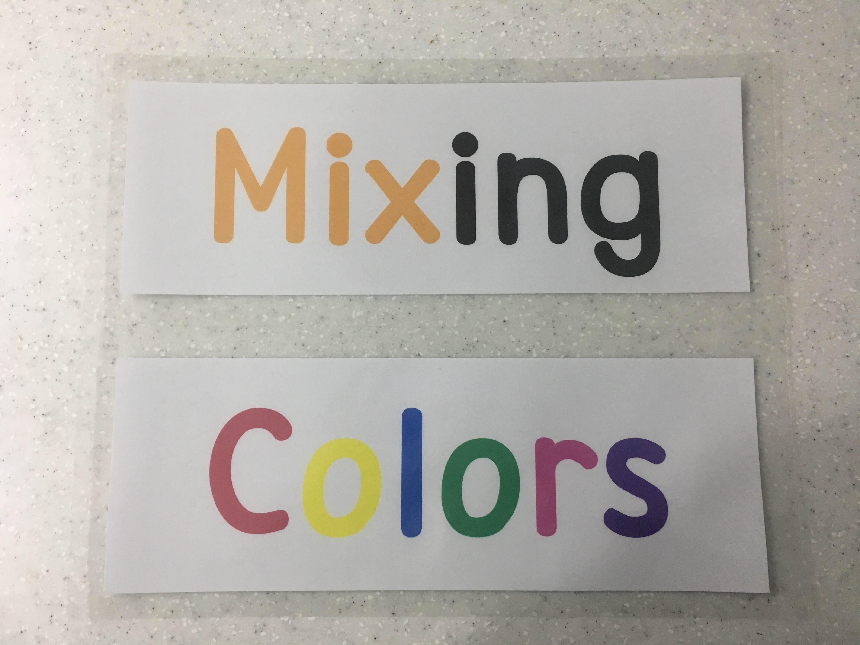

- Color flashcards : red, blue, yellow, purple, green, orange

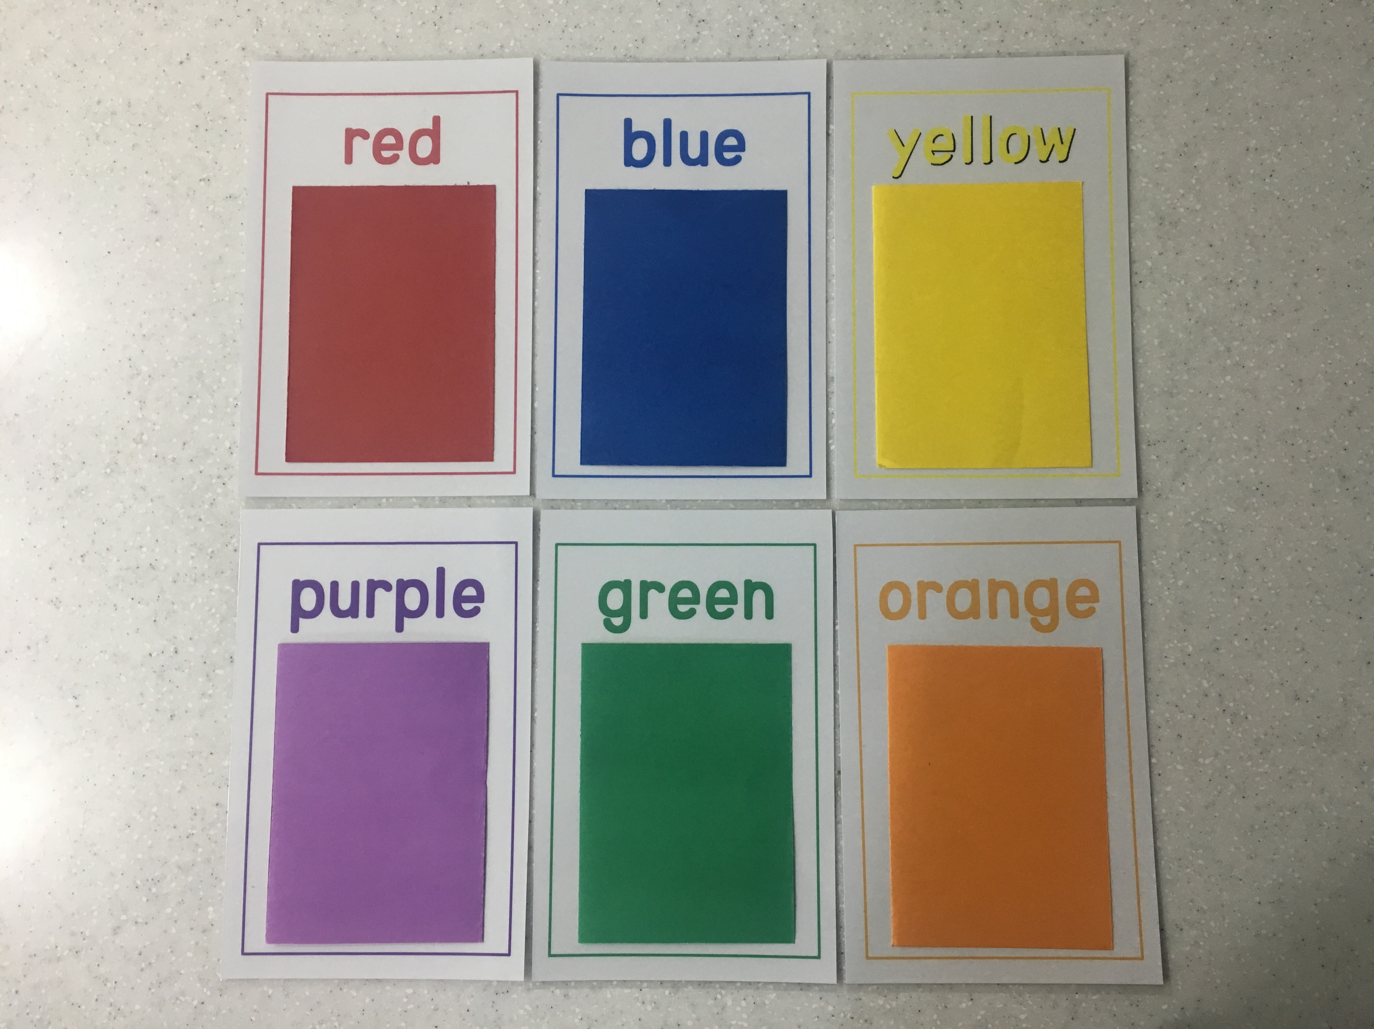

- Water colors : red, blue, yellow
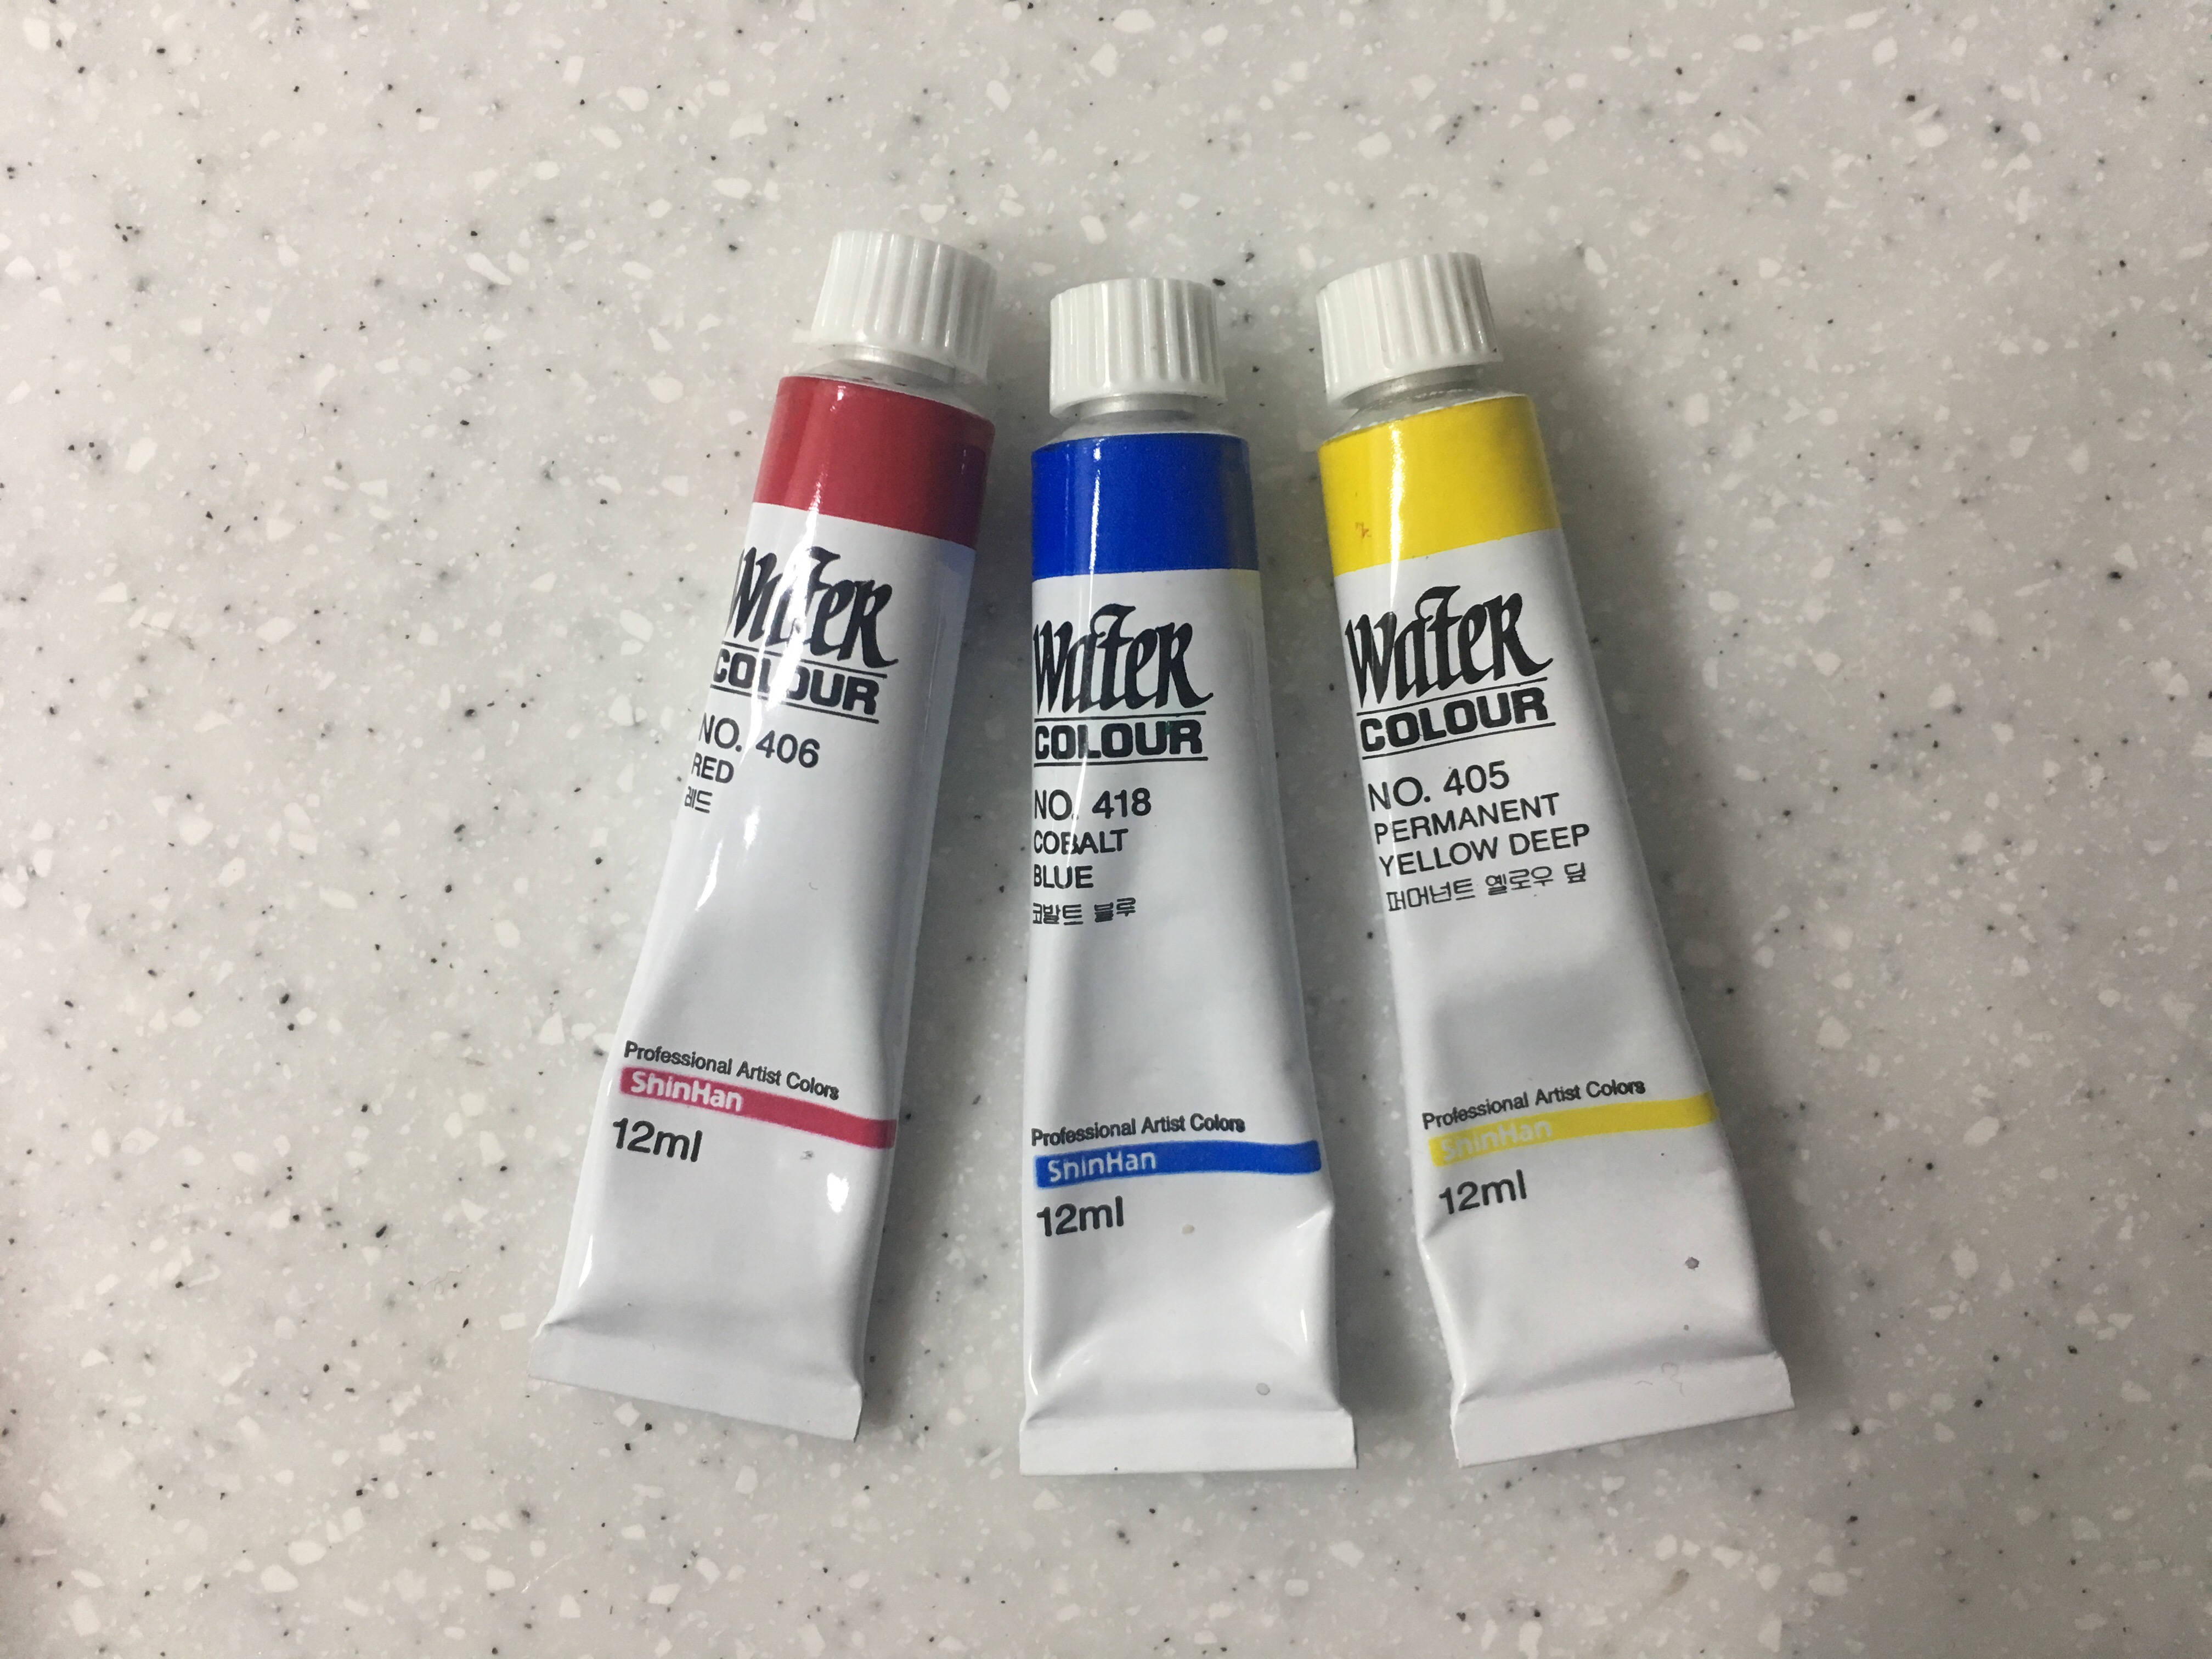

- Three clear plastic cups of water
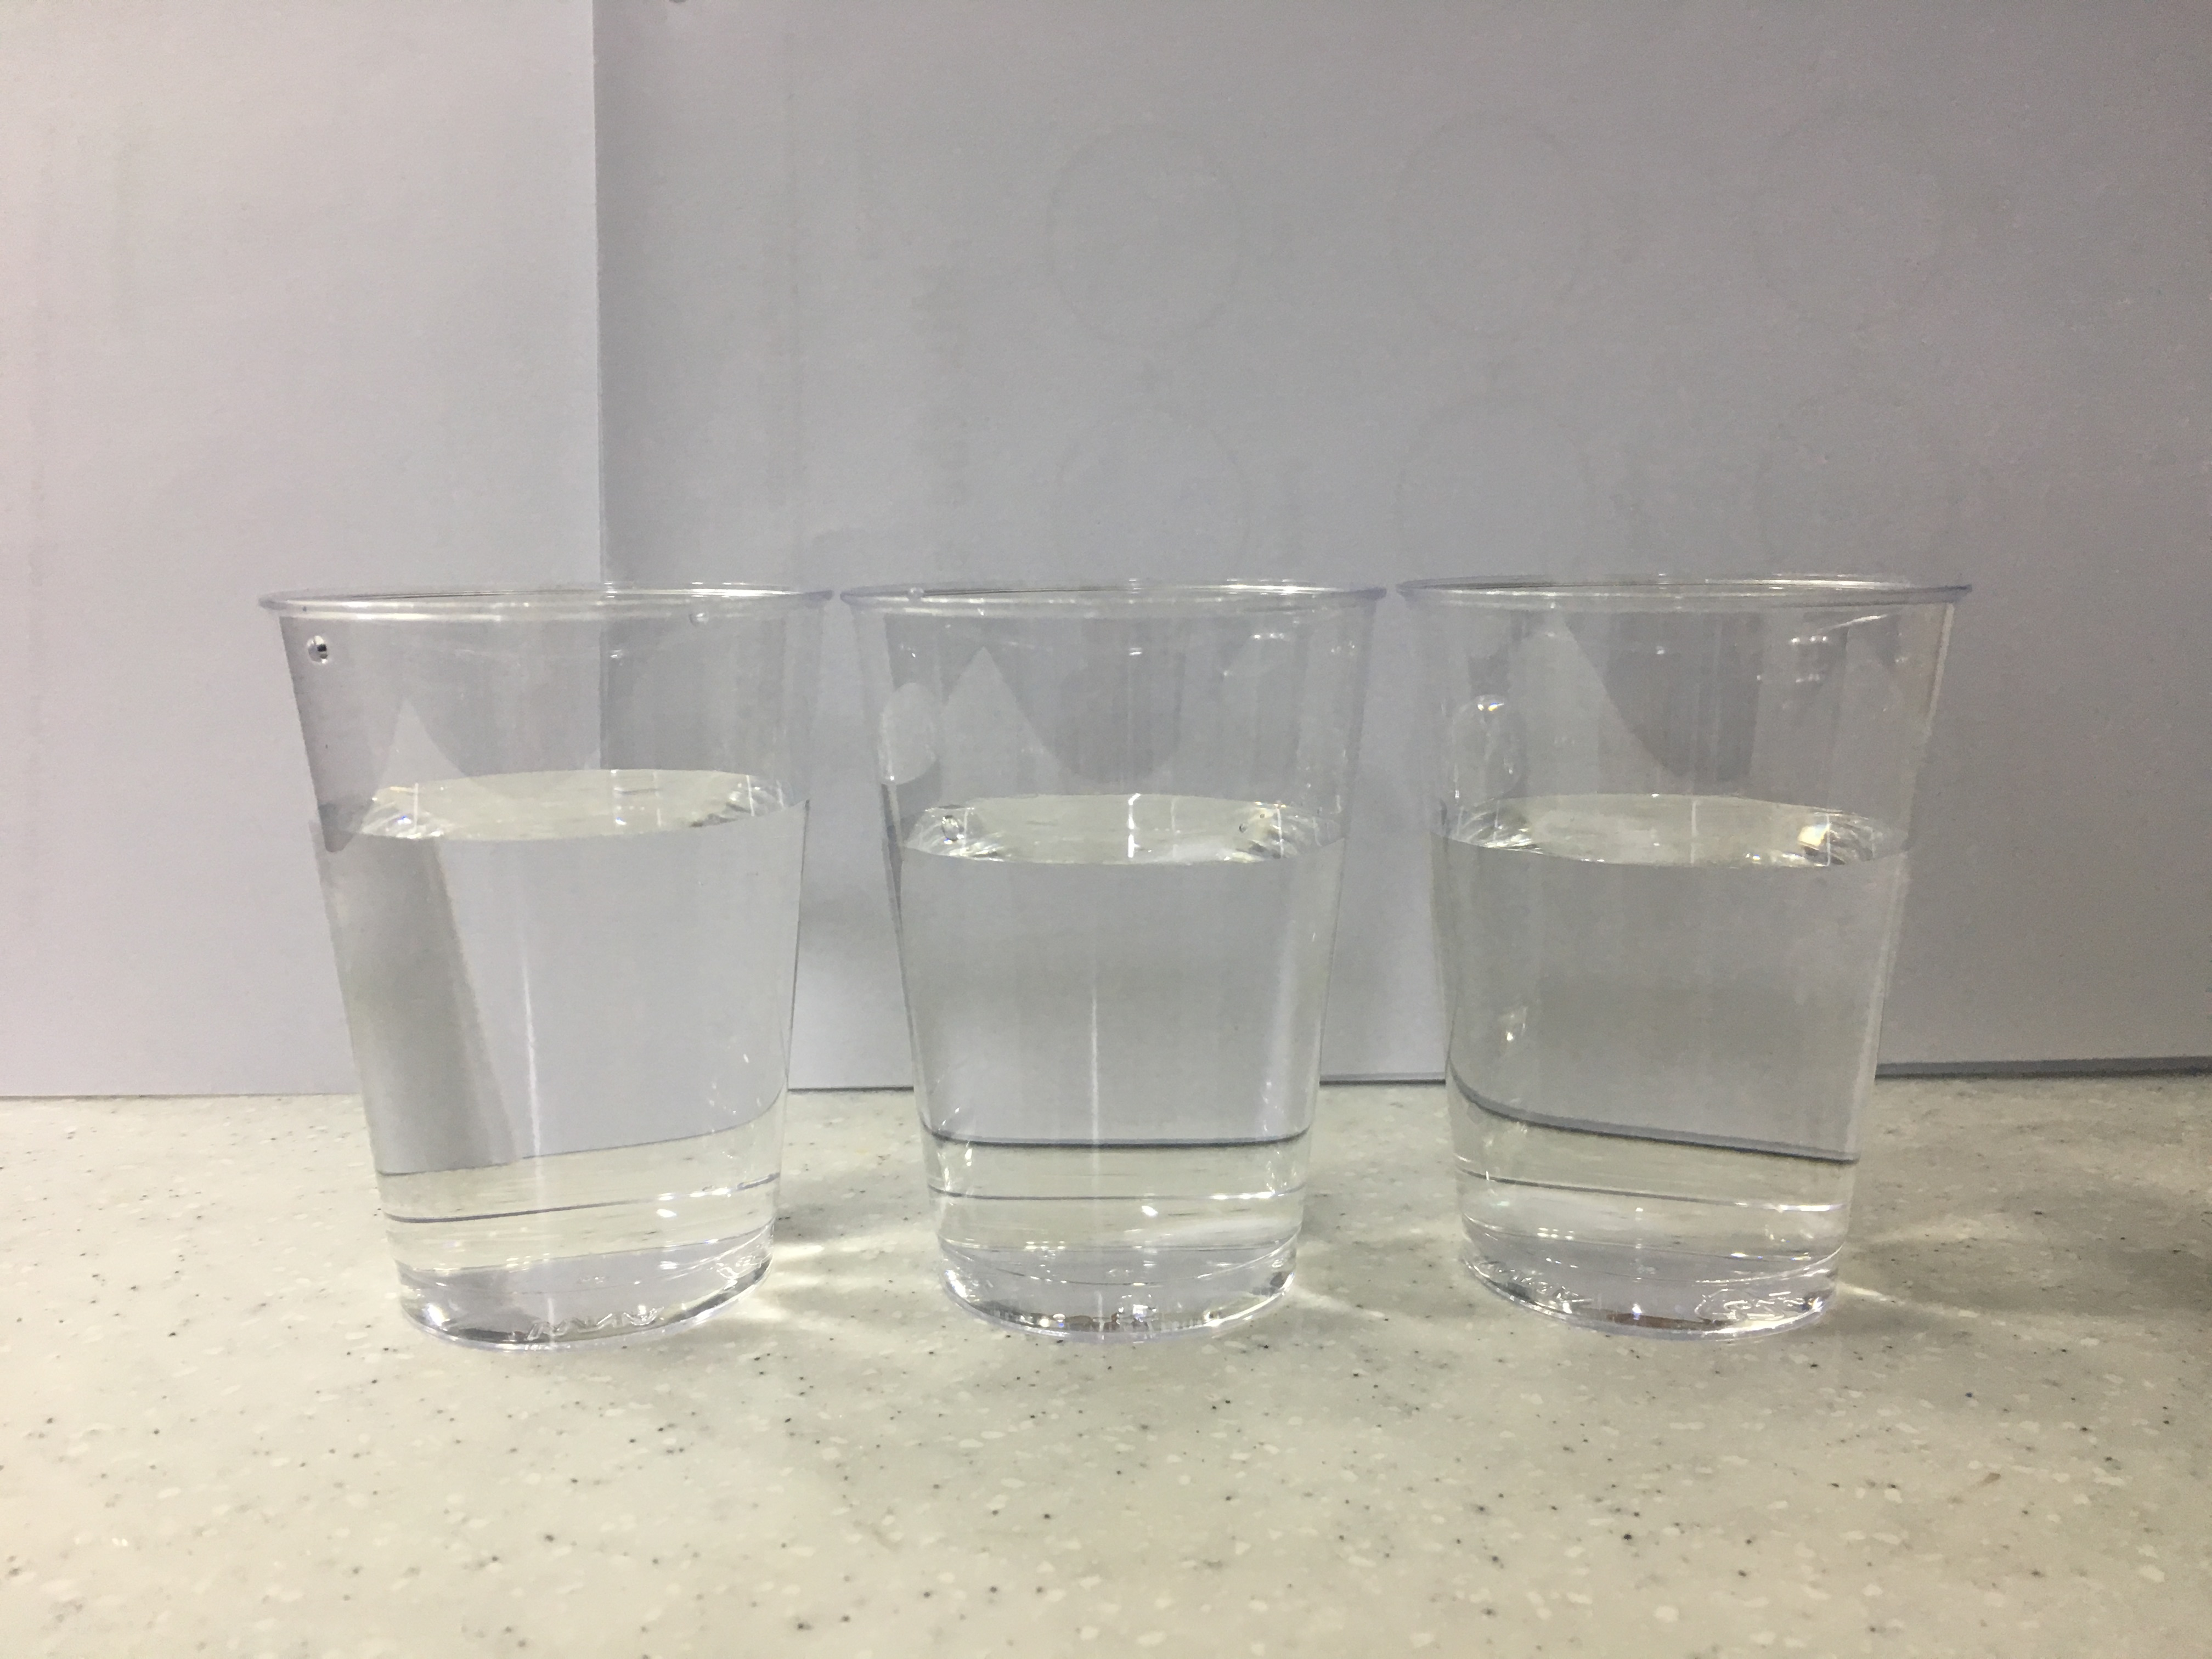

- Three clear plastic cups
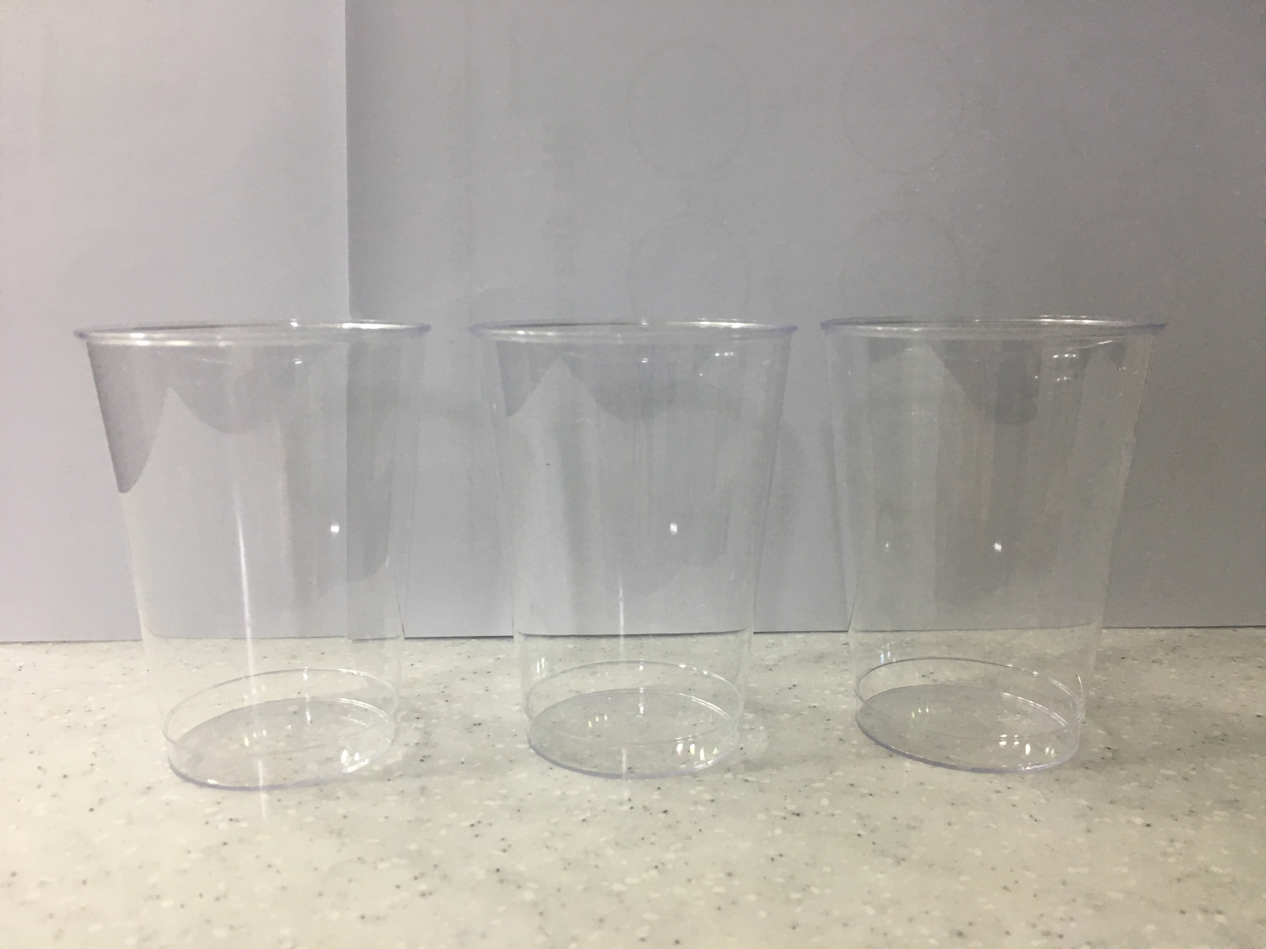

- Sticks
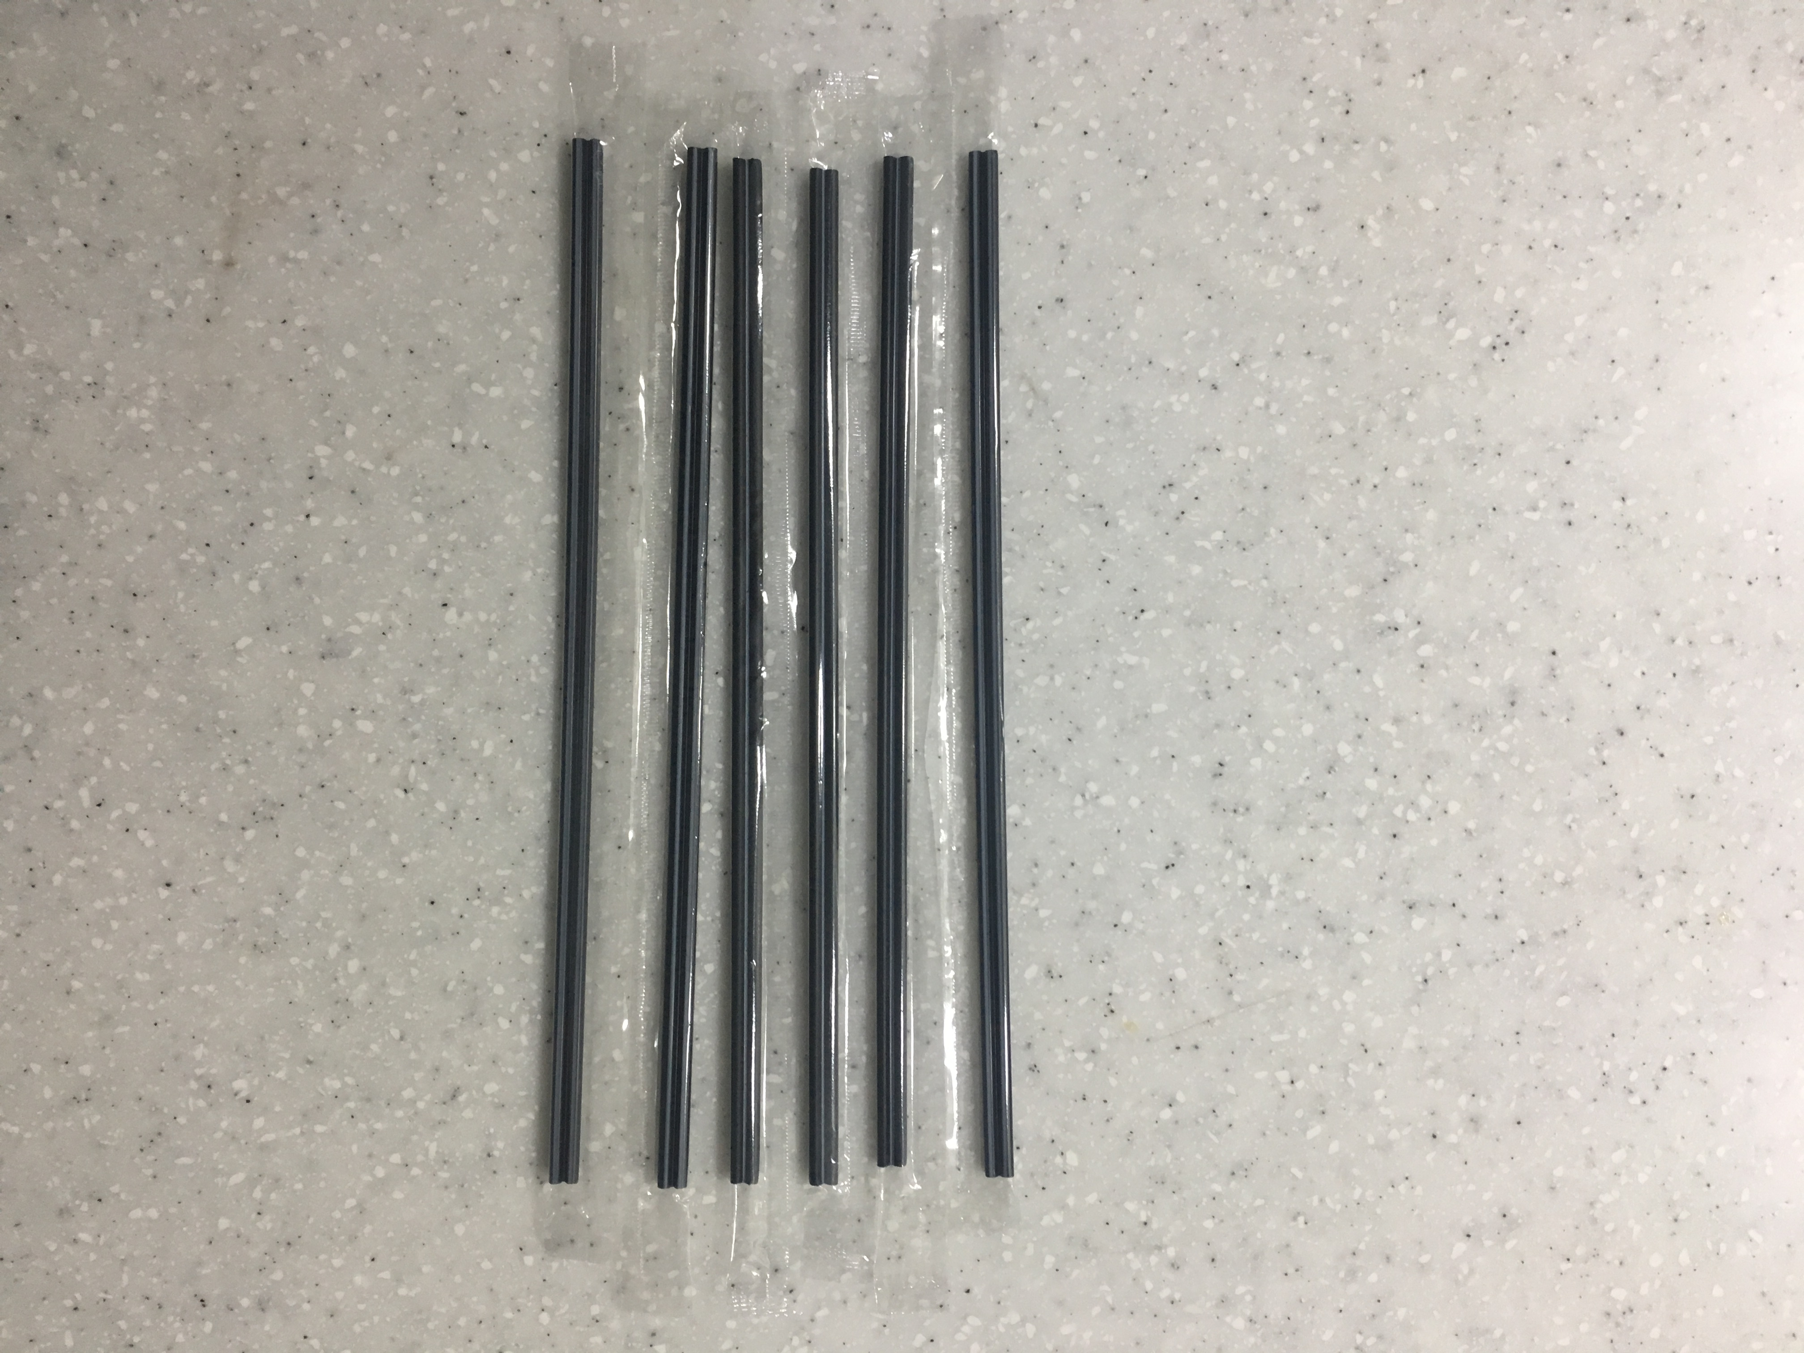

- 7 pieces of paper
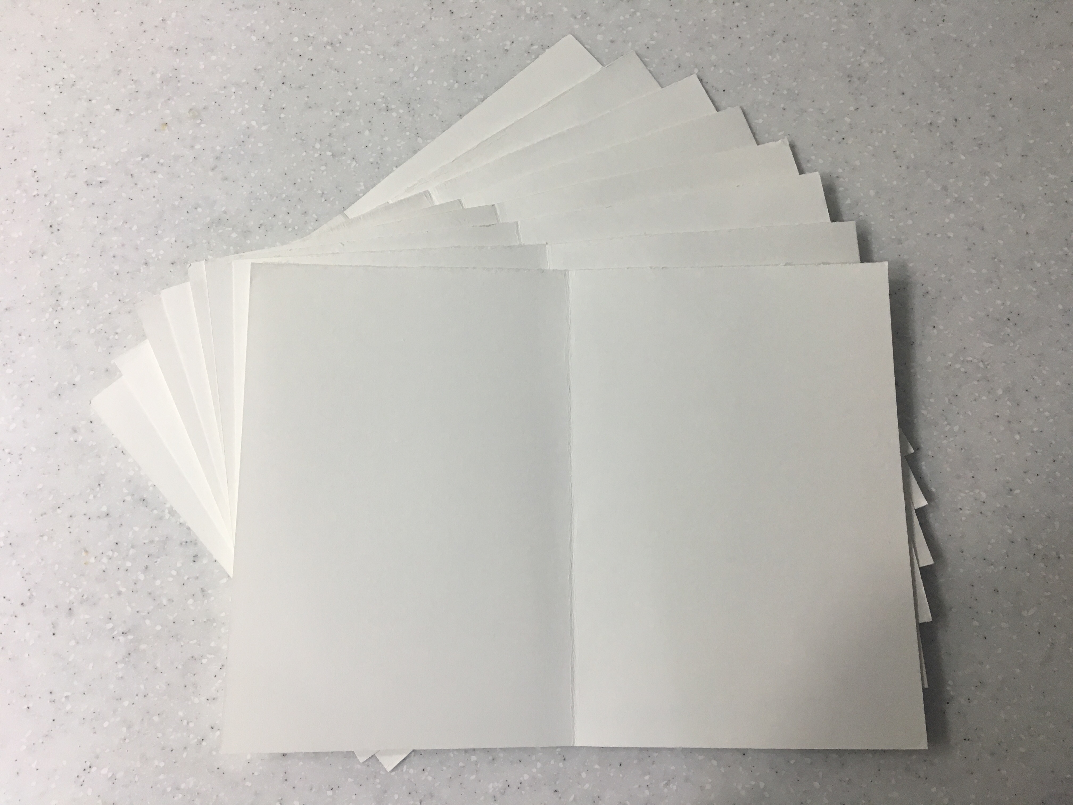

- 4 plastic plates
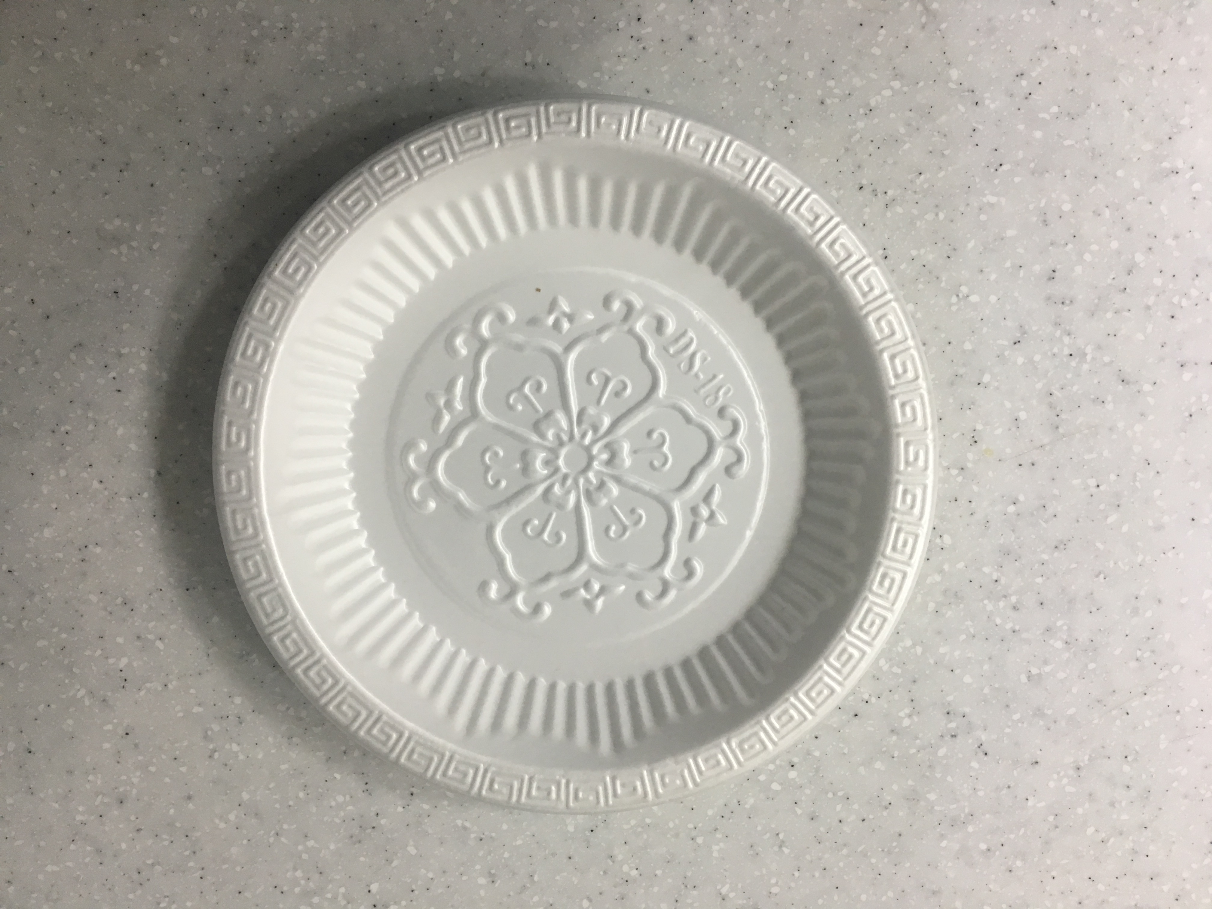

- Wet tissue
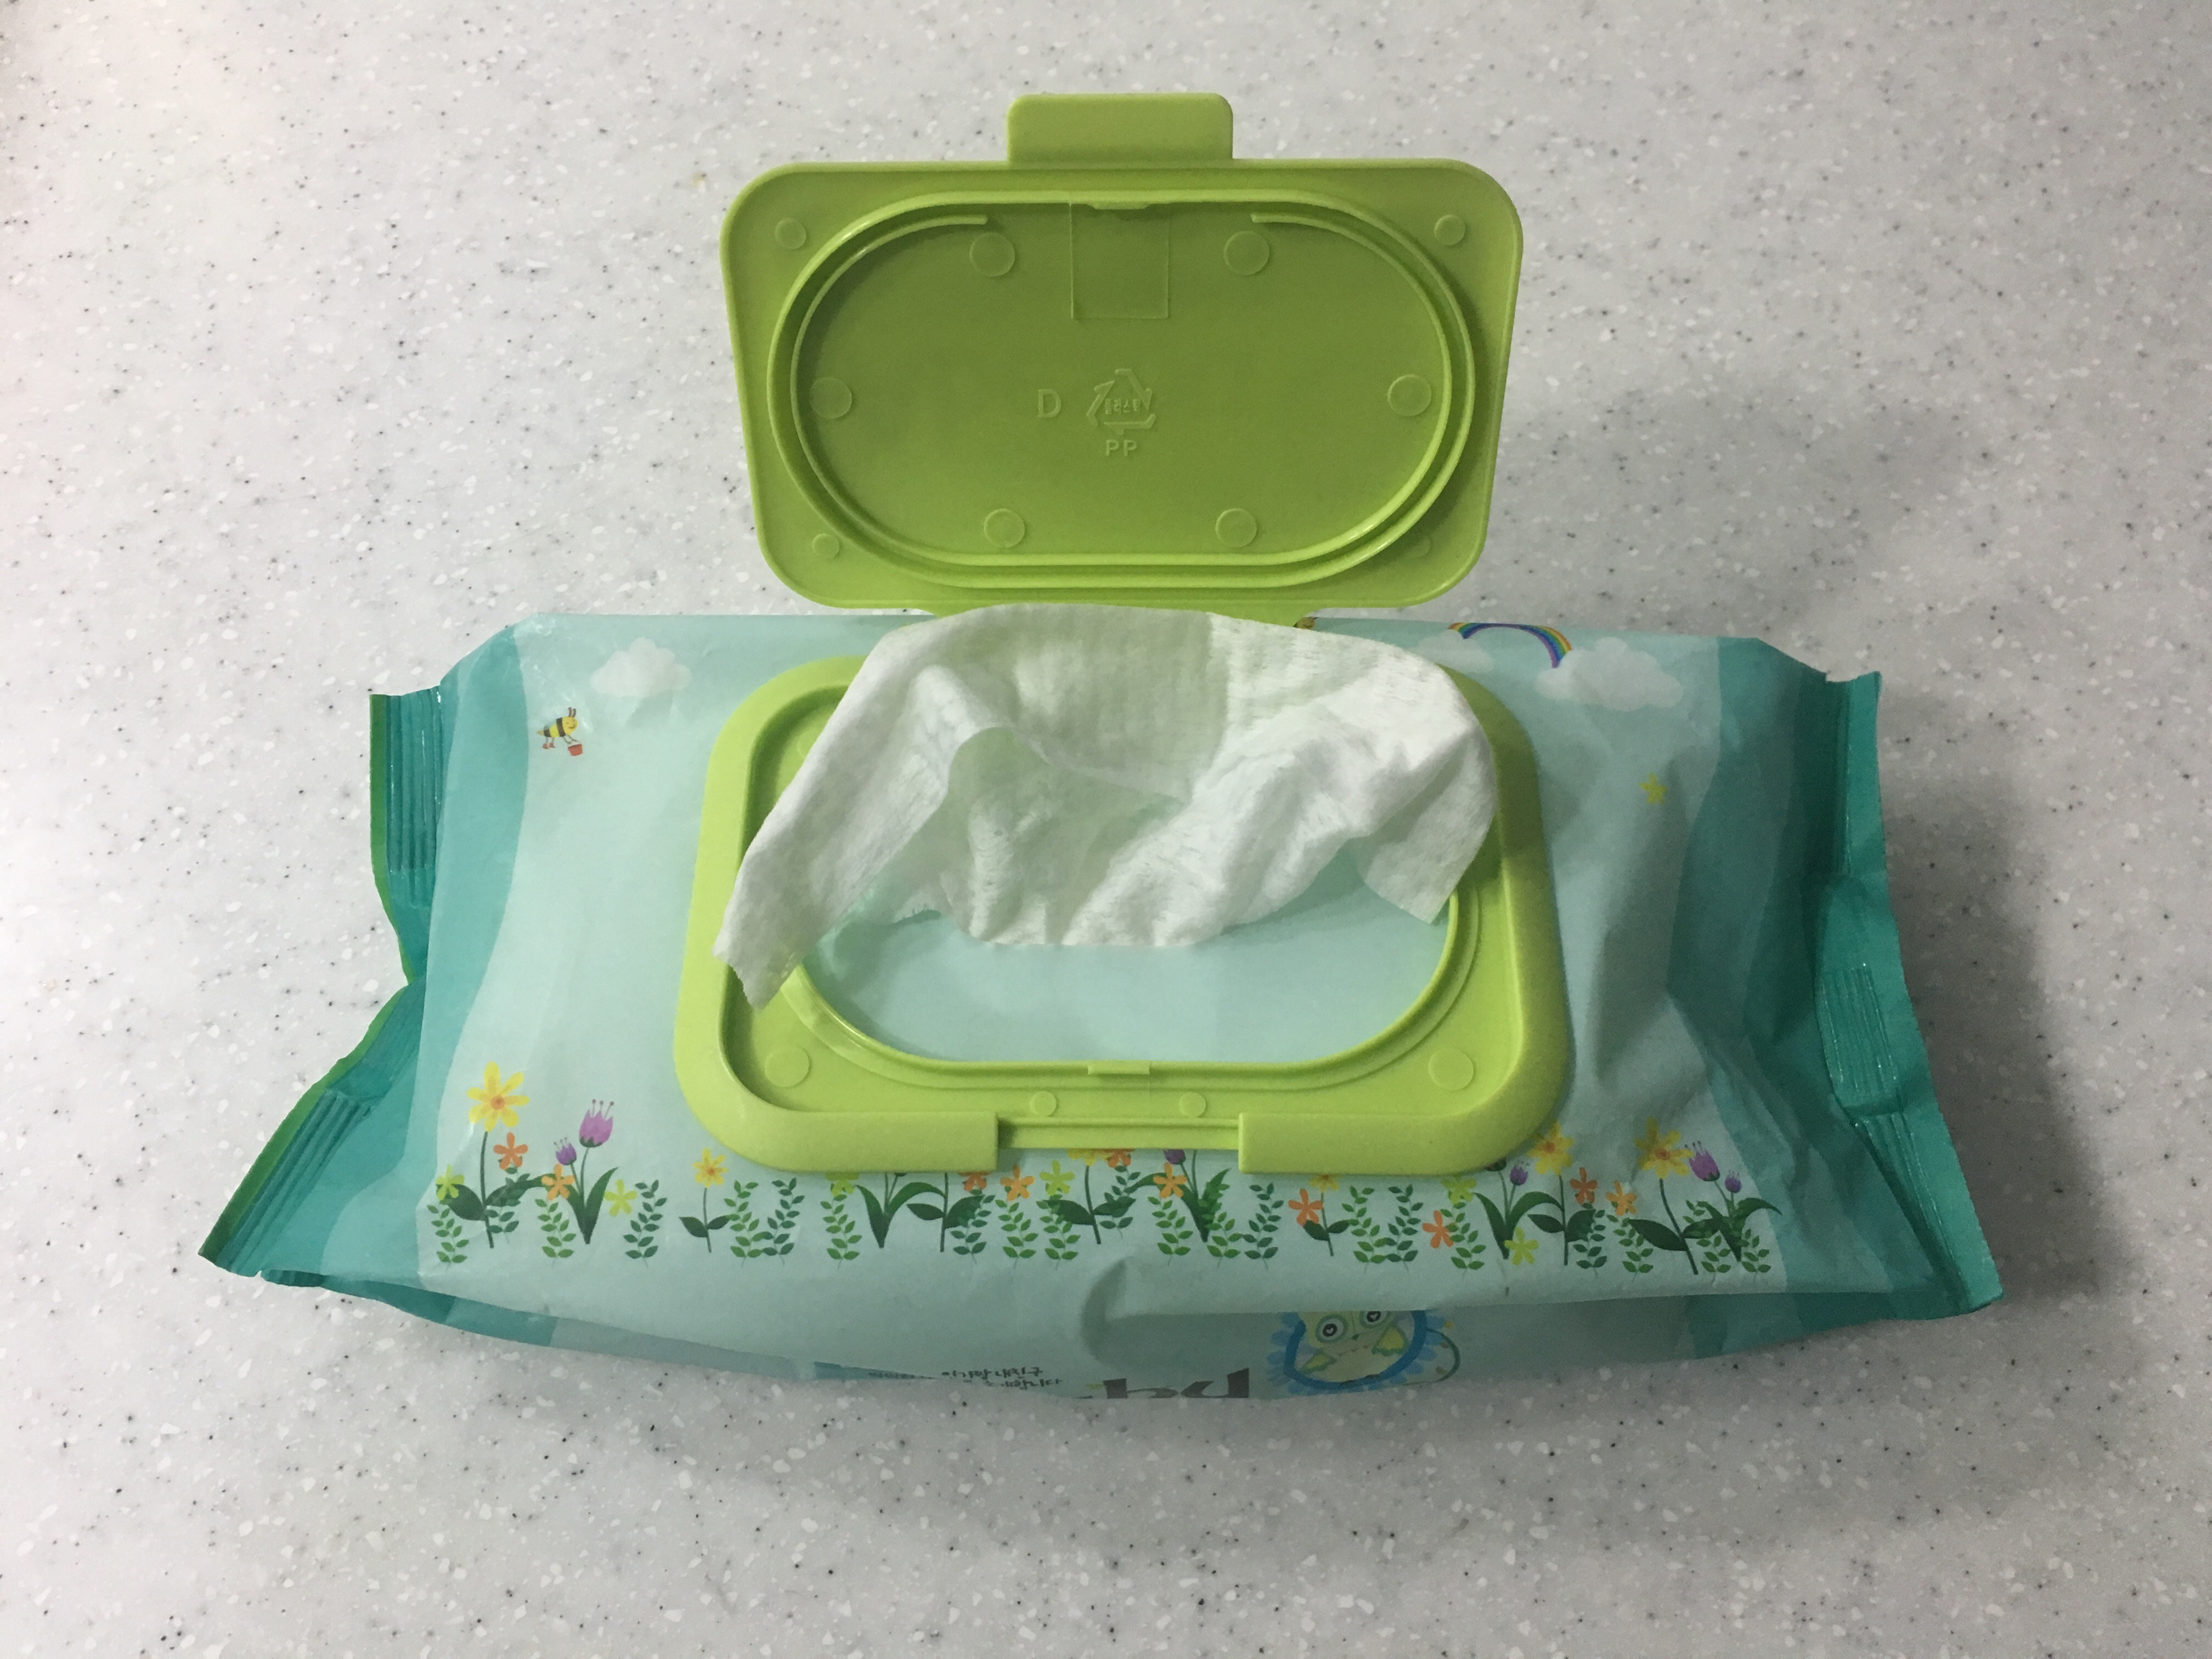

- Colored papers : red, blue, yellow, purple, green, orange, pink, white, black, gray
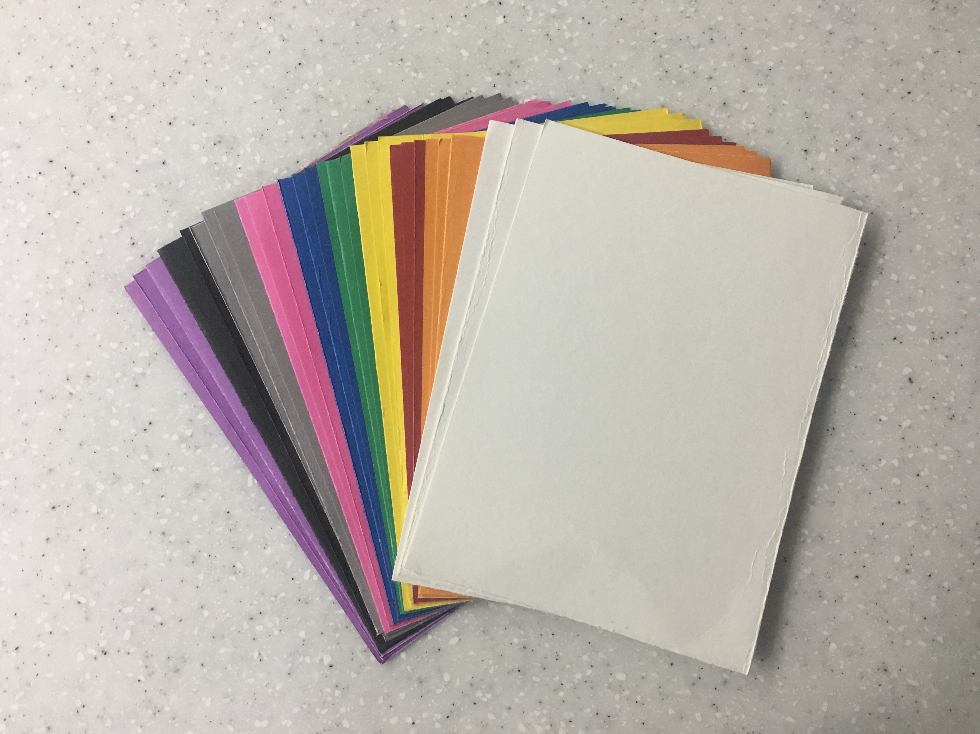

- Colored pencils(SOS)
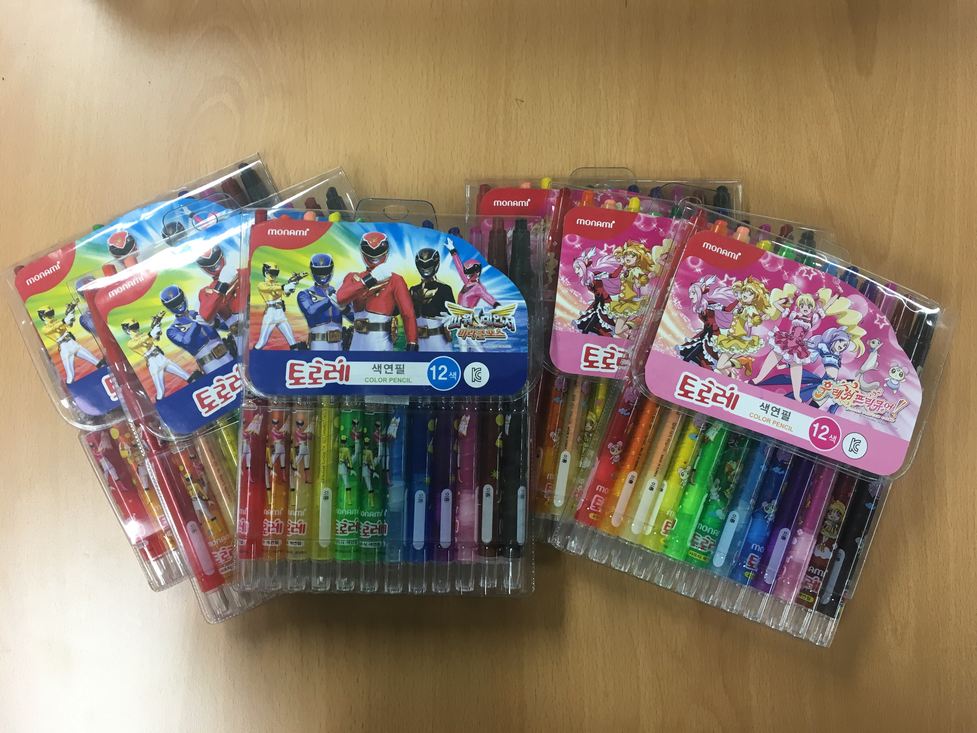

- A worksheet for tips
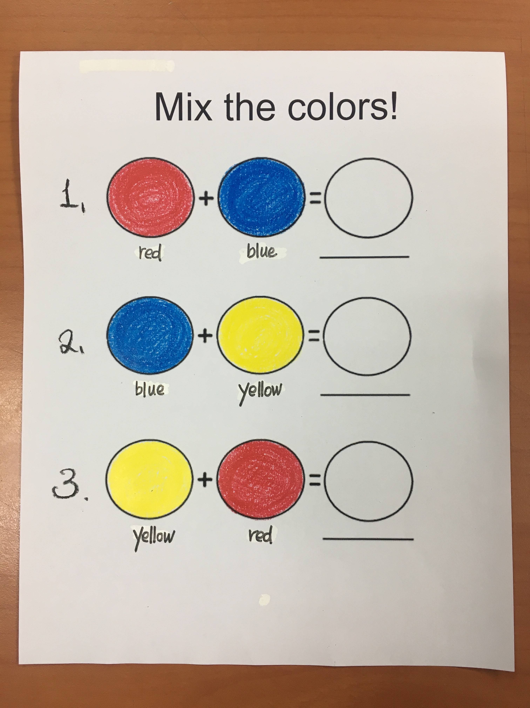

- Worksheet(SOS)
Mix the colors!


